PART 7 ­ DESIGNATIONS»Schedules and Designations»

New Zealand Railways Corporation

Designation Schedule ­ New Zealand Railways Corporation (KiwiRail)

Number | Purpose | Location
6300 | Develop, operate and maintain railways, railway lines, railway infrastructure, and railway premises ... | North Auckland Railway Line from Portage Road, Otahuhu to Ross Road, Topuni
6301 | Develop, operate and maintain railways, railway lines, railway infrastructure, and railway premises ... | Newmarket Branch Railway Line from Remuera Road, Newmarket to The Strand, Parnell
6302 | Develop, operate and maintain railways, railway lines, railway infrastructure, and railway premises ... | North Island Main Trunk Railway Line  from Buckland to Britomart Station, Auckland Central
6303 | Develop, operate and maintain railways, railway lines, railway infrastructure, and railway premises ... | Avondale Southdown Railway Line from Soljak Place, Mount Albert to Bond Place, Onehunga
6304 | Develop, operate and maintain railways, railway lines, railway infrastructure, and railway premises ... | Onehunga Branch Railway Line from Onehunga Harbour Road, Onehunga to Station Road, Penrose and Neilson Street, Tepapa
6305 | Develop, operate and maintain railways, railway lines, railway infrastructure, and railway premises ... | Southdown Freight Terminal at Neilson Street (adjoins No. 345), Onehunga
6306 | Develop, operate and maintain railways, railway lines, railway infrastructure, and railway premises ... | Mission Bush Branch Railway Line from Mission Bush Road, Glenbrook to Paerata Road, Pukekohe
R6307 | Develop, operate and maintain railways, railway lines, railway infrastructure, and railway premises ... | Manukau Rail Link from Lambie Drive (off­ramp), Manukau City Centre to Onslow Drive, Wiri

6300 North Auckland Railway Line

Designation Number | 6300
Requiring Authority | New Zealand Railways Corporation (KiwiRail)
Location | North Auckland Railway Line from Portage Road, Otahuhu to Ross Road, Topuni
Rollover Designation | Yes
Legacy Reference | Designations H13­09 & B09­06, Auckland Council District Plan (Isthmus Section) 1999; Designation NZR1, Auckland Council District Plan (Waitakere Section) 2003; and Designation 501, Auckland Council District Plan (Rodney Section) 2011
Lapse Date | Given effect to (i.e. no lapse date)

Purpose

The purpose of the designation is to develop, operate and maintain railways, railway lines, railway infrastructure,

and railway premises as defined in the Railways Act 2005.

Conditions

- See Diagram B09­06 for strata diagram for land adjacent to Broadway, Newmarket.

- No additions or alterations shall be made to the building scheduled in the District Plan (Map Reference E10­ 23 Remuera Railway Station and Signal Box) other than in accordance with an outline plan submitted and processed in terms of Section 176A of the Resource Management Act 1991. This provision shall also apply to the interior of the building and the site surrounds as dimensioned in the Plan.

The following conditions apply between points X: 1,750,777.116m Y: 5,914,020.693m and X: 1,737,958.656m and Y: 5,921,597.470m (NZTM2000):
- Where an outline plan of works is submitted in accordance with s176A of the Resource Management Act 1991, prior to commencing the project or work, that plan shall be accompanied by:
  - A statement outlining the District Plan objectives and policies relevant to the works proposed; and
  - An assessment of the effects the works described in the outline plan will have on the environment.

Explanation:
While it is accepted that the project works will be (or should be) in accordance with the designated purpose, the Council will wish to address the relevant objectives and policies of the Plan and be assured that the works will not adversely affect the environment. The Council’s principal opportunity to influence the works to assist the requiring authority to meet its environmental responsibilities is through the outline plan, and the assessment of compliance and effects will assist in determining whether to request changes.

- Appropriate sedimentation and erosion control measures shall be employed for any new earthworks on the designated site.

Explanation:
The District Plan outlines erosion and sediment control measures for earthworks which are above a certain threshold, with that threshold varying according to the particular environment. Compliance with these measures would generally satisfy condition 4. Note that major earthworks may require a consent from the Council.

Attachments
Diagram B09­06 ­ Strata Diagram for Land Adjacent to Broadway, Newmarket

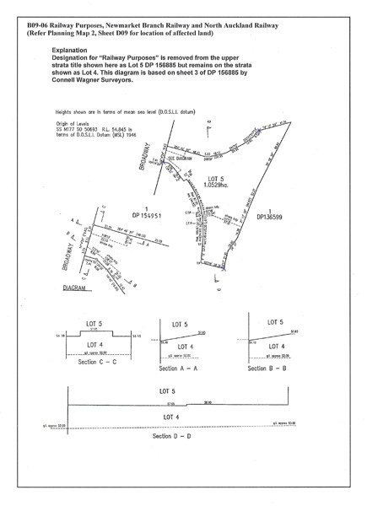

6301 Newmarket Branch Railway Line

Designation Number | 6301
Requiring Authority | New Zealand Railways Corporation (KiwiRail)
Location | Newmarket Branch Railway Line from Remuera Road, Newmarket to The Strand, Parnell
Rollover Designation | Yes
Legacy Reference | Designation B09­06, Auckland Council District Plan (Isthmus Section) 1999; and Designation 282, Auckland Council District Plan (Central Area Section) 2005
Lapse Date | Given effect to (i.e. no lapse date)

Purpose

The purpose of the designation is to develop, operate and maintain railways, railway lines, railway infrastructure, and railway premises as defined in the Railways Act 2005.

Conditions
The following conditions apply between points X: 1,758,321.043m Y:5,920,188.314m and X 1,758,597.328m Y: 5,920,477.525m (NZTM2000):1. With the exception of the temporary station site, the designation (for existing and future corridors) is limited as to airspace at 6m above the rail tracks and the future corridor to the Britomart Transport Centre is limited to both airspace and substrata as shown in Diagram 282.

2. Development of the temporary station site shall comply with the underlying development controls.

The following conditions apply between points X: 1,758,651.726m Y: 5,918,459.655m and X 1,758,321.043m Y: 5,920,188.314m (NZTM2000):
3. Where the Parnell Tunnel passes under the following properties, the designation applies to the subsoil space only: Allotment 57, Section 3 Suburbs of Auckland, Survey Office Plan 47222;
Section 1, SO 62979;
Lot 1, DP 150385;
Part Lot 1, DP 138824; and
Lot 2, DP 20720.

For these properties, the extent of the designation is limited to the subsoil space owned by the requiring authority and recorded on the certificates of title. The location of these properties and the strata nature of the designation is illustrated in Diagram B09­06(1).

- Where the Parnell Tunnel passes under Domain Drive and Parnell Road the designation applies to subsoil space only. The location of these roads in relation to the tunnel and the strata nature of the designation is illustrated in Diagram B09­06(1).

- No buildings and structures shall be located in the designation area on the Domain (see Diagram B09­06(2)) except for any enabling works required for the construction of the Parnell Railway Station and its associated structures (including platforms and pedestrian connections such as over bridges, underpasses, footpaths and gantry structures within the station vicinity).

- Detailed designs and plans shall be prepared prior to commencement of works to mitigate the adverse visual and amenity effects of the soil nail retaining walls and batter slopes in the proposed alteration to the designation. The details shall include:
  - Batter slope treatment and planting details; and
  - Soil nail retaining wall details including visual relief and treatment to minimise their visual impact and to integrate into the surrounding landform and vegetated characteristics of the Auckland Domain. The use of MacMatR or similar softening techniques should be investigated to minimise their visual impact.

- Detailed landscape mitigation planting plans shall be prepared by a Registered Landscape Architect to mitigate the adverse visual and amenity effects of the Auckland Domain vegetation removal. The plans shall have input from an ecologist and interested iwi groups and be submitted for approval to the Parks, Sport and Recreation Manager. The landscape plans should seek to retain the largest and structurally sound trees which are to be indicated on the plans. The plans shall include:
  - Detailed landscape planting plans with tree and plant species, sizes and spacing;
  - Landscape specifications; and
  - Implementation and maintenance programme.

- Detailed plans and cross sections of the proposed pedestrian underpass, showing the exact location and visual perspectives of the proposed underpass and re­instatement of the existing underpass, shall be approved by the Parks, Sport and Recreation Manager prior to commencement of works, if the outline plan of works is waived. The pedestrian access path should be designed and aligned to minimise any adverse effects on the existing vegetation

within the Domain land, including the Puriri tree in close proximity to the proposed underpass. A Crime Prevention Through Environmental Design (CPTED) assessment shall be undertaken of the pedestrian underpass to minimise threats to personal safety.

Advice Note
1. The New Zealand Historic Places Trust Accidental Discovery Protocol be adopted by all contractors working on site.

Attachments

Diagram 282 ­ Auckland Railway Station and Railway Designation Heigts
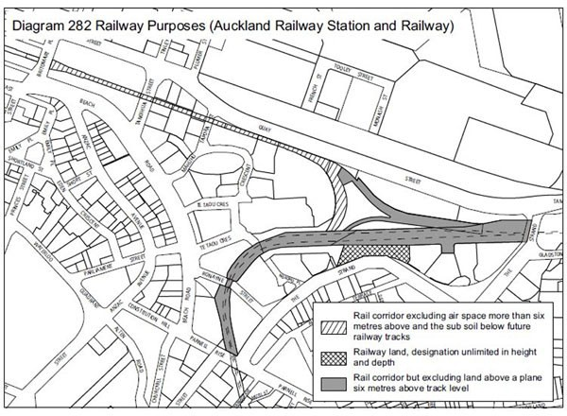

Diagram B09­06(1) ­ Strata Diagram for Parnell Tunnel

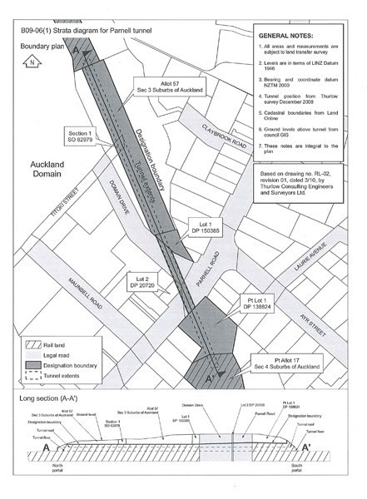

Diagram B09­06(2) ­ Railway Designation on Auckland Domain Subject to Conditions

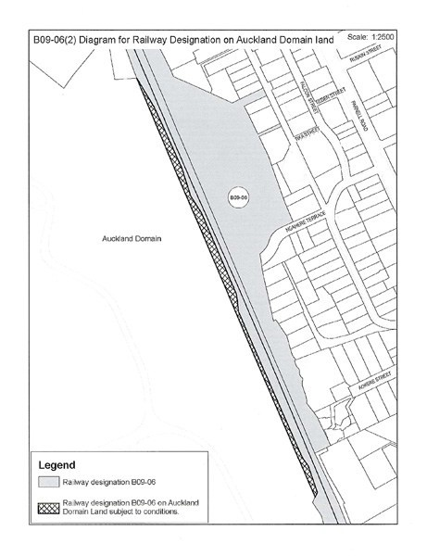

6302 North Island Main Trunk Railway Line

Designation Number | 6302
Requiring Authority | New Zealand Railways Corporation (KiwiRail)
Location | North Island Main Trunk Railway Line from Buckland to Britomart Station, Auckland Central
Rollover Designation | Yes
Legacy References | Designation 89, Auckland Council District Plan (Franklin Section)  2000; Designation 11, Auckland Council District Plan (Papakura Section) 1999; Designation 230, Auckland Council District Plan (Manukau Section) 2002; Designation B10­05, Auckland Council District Plan (Isthmus Section) 1999; Designation 282, Auckland Council District Plan (Central Area Section) 2005
Lapse Date | Given effect to (i.e. no lapse date)

Purpose

The purpose of the designation is to develop, operate and maintain railways, railway lines, railway infrastructure, and railway premises as defined in the Railways Act 2005.

Conditions

The following conditions apply between points X: 1,763,282.256m Y: 5,909,226.484m and X: 1,758,983.051m Y: 5,920,480.938m (NZTM2000):
- Any activity on land within the defined Tamaki Drive Scenic Way (Map Reference B10­08) shall comply with the Auckland City Design Guidelines Tamaki Drive.

- The geological feature which is scheduled in the District Plan (Map Reference D12­04) shall not be excavated, physically investigated, damaged, or altered, other than in accordance with an outline plan submitted and processed in terms of Section 176A of the Resource Management Act 1991.

- Where the Purewa Tunnel passes under the following properties, the designation applies to subsoil space only: Lot 416, DP 41185;
Lot 1, DP 74916;
Lot 2, DP 74916;
Part Lot 2, DP 40127;
Part Lot 1, DP 40127;
Part Lot 22, DP 18321; and
Part Lot 19, DP 18321.

For these properties, the extent of the designation is limited to the subsoil space owned by the requiring authority and recorded on the certificates of title. The location of these properties and the strata nature of the designation is illustrated in Diagram B10­05(1).

- Where the Purewa Tunnel passes under St Johns Road, the extent of the designation is limited to the subsoil space owned by the requiring authority and recorded on Survey Office Plan 22701. The location of this road in relation to the tunnel and the strata nature of the designation is illustrated in Diagram B10­05(1).

The following conditions apply between points XL 1,758,983.051m Y: 5,920,480.938m and X: 1,757,893.28m Y: 5.920,853.469m (NZTM2000):
- With exception of the temporary station site, the designation (for existing and future corridors) is limited as to airspace at 6m above the rail tracks and the future corridor to the Britomart Transport Centre is limited to both airspace and substrata as shown in the Diagram 282.

- Development of the temporary station site shall comply with the underlying development controls.

Attachments

Diagram B10­05 ­ Purewa Tunnel Strata

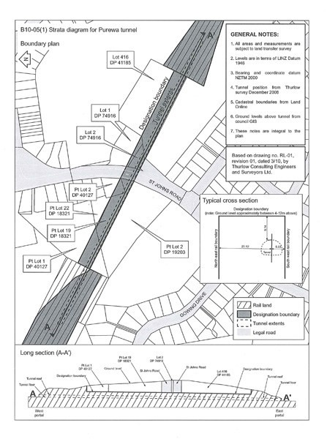

Diagram 282 ­ Auckland Railway Station and Railway Designation Heights

6303 Avondale Southdown Railway Line

Designation Number | 6303
Requiring Authority | New Zealand Railways Corporation (KiwiRail)
Location | Avondale to Southdown Railway Line from Soljak Place, Mount Albert to Bond Place, Onehunga
Rollover Designation | Designation G08­05, Auckland Council District Plan (Isthmus Section) 1999
Lapse Date | 12 years from being operative in the Unitary Plan unless given effect to prior

Purpose

The purpose of the designation is to develop, operate and maintain railways, railway lines, railway infrastructure, and railway premises as defined in the Railways Act 2005.

Conditions

- That prior to implementation of the designation an assessment of environmental effects be undertaken to determine effects the works will have on the environment and the most appropriate means of mitigating these effects.

- That a landscape plan be submitted for approval to the Council at the time of detailed design including fencing and planting which will be implemented at the boundary of the line with all land zoned residential and open space to minimise noise effects and provide screening.

- That vehicle access along New North Road, Richardson Road, May Road, Dominion Road, Hayr Road,

Hillsborough Road, Queenstown Road, Pleasant Street, Symonds Street, Forbes Street, Normans Hill Road, Quadrant Road, Hill Street, Selwyn Street, Onehunga Mall, Galway Street, Spring Street, Victoria Street and Alfred Street be maintained when construction is completed. All crossings to be grade separated, with the exception of local roads.

- The short term construction effects including noise, visual effects and dust be reduced through appropriate construction methods.

- The term for this designation shall be 12 years from the inclusion of the designation in the District Plan.

Attachments

No attachments.

6304 Onehunga Branch Railway Line

Designation Number | 6304
Requiring Authority | New Zealand Railways Corporation (KiwiRail)
Location | Onehunga Brach Railway Line from Onehunga Harbour Road, Onehunga to Station Road, Penrose and Neilson Street (Southdown Freight Terminal), Tepapa
Rollover Designation | Yes
Legacy Reference | Designation G12­07, Auckland Council District Plan (Isthmus Section) 1999
Lapse Date | Given effect to (i.e. no lapse date)

Purpose

The purpose of the designation is to develop, operate and maintain railways, railway lines, railway infrastructure, and railway premises as defined in the Railways Act 2005.

Conditions

No conditions.

Attachments

No attachments.

6305 Southdown Freight Terminal

Designation Number | 6305
Requiring Authority | New Zealand Railways Corporation (KiwiRail)
Location | Neilson Street (adjoins No. 345), Onehunga
Rollover Designation | Yes
Legacy Reference | Designation H11­11, Auckland Council District Plan (Isthmus Section) 1999
Lapse Date | Given effect to (i.e. no lapse date)

Purpose

The purpose of the designation is to develop, operate and maintain railways, railway lines, railway infrastructure, and railway premises as defined in the Railways Act 2005.

Conditions

No conditions.

Attachments

No attachments.

6306 Mission Bush Branch Railway Line

Designation Number | 6306
Requiring Authority | New Zealand Railways Corporation (KiwiRail)
Location | Mission Bush Branch Railway Line from Mission Bush Road, Glenbrook to Paerata Road, Pukekohe
Rollover Designation | Yes
Legacy Reference | Designation 90, Auckland Council District Plan (Franklin Section) 2000
Lapse Date | Given effect to (i.e. no lapse date)

Purpose

The purpose of the designation is to develop, operate and maintain railways, railway lines, railway infrastructure, and railway premises as defined in the Railways Act 2005.

Conditions

No conditions.

Attachments

No attachments.

R6307 Manukau Rail Link

Designation Number | R6307
Requiring Authority | New Zealand Railways Corporation (KiwiRail)
Location | Manukau Rail Link from Lambie Drive (off­ramp), Manukau City Centre to Ons
Rollover Designation | No
Legacy Reference | N/A
Lapse Date | Given effect to (i.e. no lapse date)

Purpose

The purpose of the designation is to develop, operate and maintain railways, railway lines, railway infrastructure, and railway premises as defined in the Railways Act 2005.

Conditions

No conditions.

Attachments

No attachments.

