PART 7 ­ DESIGNATIONS»Schedules and Designations»

Kordia Ltd

Designation Schedule ­ Kordia Ltd

Number | Purpose | Location
3300 | Microwave transmission corridor ... | 100 Victoria Street West, Central Auckland to 539 Scenic Drive, Waiatarua
3301 | Broadcasting and telecommunications facility ... | 539 Scenic Drive, Waiatarua
3302 | Broadcasting and telecommunications facility ... | Kaipara Hills Road (Pt Allotment 201 Psh Tauhoa), Kaipara Hills
3303 | Broadcasting and telecommunications facility ... | 192 Browns Bay Road, Pine Hill
3304 | Broadcasting and telecommunications facility ... | Repeater Road (Pt Allotment 33 Psh of Atou and Pt Allotment 65A Psh of Atou), Hunua Ranges

3300 Microwave Transmission Corridor

Designation Number | 3300*
Requiring Authority | Kordia Ltd
Location | 100 Victoria Street West, Auckland Central to 539 Scenic Drive, Waiatarua
Rollover Designation | Yes
Legacy Reference | Designation 301, Auckland Council District Plan (Central Area Section) 2005; Designation B08­02, Auckland Council District Plan (Isthmus Section) 1999; and Designation K2, Auckland Council District Plan (Waitakere Section) 2003
Lapse Date | Given effect to (i.e. no lapse date)

*Joint Kordia Ltd and Television New Zealand Ltd (Designation 300) designation from 100 Victoria Street West, Auckland Central to Ponsonby Road, Ponsonby. Kordia Ltd only designation from Ponsonby Road to 501 Scenic Drive, Waiatarua.

Purpose

Microwave transmission corridor ­ a protection corridor of specified height (elevation above sea level) and width through which no building, structure or tree can pass to ensure continuity of a microwave linking / transmission path from the Television New Zealand Studios at 100 Victoria Street West, Central Auckland to the Waiatarua transmission tower at 539 Scenic Drive, Waiatarua.

Conditions

- All masts, antennas, aerials and other facilities must comply with New Zealand Standard NZS6609: 1990 or any amendments, at all times.

The following table shows, at specific points along the path of the corridor, the width of the corridor and the base­height of the corridor. Intermediate widths and heights shall be determined by extending straight lines between adjacent points.

Path Length (KM) | Corridor Width (m) | Maximum Obstruction Height above Mean Sea Level (m)
0.000 (a) | 6.8 | 62.6
0.025 | 6.8 | 63.0
0.050 | 6.8 | 63.4
0.075 | 6.8 | 63.8
0.100 | 6.8 | 64.2
0.125 | 6.8 | 64.6
0.150 | 6.8 | 65.0
0.175 | 6.8 | 65.4
0.200 | 6.8 | 65.8
0.225 | 6.8 | 66.2
0.250 | 6.8 | 66.6
0.275 | 6.8 | 67.0
0.300 | 6.8 | 67.3
0.325 | 6.8 | 67.7
0.350 | 6.8 | 68.1
0.375 | 6.8 | 68.5
0.400 | 6.8 | 68.9
0.425 | 6.8 | 69.3
0.450 | 6.8 | 69.7
0.475 | 6.8 | 70.1
0.500 | 6.8 | 70.5
0.525 | 6.8 | 70.9
0.550 | 6.8 | 71.3
0.575 | 6.8 | 71.7
0.600 | 6.8 | 72.1
0.625 | 6.8 | 72.5
0.650 | 6.8 | 72.9
0.675 | 6.8 | 73.3
0.700 | 6.8 | 73.7
0.725 | 6.8 | 74.1
0.750 | 6.8 | 74.5
0.775 | 6.8 | 74.9
0.800 | 6.8 | 75.3
0.825 | 6.8 | 75.7
0.850 | 6.8 | 76.1
0.875 | 6.8 | 76.5
0.900 | 6.9 | 76.8
0.925 | 7.0 | 77.2

Path Length (KM) | Corridor Width (m) | Maximum Obstruction Height above Mean Sea Level (m)
0.950 | 7.1 | 77.6
0.975 | 7.2 | 77.9
1.000 | 7.3 | 78.3
1.10 | 7.6 | 79.7
1.20 | 7.9 | 81.1
1.30 | 8.2 | 82.6
1.40 | 8.5 | 84.1
1.50 (b) | 8.8 | 85.5
1.60 | 9.1 | 87.0
1.70 | 9.3 | 88.5
1.80 | 9.6 | 90.0
1.90 | 9.8 | 91.5
2.00 | 10.0 | 93.0
2.10 (c) | 10.2 | 94.5
2.20 | 10.4 | 96.1
2.30 | 10.6 | 97.6
2.40 | 10.8 | 99.1
2.50 | 11.0 | 100.7
2.60 | 11.2 | 102.2
2.70 | 11.4 | 103.8
2.80 | 11.6 | 105.3
2.90 | 11.7 | 106.9
3.00 | 11.9 | 108.4
3.10 | 12.1 | 110.0
3.20 | 12.2 | 111.6
3.30 | 12.4 | 113.2
3.40 | 12.5 | 114.7
3.50 (d) | 12.7 | 116.3
3.60 | 12.8 | 117.9
3.70 | 12.9 | 119.5
3.80 | 13.1 | 121.1
3.90 | 13.2 | 122.7
4.00 | 13.3 | 124.3
4.5 | 13.9 | 132.4
5.0 | 14.4 | 140.6
5.5 | 14.8 | 148.8
6.0 | 15.2 | 157.2
6.5 | 15.5 | 165.6
7.0 | 15.8 | 174.2

Path Length (KM) | Corridor Width (m) | Maximum Obstruction Height above Mean Sea Level (m)
7.5 | 16.0 | 182.8
8.0 | 16.2 | 191.4
8.5 | 16.3 | 200.2
9.0 | 16.4 | 209.0
9.5 | 16.4 | 218.0
10.0 | 16.4 | 227.0
10.5 | 16.4 | 236.0
11.0 | 16.3 | 245.2
11.5 | 16.1 | 254.4
12.0 | 15.9 | 263.7
12.5 | 15.7 | 273.1
13.0 | 15.4 | 282.6
13.5 | 15.1 | 292.1
14.0 | 14.7 | 301.8
14.5 | 14.2 | 311.5
15.0 | 13.7 | 321.3
15.5 | 13.1 | 331.2
16.0 | 12.4 | 341.2
16.5 | 11.6 | 351.4
17.0 | 10.6 | 361.6
17.5 | 9.6 | 372.0
18.0 | 8.2 | 382.5
18.5 | 6.8 | 393.2
19.0 | 6.8 | 403.2
19.1 | 6.8 | 405.2
19.2 | 6.8 | 407.2
19.3 (e) | 6.8 | 409.2

Key specific points:
  - Network Centre;
  - Ponsonby Road;
  - Corner of Richmond Road and Chamberlain Street;
  - Corner of Old Mill Road and West View Road; and
  - Waiataru.

- Any significant increase in radio frequency energy levels from this source shall comply with the Auckland City Consolidated Bylaw 1991 and any statutory regulation controlling radio frequency exposure levels.

Attachments

Cross­sections of Land Contour and Path Height

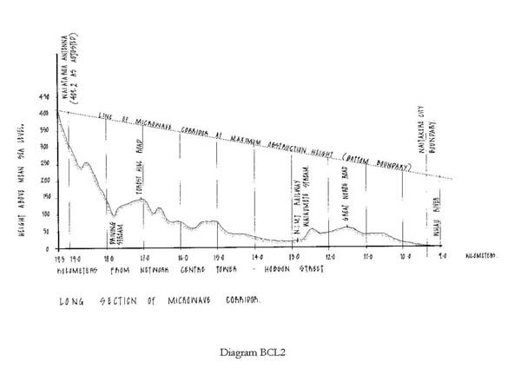

Technical Paper on Corridor Dimension and Radio Frequency Emissions

Click here for PDF

3301 Waiatarua Broadcasting and Telecommunications Facility

Designation Number | 3301
Requiring Authority | Kordia Ltd
Location | 539 Scenic Drive, Waiaturua
Rollover Designation | Yes
Legacy Reference | Designation K1, Auckland Council District Plan (Waitakere Section) 2003
Lapse Date | Given effect to (i.e. no lapse date)

Description

Broadcasting and telecommunications facility ­ the continued operation of the existing broadcasting and telecommunications facility including two lattice towers of 121.9m and 27.5m height, a transmission building with roof top antenna mounting gantry, broadcasting and telecommunication antennas, and ancillary and associated works including power transformer, back­up power generator etc.

Conditions

- The Notice shall be given effect to in accordance with the requirement/application and assessment of effects on the environment prepared by Hey Consulting 2011 Limited, and Plans titled ‘Waiatarua Tower Layout’ being drawing number 18141­101, ‘Waiatarua Tower Locations", "Waiatarua Tower No 2 Antenna Locations" 18141­ 102, "Waiatarua Building East Gantry Antenna Locations" 18141­103 and "Waiatarua Site Plan" being drawing Ref 18141­010.

- An Outline Plan is not required for the addition and replacement of antennas on the existing tower provided the antenna including the mount, the shroud, and ancillary equipment shall fit within the dimensions of a square shape in plan view that, when measured from the centre of the tower, does not increase the effective visual width of the tower by more than 50% (see attached Diagram 1).

- An Outline Plan is not required for the addition or replacement of antennas attached to or above the existing transmission building provided that:
  - No gantry, pipe mount or antenna extends to an elevation greater than 3m above the roof line of the building; and/or
  - No antenna affixed to a building measures greater than 1.2m in dimension.

- No new structures shall be erected on the site without submission of an Outline Plan of works pursuant to section 176A of the Resource Management Act 1991 other than the antennas set out in conditions 2 and 3 above.

- Structures which are either intended to replace existing structures or any temporary structures erected for the purposes of allowing maintenance or repair of existing structures are permitted provided that any temporary or replaced structures are removed once any such replacement, maintenance or repair has been completed.

- Only two telecommunications tower shall be on the site with the main tower having a maximum height of 121.9m and a secondary tower having a maximum height of 27.5m including any attachments.

- Radio frequency radiation emissions from the site shall comply with NZS 2772.1:1999 Radio Frequency Fields (Maximum Exposure Levels ­ 3kHz to 300GHz).

Attachments

Site and Locality Plan
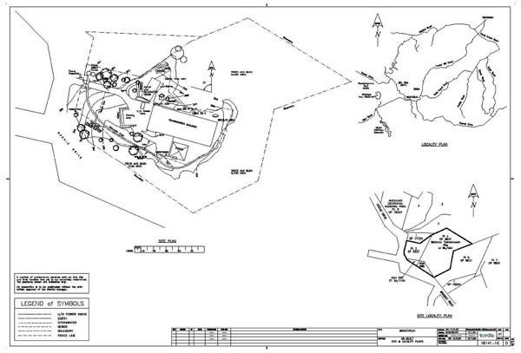

Tower elevations (Main and Secondary Towers)
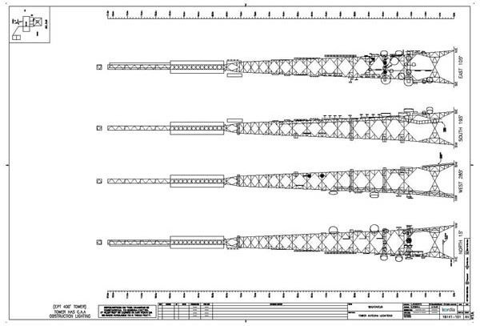

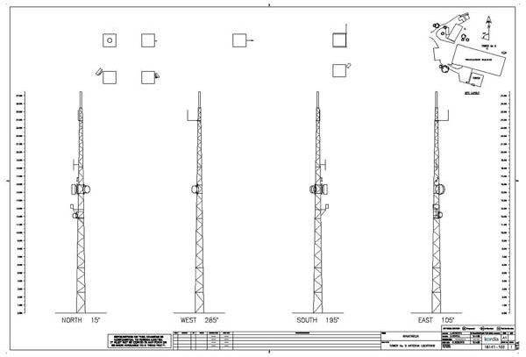

Building East Gantry Antenna Locations
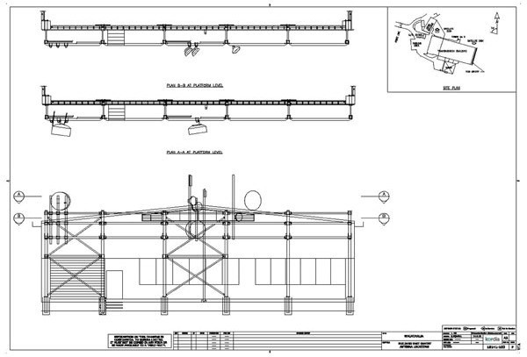

Diagram 1 ­ Depiction of Antenna Size Condition and Potential Effect

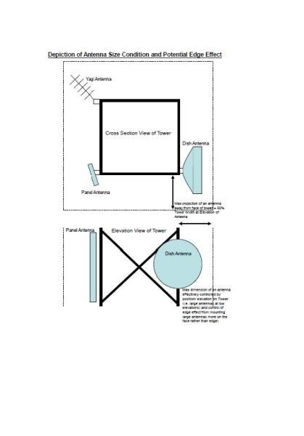

Radio Frequency Emissions Producer Statement

Click here for PDF

3302 Kaipara Hills Broadcasting and Telecommunications Facility

Designation Number | 3302
Requiring Authority | Kordia Ltd
Location | Kaipara Hills Road (Pt Alottment 201 Psh Tauhoa), Kaipara Hills
Rollover Designation | Yes
Legacy Reference | Designation 970, Auckland Council District Plan (Rodney Section) 2011
Lapse Date | Given effect to (i.e. no lapse date)

Purpose

Broadcasting and telecommunications facility ­ the continued operation of the existing broadcasting and telecommunications facility including a monopole mast of 23m height, a transmission building with ancillary and associated works including power transformer, back­up power generator etc.

Conditions

General
The activity shall proceed in general accordance with the Notice Of Requirement submitted to council, dated 31st August 2000, and attached plans drawn by Connell Wagner Ltd, Numbered 4290NT/A01, A02, C01, C02, and C03, and plans drawn by Woodward­Clyde (NZ) Ltd Numbered AA28110026/01/A­001 and AA28110026/01/S­001 including the recessive colour scheme proposed.

Additional Equipment
The following equipment shall be permitted to be attached to or erected on the mast and associated structures or elsewhere on the site, on a permanent basis without the provision of an Outline Plan pursuant to section 176A of the Resource Management Act in terms of conditions 1 above:
  - A steel unipole mast of up to 23m height with an additional 2m lightning rod located at the top of the mast;
  - Up to six (6) dish antennas with a diameter greater than 2.5m, but less than 5.0m;
  - Broadcasting, telecommunication and radio communication antennas including whip, grid, yagi, dipoles and panels or similar ancillary equipment, but no single antenna shall have a solid frontal surface area of greater than 5.0m2 or 2.5m in diameter in the case of dish antennas unless otherwise specified in (b) above;
  - Up to two single storey equipment shelters with a combined floor area of less than 50m2; and
  - A vehicular access track between the level area of the proposed mast and the road adjacent together with an area for parking and turning adjacent to the main structures.

New Structures
No new structures shall be erected on the site without the submission of an Outline Plan pursuant to section 176A of the Resource Management Act other than those provided for in condition 2 above, or structures on the site, or any other temporary structures erected for the purposes of allowing maintenance or repair of existing structures (providing that such temporary structures will be removed once any such maintenance or repair has ceased).

Radio Frequency Exposure
  - The Broadcasting and telecommunications facility shall be operated so that it satisfies the requirements of NZS2772.1:1999 in respect of all areas to which the public may have access.
  - A report from a suitably qualified person shall be submitted to the satisfaction of the Consents Manager within three months of the installation commencing operation, confirming that the site is operating in accordance with the NZS2772.1:1999.
  - If the levels do not comply with NZS2772.1:1999, operation shall cease until such time as measures are put

in place to ensure compliance with the standard.

Landscaping
A landscape plan and ongoing plant maintenance programme, involving screen planting of indigenous shrubs and small trees around the facility, with the intent of providing screening for the ancillary buildings and
compound, shall be submitted to the Consents Manager, within six months of the date of commencement of the work on the site for the designation. This landscape planting is to form a continuation of the existing vegetation, which extends down the southern slopes of the site. Planting shall be completed by the end of the first planting season following the commencement of work on the site.

Archaeological Sites
In the event of an archaeological site being uncovered work is to cease immediately in the vicinity of the discovery and the NZ Historic Places trust is to be contacted so that appropriate action can be taken before work may recommence.

Silt Retention
Before commencement of any works, adequate silt retention structures as detailed in the Auckland Council Technical Publication No. 90 “Erosion and Sediment Control Guidelines for Land Disturbing Activities in the Auckland Region” shall be installed. These structures shall be maintained and cleaned out as necessary until such time as complete grass cover or other non­erodible surfacing, has been re­established over the site.

Access and Parking
All access, parking and manoeuvring areas shall be formed to a permanent all weather metalled standard to the dimensions set out in the council’s “Standards for Engineering Design and Construction”, prior to the commencement of the activity.

Note:
A geotechnical report will be required to be submitted with the application for Building Consent. The report shall address the stability of the site and the control of stormwater from the creation of an impermeable surface.

Note:
The Requiring Authority is advised that the site on which the proposed development is situated could be subject to Natural Hazards that may require the Council to invoke a s36(2) Notice Pursuant to the Building Act 1991 at the time a Building Consent is issued for any structure on the land.

Administration Fee
The applicant shall pay to Council the administrative fee for processing of this Notice of Requirement within one month of the requirement being confirmed or prior to the us commencing, whichever is the sooner.

Monitoring Condition
The applicant shall pay to Council a monitoring charge of the actual and reasonable costs to be paid within one month of the Requirement being Confirmed or prior to the Activity commencing/prior to any site works commencing/whichever is the sooner.

Note:
Please note that this charge covers on site visit only. Should other site visits/works be required to ensure compliance, then further charges will be payable as set out in Council’s “Schedule of Fees and Charges”.

Attachments

Site Plan

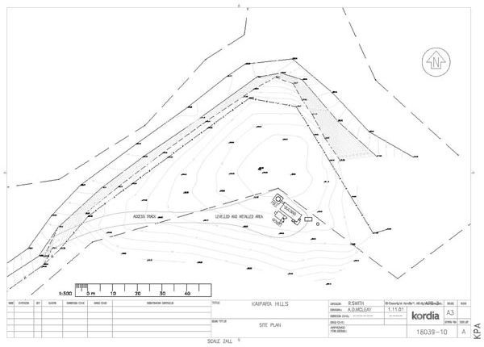

Pole Antennae Layout
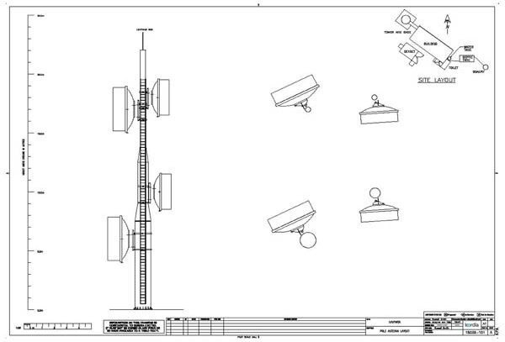

Proposed Equipment Shelter and Slab Layout

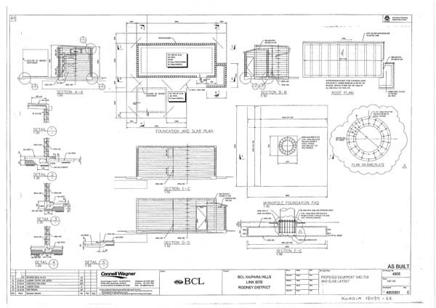

Radio Frequency Emissions Producer Statement

Click here for PDF

3303 Pine Hill Broadcasting and Telecommunications Facility

Designation Number | 3303
Requiring Authority | Kordia Ltd
Location | 192 Browns Bay Road, Pine Hill
Rollover Designation | Yes
Legacy Reference | Designation 184, Auckland Council District Plan (North Shore Section) 2002
Lapse Date | Given effect to (i.e. no lapse date)

Purpose

Broadcasting and telecommunications facility ­ the continued operation of the existing broadcasting and telecommunications facility including a monopole mast of 27.5m height, a transmission building with ancillary and associated works and activities.

Conditions

- The following equipment shall be permitted to be attached to or erected on the existing mast, on a permanent basis without the provision of any outline plan of works pursuant to section 176A of the Resource Management Act 1991:
  - Broadcasting, telecommunication and radio communication antennas including, whip, grid, yagi, dipoles and panels or similar ancillary equipment, but no single antenna dish or panel shall have a solid frontal surface area of greater than 0.6m2 or dimension greater than 1.2m in length or 0.6m in width;
  - Any dish shaped antenna greater than 0.3m in diameter must be attached to the mast at an elevation no greater than 18m;
  - Up to two dish shaped antennas of 1.2m in diameter at a max height above ground of 14m; and
  - No part of an antenna may project a horizontal distance greater than 1.4m from the face of the mast measured radially on an axis from the centre of the mast to the furthermost edge of the antenna.

- Antennas may only be mounted on the Mast and or the telecommunications building. No antennas or additional masts may be mounted else where on the site or the access to the site from Browns Bay Road.

- No new structures shall be erected on the site without submission of an Outline Plan of works pursuant to section 176A of the Resource Management Act 1991 other than the antennas set out in condition 1.

- Structures which are either intended to replace existing structures or any temporary structures erected for the purposes of allowing maintenance or repair of existing structures are permitted (provided that such temporary structures will be removed once any such maintenance or repair has ceased).

- Only one monopole telecommunications mast shall be on the site with a maximum height of 27.5m including any attachments (makes provision for a lightening rod).

- The maximum area of buildings permitted on the site shall be a sum total of 40m2 and shall have a height no greater than 5m above ground.

- All new antennas shall be grey (or similar) in colour with a reflectivity less than 33% as measured by the British Standard BS5252 colour range.

- Radio frequency radiation emissions shall comply with Resource Management (National Environmental

Standards for Telecommunication Facilities) Regulations 2008 – Clause 4 Telecommunication facilities generating radiofrequency fields.

- The noise levels generated by the activity must at all times comply with section 10.5 of the Auckland Council District Plan (North Shore Section) 2002.

- Kordia shall retain financial responsibility for all equipment and telecommunications activities from the site either through commercial agreement with clients or ownership of equipment.

- Kordia is responsible for ensuring that any third parties services located on the mast do not interfere with the transmission of telecommunication and radiocommunication services.

Advice Notes
- Any works outside the ‘envelope of effects’ established by the conditions of the Notice of Requirement (as above) will require an alteration to the designation to be lodged and processed in accordance with Section 181 of the Resource Management Act 1991.

- Prior to undertaking any works on site the applicant/requiring authority must first obtain written consent from Water Care Services Limited who are responsible for the underlying designation with ‘prior status’ (Designation
102) in accordance with Section 176 of the Resource Management Act 1991.

Attachments

Site and Locality Plan
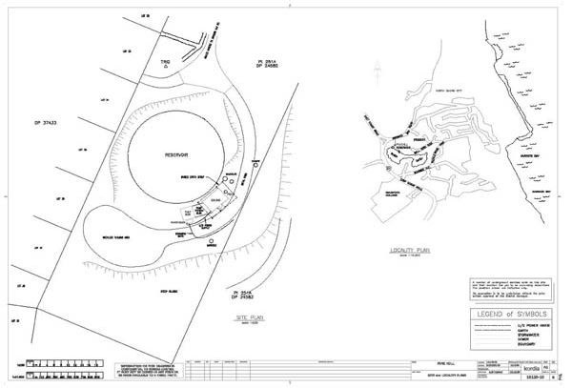

Pole Antennae Lacations

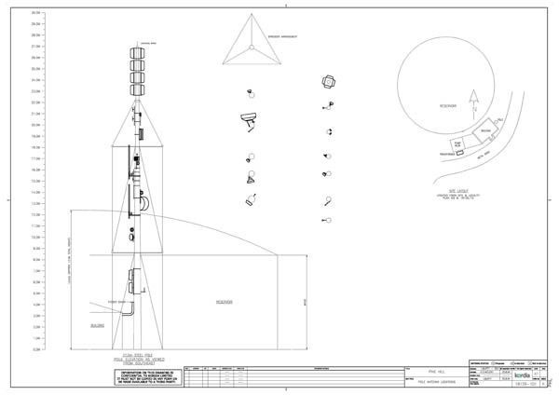

Radio Frequency Emissions Producer Statement

Click here for PDF

3304 Hunua Broadcasting and Telecommunications Facility

Designation Number | 3304
Requiring Authority | Kordia Ltd
Location | Repeater Road (Pt Alottment 33 Psh of Atou and Pt Allotment 65A Psh of Atou), Hunua Ranges
Rollover Designation | Yes
Legacy Reference | Designation 17, Auckland Council District Plan (Franklin Section) 2000
Lapse Date | Given effect to (i.e. no lapse date)

Purpose

Broadcasting and telecommunications facility ­ the continued operation of the existing broadcasting and telecommunications facility including a lattice tower of 20m height, a transmission building with ancillary and associated works including power transformer, back­up power generator etc.

Conditions

- The Notice shall be given effect to in accordance with the requirement/application and assessment of effects on the environment prepared by Hey Consulting 2011 Limited, and Plans titled ‘Hunua Tower Layout’ being drawing number 18115­101, 18115­101mod and ‘Hunua Site and Locality Plans’ being drawing Ref 18115­102.

- An Outline Plan is not required for the addition and replacement of antennas on the existing tower provided the antenna including the mount, the shroud, and ancillary equipment shall fit within the dimensions of a square shape in plan view that, when measured from the centre of the tower, does not increase the effective visual width of the tower by more than 50% (see attached Diagram 1).

- No new structures shall be erected on the site without submission of an Outline Plan of works pursuant to section 176A of the Resource Management Act 1991 other than the antennas set out in condition 2 above.

- Structures which are either intended to replace existing structures or any temporary structures erected for the purposes of allowing maintenance or repair of existing structures are permitted provided that any temporary or replaced structures are removed once any such replacement, maintenance or repair has been completed.

- Only one telecommunications tower shall be on the site with a maximum height of 20m including any attachments. This includes the provision for a lightning rod.

- Radio frequency radiation emissions from the site shall comply with NZS 2772.1:1999 Radio Frequency Fields (Maximum Exposure Levels ­ 3kHz to 300GHz).

Attachments

Site and Locality Plan

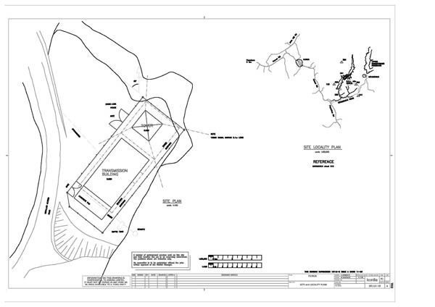

Tower Antennae Locations
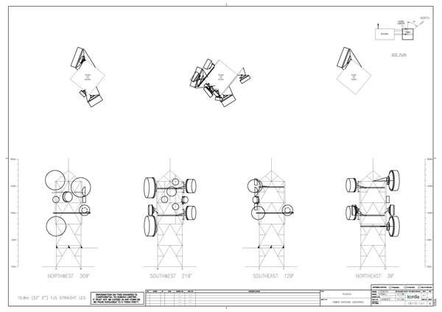

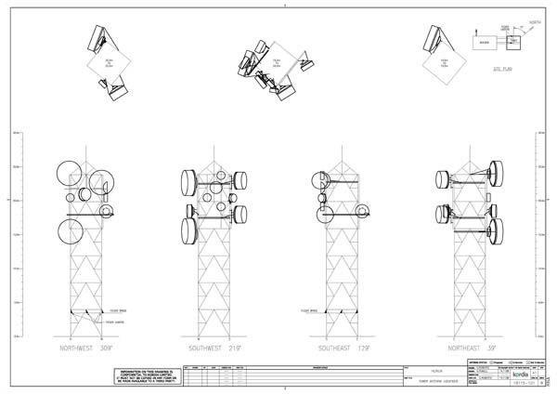

Diagram 1 ­ Depiction of Antenna Size Condition and Potential Effect

·
»>c;;r----..,

\.r.-...__ ,r'J\ J I!

·--
...._.....I

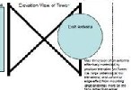----·- ----------..:e""..;..'"::

Radio Frequency Emissions Producer Statement

Click here for PDF

