PART 5 ­ APPENDICES»Appendix 11 Precincts»

Appendix 11.6 South

Appendix 11.6.1 Beachlands 1

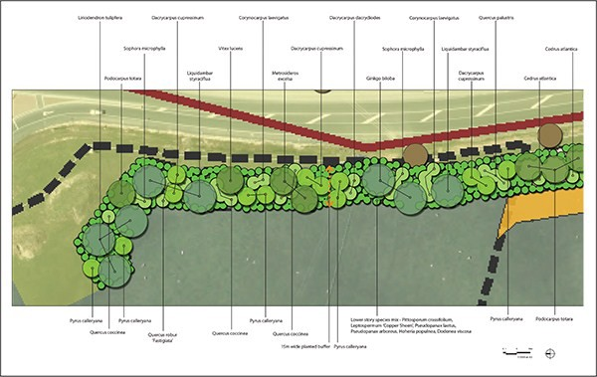Landscape buffer area planting plan and planting schedule Figure 1:

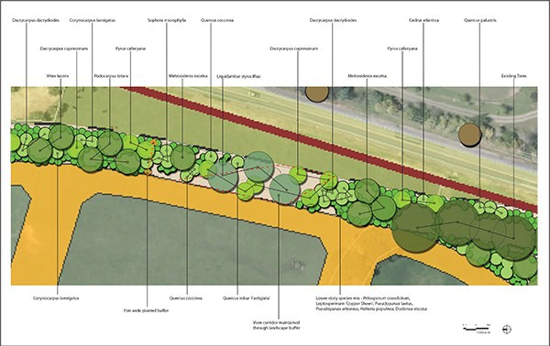

Figure 2:
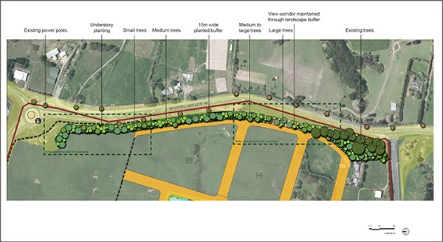

Table 1:

Code | Botanic name | Common name | Min PB size | Min height when planted  (mm) | Spacing (mm) | Percentage  / number
Medium to large trees |  |  |  |  |  | 100%/130
DAC cup | Dacrycarpus cupressinum | Rimu | PB95 | 2500 | As  shown | 10%/13
DAC dac | Dacrycarpus dacrydiodes | Kahikatea | PB95 | 2500 | As  shown | 10%/13
GIN bil | Ginkgo biloba | Ginkgo | PB95 | 2500 | As  shown | 10%/13
LIR tul | Liriodendron tulipfera | Tulip tree | PB95 | 2500 | As  shown | 10%/13
LIQ sty | Liquidambar styraciflua | American sweet  gum | PB95 | 2500 | As  shown | 20%/26
MET exc | Metrosideros excelsa | Pohutukawa | PB95 | 2500 | As  shown | 20%/26
POD tot | Podocarpus totara | Totara | PB95 | 2500 | As  shown | 10%/13
VIT luc | Vitex lucens | Puriri | PB95 | 2500 | As  shown | 10%/13
Small to medium trees |  |  |  |  |  | 100%/220
CED atl | Cedrus atlantica | Atlas cedar | PB50 | 2000 | As  shown | 10%/22
COR lae | Corynocarpus laevigatus | Karaka | PB50 | 2000 | As  shown | 20%/44
PYR cal | Pyrus calleryana | Callery pear | PB50 | 2000 | As  shown | 20%/44

Code | Botanic name | Common name | Min PB size | Min height when planted  (mm) | Spacing (mm) | Percentage  / number
SOP mic | Sophora microphylla | Kowhai | PB50 | 2000 | As  shown | 20%/44
QUE coc | Quercus coccinea | Scarlet oak | PB50 | 2000 | As  shown | 10%/22
QUE pal | Quercus palustris | Pin oak | PB50 | 2000 | As  shown | 10%/22
QUE rob | Quercus robur 'Fastigiata' | Fastigate oak | PB50 | 2000 | As  shown | 10%/22
Understory Planting |  |  |  |  |  | 100%/500
DOD vis | Dodonea viscosa | Akeake | PB28 | 1500 | As  shown | 20%/100
HOH pol | Hoheria populnea | Lacebark | PB28 | 1500 | As  shown | 20%/100
LEP cop | Leptospermum 'Copper Sheen' | Manuka hybrid | PB28 | 1500 | As  shown | 15%/75
PIT cra | Pittosporum crassifolium | Kara | PB28 | 1500 | As  shown | 15%/75
PSE arb | Pseudopanax aboreus | Five finger | PB28 | 1500 | As  shown | 15%/75
PSE lae | Pseudopanax laetus |  | PB28 | 1500 | As  shown | 15%/75

Appendix 11.6.2 Kingseat

Appendix 11.6.2.1 Typical road cross sections

Figure 1
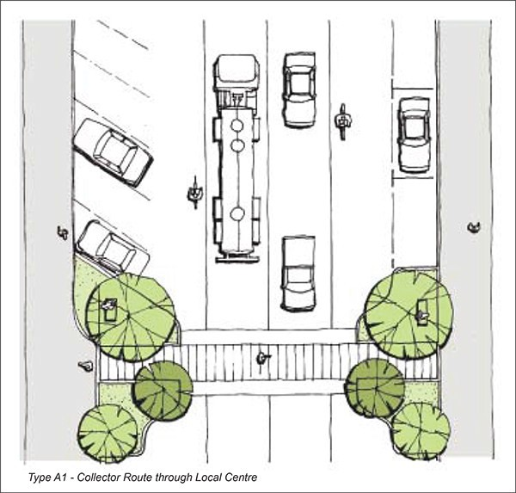

Figure 2
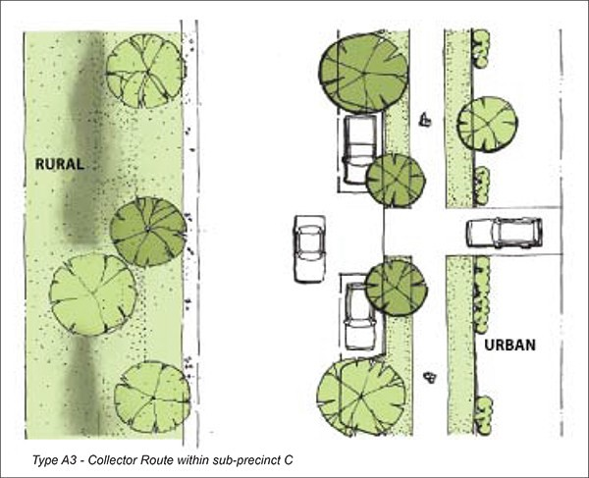

Figure 3
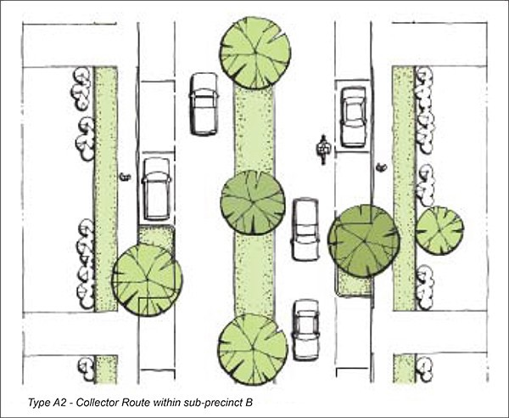

Figure 4
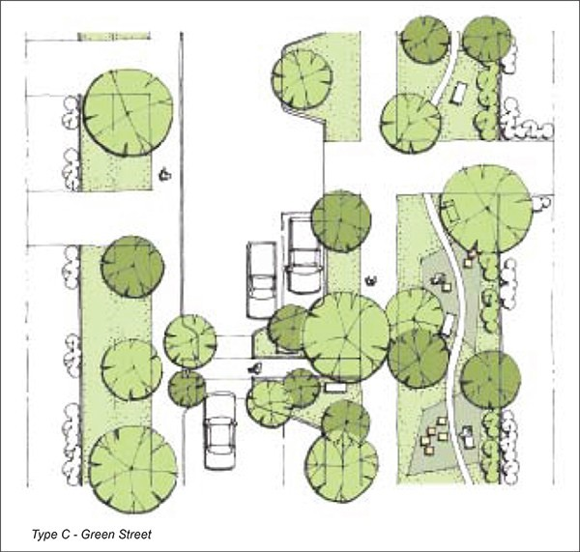

Figure 5
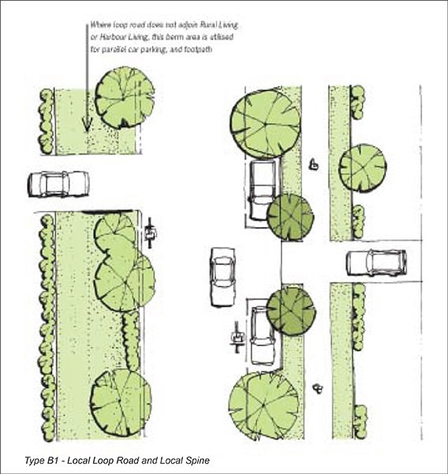

Appendix 11.6.2.2 Schedule of protected heritage places

Item. Reference (Diagram  Plan 3) | Name | Verified Location | Verified Legal Description | Category | Known Heritage Values | Extent of Place | Exclusions | Additional Controls for Archaeology | Place of Significance to Maori
A.54 | Kingseat Hospital Administration  Building | Former Kingseat Hospital  site | (Lot 1 DP  137234) | B | F,G,H | Refer to  planning  maps
A.57 | Kingseat Hospital Villa 11 | Former Kingseat Hospital  site | (Lot 1 DP  137234) | B | F,G,H | Refer to  planning  maps

A.58 | Kingseat Hospital Villa 12 | Former Kingseat Hospital  site | (Lot 1 DP  137234) | B | F,G,H | Refer to  planning  maps
A.59 | Kingseat Hospital Villa 13 | Former Kingseat Hospital  site | (Lot 1 DP  137234) | B | F,G,H | Refer to  planning  maps
A.61 | Former Nurses Home | Former Kingseat Hospital  site | (Lot 1 DP  137234) | B | F,G,H | Refer to  planning  maps
A.62 | Kingseat Hospital Ancillary  Building 1 | Former Kingseat Hospital  site | (Lot 1 DP  137234) | B | F,G,H | Refer to  planning  maps
A.63 | Kingseat Hospital Ancillary  Building 2 | Former Kingseat Hospital  site | (Lot 1 DP  137234) | B | F,G,H | Refer to  planning  maps
A.64 | Kingseat Hospital Ancillary  Building 3 | Former Kingseat Hospital  site | (Lot 1 DP  137234) | B | F,G,H | Refer to  planning  maps
A.65 | Kingseat Hospital Ancillary  Building 4 | Former Kingseat Hospital  site | (Lot 1 DP  137234) | B | F,G,H | Refer to  planning  maps
A.66 | Kingseat Hospital Ancillary  Building 5 | Former Kingseat Hospital  site | (Lot 1 DP  137234) | B | F,G,H | Refer to  planning  maps
A.67 | Kingseat Hospital Ancillary  Building 6 | Former Kingseat Hospital  site | (Lot 1 DP  137234) | B | F,G,H | Refer to  planning  maps
B.21 | Main access road from Kingseat Road | Former Kingseat Hospital  site | (Lot 1 DP  137234) | B | F,G,H | Refer to  planning  maps
B.22 | Main entrance gates, piers and wing walls | Former Kingseat Hospital  site | (Lot 1 DP  137234) | B | F,G,H | Refer to  planning  maps
D.20 | Archaeological Terraces | 112B  McRobbie Road  (E 1758965 N  5890134) | (Lot 2 DP112871) | B |  | Refer to  planning maps |  | Yes

D.21 | Archaeological Terraces | 125  McRobbie Road | (Lot 4 DP  173114) | B |  | Refer to  planning  maps |  | Yes
D.22 | Amenity Space | Former Kingseat Hospital  site | (Lot 1 DP  137234) | B | F,G,H | Refer to  planning  maps

Appendix 11.6.2.3 Schedule of protected trees

Former Kingseat Hospital site

Map 3 Reference | Common Name | Botanical Name | Number of Trees | Location and address | Legal description
C.75 | Tulip Tree | Liriodendron  tulipifera | 1 | Former Kingseat  Hospital site | Lot 1 DP 137234
C.77 | Norfolk Pine Bermudan Juniper | Auracaria heterophylla Juniperis  bermudiana | 1 | Former Kingseat Hospital site  (Lot 1 DP  137234) | Lot 1 DP 137234
C.78 | Phoenix Palms | Phoenix canariensis | 1 | Former Kingseat Hospital site  (Lot 1 DP  137234) | Lot 1 DP 137234
C.81 | Rimu | dacrydium cupressinum | 1 | Former Kingseat Hospital site  (Lot 1 DP  137234) | Lot 1 DP 137234
C.82 | Kauri | agathis australis | 1 | Former Kingseat Hospital site  (Lot 1 DP  137234) | Lot 1 DP 137234
C.83 | Kauri | agathis australis | 1 | Former Kingseat Hospital site  (Lot 1 DP  137234) | Lot 1 DP 137234
C.84 | Kahikatea | dacrycarpus dacrydioides | 150 | Former Kingseat Hospital site  (Lot 1 DP  137234) | Lot 1 DP 137234
C.85 | Copper Beech English Oak | fagus sylvatica var purpurea quercus robur | 1  1 | Former Kingseat Hospital site  (Lot 1 DP  137234) | Lot 1 DP 137234
C.86 | English Oak Turkey Oak | quercus robur quercus cerris | 1  1 | Former Kingseat Hospital site  (Lot 1 DP  137234) | Lot 1 DP 137234
C.88 | Liquidambar | Liquidambar styraciflua | 1 | Former Kingseat Hospital site  (Lot 1 DP  137234) | Lot 1 DP 137234

C.89 | London Plan Tree | platanus x acerifolia) | 2 | Former Kingseat Hospital site  (Lot 1 DP  137234) | Lot 1 DP 137234
C.90 | Oak tree  London Plan Tree | quercus robur platanus xacerifolia | 1  1  1 | Former Kingseat Hospital site  (Lot 1 DP  137234) | Lot 1 DP 137234
C.92 | Chinese Fir Turkey Oak | cunninghamia lanceolata quercus cerris | 1  1 | Former Kingseat Hospital site  (Lot 1 DP  137234) | Lot 1 DP 137234
C.96 | Oak Tree #1 | quercus spp |  | Former Kingseat Hospital site  (Lot 1 DP  137234) | Lot 1 DP 137234
C.97 | Oak tree # 1 | quercus spp | 2 | Former Kingseat Hospital site  (Lot 1 DP  137234) | Lot 1 DP 137234
C.100 | Oak tree | quercus spp | 1 | Former Kingseat Hospital site  (Lot 1 DP  137234) | Lot 1 DP 137234
C.102 | Oak trees | quercus spp | 1 | Former Kingseat Hospital site  (Lot 1 DP  137234) | Lot 1 DP 137234
C.103 | Wellingtonia English Oak | sequoiadendron giganteum quercus robur | 1  1 | Former Kingseat Hospital site  (Lot 1 DP  137234) | Lot 1 DP 137234
C.104 | Totara | Podocarpus totara | 1 | Former Kingseat Hospital site  (Lot 1 DP  137234) | Lot 1 DP 137234
C.108 | Norfolk Pine | auracaria heterophylla | 1 | Former Kingseat Hospital site  (Lot 1 DP  137234) | Lot 1 DP 137234
C.109 | Norfolk Pine | auracaria heterophylla | 1 | Former Kingseat Hospital site  (Lot 1 DP  137234) | Lot 1 DP 137234
C.111 | Red Flowering Gum | corymbia ficifolia | 1 | Former Kingseat Hospital site  (Lot 1 DP  137234) | Lot 1 DP 137234

C.112 | Red Flowering Gum | corymbia ficifolia | 1 | Former Kingseat Hospital site  (Lot 1 DP  137234) | Lot 1 DP 137234
C.116 | Marri, Flowering Gum | Ficifolia | 1 | Former Kingseat Hospital site  (Lot 1 DP  137234) | Lot 1 DP 137234
C.117 | Chestnut | aesculus hippocastanum | 1 | Former Kingseat Hospital site  (Lot 1 DP  137234) | Lot 1 DP 137234
C.121 | Magnolia Himalayan cedar | magnolia grandiflora cedrus deodara | 1 | Former Kingseat Hospital site  (Lot 1 DP  137234) | Lot 1 DP 137234
C.127 | Tulip tree | liriodendron tulipifera | 1 | Former Kingseat Hospital site  (Lot 1 DP  137234) | Lot 1 DP 137234
C.130 | Photinia | photinia x fraseri “Red Robin’ | 1 | Former Kingseat Hospital site  (Lot 1 DP  137234) | Lot 1 DP 137234
C.131 | Maidenhair tree | ginkgo biloba | 1 | Former Kingseat  Hospital site | Lot 1 DP 137234
C.134 | Maidenhair | ginkgo biloba | 1 | Former Kingseat  Hospital site | Lot 1 DP 137234
C.135 | Norfolk Pine | auracaria  heterophylla | 1 | Former Kingseat  Hospital site | Lot 1 DP 137234
C.141 | Magnolia | Magnolia  grandiflora | 2 | Former Kingseat  Hospital site | Lot 1 DP 137234
C.142 | Tulip Tree | liriodendron  tulipifera | 1 | Former Kingseat  Hospital site | Lot 1 DP 137234
C.143 | Tulip Tree | liriodendron  tulipifera | 1 | Former Kingseat  Hospital site | Lot 1 DP 137234
C.145 | London Planes Tulip Tree  Camphor laural tree | platanus x acerifolia liriodendron  tulipifera cinnamomum  camphora | 7  1  1 | Former Kingseat Hospital site | Lot 1 DP 137234
C.146 | English Oak tree | quercus robur | 1 | Former Kingseat  Hospital site | Lot 1 DP 137234
C.147 | Oak | quercus spp | 2 | Former Kingseat  Hospital site | Lot 1 DP 137234

C.148 | London Plane Tulip Tree Camphor Laurel Bull Bay | platanus x acerifolia  iriodendron tulipifera  cinnamomum camphora  magnolia grandiflora | 4  1  1  1 | Former Kingseat Hospital site | Lot 1 DP 137234
C.149 | Phoenix Palms | phoenix  canariensis | 18 | Former Kingseat  Hospital site | Lot 1 DP 137234
C.150 | Moreton Bay Fig | ficus macrophylla | 2 | Former Kingseat  Hospital site | Lot 1 DP 137234
C.151 | London Plane | platanus x  acerifolia | 1 | Former Kingseat  Hospital site | Lot 1 DP 137234
C.152 | Pohutukawa | vitex lucens | 6 | Former Kingseat  Hospital site | Lot 1 DP 137234
C.153 | London Plane | platanus x  acerifolia | 1 | Former Kingseat  Hospital site | Lot 1 DP 137234
C.154 | Norfolk Pine | auracaria  heterophylla | 1 | Former Kingseat  Hospital site | Lot 1 DP 137234
C.156 | Holm Oak | quercus ilex | 1 | Former Kingseat  Hospital site | Lot 1 DP 137234
C.157 | Oak tree | quercus spp | 1 | Former Kingseat  Hospital site | Lot 1 DP 137234
C.158 | Turkey Oak tree | quercus cerris | 1 | Former Kingseat  Hospital site | Lot 1 DP 137234
C.161 | Hungarian Oak  tree | quercus frainetto | 1 | Lot 1 DP 137234
C.168 | London Plane | platinus x  acerifolia | 5 | 1016 Linwood  Road | Lot 1 DP400117
C.169 | Gum Tree | eucalyptus spp | 1 | 1016 Linwood  Road | Lot 1 DP400117
C.170 | Black Poplar | populus nigra | 1 | 1016 Linwood  Road | Lot 1 DP400117
C.175 | Sessile Oak tree | quercus petraea |  | 112B McRobbie  Road | Lot 2 DP112871

Appendix 11.6.3 Pararekau and Kopuahingahinga Islands

Pararekau Island Planting Guidelines Purpose
These planting guidelines relate to the Pararekau and Kopuahingahinga Islands precinct, which applies to Pararekau Island and an access roading area within Kopuahingahinga Island, and two causeways that link both Islands to the mainland, as shown on the planning maps. The precinct provisions set out in this Unitary Plan rely strongly on achieving the vision in the Pararekau Island Landscape Concept Plan (refer to appendices
      - and 11.3.1.2) to achieve the environmental outcomes which seek to protect the natural character of the coastal environment from inappropriate subdivision and development, and avoid adverse effects on the landscape character and rural amenity values of this rural zone.

The rules and assessment criteria for subdivision and development require consistency with the landscape concept plan and the following planting guidelines:
        - the subdivision standards require landscaping to be provided for each management area identified within the concept plan to be consistent with that plan and this planting guideline

        - the subdivision standards also require any application for subdivision within the precinct to provide a landscape plan which must include a plant species schedule detailing species and mix grades at the time of planting, with comment on the degree of consistency with the planting guideline and explanation for any variance with this guideline

        - the assessment criteria for applications for controlled resource consent for subdivision within
the precinct will be assessed in terms of matters including the extent to which the proposed landscape plan will assist in ensuring a cohesive landscaping theme consistent with the concept plan and planting guidelines. This theme is of a parkland with larger free species and the integrated management of open space, whether within countryside living sites that will be privately and individually owned or areas intended for common ownership.

Creating habitats for native lizards
Native lizards are known to be present on the islands and planting should seek to provide them with suitable habitats. Information provided by the Department of Conservation's Gardening for Ornate Skinks includes:
        - ornate skinks inhabit forest or open areas with deep leaf litter, or stable cover such as deep rock piles or thick vegetation

        - they prefer damp, humid conditions

        - the species is very secretive.

Plant species and size guidelines for the management areas shown on the concept plan include:
        - esplanade strip

        - recreation and arainage areas

        - access area

        - countryside living sites

        - revegetation implementation technique

        - monitoring and maintenance.

Protection from predators, including pet cats can be partly achieved by creating a thick and diverse garden with

plenty of cover. Treed areas or tall scrublands should have a layer of shade tolerant ground vegetation. Ferns, swamp musk, renga renga or creeping fuchsia are good options because they will also help maintain a high humidity. This information should be taken into account when providing planting.

Plant species recommendations
Explanade reserve
The esplanade area revegetation will consist of a mix of hardy native species suited to a coastal environment. Reference has been made, for plant species selection, to the Hingaia Ecology Report – Concepts and Guidelines, Dr Andrea Julian, August 2002 (unpublished).

Table 1:

Botanical name | Common name | Size at planting
Coprosma repens | taupata
Coprosma robusta | karamu | PB ¾ ­ 3
Cordyline Australis | cabbage tree | PB ¾ ­ 3
Cortaderia flavicans | toetoe | PB ¾ ­ 3
Corynocarpus laevigatus | karaka | PB ¾ ­ 3
Cyathpoides junipera | mingimingi | PB ¾ ­ 3
Geniostoma rupestre | hangehnage | PB ¾ ­ 3
Hebe strica | koromiko | PB ¾ ­ 3
Leptospermum scoparium | manuka | PB ¾ ­ 3
Metrosideros excelsa | pohutukawa | PB ¾ ­ 3
Myrsine australis | mapou | PB ¾ ­ 3
Olearia furfuracea | akepiro | PB ¾ ­ 3
Phormium tenax | harakeke | PB ¾ ­ 3
Pseudopanax lessonii | houpara | PB ¾ ­ 3
Sophora microphylla | kowhai | PB ¾ ­ 3

Table 2: Salt marsh

Botanical name | Common name | Size at planting
Apodasmia simiilis | oioi/jointed wire rush | PB ¾ ­ 3
Baumea juncea |  | PB ¾ ­ 3
Juncus maritimus var australiensis | Sea rush | PB ¾
Plagianthusdivaricatus | Maakaka/salt marsh ribbonwood  Riibbonwood | PB ¾

Recreation and drainage areas

Table 3: Riparian

Botanical name | Common name | Size at planting
Coprosma robusta | karamu | PB ¾ ­ 2
Cordyline australis | cabbage tree | PB ¾ ­ 3

Entelia arborescens | whau | PB ¾ ­ 2
Hebe strica | koromiko | PB ¾ ­ 3
Leptospermum scoparium | manuka | PB ¾ ­ 2
Myrsine australis | mapou | PB ¾ ­ 2
Phormiumtenax | harakeke | PB ¾ ­ 3
Sophora microphylla | kowhai | PB ¾ ­ 2

Table 4: Wetland

Botanical name | Common name | Size at planting
Carex secta | pukio | PB ¾ ­ 2
Carex virgata |  | PB ¾ ­ 2
Cordyline australis | cabbage tree | PB ¾ ­ 2
Cyperus ustulatus | giant umbrella sedge | PB ¾ ­ 2
Leptospermum scoparium | manuka | PB ¾ ­ 2
Phormiumtenax | harakeke | PB ¾ ­ 2
Schoenoplectus validus | kuta | PB ¾ ­ 2
Typha orientalis | raupo | PB ¾ ­ 2

Access area

Table 5: Amenity

Botanical name | Common name | Size at planting
Chionochioa flavicans |  | PB 3
Fagus sylvatica var. purpurea | Copper beech | PB 40 – 150
Phormium cookianum | Mountain flax | PB 3 – 5
Quercus palastrus | Pin oak | PB 40 – 150

Countryside living sites

Design concept
As partof the overall concept for Pararekau Island, it is important that structural landscaping is provided for each countryside living site at the time of subdivision and at the same time as the balance of the planting within the access area, recreation and drainage area, and esplanade strip. This will ensure planting achieves a consistent landscape character of a parkland with large areas of open space.

Planting for countryside living sites must be:
        - consistent with the concept plan in 11.3.1.2

        - include native and exotic trees at least 1.8m tall at the time of planting , that will grow to a height providing a relatively open framework for each lot, and contribute to the intended parkland character of the island

        - provide a native understorey to create habitats for birds and lizards and provide ecological corridors between the ecological restoration areas, including the recreation and drainage areas

        - integrate with the planting schedules in this guideline for each lot in the access area, recreation and drainage area, and esplanade strip

        - avoid lineal planted edges along lot boundaries to deliver privacy for each lot identified on the structure plan in 11.3.1.1

        - contribute to mitigating potential adverse effects of household units and accessory buildings on the natural character of the coastal environment and the landscape character and amenity values of the island.

The subdivision rules require that at the time of subdivision, countryside living sites, excluding the access area, esplanade strip, and recreation and drainage areas, will be planted and maintained in native and exotic trees and shrubs and underplanting consistent with the landscape concept plan, access area plans and planting guidelines.

Revegetation implementation technique Sourcing
All plant material must be eco­sourced.

Once the contract and planting programme is confirmed, the landscape contractor must source all plant material to ensure the best hardy nursery stock available is secured. All plants must be healthy and vigorous, with well­developed root systems, free of disease, pests and physical damage. They must be well
branched, symmetrically shaped and matched to the site.

Planting methodology
Layout and plant densities must be at 1.4m spacing i.e. 5000 stems/ha. This is a general guide only and is dependent on species combinations and growth form.

All planting must be done based on established revegetation techniques in relation to matching species with site conditions, soil type, soil/moisture conditions, aspect, exposure and recognition of individual species relationships and growth habit.

Cell and tube grades and open ground material must be planted with a double spade cut to shatter soil structure to allow rapid root formation and nutrient uptake.

Larger grade plants and plastic bag (PB) sizes must be planted in hand dug holes. The base of the planting hole is to be broken up to shatter soil structure to allow rapid root formation and nutrient uptake.

All plant species must be planted with a twice­yearly controlled release general fertiliser, such as Nutricote or Osmocote Plus and rain crystals, applied to the manufacturer’s recommendations. The rain crystals must be distributed through the base of the hole. If the plant is on a slope then the fertiliser must be placed dominantly on the upper hillside.

All plants must have an identification stake close by. This will allow rapid identification of plants at the maintenance stage and assist the monitoring process for the detection and control of plant mortality and success rates.

Monitoring/maintenance
Regular monitoring must be done at monthly intervals, dependent on prevailing weather conditions, for for the first three years of each planting stage, then half­yearly.

Hand removal and/or herbicide spray, such as Roundup or Fusilade W6 must be done in spring and autumn as necessary.

Maintenance period
        - Initial three years ­ rigorous regime, including replacement of losses over 10 per cent in the winter season following maintenance visits

        - Ongoing thereafter.

No watering is required as plant material is chosen for specific aspect/slope/soil/type/moisture regime. Crystal rain and fertiliser must be used at time of planting.

Pest control
Rabbit and possum eradication/control area generally the landowners’ responsibility. Control must be done prior to planting to decrease pest numbers. Ongoing control must be by way of poisoning as outlined below:
        - rabbits: Pindone cereal pellets should be hidden in short lengths of terracotta or plastic pipe during dry weather

        - possums: Pindone could be used as could bait stations using brodifacoum or cholecalciferol pellet baits.

Monitoring of planting for damage must be done post­planting in spring/autumn and control methods executed as necessary

Watering
No watering will be necessary, as the plant species have been selected to tolerate on0site conditions.

