PART 5 ­ APPENDICES»

Appendix 1 Structure plan requirements and Metropolitan Urban Area 2010

Appendix 1.1 Structure plan requirements for future urban zoned greenfield land and brownfield land

[all provisions in this appendix are: rps/dp]

Structure plans establish the spatial development pattern of land use and the transport and services network within a defined area. A detailed examination of the opportunities and constraints relating to the land is required and will ensure the effects of development are addressed in advance of development occurring.

These provisions set out the matters in respect of the preparation of structure plans for:
- Greenfield land within the Future Urban zone prior to the change to urban zones as required by Chapter B: RPS ­ Section 2.3, Policies 2 and 4 and Section 2.5, Policies 1 and 3 (also described in the Chapter A: Introduction, Section 4.2).

- Brownfield land, when land within the urban area is proposed to be given comprehensively different urban zones from the existing zones. The level of analysis required for a brownfield structure plan needs to be appropriate to the scale of development.

A structure plan will be part of the plan change required to rezone land. This document sets out:
- how the structure plan responds to the Unitary Plan

- the external documents to be taken into account.

- the matters that the structure plan must identify, investigate and address

- further specialist documents that are required to support the structure plan.

Structure planning is to be used to:
  - identify and consider greenfield land within the RUB which has a Future Urban zone and is proposed to be given an urban zone from the Unitary Plan suite of zones (residential, centres, business, public open space, special purpose zones)

  - identify and consider brownfield land within the metropolitan area 2010 as shown in Appendix 1.2 which is proposed to be given comprehensively different urban zones from the existing zones.

  - identify and consider the scale (including densities), mix and pattern of different land uses such as residential, business, special purpose, and open space in the structure plan area

  - balance often competing demands to protect existing features and the need to establish urban development and supporting infrastructure that achieve more sustainable and efficient communities

  - identify amenity outcomes for new liveable neighbourhoods

  - identify key infrastructure requirements to support the proposed land uses and the wider community

  - involve key stakeholders, infrastructure providers and landowners in the development of the structure plan area

  - identify the significant strategic purpose of the conversion of the brownfield land, including where

appropriate expansion of centres to support growth and intensification, improving accessibility to the coast and public open space, providing connections between existing developed urban areas, and more efficient use of urban land.

Structure planning must consider the following:
  - the wider directions of the Auckland Plan, considered as an integrated whole. Particular regard must be given to the Auckland Plan Development Strategy, including the integration of the structure plan area, with the surrounding area and the sub­region

  - the objectives and policies of the Unitary Plan, in particular the whole of the RPS.

  - any relevant national RMA documents, such as the New Zealand Coastal Policy Statement, other national policy statements and national environmental standards.

  - council’s land release strategy, implementation programmes and Long Term Plan.

  - any relevant management plans including: local board plans, area plans, stormwater catchment, planning analysis and associated network discharge consents.

  - any relevant strategies, plans or programmes of economic, environmental, social and cultural infrastructure providers including Watercare and Auckland Transport with particular regard to the Integrated Transport Programme and Regional Land Transport Plan and Watercare’s Asset Management Plan.

  - New Zealand Standard 4404:2010, and the council’s Code of Practice for Land Development and Subdivision.

  - any relevant iwi planning documents, Treaty settlement legislation as a result of settlements, and Waitangi Tribunal claims.

  - the council’s Parks and Open Space Strategy.

  - the council’s Auckland Design Manual­ neighbourhood section.

  - the feedback of landowners, infrastructure providers and communities gained through consultation during the structure planning process.

  - for brownfield areas, a range of alternative land uses.

The structure plan content

The structure plan must identify, investigate and address the following matters:
  - urban growth

i.

ii.

iii.

iv.

v.
the future supply and projected demand for residential and business land in the structure plan areas is consistent with council’s land release strategy and will achieve an appropriate capacity to meet the sub–regional greenfield growth projections for new dwellings in the Auckland Plan ( 2012) Development Strategy.

the phases and timing for the staged release of greenfield land or the staged conversion of brownfield land for urban development, with the coordination of infrastructure.

the location and form of the urban edge, including the type of urban edge or boundary to be created, its appropriateness to the structure plan area and the surrounding area and how transitions between and within the area to be urbanised and other areas with different activities and uses or different densities/typologies are to be managed.

linkages and integration with existing urban and/or rural zoned land adjoining the structure plan area through careful edge or boundary treatment.

opportunities to improve access to landlocked parcels, including Māori land.

  - natural environment

i.

ii.

iii.

iv.
the maintenance, enhancement and/or protection of the values of the natural character of the land and receiving environments including natural and cultural heritage. Developers must demonstrate how the proposed land use, subdivision and development controls respond to such values.

the integration of green networks (such as natural freshwater and coastal systems, and ecological corridors) with open space and pedestrian networks, showing how they reflect the underlying natural character values and provide for environmental restoration and biodiversity.

the measures to manage natural hazards and contamination, including avoidance, adaption, or remediation.

the location of mineral resources and how they are to be managed.

  - urban structure

i.

ii.

•

•

•

•

•
a compact urban form in accordance with the RPS, Section 2.1 policies.

the design process and key desirable urban form at the neighbourhood scale in accordance with the RPS Section 2.2 objectives and polices, including:

urban form and structures designed to maximise pedestrian connectivity with a network of streets and small block sizes allowing for a choice of routes, particularly near centres and public transport facilities.

the provision of a diversity of site sizes within neighbourhood blocks to maximise housing choice and where appropriate a range of business activity, and mixed use to enable employment and residential activity

the provision of public open spaces which are highly visible from streets and of a scale and quality to meet identified community needs.

the transition within the structure plan area between different activities, and densities.

incorporation of water sensitive design and green infrastructure within developments to reduce impacts on the environment while enhancing urban amenity.

  - use and activity

i.

ii.

iii.

iv.

v.

vi.
the adoption of standard Unitary Plan zones to avoid the introduction of additional zones and the recognition of place based provisions and values through the use of precincts and overlays. For brownfield sites, the inclusion of concept plans or framework plans to provide greater certainty of outcomes in advance of resource consents.

establishment of new centres and the expansion of existing centres with a diverse function and role that complements the hierarchy and network of existing centres. Centres should be located and designed to maximize access by walking, cycling and public transport.

a mix of residential densities sufficient to support the viability of centres, and mixed communities and provide housing choice and walking, cycling and public transport.

mix and distribution of land uses within the structure plan area to provide opportunities for appropriate business activities and employment, community and educational facilities and open space close to where people live.

the location and protection of significant infrastructure and the avoidance of reverse sensitivity effects on significant land uses and infrastructure.

the location, size and general design of Retained Affordable Housing.

  - movement networks

i.

ii.

iii.

iv.
integration of land use and the local and strategic transport network.

the layout of the transport network and facilities (roads, public transport, cycle and pedestrian networks, parking) that are safe, direct, legible, attractive and well connected with a choice of routes to public transport, local facilities and amenities, that are integrated with land uses and the surrounding area.

the road network and hierarchy to support multi modal transport and accessibility that is interconnected and includes the location of connections to ensure a number of access points to and from the area.

the transport related effects of the scale, intensity, mix and distribution of land uses and the mitigation and management of these effects.

  - infrastructure

i.

ii.

iii. iv.
the location, scale and capacity of new and existing public reticulated water supply and wastewater disposal networks.

the location and function of stormwater management facilities based on, principles of water sensitive urban design, including the retention of natural water systems and the primary use of on­site flow and quality controls (and related impervious area limits) to manage stormwater from proposed sites and roads. The use of hard engineering solutions is a secondary management approach.

the location and scale of other new infrastructure.

social and cultural infrastructure, including educational facilities, libraries and marae, to cater for the needs of the community and neighbourhoods and the timing of its availability.

  - heritage
    - the existence of features or values which warrant protection or preservation such as historic heritage or sites and places of significance Māori.

Supporting documents

  - The following documents are required to provide detail on specialist subjects and support the structure plan:

i.

ii.

iii. iv.
v.

vi. vii. viii. ix.
x.

xi.
structure plan neighbourhood design statement

stormwater network plan, including updates to catchment or zone management plans and variations to existing or new network discharge consents, where relevant.

integrated transport assessment.

cultural landscape mapping and cultural impact assessment. water and wastewater servicing plan.
phasing and implementation plan geotechnical assessment archaeological or heritage assessment freshwater and ecological assessment other Infrastructure Plan
funding and Implementation

xii.

xiii.
affordable Housing Assessment

additional supporting documents for brownfield development:

- structure plan urban design and landscape assessment

- brownfield – economic analysis, including assessment of costs and benefits and regional economic impact and opportunity costs.

- land contamination and remediation assessment.

  - The documents supporting the structure plan for brownfield developments need to be at a level appropriate to the brownfield area.

Other documents may be required to support the structure plan, depending on the characteristics of the land and water resources of the area.

Appendix 1.2 Metropolitan Area 2010

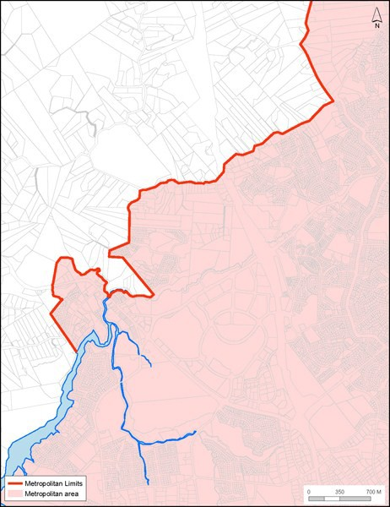[all provisions in this appendix are: rps] Map 1: Albany

Map 2: Ambury
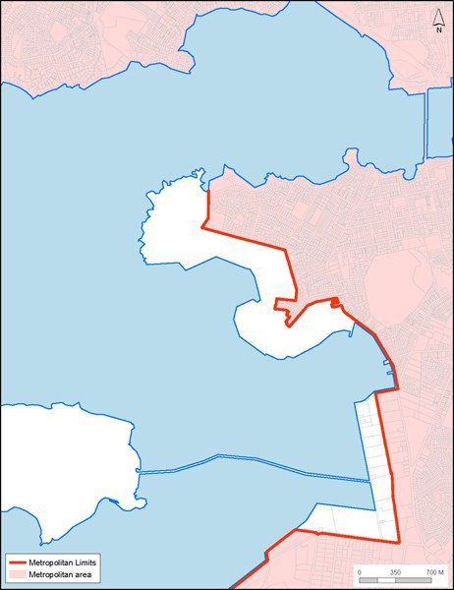

Map 3: East Tamaki / Manurewa East
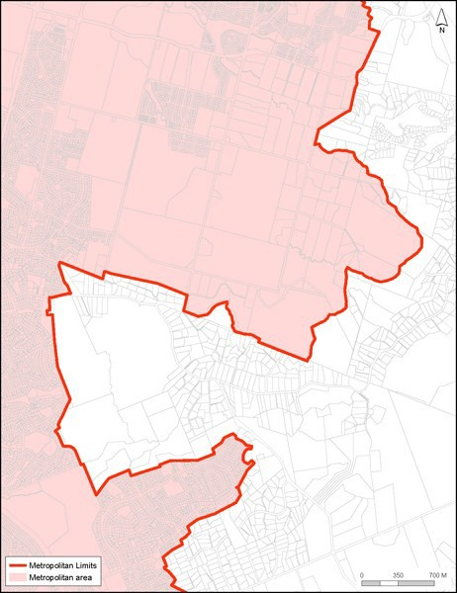

Map 4: Hatfields ­ Orewa
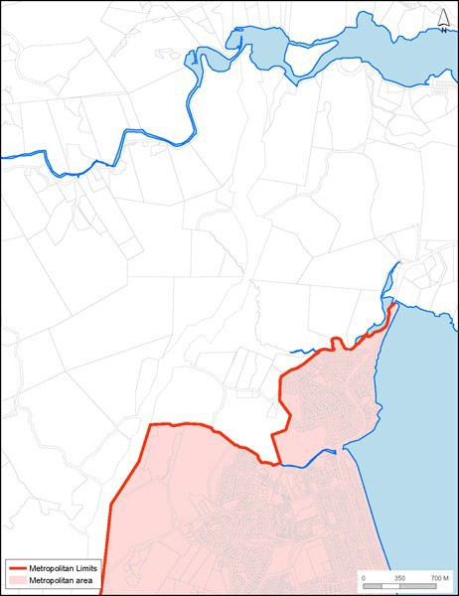

Map 5: Henderson Valley ­ Oratia
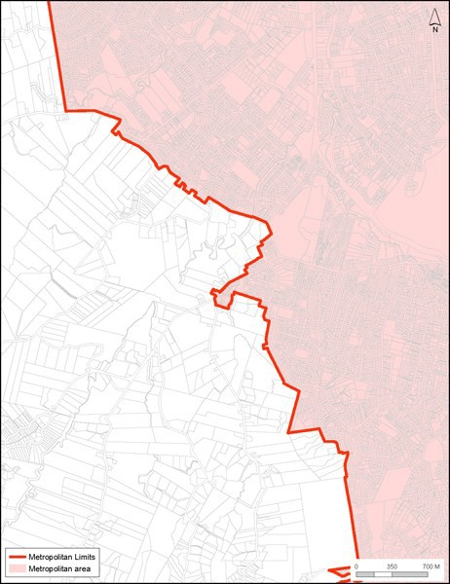

Map 6: Hingaia / Drury South
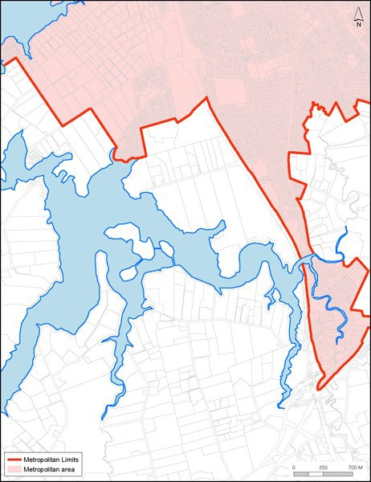

Map 7: Hobsonville
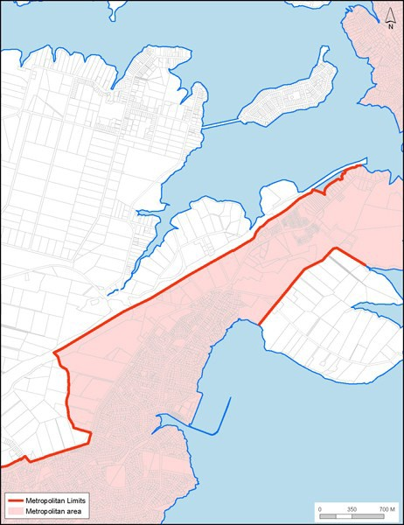

Map 8: Ihumatao
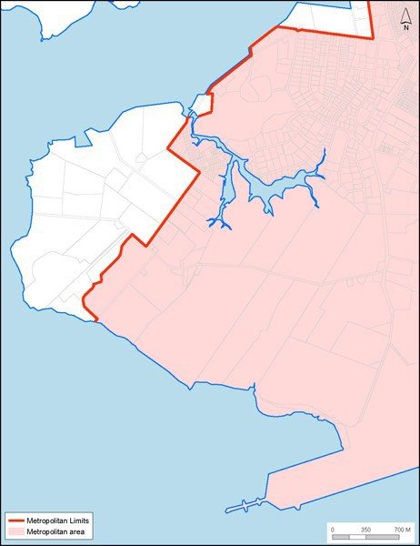

Map 9: Konini ­ Waima / Laingholm
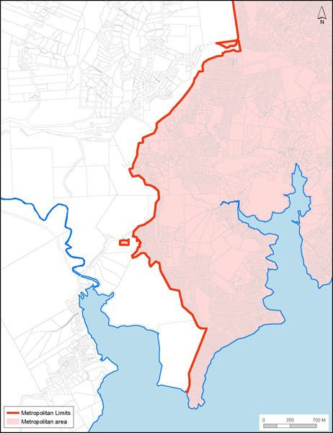

Map 10: Long Bay
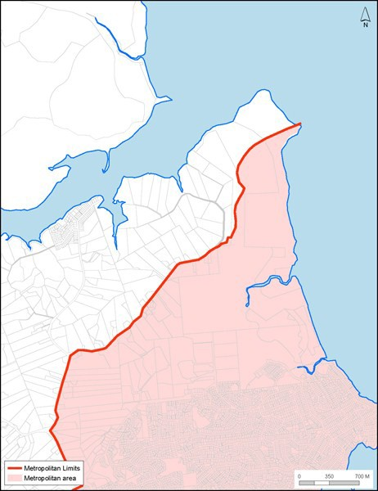

Map 11: Mangere East
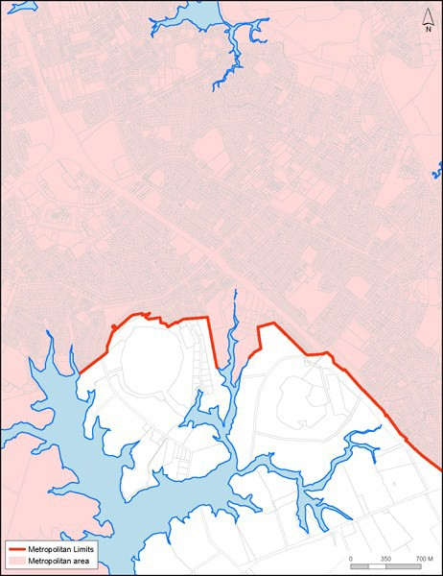

Map 12: Massey / Massey North
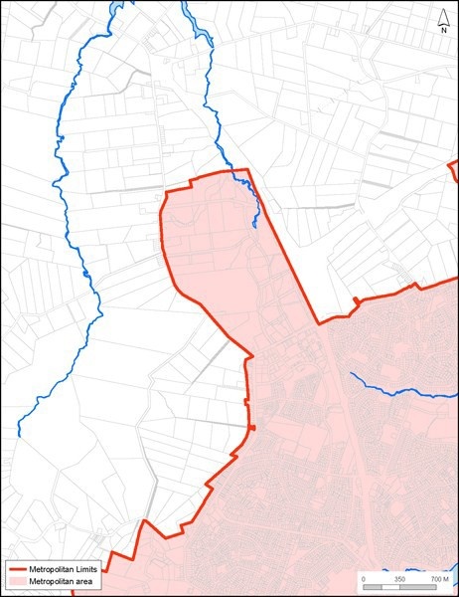

Map 13: Border ­ Orewa
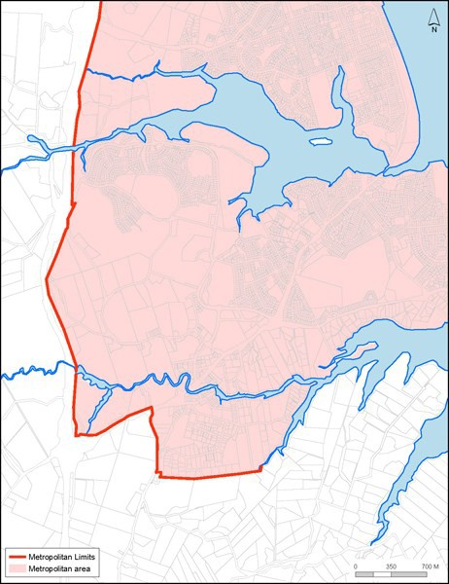

Map 14: Papakura / Drury
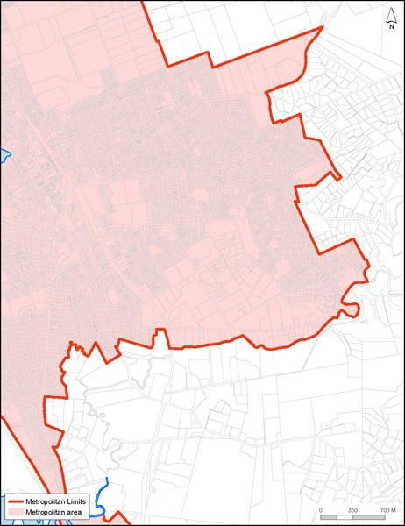

Map 15: Puhinui
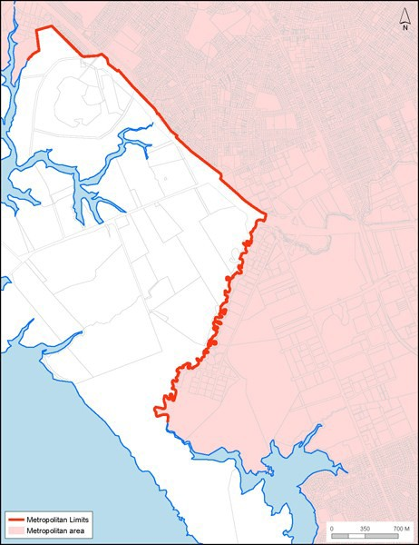

Map 16: Shakespear
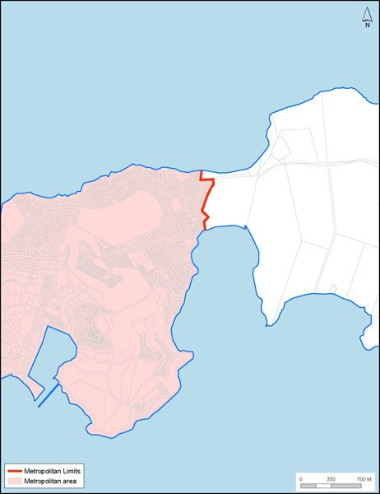

Map 17: Swanson ­ Ranui
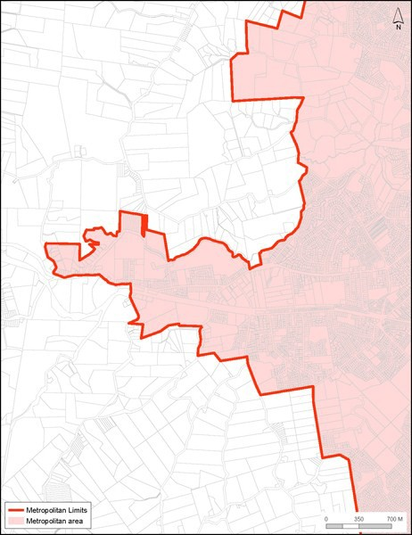

Map 18: Takanini
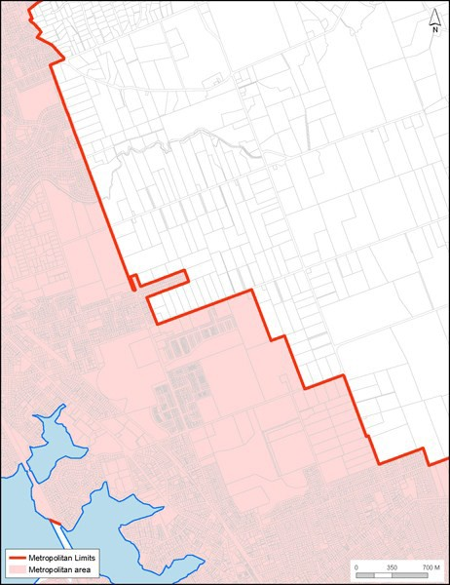

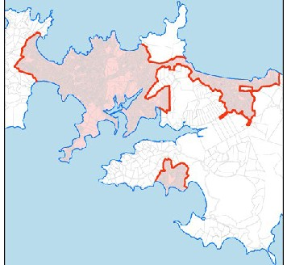M 19: Waiheke lshnd

-lo'dl'""""l'I.Qb
lo'di'W'..a...-·

Map 20: Whitford
