PART 5 ­ APPENDICES»

Appendix 2 Infrastructure

Appendix 2.1 Airport approach path

Steps for assessing a specific proposal
- Identify the property on the planning maps and determine whether it is affected by the height restrictions.

- Assuming all or part of the property is affected, identify which of the three controls applies: (a) fan; (b) transitional side surface; (c) horizontal surface.

- The following examples illustrate the restrictions as they apply to North Shore Airfield. The same method should be used at Kaipara Flats and Parakai using the gradients and heights specified for those airfields in the table on the previous page.

Land affected by a fan

Determine the distance from the beginning of the fan at the runway threshold to the proposed building site or area to be planted with trees.
Calculate the permitted height i.e. divide distance by 40 (1 in 40 slope)

e.g. For distance of 325m

Height is 325 = 8.125m 40

Then determine the difference in ground level between the threshold of the fan and the site in question. The four threshold ground levels are shown on the 1:30,000 plan. For the fan which passes over Wilks Road, the threshold ground level is 65m above mean sea level (MSL).

If the ground level on a proposed site is higher than 65m above MSL, the actual height limit will be 8.125m less the difference in ground level, say 3m, resulting in a maximum permissible height for buildings of 5.125m.

If the ground level on a proposed site is lower than at the threshold the difference from the fan level must be added to the original calculation.

The applicant will need to confirm the ground level in terms of MSL to accurately determine compliance.

Figure 1: Land affected by a fan
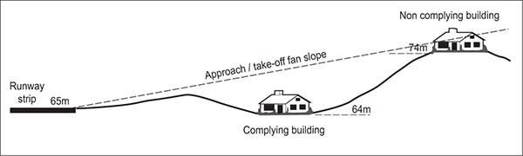

  - Land affected by transitional side surface

i.

ii.

c.
Beside the runway itself
Determine the distance from the edge of the runway strip shown on the planning map.
e.g. For a distance of 150ms at the slope of 1 in 7 Height is 150 = 21.428m
7

Beside a fan

Determine the distance from the edge of the fan(s) (a), measured at right angles to the fan centre line, and the distance from the corresponding point on the fan centre line to the runway threshold (b) (see diagram below).
(a) = 65m and (b) = 40m 65m at 1 in 40 65 = 1.625m
40

40m at 1 in 7 40 = 5.714m
7
7.339m

+ or – ground level difference

Horizontal surface
This surface is located at 107m above MSL. Determine the ground level of the site and assess the difference between it and 107m to determine the maximum permitted height.

Figure 2: Land affected by a transitional side surface
