6 Rural zones

Introduction
There are five rural zones:
•. Rural Production

- Mixed Rural

- Rural Coastal

- Rural Conservation

- Countryside Living

They form the rural management framework of this Unitary Plan and are based on the, current and potential future land use, existing subdivision pattern and the type and extent of natural and physical values present.

Many activities take place in more than one rural zone. Their management is addressed by the following general set of objectives and policies that are relevant across all the rural zones:
- Rural production

- Rural character

- Amenity values

- Rural industries and services and non residential activities

- Land subdivision.

These general provisions are followed by objectives and policies relevant to individual zones and reflect the diversity between each. They provide the management framework for subdivision and activities in Auckland’s rural areas and need to be considered together.

Rural Production
This is the main zone for a wide range of rural production activities and related rural services and industries. The focus is on maintaining the productive capacity of the land, its natural and amenity values and a rural character that is based on rural activities. Activities that have amenity expectations that cannot be met within, or are not compatible with a rural production environment are discouraged. This zone is a principal donor and receiver area for transferable rural site subdivision, which along with boundary relocation, are the only tools for rural subdivision in this zone.

Mixed Rural
This zone currently covers areas at Omaha, west of Orewa, around the Woodhill Forest, around the southern Manukau Harbour inland from the Rural Coastal zone, up the spine of the Awhitu Peninsula, to the north of Pukekohe, and in the Drury­Ardmore­Clevedon area. It provides for a mix of rural production and other rural­ related activities. Sites in this zone are generally smaller than in the Rural Production zone, and many are used for rural lifestyle development, tourism as well as rural activities. The range of activities provided for in the zone and their activity status are very similar to the Rural Production zone, but more diversity of uses – both rural production and rural­related – being appropriate.

Rural Coastal
This zone protects and manages the high amenity values of rural areas along Auckland's harbours, estuaries and coastline while enabling the development and operation of a range of rural and marine related activities. The

important recreational attributes of the coastal environment are supported, but further rural lifestyle subdivision is restricted. Much of this zone has high natural character, outstanding natural landscape and significant
ecological area overlays that include both land and the adjacent coastal marine area.

Rural Conservation
The Rural Conservation zone enables established rural activities to continue, but has a conservative approach to new land uses, subdivision and development so that the natural values of the zone are maintained. This zone contains one precinct, the Waitākere Ranges and Bush Living, which reflects the special qualities of the area and their significance to greater Auckland.

Countryside Living
This zone provides for rural lifestyle development in identified areas of rural land which are generally close to urban Auckland or to rural and coastal towns. There is considerable diversity in topography, land quality and landscape character within the Countryside Living zone, which results in a diversity of minimum site sizes. Priority is given to the maintenance of a lifestyle level of amenity, and activities that adversely affect this high amenity expectation are discouraged. The Countryside Living zone is the principal receiver area for transferable rural site subdivision from other rural zones.

General objectives and policies

    - Rural economy

Objectives
      - Rural Auckland is recognised as a place where people live, work and play. A diverse range of activities that support these functions are enabled.

      - Rural production activities are provided for throughout rural Auckland where they are compatible with the purpose of individual rural zones.

      - Land with high productive potential continues to be used for rural production and not for other uses.

Policies
- Enable activities based on production from the land or use of the land resource and recognise them as a primary function of Auckland’s rural areas.

- Require rural production activities to contain and treat their adverse environmental effects on­site to the fullest extent practicable to protect natural environmental values, avoid nuisance effects and maintain local amenity values and avoid sediment and discharges to freshwater and the CMA.

- Discourage land use activities and development not based on, or related to, rural production from locating on elite and prime land or prevent their use for that purpose.

- Recognise and maintain the productive potential of land of lesser soil quality, but with special growth characteristics, such as favourable microclimate, good drainage and availability of water, for rural production purposes, and prevent its use for urban development or countryside living.

- Enable a diverse range of rural production and non­rural production activities to operate in rural areas by:
  - directing incompatible activities such as rural production and rural lifestyle development into different zones

  - controlling the type and scale of non­residential activities in rural areas so they do not create expectations of urban and residential amenities and services, and impose reverse sensitivity demands on established rural production activities

  - managing activities in rural zoned land to maintain the natural values, open space and recreational attributes of public reserves and parks, freshwater lakes and the CMA, as part of using and enjoying rural Auckland

Rural character and amenity values

Objective
      - The character and amenity values of rural areas is recognised and maintained while accommodating the localised character of different parts of these areas.

Policies
- Require rural subdivision and rural activities to:
  - be of a nature, scale, intensity and location that retains the rural character of the zone

  - avoid, remedy or mitigate adverse effects, including adverse cumulative effects.

- Enable subdivision and activities in rural areas only when the followingcharacteristics are maintained:
  - a predominance of rural working environments

  - land in pastures, trees, crops or indigenous vegetation, and with a degree of naturalness

  - a low density of buildings and structures

  - land tenure with a diversity of site sizes and shapes

  - few buildings and activities of an urban scale, nature and design, other than residential buildings, greenhouses and other approved rural production and rural commercial services

  - a general absence of urban scale or type of infrastructure, such as roads with full kerb and channel, sealed footpaths and vehicle crossings, streetlights, bus shelters, sealed and demarcated car parking areas

  - generally narrow roads with open drains, some unsealed, with low speed geometry and low traffic volumes, except for state highways and arterial roads

  - the intensity of the activity, including the number of people using the site, hours of operation and number of vehicle trips generated, is compatible with the purpose of the zone in which it is located and avoids reverse sensitivity effects.

- Accept that in the Rural Production, Mixed Rural and Rural Coastal zones to accept the following aspects are a typical part of these zones:
  - the presence of large numbers of farmed animals and extensive areas of plant or fruit crops, plantation forests and farm forests

  - noise, odour, dust, traffic and visual effects associated with use of the land for farming, horticulture, forestry, mineral extraction, cleanfill and motorised sports

  - the presence of existing mineral extraction activities identified on the planning maps

  - accessory buildings which dot the landscape, particularly where farming activities are the dominant activity

  - natural landforms and vegetation, coastal and freshwater bodies and open space.

  - activities which provide for the relationship of Mana Whenua to their ancestral land and taonga.

Rural industries, services and non­residential activities

Objectives
      - Rural production activities in the Rural Production, Mixed Rural, Rural Coastal and Countryside Living zones are supported by rural industries and services, while avoiding reverse sensitivity conflicts and managing adverse environmental effects.

      - Rural industries and services inappropriate in the Rural Conservation zone are avoided.

      - Rural industries and services are compatible in size, scale and function with the purpose and character of the rural zone where they are proposed to locate.

      - The rural economy and the well­being of people and local communities are maintained or enhanced by social, cultural and economic non­residential activities, while the area’s rural character is retained.

      - Industries, services and non­residential activities of an urban type and scale unrelated to rural production activities are directed away from rural zones.

Policies
- Enable rural industries and services in rural zones where:
  - they support rural production activities, including the processing of minerals, agricultural, horticultural and aquaculture processing and packing, and the packing, processing and appropriate manufacturing of goods from primary production in the local area

  - they provide rural services such as rural contracting, boarding of domestic animals, veterinary, and quarantine and research services relating to primary production.

  - they provide rural services such as boarding of domestic animals provided that:

i.

ii.

iii.
animal breeding or boarding is designed and managed to be in accordance with best practice

buildings and accessory buildings that accommodate dogs is in accordance with appropriate acoustic engineering practice and standards

animal breeding or boarding have a minimal impact on adjoining dwellings. Matters considered will include visual impact, noise, odour, dust, traffic generation and vermin control.

- Intensive farming is enabled in the Rural Production, Mixed Rural and Rural Coastal areas only, provided that:
  - intensive farming should establish and operate in accordance with the most relevant codes of practice

  - buildings and effluent treatment ponds located on elite or prime land should employ measures such as application of nutrients to increase plant production on the productive land not covered by ponds/buildings.

- Enable non­residential activities in rural areas where they have a clear and genuine connection with the resources, amenities, characteristics and communities of the areas, with a focus on:
  - education, healthcare and community facilities that serve the local rural area and provide services not able to be met by similar facilities in rural towns and settlements

  - marae and non­residential activities associated with papakāinga

  - outdoor recreation and pursuits, nature, rural and wilderness experiences, and relaxation activities

  - tourist facilities and services with a clear operational connection to the natural and physical resources of rural and coastal areas

  - festivals and events, including those connected with local food and beverage production

  - artisan industries, artistic endeavours and creative industries including handcrafts and goods produced from the site’s resources, and film production

  - wineries

  - produce stalls and farmers’ markets

  - plant nurseries, where produce is grown on­site

  - small­scale retail activities, such as cafés that are accessory to the site’s principle activity.

- Require buildings and other significant structures to be in character with the surrounding rural area and, as far as practicable, to be of a similar scale and form to buildings required for non­intensive rural production activities.

- Locate and size sites sufficiently to:
  - avoid creating reverse sensitivity conflicts, particularly in relation to Countryside Living zones

  - contain and manage adverse effects on­site

  - avoid, remedy or mitigate adverse effects on traffic movement and the road network.

- Avoid non­residential activities of a size, function, intensity or character typical of those in urban areas from locating in rural zones, and locate them within the urban area, including rural and coastal towns or serviced rural and coastal villages.

- Enable forestry where it:
  - does not affect shading of dwellings, pasture growth or horticultural crops on adjoining sites;

  - is established and managed in a way which does not adversely affect indigenous vegetation or riparian areas

  - employs appropriate management techniques and is located to avoid adverse effects on neighbouring sites.

- Direct cleanfills and managed fills away from Rural Conservation or Countryside Living zones. Where cleanfills are established in other rural zones:
  - they will not adversely affect or inhibit the use of surrounding land for productive purposes or for carrying out any permitted, restricted discretionary or discretionary activity

  - their completed state should be compatible in terms of appearance, form and location with the existing amenity values of the surrounding environment.

Rural Production zone

Zone description
The purpose of the Rural Production zone is to provide for the use and development of land for rural production activities, while maintaining the natural and amenity values and rural character of the rural and coastal environments.

Farming activities generate various waste products and contaminants that have the potential to pollute rivers and streams and groundwater. Many of the activities which produce these contaminants are essential for the operation of rural production activities. However, these activities can give rise to increased levels of suspended sediment, chemical and nutrients and bacteria from faecal matter. Some of the most common discharges from rural production activities that need to be managed are the disposal of effluent from dairy sheds and other intensive livestock activities and leachate from offal holes, silage storage and composted materials.

This is the largest rural zone on the Auckland mainland. Its physical, climatic and production characteristics vary across the region, including rolling to steep hill country distant from the RUB, and flat to rolling lowlands with highly productive soils close to the metropolitan area.

In the north, the zone is characterised by:
    - Auckland’s highest number of remaining large rural properties

    - low intensity settlement, significant natural areas and natural resources

    - an environment less modified by humans than other zones in the north

    - opportunities to conserve and enhance native vegetation and wildlife.

In the south, the zone is characterised by:
    - intensively subdivided land tenure pattern, particularly on lowland areas

    - the largest horticultural production area in Auckland, centred on the highly productive soils of the Franklin lowlands

    - mixed primary production including pastoral farming and forestry relating to topography, land tenure pattern and water availability on the west and east coasts

    - the Hunua Ranges providing the backdrop to production land in the east.

Objectives
- A wide range and diversity of rural production activities take place in the Rural Production zone.

- Rural production activities largely manage their adverse environmental effects on site.

Policies
- Provide for a diverse range of existing and new rural production activities in the Rural Production zone and recognise their role in determining the zone’s rural character.

- Encourage diverse forestry activities including:
  - planting and management of new and existing forests in recognition of their production values, land stability and carbon sequestration functions, and multiple use for active recreation

  - woodlots and farm­scale forestry

  - planting of indigenous species and amenity exotic species for long­term production purposes and the eventual harvesting of these species.

- Enable the establishment of new and the expansion of existing greenhouses in specific locations where there are advantages for operational efficiencies, transport accessibility and the provision of energy

such as natural gas supplies and services, and manage the amenity expectations of other activities in these areas.

- Provide for intensive farming, other than for mustelid species, while managing the adverse effects and require compliance with good industry practice.

- Require intensive farming of new species, including terrestrial, freshwater and marine species not currently farmed in the Rural Production zone to:
  - be designed and operated to prevent the escape of any species of animal or plant that could have an adverse effect on the natural environment

  - not include any mustelid species.

- Provide for accessory farm and forestry buildings and other operational structures such as stockyards, pump houses and fences as part of the landscape character of this zone, but avoid buildings and structures, other than fences and pump­houses, in coastal yards, riparian margins, wetlands and existing areas of indigenous vegetation.

Mixed Rural zone

Zone description
The purpose of the Mixed Rural zone is to provide for mixed rural production, generally on smaller rural sites, non­residential activities of a scale compatible with smaller site sizes, and existing rural lifestyle development.

These areas have a history of horticulture and viticulture, including greenhouse production of flowers, fruit and vegetables, wine production, intensive poultry farming, and equine­related activities and services. This has given rise to associated buildings and other structures such as packhouses, coolstores, wineries, and equine training tracks and buildings for indoor rural production. These activities have in turn supported the establishment of produce stalls and retail services such as cafés and restaurants and tourist and visitor­related facilities.

Rural sites in the Mixed Rural zone are often larger than those in Countryside Living zones. This means they provide greater flexibility to accommodate a range of rural production activities and associated non­residential activities while still ensuring good amenity levels for residents who use their land for rural lifestyle purposes.

Objectives
- The existing pattern of landholdings, and non­residential activities that support them, is used by a diverse range of rural production activities.

- Land with high productive potential for rural production is retained.

- The continuation of rural production and associated non­residential activities in the zone is not adversely effected by rural lifestyle activity.

- The rural character of the zone is maintained with good amenity values while continuing the mix of rural production, non­residential and rural lifestyle activities.

Policies
- Enable land­based production activities that are compatible with the existing subdivision pattern and recognise them as significant elements of, and the primary contributor to, rural character within the Mixed Rural zone.

- Avoid locating rural production and non­residential activities that produce significant levels of odour, noise and traffic movement or significant discharges of contaminants to land or water that cannot be managed within the boundaries of the site in the zone.

- Enable on­site processing and storage facilities for agricultural and horticultural produce where their scale and operation is compatible with the character and amenity values of the zone.

- Acknowledge the mixed activities occurring in the zone when managing reverse sensitivity conflicts by:
  - limiting the size, scale and type of non rural production activities

  - retaining the larger site sizes within this zone

  - preventing further subdivision for new rural lifestyle sites

  - requiring good on­site management of rural production activities

  - maintaining a level of amenity that reflects the presence of:

i.

ii.
rural production and processing activities that generate rural odours, noise from stock and the use of machinery, and the movement of commercial vehicles on the local road network

non­residential activities which may generate noise, light and traffic levels greater than those found in areas of solely countryside living

  - supporting the continued use of the local road network for horse­riding.

Rural Coastal zone

Zone description
The purpose of the Rural Coastal zone is to retain the high amenity values of rural areas along Auckland’s harbours, estuaries and coastline, while enabling rural production and local non­residential activities, maintaining recreational opportunities, and managing the effects of scattered rural lifestyle development.

The zone is generally more extensive than the coastal environment line identified by using New Zealand Coastal Policy Statement criteria. It recognises the significance of the coast to the character and identity of Auckland and its role as a favoured place to live and work and for recreational and leisure activities. The integrated management of the coastal environment, and in particular the coastal edge and margins of lakes and rivers is of utmost importance to Mana Whenua. The zone therefore includes areas beyond the immediate coastal environment that have landscape and amenity links to the coast.

Much, but not all of the zone and the adjacent CMA are covered by environmental overlays that map areas of OHNC, ONL and SEA. The zone itself is the principal mechanism for managing land­use activities.

Rural production activities continue to operate throughout the zone, but it is under significant development pressure for coastal town and village settlement; further rural lifestyle opportunities; recreational, tourism and visitor activities; and diverse small home­based enterprises. It also provides opportunities to access the CMA and support marine­related activities. An integrated management approach is needed for land activities and the use and development of the CMA.

There are significant differences in topography, landscape character, existing rural land uses, transport accessibility and intensity of rural lifestyle development between different parts of the zone. These factors influence the rural character, amenity values and the ability to accommodate land­use changes and more intensive levels of development.

The first set of objectives and policies apply to all parts of the Rural Coastal zone. The second set contains area­specific objectives and policies covering:
    - Pākiri coastal area

    - Whangateau to Waiwera coastal area

    - Kaipara South Head and Harbour coastal area

    - Muriwai­Te Henga coastal area

    - Tasman coastal area

    - Manukau Harbour coastal area

    - Tāmaki­Firth coastal area

Objectives
- Rural production activities are enabled while managing any adverse effects on the high natural character, landscape, biodiversity, ecological and amenity values, and Mana Whenua cultural heritage values of the Rural Coastal zone.

- The development and operation of other activities that provide recreational and local non­residential services are enabled where they maintain and enhance the zone’s high natural values, rural and coastal character and amenity values.

- Buildings do not dominate and are unobtrusive with the high natural character, landscape, biological and ecological values of the zone.

- Further rural lifestyle subdivision is prevented across the zone.

- The significant relationship between land, freshwater bodies and the CMA and their contribution to Auckland’s rural coastal character is maintained and enhanced.

- The differences in coastal character in different parts of the zone are recognised and activities and development managed to maintain and enhance important local coastal character.

Policies
- Manage activities and development to maintain the distinctive character of the zone which is a combination of:
  - a high degree of naturalness

  - high biodiversity, ecological and amenity values based on particular physical and natural features such as beaches, ridgelines, estuaries, harbours, indigenous vegetation, wetlands, or similar unifying features

  - physical and visual links between land, freshwater lakes and the CMA

  - the traditional cultural relationships Mana Whenua has with the coastal environment

  - a predominance of pastoral farming and forestry with a low density of buildings and other significant structures.

- Enable the continuation of rural production activities and the construction of accessory buildings and structures, such as fences and stockyards, for farming purposes.

- Provide for the continued operation of forestry, including harvesting and replanting, in existing forest areas, but require evaluation of new forestry proposals in Natural Character, ONL and SEAs identified on the overlay maps.

- Manage the visual and coastal character effects of commercial greenhouses and buildings for intensive farming purposes.

- Avoid non­rural production activities that:
  - require significant areas of buildings

  - have open areas of exposed ground

  - require significant earthworks or changes to natural landforms

  - generate noise and odour beyond the boundary of the site

  - produce significant discharges that cannot be practicably contained and treated on site

  - generate significant numbers of daily vehicle movements, particularly on scenic and tourist routes

  - impact significantly on biodiversity and ecological values.

- Protect the open space, recreational and natural environment experience provided by regional parks, other public open space and marine reserves by requiring subdivision and activities around these public areas to not adversely affect their character, values and use.

- Manage the zone as a donor and not a recipient area of transferrable rural site development.

- Maintain the rural coastal character and high amenity values by controlling the number, location, size and visual impact of dwellings and other non­residential buildings and their curtilage and accessways.

- Manage the individual and cumulative adverse effects of buildings and other significant structures to maintain high­quality natural landscapes, high levels of amenity and local rural coastal character by:
  - requiring buildings and other significant structures to be of a scale, location, design and density that integrates them into the rural coastal landscape

  - avoiding locating buildings, other than those for farm utility purposes, on the top of ridgelines so that their profile does not protrude above the natural line of the ridge

  - making building platforms and accessways the minimum size necessary to safely perform their function, and that earthworks required to establish these facilities are re­vegetated as soon as possible to cover bare soil exposure, particular on side batten surfaces

  - not locating buildings and other significant structures in coastal yards and riparian margins, except for fences and structures with a functional need for such a location.

10.

Recognise the importance of individual major roads in the zone that:

- provide access to coastal settlements, public open space and the coast

- function as major transport routes for rural produce

- are major scenic and tourist routes

- are preferred locations for recreation, tourism, visitor facilities and services and the sale of produce and crafts

- act as gateways to Auckland.

11.
Enable the development of appropriate activities, while ensuring that the transport function of the road and its scenic values are not compromised.

Pākiri coastal area

Background
The Pākiri coastal area includes the coastal land between Te Arai Point and J Greenwood Road to the south of Pākiri village. Being the backdrop to Pākiri Beach, it is the only lengthy, exposed, high­energy beach on mainland Auckland’s east coast. In contrast to other areas on this coastline, it has a distinctly remote and wild rural character.

The area is characterised by hill country in the south and west which gives way to rolling rural land, sand dunes and flat pastoral land in the north and east. The sand dunes, along with historically planted exotic forests form a natural interface between the beach and the pastoral land further affield. The areas of indigenous and exotic forest on the hills lying to the west of the Pākiri coastal area form a physical and visual backdrop to the area, particularly in the southern part.

The Pākiri coastal area is characterised by an existing rural lifestyle and beach settlement to the south of Mangawhai Forest, focussed on the Pākiri River area. Pākiri Regional Park is located to the south of the river. There are limited public road access points to Pākiri Beach. At Te Arai Point, located towards the northern end of the coastline, has a public reserve, regional park, scenic lookout and a golf course.

Objectives
      - Low levels of built development in the Pākiri coastal area are maintained to retain its coastal character and the scenic and recreational values of Pākiri Beach.

      - Development of Māori land is provided for in a way that retains the dominance of natural elements and scenic values over any built development.

Policies
- Avoid beachfront residential and rural lifestyle development in the Pākiri coastal area to retain the undeveloped character of Pākiri Beach.

- Maintain existing public roads and other access ways to Pākiri Beach, but manage the type and intensity of development along these roads to protect their low­key development character.

- Require buildings to locate outside the active dune system to protect the physical and ecological values of the dune system itself and to ensure its long­term stability.

- Manage built development on existing rural titles and from title boundary realignments so that the size, location and density of buildings does not dominate over natural elements and the area retains a rural character rather than one of rural lifestyle domestication.

- Minimise the visual and landscape impacts of buildings, when implementing policy 4 above in areas where there are important public views to and from Pākiri Beach and the rural backdrop, including:
  - views to and from the beach at the Pākiri River mouth

  - views to and along Pākiri Beach and the southern coastal hills from Pākiri Regional Park

  - views to and from the beach at Te Arāi Point.

- Avoid activities and development that adversely affect the natural character, recreational use, and water quality of the catchment of the Cape Rodney to Ōkakari Point/Goat Island Marine Reserve, particularly on the coastal hills fronting the reserve.

- Provide for the ongoing operation of the Mangawhai Forest and its multiple purposes for timber production and sand dune stabilisation, and for its landscape and open space values as a backdrop to Pākiri Beach.

- Enable the use of Māori land in the area for papakāinga and other associated purposes, but recognise the high natural values of the area by:

  - concentrating built development in areas of lower visual prominence

  - cluster development rather than expansion along the coastal edge

  - maintaining existing vegetation and landform character as far as practicable

  - managing the scale of development to reflect papakāinga and marae needs, rather than more intensive forms of development.

Figure 1: Pākiri coastal area
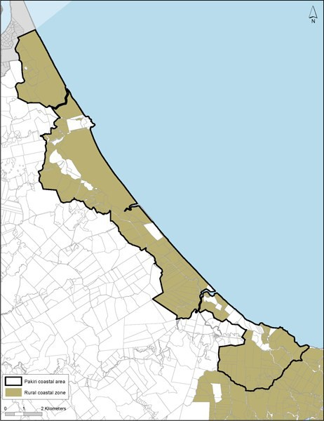

    - East Coast area ­ Whangateau to Waiwera

Background
The East Coast area extends from Rodney Road (Pākiri Hill) south as far as the northern bank of Waiwera River. Its inland boundary generally follows State Highway 1 from Waiwera to Warkworth, before extending northeast to the east of Matakana Road and along Leigh Road. Public roads are located along the ridgelines and provide access to the coastal edge.

This coastal area is typically characterised by an indented and variable coastline with steep headlands, small coves, sheltered beaches and harbours, interspersed with extensive, more exposed sandy beaches. A sequence of five major estuaries are distributed along the eastern coast area – Whangateau, Matakana, Mahurangi, Pūhoi and Waiwera. Within these estuarine environments, inter­fingering of land and water provides extensive nooks and crannies which brings the coastal environment some distance inland as it follows these inlets.

Between Mahurangi and Waiwera, the land is characterised by steep to rolling rural land with extensive areas of indigenous vegetation and partially bush­clad slopes. In general, there are few areas of flat land, the largest areas being at Omaha Beach and Omaha flats. Given the hilly topography, the areas have high view amenity from land out to sea, both nearshore across estuaries and to more distance islands in the Hauraki Gulf.

Much of the coastal edge is identified as having areas of ONHC with further expanses of land identified as ONLs and SEAs.

Five regional parks at Tāwharanui, Scandretts, Mahurangi East, Mahurangi West and Wenderholm provide public access and recreational opportunities, as well as being significant ecological areas.

The East Coast area provides a favourite location for rural lifestyle development and coastal holiday homes. It also provides extensive opportunity for recreational use of the coastline and estuarine areas, with scattered boat launching facilities. The satellite town of Warkworth and the coastal settlements of Snells Beach, Leigh, Point Wells, Omaha, Matakana, Sandspit and Waiwera are all close to the East Coast area.

Objectives
      - The open, high­quality coastal landscape character and the natural environmental values of the East Coast area are retained.

      - Recreational, home occupation, marine transport and tourism activities are supported where they are consistent the coastal landscape character and natural environmental values of the area.

      - The management of activities and development is integrated with the management of growth in identified rural and coastal towns and settlements.

      - The high natural values of the east coast estuaries are maintained by requiring high performance standards for activities and development on land.

Policies
- Require dwellings, their curtilage and access to be located sensitively in the landscape, with particular consideration of their size, location, scale and density, ability to tuck into the landscape and the desire for views against visual dominance in landscape.

- Assess the visual and landscape impacts of greenhouses and buildings for intensive farming in the rural area.

- Avoid locating dwellings and other significant buildings on ridgelines and the construction of urban type access ways up or across visually significant slopes.

- Recognise and support the high recreational values of the area, particularly accessibility to, and use of,

the CMA by enabling:
  - the continued use of Sandspit as a transport terminal to Kawau Island

  - the efficient operation of existing public boat launching facilities and the establishment of new public facilities in appropriate locations.

- Avoid activities and development of a type, scale or location that adversely affects the public use and enjoyment of regional parks and other public open space for:
  - active and passive recreation, both on land and in the adjoining CMA

  - appreciation of open space, scenic and natural landscape values

  - centres for biodiversity management and enhancement

  - farmland management.

- Enable the development and operation of local home occupations that support rural production, tourist trails, farmers’ markets and tourist facilities in centres such as Warkworth, Snells Beach­Algies Bay and Matakana.

- Concentrate larger scale tourist facilities, including tourist accommodation, in rural and coastal towns.

Figure 2: East Coast Area ­ Whangateau to Waiwera

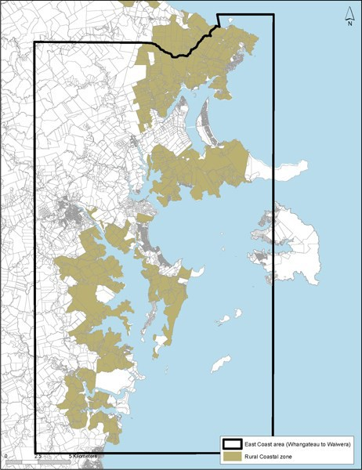

    - West Coast area ­ Kaipara South Head and harbour

Background
The West Coast area includes significant areas of Kaipara South Head, the Ōkahukura (Tāpora) Peninsula and the eastern coastal margins of the Kaipara Harbour. The area is characterised by a predominance of rural production activity, particularly pastoral farming activities and forestry and its significance to Māori. Long, high­ energy beaches backed by sand dunes are located along the coast, terminating in the significant high dune landforms and Papakanui spit at South Kaipara Head. Three main roads serve the area – State Highway 16, South Head Road and Run Road­Journey's End. There are high­amenity views of the harbour from State Highway 16 in particular.

Flat coastal alluvial plains are a special landscape feature in the Kaipara Harbour catchment. These are backed by a convoluted coastline with rolling hills. This harbour is highly tidal with extensive areas of exposed intertidal flats and defined low tidal channels and occasional mangrove communities. The remaining natural areas are important due to past vegetation clearance and wetland drainage. Activities such as sand extraction, marine farming and tidal energy generation occur in the Kaipara Harbour.

Significant bird habitats are present along the coastal margins and in the harbour, particularly around the sand islands at Tāpora. Tāpora, Wharehine and Port Albert are sensitive to development due to the elevated nature of many of the surrounding roads, and due to the rolling and often open natural of the land which also connects to the low lying alluvial plains.

Development has increased in particular along the west coast of the Kaipara Harbour and along South Head. A pattern of typically large properties and low­density settlement provides a rural and semi­remote character.

Woodhill Forest along the western margins of South Kaipara peninsula provides production, recreation, sand stabilisation and landscape functions. It is a significant site for active sports such as mountain biking.

Topography and private land ownership limits access to the coastal edge in many areas. However, Ātiu Creek Park provides public access to the Ōruawhero arm of Kaipara Harbour.

Small bach communities are located at Shelly Beach, Journey's End and Port Albert, with Shelly Beach providing the main boat launching facility.

South Head and the coast of the Kaipara Harbour while generally meeting the above description are noted as areas which are also recognised as being under pressure for development that is not directly related to rural production activity due to the coastal location and proximity to metropolitan Auckland.
However, there are areas of significant landscape – identified in the overlays as ONC, HNC, and ONL, which are considered to be at risk of degradation. Control over the built environment in these areas is considered prudent in order that the semi­remote character and the rural/coastal landscape, environmental and amenity values present are retained.

To recognise these qualities the whole area isincluded in the Rural Coastal zone with particular development
and subdivision controls that enable normal rural activities such as farming and forestry to continue as permitted activities, albeit subject to more stringent environmental controls (relating to buildings, earthworks on sites 40 hectares and less in area (that are not already provided for as a Permitted Activity), tree and bush removal, and wetland/watercourse modification to ensure they respond sensitively to the landscape qualities present.

Development controls to recognise these features and associated values include a slightly higher height allowed for dwellings, with slightly greater maximum height for farm and forestry rural accessory buildings within an identified ONL.

Objectives
      - The special and distinctive coastal and rural character of the West Coast area is retained.

      - Land­based activities and development are managed to protect the area’s Outstanding and High Natural Character and landscape values, and its ecological, recreation and amenity values.

      - The relationship between the land, the Tasman Coast and the Kaipara Harbour, and the physical, ecological, landscape, amenity and production connections between the two is recognised and maintained.

      - Significant Māori associations with the Kaipara Harbour area recognised and provided for.

Policies
- Enable rural production activities, particularly pastoral farming and forestry, for their economic and social contribution to Auckland and for their role in retaining a remote rural and coastal character.

- Maintain a low intensity of built development, where buildings are for farming and forestry purposes rather than for rural lifestyle purposes.

- Require buildings for intensive farming to be sited to minimise visual impacts on natural character and landscape values.

- Retain a range of land holding sizes, particularly those larger land holdings used for pastoral farming activities.

- Improve public access to the Kaipara Harbour, including boat launching facilities where this does not adversely affect important habitat areas, such as the Tāpora sand islands.

- This part of the Rural Coastal zone (Figure 3 below) reflects the special and distinctive coastal and rural character of parts of the Kaipara Harbour and South Head areas, these rural and semi­remote areas are influenced by the Tasman Sea and Kaipara Harbour. This part of the zone encompasses the following:
  - rural coastal character

  - high amenity values

  - high natural character

  - high landscape values

- Require subdivision and land use activities to enhance and protect the distinctive special character of the policy area and ensure that the landscapes and sensitive environments are protected.

Figure 3: West Coast area ­ Kaipara South Head and harbour
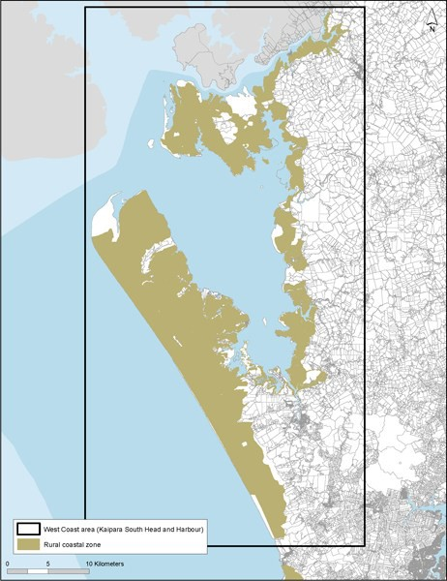

    - Muriwai to Te Henga coastal area

Background
This coastal area of Muriwai to Te Henga consists of the rugged coastal strip between Muriwai and Bethells Beach/Te Henga and the area inland as far as the edge of the hill country west of Waitākere township. Although some parts of the area are more distant from the coast, they are included in the coastal area because of their open space and natural qualities.

Typically this area is characterised by its predominance of natural qualities, including open space that is largely unmodified by the built environment, significant roads or other landscape modifications.

Largely uninhabited steep, rugged indented coastal cliffs are present along the West Coast with small beaches amid high, rocky headlands. Rolling to steep hills extend inland from the coast. Areas of regenerating and significant indigenous vegetation are also present.

Rural lifestyle development to the south of Muriwai settlement is focused on Ōaia and Constable Roads but set back from the coastal edge. An Open Space zone running the length of the Muriwai/Bethells Beach coastline separates the coastal area from the CMA.

Part of the area to the south is included in the Waitākere Ranges Heritage Area.

Objectives
      - The natural, coastal and non­urban character of the Muriwai­Bethells Beach coastal area is protected and retained.

      - Activities are managed in this coastal area to maintain the values of the adjoining Open Space zone.

Policies
- Manage built development on existing rural titles and from title boundary realignments so that its size, location and density of buildings does not dominate natural elements and the area retains a rural character rather than one of rural lifestyle domestication.

- Avoid site dwellings and accessory buildings overlooking public walkways or locations such as headlands or ridgelines where they would be highly visible from the Open Space zone.

- Avoid built development requiring significant clearance of existing regenerating and established indigenous vegetation.

Figure 4: Muriwai to Te Henga coastal area
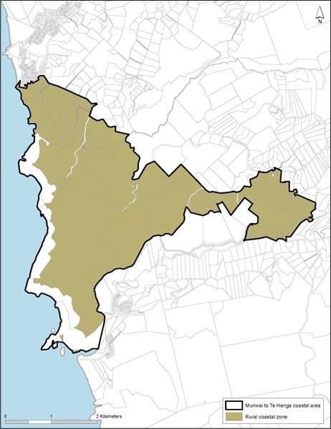

    - Tasman Coast area ­ Āwhitu Peninsula

Background
The Tasman coastal area comprises the western margins of the Āwhitu Peninsula. This is a relatively straight section of coast extending from the Manukau Harbour south to the council boundary with Waikato District.

The area is characterised by several distinctive landforms, including a narrow beach backed by a steep bluff that typically rises sharply to 120­190m above sea level and several dune lakes. Public roads are generally 1.5­3 km inland with no direct access to the coast, apart from at Karioitahi Beach and Hamilton’s Gap.

The length of the sandy Tasman Coast is prone to coastal erosion and sand­drift. Severe blowouts, migrating dunes and sand sheets can be exacerbated when vegetation is disturbed. The dune lakes of Pēhiākura and Pokorua are generally surrounded by privately­owned land and lack public road access.

The area as a whole is one of high natural character and outstanding natural landscapes. Steep hill country gives the area a wild, scenic and remote landscape character. Pastoral land comprises large farm holdings with pockets of indigenous vegetation and forestry. Settlement is typically sparse – characterised by farm houses and accessory buildings and located adjacent to existing roads.

A long history of Māori settlement has left a legacy of places and sites of significance to local iwi and strong cultural associations with the peninsula as a whole.

Objectives
      - The high natural values, including natural character, landscapes and other resources are protected from inappropriate subdivision, use and development while providing for rural activities.

      - Natural coastal processes are recognised and managed by avoiding activities that would create or exacerbate coastal erosion and sand blowouts along the Tasman coastline.

      - The potential for this coastal area to support renewable wind energy generation facilities is acknowledged.

Policies
- Provide for limited subdivision, use and development that will enable coastal natural character and landscape values to be maintained and enhanced.

- Avoid land modification and development along sandy coastal margins and seaward faces of the coastal escarpments or ridgelines.

- Encourage protection of stands of indigenous bush, and restoration and enhancement planting of indigenous trees, shrubs and other plants along the coastal escarpments and ridgelines.

- Promote public access to the coast in strategic locations, in conjunction with environmental protection, enhancement or restoration and in a way that does not adversely affect coastal processes and natural character and significant indigenous vegetation and habitats.

- Recognise the wild, scenic, and remote values of the Tasman Coast.

Figure 5: Tasman Coast area ­ Āwhitu Peninsula
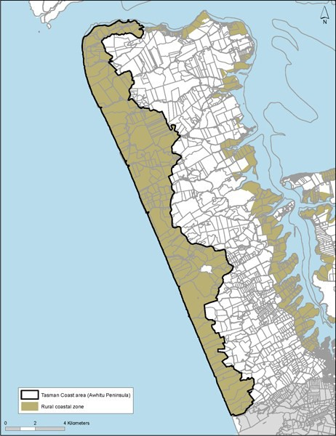

    - Manukau Harbour coastal area

Background
The Manukau Harbour coastal area encompasses the harbour fringe from Wattle Bay at the harbour entrance to the Whangamaire Stream arm of the Pāhurehure Inlet, west of Hingaia.

This coastal margin is physically diverse with a wide variety of environments including beaches, headlands, cliffs and estuaries. It is characterised by low lying rural flatlands, low terraces and rolling topography deeply
indented by the Waiuku and Taihiki rivers and various estuarine creeks and inlets.

The coastal area forms part of the wider Franklin lowlands with highly productive soils, pastoral and horticultural land uses and an intensive pattern of land subdivision into small rural sites.

The Waiuku River, indented toward the mainland, is associated with low coastal cliffs and rural land sloping down to a mangrove­lined estuary, where views are available across land and water. The eastern margin of the Āwhitu Peninsula with coastal terraces and flats, is backed by higher and steeper areas, and a sequence of inlets and prominent coastal headlands from Matakawau south to Waiuku township.

The small coastal settlements are located at Clarks, Waiau and Glenbrook beaches, with scattered, typically traditional bach areas at Wattle Bay, Ōrua Bay, Big Bay, Graham’s Beach and Matakawau Point which are zoned as coastal settlements rather than rural coastal.

Low elevation views out and across Manukau Harbour are afforded from the local headlands. Inter­tidal banks and flats of the Manukau Harbour are visually prominent, and provide an area of international significance for roosting and feeding for migratory wading birds. The coastal margin pastoral land is utilised by birds as part of the wider southern Manukau Harbour wildlife habitat.

There are larger holdings on the eastern Āwhitu coastline than along the southern Manukau coast, with a predominance of pastoral farming activities. Overall in this location there is a relative absence of dwellings in proximity to much of the coastline. Natural character is based on agricultural land uses and absence of built development rather than the presence of indigenous vegetation. The area also has important cultural significance.

Āwhitu Regional Park provides important public recreational and access point to the coast to the Manukau Harbour.

Objectives
      - Rural production activities are continued in the Manukau Harbour coastal area while maintaining its rural coastal character and visual amenity values.

      - Activities in the coastal area are managed to protect the ecological values of the Manukau Harbour, particularly identified wader bird habits, and the visual and landscape interconnections between land and sea.

      - Identified special character areas are protected from inappropriate land use activities, built development and further subdivision.

      - Coastal and riparian vegetation quality and quantity in the coastal area are improved.

      - Built development and inappropriate land use activities are avoided within critical coastal margins at risk of coastal flooding or erosion.

Policies
- Recognise the significance of the coastal margin setback in maintaining the natural character of the coastal edge, providing a natural buffer to coastal erosion flooding and contributing to the visual amenity

values of the Manukau Harbour coastal edge.

- Require dwellings and other significant built development, other than fences, to locate outside the coastal margin setback.

- Protect the special character areas listed in policy 4 below by:
  - controlling the location, scale and density of built development

  - having vegetation cover and production land uses that are appropriate to the area in terms of use by wader birds.

- Recognise the following areas are identified as being of special character in the Manukau Harbour coastal area:
  - Clarks Beach to Seagrove and Ellets Beach

  - Pollok Spit

  - Āwhitu Regional Park and Environs

  - Waipipi Creek Roosts

  - The Western Needles Promontory

  - Kelly’s Landing Headland

  - Dickey’s Landing Headland/Kauri Point Headland

  - Kauri Road Headland

  - Andrew Pye Road Headland

  - Mako Point Headland

  - Headland between Wattle Bay and Ōrua Bay.

- Improve public access to, and along, the coastal edge, except in identified wader bird and wāhi tapu areas, by providing esplanade and other reserves.

- Avoid activities and development of a type or scale or location that adversely affects the public use and enjoyment of the Āwhitu Regional Park for:
  - active and passive recreation, both on land and in the adjoining CMA

  - appreciation of open space, scenic and natural landscape values

  - farmland management.

- Require enhancement of the coastal edge and riparian margins as part of any development for rural lifestyle purposes or non­residential activities.

Figure 6: Manukau Harbour coastal area
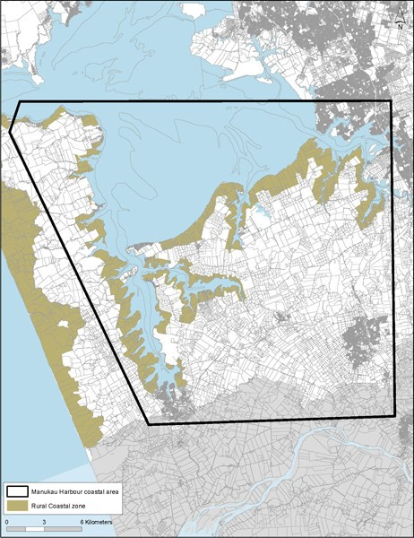

    - Tāmaki Firth coastal area

Background
The Tāmaki Firth coastal area encompasses rural coastal land from Maraetai south­east to the regional boundary south of Matingarahi on the Firth of Thames.

It is a mixture of flat land around the lower reaches of the Wairoa River and at Kawakawa Bay, Ōrere Point and Waimangu Point, separated by rolling to steep hill country. This coastal area is predominantly pastoral land but backs onto steep forest­covered hill country in the north and the Hunua Ranges in the south. There is no continuous coastal road connecting the area as a whole.

It is typically characterised by a variable coastline with a rocky shoreline of small coves and headlands, cliffs, wider sandy beaches, prominent headlands, shallow beaches, separated by rolling land, which gives way to shallow gravel beaches in the south.

Pastoral farming is predominant, interspersed with local areas of indigenous vegetation. There are four regional parks within the area ­ Duder, Waitawa, Tawhitokino and Tāpapakanga.

In terms of settlements, there is a rural town at Clevedon and coastal settlements at Kawakawa Bay and Ōrere Point. A new rural residential node at Matingarahi extends both sides of the main coastal road.

The area is historically significant to Māori, including Umupuia. Important coastal pōhutukawa give the area its name ­ the Pōhukutawa Coast.

The southern part of this coastal area acts as the entry to coastal Firth of Thames and provides a significant bird habitat and many natural features.

Objectives
      - The rural production, rural and open space character of the Tāmaki Firth coastal area is maintained.

      - The creation of new settlements or rural lifestyle nodes near Matingarahi are avoided.

      - The scenic values associated with the Pōhutukawa Coast highway are maintained.

      - Coastal pōhutukawa trees are protected.

Policies
- Enable rural production activities for their economic and social contribution to Auckland and for their role in retaining the rural and coastal character of this area.

- Avoid establishing new rural lifestyle settlement nodes along the coastal edge and contain Matingarahi within its existing boundaries.

- Avoid locating dwellings and other significant buildings on prominent headlands and ridgelines and the construction of urban type access ways up or across visually significant slopes.

- Manage the location, type and scale of non rural production activities along the Pōhutukawa Coast Highway to ensure that its rural character and scenic values are maintained.

- Avoid activities and development of a type or scale or location that adversely affect public use and enjoyment of regional parks and other public open space for:
  - active and passive recreation, both on land and in the adjoining CMA

  - appreciation of open space, scenic and natural landscape values

  - centres for biodiversity management and enhancement

  - farmland management.

- Recognise and support the high recreational values of the area, particularly accessibility to and use of the CMA by enabling the efficient operation of existing public boat launching facilities and the establishment of new public facilities in appropriate locations.

Figure 7: Tamaki Firth coastal area
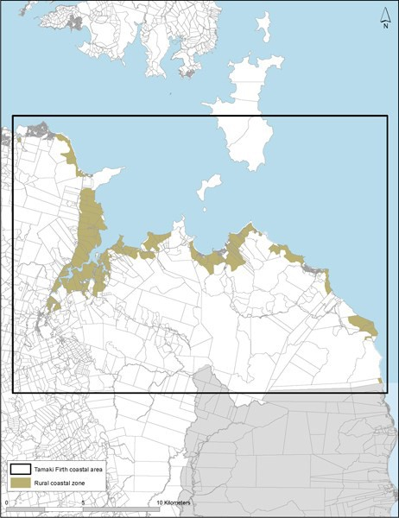

  - Rural Conservation zone

Zone description
The Rural Conservation zone comprises biophysically distinctive areas in rural Auckland. All have important natural values requiring maintenance and protection. However, they are largely in private ownership and are used for a range of purposes, including residential, low­impact recreational activities, conservation and open space.

Most areas have significant indigenous vegetation cover, are important wildlife habitats, or contain important natural features such as dune lakes. Most have been identified as SEAs, ONLs and areas of OHNC.

The purpose of this zone is to enable established rural and residential activities to continue, but to adopt a conservative approach to new land uses, subdivision and development so that the natural values of the zones are maintained and protected.

The zone contains one precinct, the Wāitakere Ranges and Bush Living precinct.

Objectives
    - The differences in landscape, natural character and distinctive environmental values of the zone are recognised and protected.

    - The inherent physical and biological properties are recognised and activities managed in a way to preserve and maintain them.

    - Existing rural and residential activities continue but further development across the zone is generally avoided.

    - Buildings and structures are unobtrusive within the natural landscape.

Policies
- Protect the landscape from significant change or modification, particularly visually intrusive buildings, structures and roads.

- Manage individual and cumulative adverse effects of buildings and other structures to protect and maintain the unique environment by:
  - requiring buildings and other structures to be of a form, scale, location and density that they are compatible with the landscape

  - avoid buildings and structures on ridgelines.

- Enable the continued use of established rural activities and recreational uses of the zone where they contribute to the unique character of the zone and allow expansion of those activities only where adverse effects are avoided or mitigated.

- Maintain and enhance water quality and quantity by:
  - avoiding new primary production activities or the expansion of existing activities where they will accelerate water abstraction from lakes

  - discouraging intensive farming, cleanfills, and rural industries and services that generate contaminant discharges to land or water and increase existing levels of diffuse nutrient input into lakes

  - minimising land disturbances, landform modification and the removal of indigenous vegetation to reduce on­site sediment discharges from any site

  - avoiding the introduction of exotic species which may undermine the ecological integrity of native terrestrial or aquatic habitats.

- Protect and maintain habitats, high­value natural areas and unique features present within the zone

through controls on earthworks, vegetation removal, grazing, wetland modification and limitations on activities and subdivision.

- Recognise the high ecological value of the dune lakes and their habitats by avoiding activities that disturb wildlife during breeding or nesting seasons.

Countryside Living zone

Zone description
This zone incorporates a range of different types of rural lifestyle development which share a common characteristic of being low­density residential development on rural land. These rural lifestyle sites include scattered rural residential sites, farmlets and horticultural sites, residential bush sites outside the urban area, papakāinga and foothills settlements.

The zone applies to areas with a diversity of physical, topographic and landscape characteristics. Some parts of the zone reflect historical subdivision patterns dating back nearly 40 years, while other areas were established on rural land that did not have significant production values, often associated with steep topography and poor soils. Bush lots enabled the protection of indigenous vegetation cover as part of the subdivision process.

Countryside Living zones located on better quality land often reflect a transition from a productive horticultural use to a rural lifestyle site as market conditions change.

Objectives
    - Amenity values are reflected in its primary use for rural living rather than rural production activities.

    - Subdivision and development for rural lifestyle purposes is delivered with quality development outcomes while the environment is protected and enhanced.

    - The quality of the environment with respect to rural character, amenity values, water quality, ecological quality, historic heritage values and the efficient provision of infrastructure is maintained and enhanced in subdivision design and development outcomes.

    - Where the Countryside Living zone adjoins the Rural Production or Mixed Rural zones, development does not compromise the ability of the land to be effectively and efficiently used for rural production activities.

    - The type and nature of land use activities allowed in the zone are restricted to those appropriate for the smaller site sizes and level of amenity value provided for.

    - Development outcomes enable land within the zone to be used for small­scale rural production activities as well as lifestyle living.

Policies
- Locate, design and implement subdivision and associated land use development to avoid urban form and character, maintain and enhance rural character, amenity values and protect and enhance environmental features by:
  - designing subdivisions to respond to the topography and characteristics of the land being developed, resulting in non­uniform patterns of development that are sensitive to the features of the environment in which they are located

  - identifying building platforms that respond to site topography and environmental characteristics

  - locating accessways, services, utilities and building platforms where these can be provided without the need for significant earthworks, retaining, benching or site contouring

  - locating accessways, services, utilities and building platforms where the location is sensitive to, and responds to, the site’s environmental features to avoid vegetation removal or adverse effects on water quality, wetlands, riparian margins, historic heritage sites or scheduled sites and places of significance for Mana Whenua. Where avoidance is not possible, mitigation measures must be proposed so that any adverse effects are minor

  - identifying opportunities for environmental enhancement of existing areas of native vegetation, wetland areas, riparian margins or the coastal edge and requiring this enhancement to be

actioned through the implementation of the development, including on an ongoing basis

  - requiring land use and subdivision development that provides the open space character anticipated in the zone and maintains a rural character through the use of rural style fencing, gates, entranceways and roads; landscape planting that reinforces local vegetation patterns and retains
a spaciousness between residential built form on adjoining sites; and requires the clustering of residential built form on individual sites

  - in subdivision that creates more than one new site, encourage the clustering of built form and the use of shared accessways and common grounds to maintain and open rural character.

  - identifying and where appropriate, requiring the provision of walkway, cycleway and bridle path networks.

- Manage the design, siting and construction of new buildings and structures so that they retain the open space and non­urban character of the zone.

- Prevent subdivision and development from compromising the safe and efficient operation of existing rural activities or industry.

- Allow a variety of site sizes in the zone that reflect local character and enable development to achieve the zone’s objectives and policies.

- Avoid or mitigate adverse effects in relation to reverse sensitivity, and the amenity values of the environment, by restricting the range of land use activities enabled in the zone.

- Prevent activities that will result in adverse effects such as noise, dust, traffic volumes, smell, visual effects, effects on health, safety and cultural values and significantly reduce the rural amenity values enjoyed in the zone.

- Acknowledge the amenity values in this zone reflect its predominant use for lifestyle living rather than for production activities.

