PART 3 ­ REGIONAL AND DISTRICT RULES»Chapter I: Zone rules»

19 Special Purpose ­ Māori Purpose zone

Activity table

The following table specifies the activity status of activities in the Māori Purpose zone.

Activity | Activity Status
Accommodation
Home occupations | P
Visitor accommodation | D
Community
Care centres up to 250m2 GFA | P
Care centres greater than 250m2 GFA | RD
Community facilities | D
Education facilities up to 250m2 GFA | P
Education facilities greater than 250m2 GFA | RD
Healthcare facilities up to 250m2 GFA | P
Healthcare facilities greater than 250m2 GFA | RD
Marae complex | P
Organised sport and recreation | RD
Urupā | RD
Commerce
Commercial services | D
Markets | P
Produce stalls | P
Offices | D
Retail up to 100m2 GFA per site | P
Retail greater than 100m2 GFA per site | RD
Development
Up to three dwellings per site | P
Four or more dwellings per site | RD
New structures or buildings associated with Māori cultural activities | P
Alterations and additions to buildings | P
Demolition of buildings | P
Integrated Māori development | D
Rural
Farming | D

Land use controls

2.1 Maximum density

  - The number of dwellings on a site must not exceed one per 300 m2 net site area.

  - No density limit applies where four or more dwellings are proposed and the site:
    - has a minimum net site area of 1200m²

    - is at least 20m wide:

i.

ii.
at the site frontage

for at least 80 per cent of the length of its side boundaries.

  - Development that does not comply with clauses 1 or 2 above is a discretionary activity.

Development controls

  - Building height

    - Marae complex (including wharenui and wharekai) and structures or buildings associated with Māori cultural activities (including but not limited to pou, waharoa, pekerangi/taiapa, whare waka) must not exceed 10m in height. Pou haki are excluded from these controls if they:
      - do not exceed an additional one third of the permitted activity height for the site

      - are not more than 300mm in diameter

      - are within the footprint of the building.

    - All other buildings must not exceed 8m in height.

Height in relation to boundary

Purpose: manage the bulk and scale of buildings at boundaries to limit over­shadowing to neighbouring properties sites and provide space between buildings.

    - Buildings must not exceed a height of 3m measured vertically above ground level at side and rear boundaries. Thereafter buildings must be set back 1m for every additional metre in height (45 degrees) up to the maximum building height.

Figure 1: Height in relation to boundary
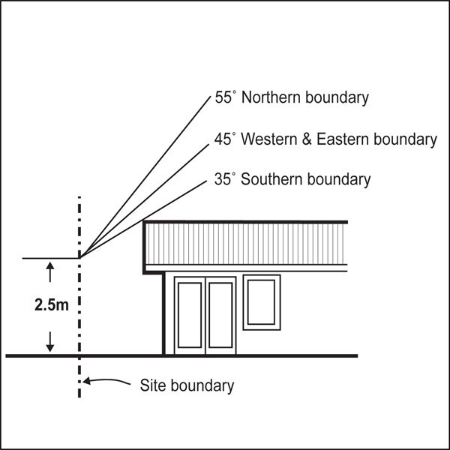

    - This control does not apply to a boundary adjoining:
      - industrial zones

      - centres and mixed use zones

      - General Business zone

      - Business Park zone

      - sites within the Public Open Space zones exceeding 2000m².

    - Where the boundary forms part of a legal right of way, pedestrian access way, or access site, the control will be taken from the farthest boundary of that legal right of way, pedestrian access way or access site.

    - A gable end or dormer may project beyond the recession plane where they are:
      - no greater than 1m in height and width measured parallel to the nearest adjacent boundary

      - no greater than 1m in depth measured horizontally at 90 degrees to the nearest adjacent boundary.

Figure 2: Height in relation to boundary exceptions
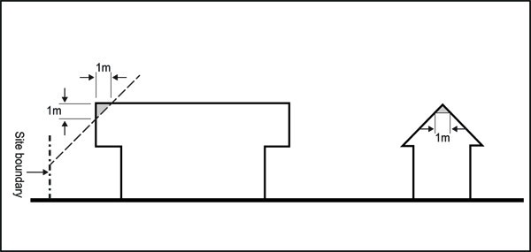

    - No more than two gable end or dormer projections are allowed for every 6m length of site boundary.

Common walls

    - Clause 3.2 above does not apply where there is an existing common wall between two buildings on adjacent sites or where a common wall is proposed.

Yards

Purpose: maintain the spacious and landscaped qualities of the streetscape and ensure dwellings are adequately set back from lakes, streams and coastal edges to maintain water quality and provide protection from natural hazards.

Table 1

Yard | Dimension
Front | 5m
Side | 1m
Rear | 1m
Riparian | 10m from the edge of permanent and intermittent  streams
Lake | 30m
Coastal protection yard | 10m, or as otherwise  specified in appendix 6.7

Building coverage

    - Maximum building coverage: 50 per cent.

Maximum impervious area

    - Maximum impervious area: 60 per cent.

Accessory buildings

    - Accessory buildings must not exceed 80m2 and 4m in height.

Outdoor living space

    - A dwelling at ground level must have an outdoor living space that is at least 40m2:
      - excluding any area with a dimension less than 1m

      - that is free of buildings, car parking and manoeuvring areas.

    - Where an entire dwelling is above ground level, the dwelling must:
      - have a balcony or roof terrace that is accessible from the principal living room and has a minimum area of 10m2 and a minimum depth of 2.4m, or

      - have access to a communal outdoor living space no less than 60m2.

Assessment ­ Restricted discretionary activities

4.1 Matters of discretion
The council will restrict its discretion to the matters below for the activities listed as restricted discretionary in the zone activity table.

  - Care centres, education facilities, healthcare facilities that are all greater than 250m2
    - intensity and scale

    - traffic and access

    - noise, lighting and hours of operation

    - Integration of mātauranga and tikanga.

  - Four or more dwellings on a site
    - intensity and scale

    - traffic and access

    - building design and external appearance

    - topography, site orientation and earthworks

    - design of landscaping

    - internal layout and on­site amenities for dwellings

    - integration of mātauranga and tikanga.

  - Urupā
    - effects on groundwater

    - integration of mātauranga and tikanga.

  - Organised sport and recreation
    - traffic and access

    - noise, lighting and hours of operation

    - integration of mātauranga and tikanga.

Assessment criteria
The council will consider the relevant assessment criteria below for the restricted discretionary activities listed above.

    - Care centres, education facilities, healthcare facilities that are all greater than 250m²
      - Intensity and scale
        - The intensity and scale of the activity, in particular the number of people involved and traffic

generated by the activity, size and location of buildings and associated parking should be compatible with the character and amenity of the surrounding neighbourhood.

ii.

For care centres, the site should be of an adequate size and road frontage to accommodate the activity. In particular, sufficient space will need to be provided for a safe pick­up and drop­ off area.

      - Noise, lighting and hours of operation
        - Noise and lighting from the activity should not adversely affect the amenity of surrounding residential properties. In determining this, consideration will be given to the location of any potentially noisy activities e.g. outdoor play areas associated with a care centre, and any proposed measures to mitigate noise including:
          - locating noisy activities away from neighbouring residential boundaries

          - screening or other design features

          - the proposed hours of operation.

      - Integration of mātauranga and tikanga
        - Development should integrate appropriate mātauranga and tikanga into the design of the built environment and open space. In determining this, consideration will be given to the expression of Māori values and the type of development proposed, including providing, for example:
          - communal facilities and spaces

          - range of housing sizes and layouts, where more than four dwellings are proposed

          - relationship between buildings and access ways e.g. marae atea, wharenui, wharekai and waharoa if present

          - materials and landscaping which reflect the natural features of the surrounding environment

          - awareness of local history and whakapapa through design.

    - Four or more dwellings on a site
      - Intensity and scale
        - Refer to the assessment criteria in 1(a) above.

      - Building design and external appearance

i.

ii.
Development should demonstrate how it responds to values identified in the Māori cultural landscape.

Development should not be required to have a similar design or layout to the surrounding neighbourhood character. Consideration will be given to the incorporation of buildings and structures associated with Māori cultural activities, as well as Māori design features which contribute positively to the public realm. Examples of how these buildings, structures and features could be used include:

- pou, waharoa, taiapa/pekerangi and other features to form focal points within the streetscene

- hard and soft landscaping features adjacent to street front boundaries to soften the impact of development

- visual breaks, decorative design features, cladding or other design features to create visual interest and avoid creating blank facades adjacent to streets, accessways, and public open spaces.

- boundary treatment that manages any potential adverse effects on adjoining residential

properties and reflects local landscape features or environments.

      - Topography, site orientation and earthworks

i.

ii.

iii.

iv.
The topography, size and proportions of the site should be suitable to accommodate the housing type proposed. In particular, additional infill or multi­unit development on steep land or narrow sites is discouraged unless sites are carefully designed to optimise on­site amenity values and complement the surrounding neighbourhood landform.

Building platforms, outdoor living spaces, car parking areas and driveways should be located and designed to respond to the natural landform and site orientation in an integrated manner.

Where possible buildings should facilitate a grounded connection to the site to encourage indoor outdoor flow and engagement with the whenua, awaawa, moana, mara kai and ngahere.

Earthworks should be be carefully considered to enhance the usefulness of the site and to encourage ease of indoor / outdoor flow. Where where retaining or earthworks are required it should be incorporated as a positive landscape or site feature by:

- integrating retaining as part of the building design

- stepping and landscaping earthworks or retaining over 1m in height to avoid dominance or overshadowing effects

- ensuring all earthworks or retaining visible to the public (including neighbours) is attractively designed and incorporates modulation, landscaping and quality materials to provide visual interest

- considering alternatives to retaining walls such as planted batters.

      - Design of landscaping

i.

ii.
The site layout should be designed to integrate and retain significant natural features including trees, streams and ecological areas.

Site landscaping should be located and designed provide a positive contribution to the surrounding streetscape and/or any adjacent public open space through incorporating expressions of Māori identity and values.

      - Internal layout and on­site amenities for dwellings

i.

ii.

iii.
Private outdoor living space should be sheltered from the prevailing wind and located to the north, west or east of the dwelling to maximise sunlight access.

Private outdoor living space should be located to take advantage of any views or outlook from or within the site. Private outdoor space at ground level should be landscaped to provide a good standard of amenity.

Any communal open spaces should be designed to:

- provide an attractive, functional and high quality outdoor environment

- be conveniently accessible to all residents

- maximise winter sunlight access.

iv.
Additionally, communal open space at ground or lower levels should be designed to be:

- overlooked by the principal living rooms, kitchen and/or balconies of dwellings to enhance safety

- located within the site to form a focus of the development.

v. Provide outdoor dining areas and mara kai (private or communal gardens) if appropriate.

vi.

vii.
The size of the communal outdoor living space should be adequate for the number of people to be accommodated within the development.

Appropriate management and maintenance systems should be provided for communal outdoor living space dependent on the scale of development and the extent of communal access to ensure it is available for all residents of the development.

      - Integration of mātauranga and tikanga
        - Refer to the assessment criteria in 1(c) above.

    - Urupā
      - Effects on groundwater
        - Development that potentially impacts on any underground water resources should demonstrate that it can:
          - maintain public health standards

          - ensure land stability of the property and adjoining land

          - safeguard the recreational, ecological values and water quality of natural water courses draining through and from the land

          - protect any underground water resources.

      - Integration of mātauranga and tikanga
        - Refer to the assessment criteria in 1(c) above.

    - Organised sport and recreation
      - Noise, lighting and hours of operation
        - Refer to the assessment criteria in 1(b) above.

      - integration of mātauranga and tikanga
        - Refer to the assessment criteria in 1(c) above.

Assessment ­ Development control infringements

5.1 Matters of discretion
In addition to the general matters set out in clause 2.3 of the general provisions, the council will restrict its discretion to the matters listed below for the relevant development control infringement:
  - Building height, height in relation to boundary, building coverage
    - effects of additional building scale on neighbouring sites, streets and public open spaces (sunlight access, dominance, visual amenity)

    - consistency with the planned future form and character of the area/zone.

  - Yards
    - effects on streetscape amenity and safety.

Assessment criteria
In addition to the general assessment criteria for development control infringements in the clause 2.3 of the general provisions, the council will consider the relevant criteria below for the development control infringement.

    - Height, height in relation to boundary, building coverage
      - Effects of additional building scale on neighbouring sites, streets and public open spaces (sunlight access, dominance, visual amenity)

i.

ii.
Infringing of the control should not result in the building dominating or unreasonably shading the outdoor living space or windows to habitable rooms of adjoining dwellings.

The building should be designed to avoid dominance, over­shadowing, or reduced access to sunlight of the adjoining dwellings and their outdoor living spaces. Methods to achieve this

include providing variations in building heights building setbacks, or breaks in building massing.

iii.

Consideration will be given to the requirement for educational buildings to have higher studs (typically 4m).

      - Consistency with the planned future form and character of the area/zone
        - The height, scale and form of dwellings within a papakāinga may not generally accord with the existing or future anticipated character of the surrounding neighbourhood.

    - Yards
      - Effects on streetscape amenity and safety
        - Development that infringes the yard control will need to demonstrate that the proposed setback is consistent with the typical depth of yard in the surrounding neighbourhood, particularly those of adjoining sites. This is particularly important where the development is in close proximity to an identified historic character or historic heritage area.

Special information requirements

  - Applications which include an on­site or communal waste­water and effluent disposal system must be accompanied by a funding and maintenance plan which demonstrates that the system will:
    - maintain public health standards

    - ensure land stability of the property and adjoining land

    - safeguard the recreational, ecological values and water quality of natural water courses draining through and from the land

    - protect any underground water resources.

