PART 3 ­ REGIONAL AND DISTRICT RULES»Chapter I: Zone rules»

1 Residential zones

Activity table

The following table specifies the activity status of activities in the residential zones.

Activity | Large Lot zone | Rural and Coastal Settlement zone | Single House zone | Mixed Housing Suburban zone | Mixed Housing Urban zone | Terrace Housing and Apartment Buildings zone
Residential
Camping  grounds | NC | D | NC | NC | NC | NC
Dwellings | P | P | P | P  up to 3 dwellings per site  RD  4 or more dwellings per site | P  up to 3 dwellings per site  RD  4 or more dwellings per site | P  One dwelling on a site  D  2 to 4 dwellings per site  RD  5 or more dwellings per site
Home  occupations | P | P | P | P | P | P
Retirement  villages | NC | NC | D | D | D | D
Supported residential care and boarding houses up to 200m² GFA per  site | NC | P | P | P | P | P
Supported residential care and boarding houses not provided for  above | NC | NC | D | D | D | D
Visitor accommodation up to 200m²  GFA per site | NC | RD | RD | RD | RD | RD

Visitor accommodation not provided for  above | NC | NC | D | D | D | D
Commerce
Dairies up to 100m2 GFA per  site | NC | D | D | RD | RD | RD
Restaurants and cafes up to 100m² GFA per  site | NC | RD | NC | NC | D | RD
Service stations on arterial  roads | NC | D | D | D | D | D
Community
Care centres up to 200m² GFA  per site | P | P | P | P | P | P
Care centres between 200m²  ­ 400m² GFA  per site | NC | NC | RD | RD | RD | RD
Care centres not provided for  above | NC | NC | D | D | D | D
Community  facilities | D | D | D | D | D | D
Education  facilities | NC | D | D | D | D | D
Emergency services on  arterial road | NC | D | D | D | D | D
Healthcare facilities up to 200m² GFA per  site | NC | RD | RD | RD | RD | RD
Healthcare facilities and associated buildings not provided for  above | NC | NC | NC | D | D | D
Rural
Grazing of livestock on sites greater than 2,000m2  net site area | P | P | NC | NC | NC | NC
Mana Whenua

Marae complex | D | D | D | D | D | D
Development
Alterations and additions to a single dwelling  on a site | P | P | P | P | P | P
Alterations and additions to two or more dwellings on a  site | P | P | P | P | P | RD
Demolition of  buildings | P | P | P | P | P | P
The conversion of a dwelling into a maximum of two dwellings complying with the land use controls in clause 3.3  below | RD | RD | P | P | P | D
Buildings accessory to the permitted and restricted discretionary non­residential activities listed  above | RD | RD | RD | RD | RD | RD
Buildings accessory to all other activities listed in this table have the same activity status as the activity itself.

Notification

  - Buildings that do not comply with the following development controls will be subject to the normal tests for notification under the relevant sections of the RMA:
    - building height

    - height in relation to boundary

    - alternative height in relation to boundary in the Mixed Housing Suburban and Mixed Housing Urban zones

    - side and rear yards in the Large Lot zone

    - maximum building length

    - building setbacks within the Terrace Housing and Apartment Buildings zone

    - building setbacks in the Terrace Housing and Apartment Buildings zone where it adjoins lower density zones

    - building coverage

    - landscaping

    - outlook.

Land use controls

  - Maximum density

    - The number of dwellings on a site must not exceed the limits specified below:

Table 1:

Zone | Dwellings
Large Lot | One dwelling per site
Rural and coastal  settlements | One dwelling per 4000m² net site area
Single House | One dwelling per site
Mixed Housing Suburban | One dwelling per 400m² net site area , or  One dwelling per 300m² net site area where the requirements of clause 3.1.2 below are met, or  One dwelling per 200m2 net site area where the requirements of clause 3.1.5 below are met
Mixed Housing Urban | One dwelling per 300m² net site area, or  One dwelling per 250m² net site area where the requirements of clause 3.1.3 below are met, or  No density limits apply where four or more dwellings are proposed and the requirements of clause 3.1.6 below are met

    - Within the Mixed Housing Suburban zone a density of one dwelling per 300m² applies where:
      - the site has a frontage of at least 7.5m in width for each dwelling and is the same width for the length required to accommodate the proposed density

      - each proposed dwelling is setback at least 4m and no more than 5m from the frontage of the site.

    - Within the Mixed Housing Urban zone a density of one dwelling per 250m² applies to proposed front sites where:
      - each proposed site has a frontage of at least 7.5m in width for each dwelling and is the same width for the length required to accommodate the proposed density

      - each proposed dwelling is setback at least 2.5m and no more than 5m from the frontage of the site.

    - Where three or four dwellings are proposed on a front site within the Mixed Housing Suburban or Mixed Housing Urban zone the site must be at least 15m wide:
      - at the frontage

      - for at least 80 per cent of the length of its side boundaries.

    - Within the Mixed Housing Suburban zone a density of one dwelling per 200m2 applies where four or more dwellings are proposed and the site:
      - has a minimum net site area of 1200m2

      - is at least 20m wide:

i.

ii.
at the frontage of the site

for at least 80 per cent of the length of its side boundaries.

    - Within the Mixed Housing Urban zone no density limit applies where four or more dwellings are proposed and the site:
      - has a minimum net site area of 1200m²

      - is at least 20m wide:

i.

ii.
at the frontage of the site

for at least 80 per cent of the length of its side boundaries.

    - To avoid doubt, within the Mixed Housing Suburban and Mixed Housing Urban zones the most restrictive density applies to existing and proposed rear sites.

    - Development that does not comply with clauses 1­6 above is a discretionary activity.

    - Clause 1 above does not apply where a dwelling is converted into two dwellings as a permitted activity.

Home occupations

1.

2.

3.

4.

5.

6.

7.

8.

9.

10.

11.
At least one person engaged in the home occupation must use the dwelling on the site as their principal place of residence.

No more than two people who do not use the dwelling as their principal place of residence may work in the home occupation.

No more than four people in total may work in the home occupation.

The sale of goods or services from the home occupation that requires customers to come to the site and the delivery of goods to and from the site may not occur before 7am or after 7pm.

Car trips to and from the home occupation activity must not exceed 20 per day. Heavy vehicle trips must not exceed two per week.
No more than one commercial vehicle associated with the home occupation may be on site at any one time.

Storage for rubbish and recycling associated with the home occupation must be provided on site and screened from public view.

Materials or goods manufactured, serviced or repaired in the home occupation must be stored and worked on within a building on the same site.

With the exception of goods ordered and distributed electronically or by mail/courier, goods sold from the home occupation must be produced on site.

A home occupation that does not comply with clauses 1­10 above is a non­complying activity.

The conversion of a dwelling into two dwellings

    - Where a dwelling is proposed to be converted into two dwellings each dwelling must have a net internal floor area of at least 40m².

    - The second dwelling must:
      - have direct access to an outdoor living space. This space may be exclusive to the dwelling or shared with the primary dwelling

      - have a common wall with the primary dwelling of no less than 3m in length or share a ceiling

and/or floor with the primary dwelling

      - comply with the daylight and minimum dimension of principal living rooms and principal bedrooms development controls.

    - The primary dwelling must exist on the date of notification of this Unitary Plan.

    - Parking is not required for the second dwelling.

Development Controls ­ Large Lot zone

4.1 Development control infringements

  - Buildings that infringe three or more of the following development controls are a discretionary activity:
    - building height

    - yards

    - maximum impervious area

    - building coverage.

Building height

Purpose: manage the height of buildings to maintain the low­rise residential character of the zone (one to two storeys).

    - Buildings must not exceed 8m in height.

Yards

Purpose: maintain the spacious character of the zone and ensure dwellings are adequately set back from lakes, streams and the coastal edge to maintain water quality and provide protection from natural hazards.

Table 2:

Yard | Minimum depth
Front | 10m
Side | 6m
Rear | 6m
Riparian | 10m from the edge of permanent and  intermittent streams
Lake | 30m
Coastal protection yard | 25m, or as otherwise specified in  appendix 6.7

Maximum impervious area

Purpose: manage the amount of stormwater runoff generated by a development.

    - Maximum impervious area: 10 per cent.

    - Maximum impervious area within a riparian yard: 10 per cent.

Building coverage

Purpose: maintain the spacious, landscape character of the zone.

    - Maximum building coverage: 10 per cent or 400m², whichever is the lesser.

Development Controls ­ Rural and Coastal Settlement zone

5.1 Development control infringements

  - Buildings that infringe three or more of the following development controls are a discretionary activity:
    - building height

    - height in relation to boundary

    - yards

    - maximum impervious area

    - building coverage.

Building height

Purpose: manage the height of buildings to maintain the rural and coastal residential character of the zone (one to two storeys).

    - Buildings must not exceed 8m in height.

Height in relation to boundary

Purpose: manage the height and bulk of buildings at boundaries to limit over­shadowing of neighbouring sites and provide space between buildings.

    - Buildings must not exceed a height of 2.5m measured vertically above ground level at side and rear boundaries. Thereafter, buildings must be setback 1m for every additional metre in height (45 degrees).

Figure 1: Height in relation to boundary
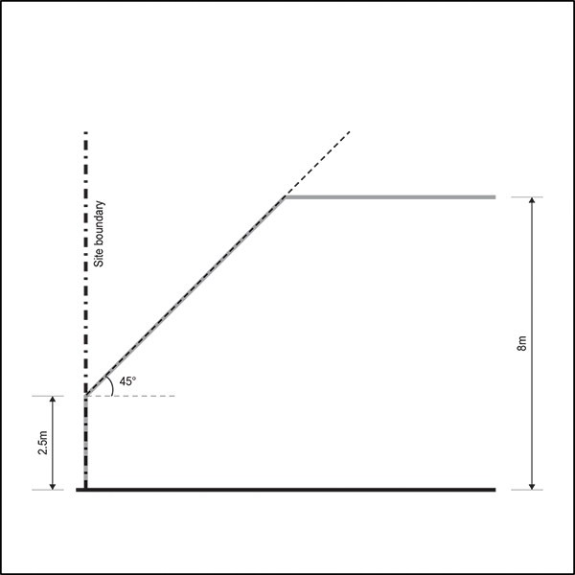

    - This control does not apply to a boundary adjoining:
      - industrial zones

      - centres and mixed use zones

      - the General Business zone

      - the Business Park zone

      - sites within the public open space zones exceeding 2000m2.

    - Where the boundary forms part of a legal right of way, pedestrian access way, or access site, the control applies from the farthest boundary of that legal right of way, pedestrian access way or access lot.

    - A gable end or dormer may project beyond the recession plane where it is:
      - no greater than 1m in height and width measured parallel to the nearest adjacent boundary

      - no greater than 1m in depth measured horizontally at 90 degrees to the nearest adjacent boundary.

Figure 2: Exemptions for a gable end or dormer
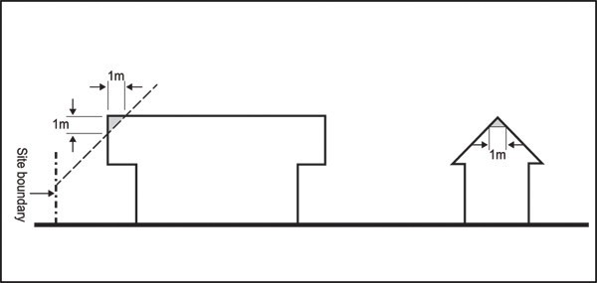

    - No more than two gable end or dormer projections are allowed for every 6m length of site boundary.

Yards

Purpose: maintain the spacious character of the zone and ensure dwellings are adequately set back from lakes, streams and the coastal edge to maintain water quality and provide protection from natural hazards.

Table 3:

Yard | Minimum depth
Front | 5m
Side | 1m
Rear | 1m
Riparian | 10m from the edge of all other permanent and  intermittent streams
Lake | 30m
Coastal protection yard | 20m, or as otherwise specified in appendix 6.7

Maximum impervious area

Purpose: manage the amount of stormwater runoff generated by a development.

    - Maximum impervious area: 10 per cent.

    - Maximum impervious area within a riparian yard: 10 per cent.

Building coverage

Purpose: maintain the rural and coastal residential character of the zone.

    - Maximum building coverage: 20 per cent or 200m², whichever is the lesser.

Outdoor living space

Purpose: provide dwellings with outdoor living space that is of a usable size and dimension and is consistent with the spacious qualities of the zone and is accessible from the principal living room.

    - A dwelling must have an outdoor living space measuring at least 80m2 that:
      - is free of building, parking, servicing and manoeuvring areas

      - excludes any area with a dimension 1m or less.

    - Where a dwelling has the principal living room at ground level, part of the required outdoor living space must be able to contain a delineated 20m2 area that:
      - has no dimension less than 4m

      - is directly accessible from a principal living room

      - has a gradient not exceeding 1 in 20.

    - Where a dwelling has the principal living room above ground level, part of the required outdoor living space must include a balcony or roof terrace that is directly accessible from the principal living room that:
      - has a minimum area of 8m2

      - has a minimum depth of 2.4m.

Garages

Purpose: ensure garages are not a dominant feature of the streetscape.

    - A garage door facing a street must be no greater than 40 per cent of the width of the front façade of the dwelling to which the garage relates.

    - Garage doors must not project forward of the front façade of a dwelling.

Development Controls ­ Single House zone

6.1 Development control infringements

  - Buildings that infringe three or more of the following development controls are a discretionary activity:
    - building height

    - height in relation to boundary

    - yards

    - maximum impervious area

    - building coverage

    - landscaping.

Building height

Purpose: manage the height of buildings to maintain the low density suburban residential character of the zone (one to two storeys).

    - Buildings must not exceed 8m in height.

Height in relation to boundary

Purpose: manage the height and bulk of buildings at boundaries to limit over­shadowing of neighbouring sites and provide space between buildings.

    - Buildings must not exceed a height of 2.5m measured vertically above ground level at side and rear boundaries. Thereafter, buildings must be setback 1m for every additional metre in height (45 degrees).

Figure 3: Height in relation to boundary

    - This control does not apply to a boundary adjoining:
      - industrial zones

      - centres and mixed use zones

      - General Business zone

      - Business Park zone

      - sites within the public open space zones exceeding 2000m².

    - Where the boundary forms part of a legal right of way, pedestrian access way, or access site, the control applies from the farthest boundary of that legal right of way, pedestrian access way or access lot.

    - A gable end or dormer may project beyond the recession plane where it is:
      - no greater than 1m in height and width measured parallel to the nearest adjacent boundary

      - no greater than 1m in depth measured horizontally at 90 degrees to the nearest adjacent boundary.

Figure 4: Exceptions for gable ends and dormers

    - No more than two gable end or dormer projections are allowed for every 6m length of site boundary.

Yards

Purpose: maintain the spacious and landscaped qualities of the streetscape and ensure dwellings are adequately set back from lakes, streams and the coastal edge to maintain water quality and provide protection from natural hazards.

Table 4:

Yard | Minimum depth
Front | 5m
Side | 1m
Rear | 1m
Riparian | 10m from the edge of permanent and intermittent  streams

Lake | 30m
Coastal protection yard | 10m, or as otherwise  specified in appendix 6.7

Common walls

Purpose: enable attached dwellings, where that pattern of development exists or where neighbours agree.

    - The height in relation to boundary and yards development controls do not apply where there is an existing common wall between two buildings on adjacent sites or where a common wall is proposed.

Maximum impervious area

Purpose: manage the amount of stormwater runoff generated by a development.

    - Maximum impervious area: 60 per cent.

    - Maximum impervious area within a riparian yard: 10 per cent.

Building coverage

Purpose: maintain the low density suburban residential character of the zone.

    - Maximum building coverage: 35 per cent.

Landscaping

Purpose:
- provide for on­site amenity and an attractive streetscape character

- improve stormwater absorption on­site.

    - At least 40 per cent of a site must comprise landscaped area of which a minimum of 10 per cent must be planted with shrubs, including at least one tree that is pB95 or larger at the time of planting.

    - At least 50 per cent of the front yard must comprise landscaped area.

Outdoor living space

Purpose: provide dwellings with outdoor living space that is of a usable size and dimension and is consistent with the spacious qualities of the zone and is accessible from the principal living room.

    - A dwelling must have an outdoor living space measuring at least 80m² that:
      - is free of buildings, parking spaces, servicing and manoeuvring areas

      - excludes any area with a dimension less than 1m.

    - Where a dwelling has the principal living room at ground level, part of the required outdoor living space must be able to contain a delineated area measuring at least 20m² that:
      - has no dimension less than 4m

      - is directly accessible from the principal living room

      - has a gradient not exceeding 1 in 20.

    - Where a dwelling has the principal living room above ground level, part of the required outdoor living space must include a balcony or roof terrace that:
      - is directly accessible from the principal living room

      - has a minimum area of 8m²

      - has a minimum depth of 2.4m.

Fences

Purpose: enhance passive surveillance of the street and maintain the open character of front yards.

    - Fences in a front yard must not exceed a height of 1.6m.

Figure 5: Fences within the front yard
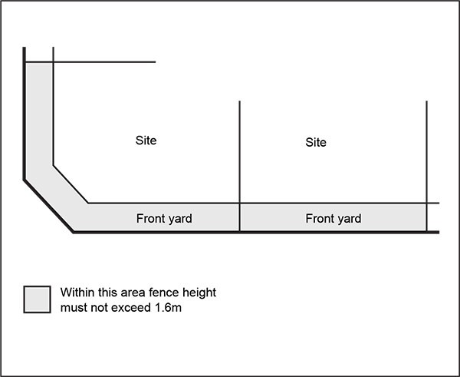

  - Garages

Purpose: ensure garages are not a dominant feature of the streetscape.

    - A garage door facing a street must be no greater than 40 per cent of the width of the front facade of the dwelling to which the garage relates.

    - Garage doors must not project forward of the front façade of a dwelling.

Universal access

Purpose: medium to large­scale residential development provides equal physical access and use for people of all ages and abilities.

    - Where a new building or development contains 10 or more dwellings, 20 per cent of those dwellings must comply with the following:
      - doorways must have a minimum clear opening width of 810mm

      - stairwells must have a minimum width of 900mm

      - corridors must have a minimum width of 1050mm

      - the principal means of access from the frontage, or the parking space serving the dwelling, to the principal entrance of the dwelling must have:

i.

ii. iii.
a minimum width of 1.2m a maximum slope of 1:20
a maximum cross fall of 1:50.

    - Where the calculation of the dwellings required to be universally accessible results in a fractional dwelling, any fraction that is less than one­half will be disregarded and any fraction of one­half or more will be counted as one dwelling.

    - All dwellings required to be universally accessible must provide at least one parking space for people with a disability. The dimensions and accessible route requirements for such parking spaces are detailed in Section 5.5 of the New Zealand Building Code D1/AS1 New Zealand Standard for Design for Access and Mobility – Buildings and Associated Facilities (NZS 4121­2001).

Development Controls ­ Mixed Housing Suburban zone

7.1 Development control infringements

  - Buildings that infringe three or more of the following development controls are a discretionary activity:
    - building height

    - height in relation to boundary

    - yards

    - maximum impervious area

    - building coverage

    - landscaping

    - outlook.

Building height

Purpose: manage the height of buildings to generally maintain a low­rise suburban residential character of the zone (one to two storeys).

    - Buildings must not exceed 8m in height.

Height in relation to boundary

Purpose: manage the bulk and scale of buildings at boundaries to limit over­shadowing to neighbouring sites and provide space between buildings.

    - Buildings must not exceed a height of 2.5m measured vertically above ground level at side and rear boundaries. Thereafter, buildings must be set back 1m for every additional metre in height (45 degrees).

Figure 6: Height in relation to boundary

    - This control does not apply to a boundary adjoining:
      - industrial zones

      - centres and mixed use zones

      - General Business zone

      - Business Park zone

      - sites within the public open space zones exceeding 2000m².

    - Where the boundary forms part of a legal right of way, pedestrian access way, or access site, the control applies from the farthest boundary of that legal right of way, pedestrian access way or access lot.

    - A gable end or dormer may project beyond the recession plane where it is:
      - no greater than 1m in height and width measured parallel to the nearest adjacent boundary

      - no greater than 1m in depth measured horizontally at 90 degrees to the nearest adjacent boundary.

Figure 7: Exceptions for gable ends and dormers

    - No more than two gable end or dormer projections are allowed for every 6m length of site boundary.

Alternative height in relation to boundary

Purpose: enable the efficient use of the site by providing design flexibility at the first floor of a dwelling.

    - This development control is an alternative to the permitted height in relation to boundary control in clause 7.3 above which may be used for development that is a density of one dwelling per 300m² or greater and complies with the land use controls in clause 3.1.2 above.

    - It will be processed as a restricted discretionary activity if it complies with clause 3 below.

    - Buildings must not exceed a height of 3.6m measured vertically above ground level at side and rear boundaries. Thereafter, buildings must be set back one metre and then 0.3m for every additional metre in height (73.3 degrees) up to 6.9m and then one metre for every additional metre in height (45 degrees).

    - The exceptions to the permitted height in relation to boundary control listed in clause 7.3 above apply.

    - A building that does not comply with this control is a discretionary activity.

Figure 8: Alternative height in relation to boundary
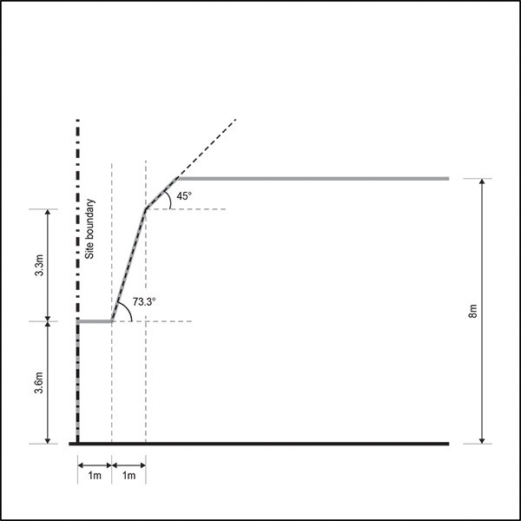

  - Yards

Purpose: Purpose: maintain an open streetscape character and ensure dwellings are adequately set back from lakes, streams and the coastal edge to maintain water quality and provide protection from natural hazards.

Table 5

Yard | Minimum depth
Front | 4m
Side | 1m
Rear | 1m
Riparian | 10m from the edge of all other  permanent and intermittent streams
Lake | 30m
Coastal  protection yard | 10m, or as otherwise specified in  appendix 6.7

Common walls

Purpose: enable attached dwellings, where that pattern of development exists or where neighbours agree.

    - The height in relation to boundary and yards development controls do not apply where there is an existing common wall between two buildings on adjacent sites or where a common wall is proposed.

Maximum impervious area

Purpose: manage the amount of stormwater runoff generated by a development.

    - Maximum impervious area: 60 per cent.

    - Maximum impervious area within a riparian yard: 10 per cent.

Building coverage

Purpose: maintain the suburban residential character of the zone.

    - Maximum building coverage for proposed sites with a density less than or equal to one dwelling per 400m²: 40 per cent.

    - Maximum building coverage for proposed sites with a density greater than one dwelling per 400m² that comply with the requirements of clause 3.1.2 above: 50 per cent.

Landscaping

Purpose:
- provide for on­site amenity and an attractive streetscape character

- improve stormwater absorption on­site.

    - For proposed sites with a density less than or equal to one dwelling per 400m² or more at least 40 per cent must comprise landscaped area.

    - For proposed sites with a density greater than one dwelling per 400m² that comply with the requirements of clause 3.1.2 above, at least 30 per cent must comprise landscaped area.

    - For clauses 1 and 2 above, the following must be met:
      - at least 10 per cent of the required landscaped area must be planted with shrubs including at least one tree that is pB95 or larger at the time of planting

      - at least 50 per cent of the front yard must comprise landscaped area.

Outlook space

Purpose:
- ensure a reasonable standard of visual and acoustic privacy between different dwellings, including their outdoor living space, on the same or adjacent sites

- encourage the placement of habitable room windows to the site frontage or to the rear of the site in preference to side boundaries, to maximise both passive surveillance of the street and privacy, and to avoid overlooking of neighbouring sites.

    - An outlook space must be provided from the face of a building containing windows or balconies to a habitable room. Where the room has two or more external faces with windows or balconies the outlook space must be provided from, in order of priority, the face with the largest balcony or largest area of glazing.

    - The minimum dimensions for a required outlook space are as follows:
      - principal living room: 6m in depth and 4m in width

      - principal bedroom: 3m in depth and 3m in width

      - all other habitable rooms: 1m in depth and 1m in width.

    - The depth of the outlook space is measured at right angles to and horizontal from the window or balcony to which it applies. Where the outlook space applies to a balcony, it must be measured from the outside edge of the balcony.

    - The width of the outlook space is measured from the centre point of the largest window on the building face to which it applies or from the centre point of the largest balcony.

    - The height of the outlook space is the same as the floor height, measured from floor to ceiling, of the building face to which the control applies.

    - Outlook spaces may be within the site, over a public street, or other public open space.

    - Outlook spaces required from different rooms within the same dwelling may overlap.

    - Outlook spaces must:
      - be clear and unobstructed by buildings

      - not extend over adjacent sites or overlap with outlook spaces required by another dwelling.

    - An outlook space at ground floor level from a principal living room may be reduced to 4m deep if privacy to adjacent dwellings is provided by fencing at least 1.6m in height.

Figure 9: Required outlook space
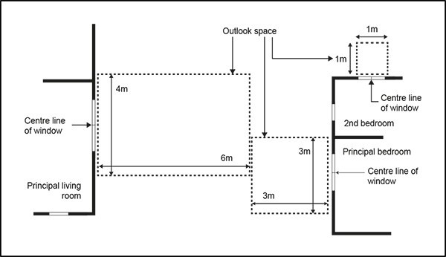

  - Separation between buildings within a site

Purpose: require reasonable separation between buildings on the same site to manage dominance, provide access to daylight and natural ventilation.

    - Buildings must be separated where the habitable room of a dwelling has windows or balconies that face out to the wall of another building on the same site (the facing wall). Where the room has two or more

external faces with windows or balconies the building separation must be applied from, in order of priority, the face with the largest balcony or the largest area of area of glazing.

    - The separation space required must be free of buildings for the depth, width and height set out below.

    - The depth of the separation space is measured at right angles to, and horizontal from, the window or balcony to which it applies across to the facing wall, excluding eaves or guttering. Where the building separation applies to a balcony, it is measured from the outside edge of the balcony.

    - For the principal living room, the depth of the separation space required is equal to the height of the facing wall above the floor level of the habitable room, or 15m, whichever is the lesser.

    - For the principal bedroom, the depth of the separation space required is 6m.

    - For other habitable rooms , the depth of the separation space required is 3m.

    - The width of the separation space is 50 per cent of its depth and is measured from the centre point of the largest window on the building face to which it applies or from the centre point of the largest balcony.

    - The height of the separation space is from the height of the floor or balcony upwards, clear to the sky except that eaves or gutters may protrude into it.

    - Where the adjacent building is not perpendicular to the distance being measured, the minimum separation depth required must be measured as an average around the centre line of the window/balcony.

Outdoor living space

Purpose: provide dwellings with outdoor living space that is of a useable size and dimension for the type of dwelling and accessible from the principal living room.

    - A dwelling at ground level must have an outdoor living space measuring at least 40m² that:
      - is free of buildings, parking spaces, servicing and manoeuvring areas

      - excludes any area with a dimension less than 1m.

    - Where a dwelling has the principal living room at ground level, part of the required outdoor living space must be able to contain a delineated area measuring at least 20m² that:
      - has no dimension less than 4m

      - is directly accessible from the principal living room

      - has a gradient not exceeding 1 in 20.

    - Where a dwelling has the principal living room above ground level, part of the required outdoor living space must include a balcony or roof terrace that:
      - is directly accessible from the principal living room

      - has a minimum area of 8m²

      - has a minimum depth of 2.4m.

    - Where an entire dwelling is above ground level, it must have an outdoor living space in the form of a balcony or roof terrace that is at least 10m² and has a minimum depth of 2.4m.

Dwellings fronting the street

Purpose: ensure dwellings are orientated to provide for passive surveillance of the street and contribute to streetscape amenity.

    - The front facade of a dwelling or dwellings on a front site must contain:
      - glazing that is cumulatively at least 30 per cent of the area of the front facade (excluding the garage door)

      - a main entrance door that is visible from the street.

Maximum building length

Purpose: manage the length of buildings along side and/or rear boundaries and the separation between buildings on the same site to visually integrate them into the surrounding neighbourhood.

    - The maximum length of a building along a side or rear boundary is 20m, after which there must be a separation of at least 5m along the same boundary to any other building on the same site.

Fences

Purpose: enhance passive surveillance of the street and maintain the open character of front yards.

    - Fences in a front yard must not exceed 1.2m in height.

Figure 10: Fences within the front yard
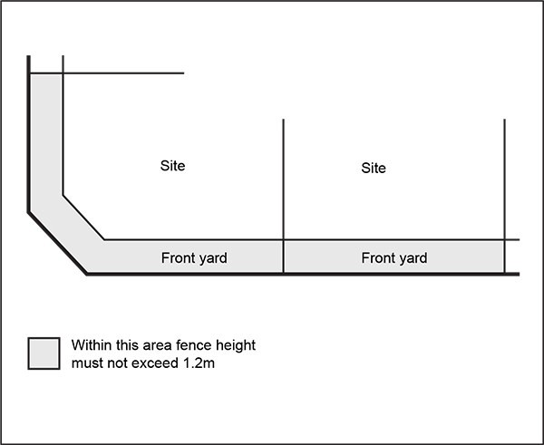

  - Garages

Purpose:
- reduce the dominance of garages as viewed from the street

- avoid parked cars over­hanging the footpath.

    - A garage door facing a street must be no greater than 40 per cent of the width of the front facade of the dwelling to which the garage relates.

    - Garage doors must not project forward of the front façade of a dwelling.

    - The garage door must be set back at least 5m from the site’s frontage.

Minimum dwelling size

Purpose: dwellings are of a sufficient size to provide for the day­to­day needs of residents.

    - Dwellings must have a minimum net internal floor area as follows:.
      - 40m2 for studio dwellings

      - 45m2 for one bedroom dwellings.

Minimum dimension of principal living rooms and principal bedrooms

Purpose: principal living rooms and bedrooms are of a size sufficient to accommodate standard size furniture and circulation space.

    - The principal living room within a dwelling must have no dimension less than 3m, measured perpendicular from the internal walls of the room.

    - The principal bedroom within a dwelling must be at least 3m in width and 3.5m in length measured perpendicular from the internal walls of the room. Cupboards and other storage space may be included in the minimum dimension.

Servicing and waste

Purpose: dwellings within medium to large­scale residential development have sufficient space within the building or site to accommodate the storage of waste.

    - A building or development containing 10 or more dwellings must provide a communal storage area for waste. The size of the communal storage area must be an aggregate of the minimum areas specified for the dwelling types below:
      - studio and one bedroom – 0.3m²

      - two bedrooms – 0.5m²

      - three bedrooms – 0.7m²

      - four or more bedrooms – 1m².

    - An additional 30 per cent in area of the total floor area area required above must be provided within the communal storage area for manoeuvring or sorting within the waste storage area.

Water and wastewater

Purpose: ensure development can be serviced by connections to the water supply and wastewater networks.

    - At the time of application for building consent, the applicant must demonstrate to the satisfaction of the council that there is an available connection to the water supply and wastewater networks.

Storage

Purpose: ensure dwellings have sufficient space for the storage of everyday household items and bulky items, such as bicycles.

    - A building or development containing 5 or more dwellings must provide covered storage space for each dwelling with internal measurements of at least 4m3, excluding storage within the kitchen and bedroom wardrobes. The storage may be within the dwelling or external to it, within the site.

    - The required storage space for each dwelling must include a single covered storage space within internal dimensions of at least 2m3.

Universal access

Purpose: medium to large­scale residential development provides equal physical access and use for people of all ages and abilities.

    - Where a new building or development contains 10 or more dwellings, 20 per cent of those dwellings must comply with the following:
      - doorways must have a minimum clear opening width of 810mm

      - stairwells must have a minimum width of 900mm

      - corridors must have a minimum width of 1050mm

      - the principal means of access from the frontage, or the parking space serving the dwelling, to the principal entrance of the dwelling must have:

i.

ii. iii.
a minimum width of 1.2m a maximum slope of 1:20
a maximum cross fall of 1:50.

    - Where the calculation of the dwellings required to be universally accessible results in a fractional dwelling, any fraction that is less than one­half will be disregarded and any fraction of one­half or more will be counted as one dwelling.

    - All dwellings required to be universally accessible must provide at least one parking space for people with a disability. The dimensions and accessible route requirements for such parking spaces are detailed in Section 5.5 of the New Zealand Building Code D1/AS1 New Zealand Standard for Design for Access and Mobility – Buildings and Associated Facilities (NZS 4121­2001).

Development Controls ­ Mixed Housing Urban zone

8.1 Development control infringements

  - Buildings that infringe three or more of the following development controls are a discretionary activity:
    - building height

    - height in relation to boundary

    - yards

    - maximum impervious area

    - building coverage

    - landscaping

    - outlook.

Building height

Purpose: manage the height of buildings to be consistent with an urban residential character of up to three storeys.

    - Buildings must not exceed 10m in height, except that 50 per cent of a building's roof, measured

vertically from the junction between wall and roof, may exceed this height by 1m, where the entire roof slopes 15 degrees or more.

Figure 11: Building height in the Mixed Housing Urban zone
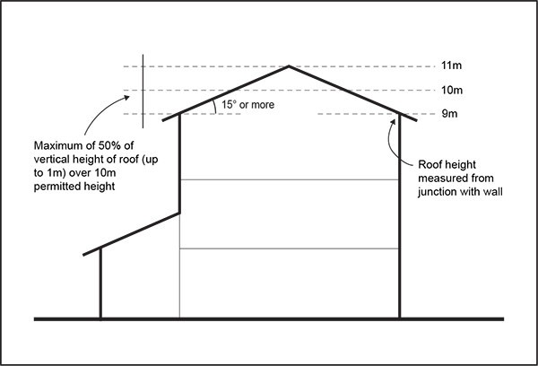

  - Height in relation to boundary

Purpose: manage the bulk and scale of buildings at boundaries to limit over­shadowing to neighbouring sites and provide space between buildings.

    - Buildings must not exceed a height of 3m measured vertically above ground level at side and rear boundaries. Thereafter, buildings must be set back 1m for every additional metre in height (45 degrees).

Figure 12: Height in relation to boundary
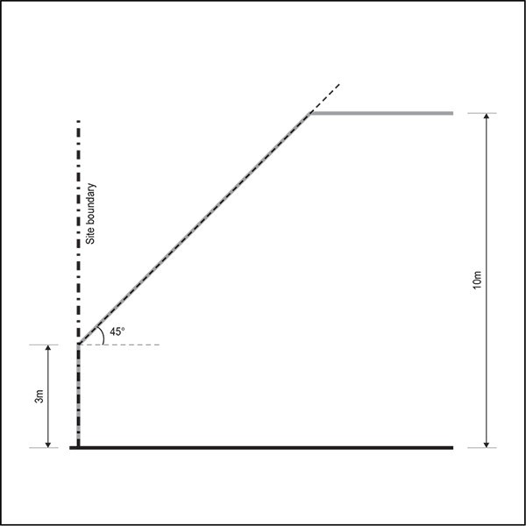

    - This control does not apply to a boundary adjoining:
      - industrial zones

      - centres and mixed use zones

      - General Business zone

      - Business Park zone

      - sites within the public open space zones exceeding 2000m².

    - Where the boundary forms part of a legal right of way, pedestrian access way, or access site, the control applies from the farthest boundary of that legal right of way, pedestrian access way or access site.

    - A gable end or dormer may project beyond the recession plane where it is:
      - no greater than 1m in height and width measured parallel to the nearest adjacent boundary

      - no greater than 1m in depth measured horizontally at 90 degrees to the nearest adjacent boundary.

Figure 13: Exceptions for gable ends and dormers

    - No more than two gable end or dormer projections are allowed for every 6m length of site boundary.

Alternative height in relation to boundary

Purpose: enable the efficient use of the site by providing design flexibility at the upper floors of a dwelling.

    - This development control is an alternative to the permitted height in relation to boundary control in clause 8.3 above which may be used for development that is a density of one dwelling per 250m² or greater and complies with the land use controls in clause 3.1.3 above.

    - It will be processed as a restricted discretionary activity if it complies with clause 3 below.

    - Buildings must not exceed a height of 3.6m measured vertically above ground level at side and rear boundaries. Thereafter, buildings must be set back one metre, and then 0.3m for every additional metre in height (73.3 degrees) up to 6.9m, and then one metre for every additional metre in height (45 degrees).

    - The exceptions to the permitted height in relation to boundary control listed in clause 8.3 above apply.

    - A building that does not comply with this control is a discretionary activity.

Figure 14: Alternative height in relation to boundary
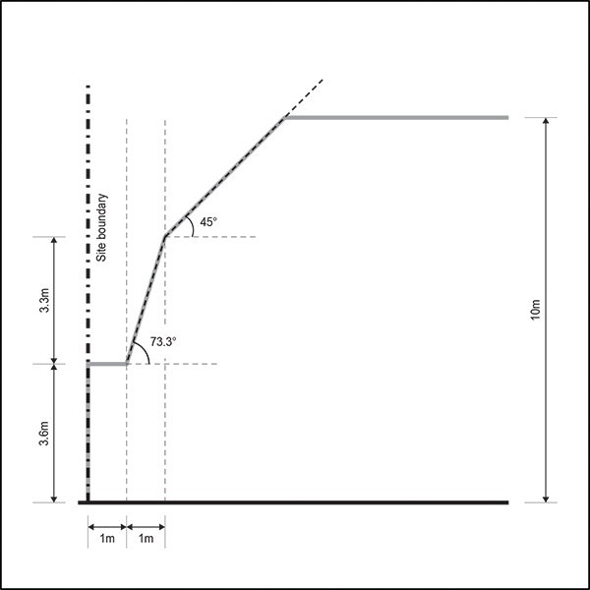

  - Common walls

Purpose: enable attached dwellings, where that pattern of development exists or where neighbours agree.

    - The height in relation to boundary and yards development controls do not apply where there is an existing common wall between two buildings on adjacent sites or where a common wall is proposed.

Yards

Purpose: create a transition from the front facade of the dwelling to the street that contributes to the quality of the streetscape and ensures dwellings are adequately set back from lakes, streams and the coastal edge to maintain water quality and provide protection from natural hazards.

Table 6:

Yard | Minimum depth
Front | 2.5m
Side | 1m
Rear | 1m
Riparian | 10m from the edge of all other  permanent and intermittent streams
Lake | 30m
Coastal  protection yard | 10m, or as otherwise specified in  appendix 6.7

Maximum impervious area

Purpose: manage the amount of stormwater runoff generated by a development.

    - Maximum impervious area for proposed sites with a density less than or equal to one dwelling per 300m²: 60 per cent.

    - Maximum impervious area for proposed sites with a density greater than one dwelling per 300m² that comply with the requirements of clause 3.2.2 above: 70 per cent.

Building coverage

Purpose: manage the density of buildings on the site consistent with the urban residential character of the zone.

    - Maximum building coverage for proposed sites with a density less than or equal to one dwelling per 300m²: 40 per cent.

    - Maximum building coverage for proposed sites with a density greater than one dwelling per 300m² that comply with the requirements of clause 3.1.3 above: 50 per cent.

Landscaping

Purpose:
- provide for on­site amenity and an attractive streetscape character

- improve stormwater absorption on­site.

    - For proposed sites with a density less than or equal to one dwelling per 300m² at least 40 per cent must comprise landscaped area.

    - For proposed sites with a density greater than one dwelling per 300m² that comply with the requirements of clause 3.1.3 above, at least 30 per cent must comprise landscaped area.

    - For clauses 1 and 2 above, the following must be met:
      - At least 10 per cent of the required landscaped area must be planted with shrubs including at least one tree that is pB95 or larger at the time of planting.

      - At least 50 per cent of the front yard must comprise landscaped area.

Outlook space

Purpose:
- Ensure a reasonable standard of visual and acoustic privacy between different dwellings, including their outdoor living space, on the same or adjacent sites

- Encourage the placement of habitable room windows to the site frontage or to the rear of the site in preference to side boundaries, to maximise both passive surveillance of the street and privacy, and to avoid overlooking of neighbouring sites.

    - An outlook space must be provided from the face of a building containing windows or balconies to a habitable room. Where the room has two or more external faces with windows or balconies the outlook space must be provided from, in order of priority, the face with the largest balcony or largest area of glazing.

    - The minimum dimensions for a required outlook space are as follows:
      - principal living room: 6m in depth and 4m in width

      - principal bedroom: 3m in depth and 3m in width

      - all other habitable rooms: 1m in depth and 1m in width.

    - The depth of the outlook space is measured at right angles to and horizontal from the window or balcony to which it applies. Where the outlook space applies to a balcony, it must be measured from the outside edge of the balcony.

    - The width of the outlook space is measured from the centre point of the largest window on the building face to which it applies or from the centre point of the largest balcony.

    - The height of the outlook space is the same as the floor height, measured from floor to ceiling, of the building face to which the control applies.

    - Outlook spaces may be within the site, over a public street, or other public open space.

    - Outlook spaces required from different rooms within the same dwelling may overlap.

    - Outlook spaces must:
      - be clear and unobstructed by buildings

      - not extend over adjacent sites or overlap with outlook spaces required by another dwelling.

    - An outlook space at ground floor level from a principal living room may be reduced to 4m deep if privacy to adjacent dwellings is provided by fencing at least 1.6m in height.

Figure 15: Required outlook space

  - Separation between buildings within a site

Purpose: require reasonable separation between buildings on the same site to manage dominance, provide access to daylight and natural ventilation.

    - Buildings must be separated where the habitable room of a dwelling has windows or balconies that face out to the wall of another building on the same site (the facing wall). Where the room has two or more external faces with windows or balconies the building separation must be applied from, in order of priority, the face with the largest balcony or the largest area of area of glazing.

    - The separation space required must be free of buildings for the depth, width and height set out below.

    - The depth of the separation space is measured at right angles to, and horizontal from, the window or balcony to which it applies across to the facing wall, excluding eaves or guttering. Where the building separation applies to a balcony, it is measured from the outside edge of the balcony.

    - For the principal living room, the depth of the separation space required is equal to the height of the facing wall above the floor level of the habitable room, or 15m, whichever is the lesser.

    - For the principal bedroom, the depth of the separation space required is 6m.

    - For other habitable rooms , the depth of the separation space required is 3m.

    - The width of the separation space is 50 per cent of its depth and is measured from the centre point of the largest window on the building face to which it applies or from the centre point of the largest balcony.

    - The height of the separation space is from the height of the floor or balcony upwards, clear to the sky except that eaves or gutters may protrude into it.

    - Where the adjacent building is not perpendicular to the distance being measured, the minimum separation depth required must be measured as an average around the centre line of the window/balcony.

Outdoor living space

Purpose: provide dwellings with outdoor living space that is of a usable size and dimension for the type of

dwelling and is accessible from the principal living room.

    - A dwelling at ground level must have an outdoor living space measuring at least 40m² that:
      - is free of buildings, parking spaces, servicing and manoeuvring areas

      - excludes any area with a dimension less than 1m.

    - Where a dwelling has the principal living room at ground level, part of the required outdoor living space must be able to contain a delineated area measuring at least 20m² that:
      - has no dimension less than 4m

      - is directly accessible from the principal living room

      - has a gradient not exceeding 1 in 20.

    - Where a dwelling has the principal living room above ground level, part of the required outdoor living space must include a balcony or roof terrace that:
      - is directly accessible from the principal living room

      - has a minimum area of 8m²

      - has a minimum depth of 2.4m.

    - Where an entire dwelling is above ground level, it must have an outdoor living space in the form of a balcony or roof terrace that is at least 10m² and has a minimum depth of 2.4m.

Dwellings fronting the street

Purpose: ensure dwellings are orientated to provide for passive surveillance of the street and contribute to streetscape amenity.

    - The front facade of a dwelling or dwellings on a front site must contain:
      - glazing that is cumulatively at least 30 per cent of the area of the front facade (excluding the garage door)

      - a door that is the main entrance to the dwelling.

Maximum building length

Purpose: manage the length of buildings along side and/or rear boundaries and the separation between buildings on the same site to visually integrate them into the surrounding neighbourhood.

    - The maximum length of a building along a side or rear boundary is 20m, after which there must be a separation of at least 5m along the same boundary to any other building on the same site.

Fences

Purpose: enhance passive surveillance over the street and maintain the open character of front yards.

    - Fences in a front yard must not exceed 1.2m in height.

Figure 16: Fences within the front yard

  - Garages

Purpose:
- reduce the dominance of garages as viewed from the street

- avoid parked cars over­hanging the footpath.

    - A garage door facing a street must be no greater than 40 per cent of the width of the front facade of the dwelling to which the garage relates.

    - Garage doors must not project forward of the front façade of a dwelling.

    - The garage door must be set back at least 5m from the site’s frontage.

Minimum dwelling size

Purpose: dwellings are of a sufficient size to provide for the day­to­day needs of residents.

    - Dwellings must have a minimum net internal floor area as follows:
      - 40m2 for studio dwellings

      - 45m2 for one bedroom dwellings.

Daylight to dwellings

Purpose: principal living rooms and bedrooms receive a good degree of daylight.

    - The principal living room must have external glazing that is at least 40 per cent of the floor area of that space.

    - Bedrooms must have external glazing that is at least 20 per cent of the floor area of that space.

Minimum dimension of principal living rooms and principal bedrooms

Purpose: principal living rooms and bedrooms are of a size sufficient to accommodate standard size furniture and circulation space.

    - The principal living room within a dwelling must have no dimension less than 3m, measured perpendicular from the internal walls of the room.

    - The principal bedroom within a dwelling must be at least 3m in width and 3.5m in length measured perpendicular from the internal walls of the room. Cupboards and other storage space may be included in the minimum dimension.

Servicing and waste

Purpose: dwellings within medium to large­scale residential development have sufficient space within the building or site to accommodate the storage of waste.

    - A building or site containing 10 or more dwellings must provide a communal storage area for waste.
The size of the communal storage area must be an aggregate of the minimum areas specified for the dwelling types below:
      - studio and one bedroom – 0.3m²

      - two bedrooms – 0.5m²

      - three bedrooms – 0.7m²

      - four or more bedrooms – 1m².

    - An additional 30 per cent in area of the total floor area area required above must be provided within the communal storage area for manoeuvring or sorting within the waste storage area.

Water and wastewater

Purpose: ensure development can be serviced by connections to the water supply and wastewater networks.

    - At the time of application for building consent, the applicant must demonstrate to the satisfaction of the council that there is an available connection to the water supply and wastewater networks.

Storage

Purpose: ensure dwellings have sufficient space for the storage of everyday household items and bulky items, such as bicycles.

    - A building or development containing 5 or more dwellings must provide covered storage space for each dwelling with internal measurements of at least 4m3, excluding storage within the kitchen and bedroom wardrobes. The storage may be within the dwelling or external to it, within the site.

    - The required storage space for each dwelling must include a single covered storage space within internal dimensions of at least 2m3.

Dwelling mix

Purpose: large­scale residential development provides variety in dwelling sizes.

    - In a single development containing more than 10 dwellings, the combined number of studio and one bedroom dwellings must not exceed 70 per cent of the total number of dwellings within the development.

Universal access

Purpose: medium to large­scale residential development provides equal physical access and use for people of all ages and abilities.

    - Where a new building or development contains 10 or more dwellings, 20 per cent of those dwellings must comply with the following:
      - doorways must have a minimum clear opening width of 810mm

      - stairwells must have a minimum width of 900mm

      - corridors must have a minimum width of 1050mm

      - the principal means of access from the frontage, or the parking space serving the dwelling, to the principal entrance of the dwelling must have:

i.

ii. iii.
a minimum width of 1.2m a maximum slope of 1:20
a maximum cross fall of 1:50.

    - Where the calculation of the dwellings required to be universally accessible results in a fractional dwelling, any fraction that is less than one­half will be disregarded and any fraction of one­half or more will be counted as one dwelling.

    - All dwellings required to be universally accessible must provide at least one parking space for people with a disability. The dimensions and accessible route requirements for such parking spaces are detailed in Section 5.5 of the New Zealand Building Code D1/AS1 New Zealand Standard for Design for Access and Mobility – Buildings and Associated Facilities (NZS 4121­2001).

Development Controls ­ Terrace Housing and Apartment Buildings zone

The following development controls apply in the Terrace Housing and Apartment Buildings zone.

9.1 Development control infringements

  - Buildings that infringe three or more of the following development controls are a discretionary activity:
    - building height

    - yards

    - building setbacks within the Terrace Housing and Apartment Buildings zone

    - building setbacks adjoining lower density zones

    - maximum impervious area

    - building coverage

    - landscaping

    - outlook.

Building height

Purpose: manage the height of buildings to provide for terrace housing and apartments of between four and six storeys.

    - Buildings must not exceed 13.5m and four storeys in height or 14.5m and four storeys in height where semi­basement parking is provided. Semi­basement parking must not exceed 1m in height.

    - If the site is subject to the Additional Building Height overlay, buildings must not exceed the height in metres shown for the site on the planning maps. Additionally, buildings must not exceed the corresponding height in storeys for the height in metres specified in the table below.

Table 7:

Building height in metres | Building height in storeys
20.5m | 6 storeys
17.5m | 5 storeys

Yards

Purpose: provide an attractive transition from the street to the front facade of the terrace housing or the apartment building and ensure dwellings are adequately set back from lakes, streams and the coastal edge to maintain water quality and provide protection from natural hazards.

Table 8:

Yard | Minimum depth
Front | 2.5m
Riparian | 10m from the edge of all other  permanent and intermittent streams
Lake | 30m
Coastal  protection yard | 10m, or as otherwise specified in  appendix 6.7

Building setbacks within the Terrace Housing and Apartment Buildings zone

Purpose: minimise the adverse effects of building height on neighbours (i.e. dominance and shading) and reduce the overall visual dominance of buildings at upper levels.

    - Where sites in the Terrace Housing and Apartment Buildings zone adjoin another site in the same zone or any other zone not specified in clause 9.5 below, the building must be set back from side and rear boundaries as follows:
      - Where the building is from one to four storeys in height the building must be setback from side and rear boundaries at least:

i.

ii.
3m for storeys one and two 5m for storeys three and four.

      - Where the building is more than four storeys the building must be setback from side and rear boundaries at least:

i.

ii.
5m for storeys one to four 7m for storeys five and six.

Figure 17: Building setbacks adjoining other Terrace Housing and Apartment Buildings zone sites

4 S:oreys
•
I I I I I I I
•
.
I
"c'
v
"

2 s oreys
Sm I dl

I

3rli • I
I.

I

I
•
I

Figure 17a Figure 17b

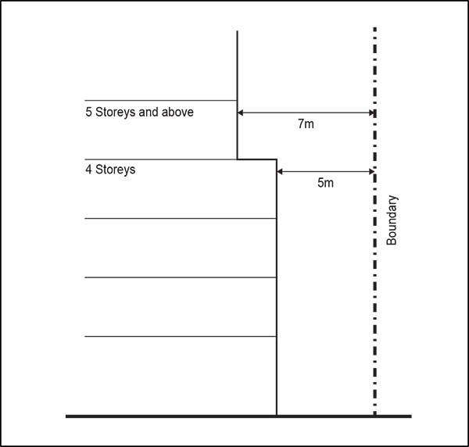

    - This control does not apply on boundaries where a common wall of the same height exists or is proposed.

Building setbacks adjoining lower density zones

Purpose: provide an appropriate transition in building bulk and scale to lower density residential zones and small public open spaces.

    - Where sites in the Terraced Housing and Apartment Buildings zone adjoin sites in the Single House zone or sites less than 2000m² in the public open space zones, the building must be set back from side and rear boundaries as follows:
      - 5m for storeys one and two

      - 9m for storeys three and four

      - 13m for storeys five and six.

Figure 18: Building setbacks adjoining Single House zone sites and sites within the public open space zones less than 2000m²

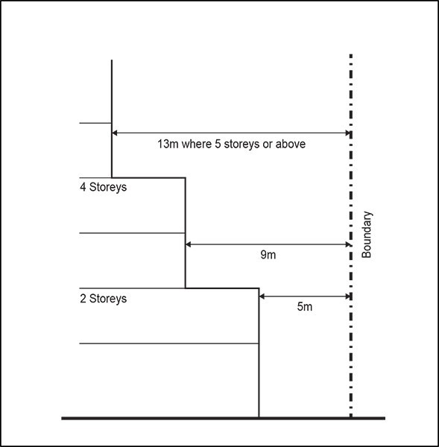

    - Where sites in the Terrace Housing and Apartment Buildings zone adjoin sites in the Mixed Housing Suburban and Mixed Housing Urban zones, buildings must be setback from side and rear boundaries as follows:
      - 3m for storeys one and two

      - 7m for storeys three and four

      - 11m for storeys five and six.

Figure 19: Building setbacks adjoining Mixed Housing Suburban and Mixed Housing Urban zone sites
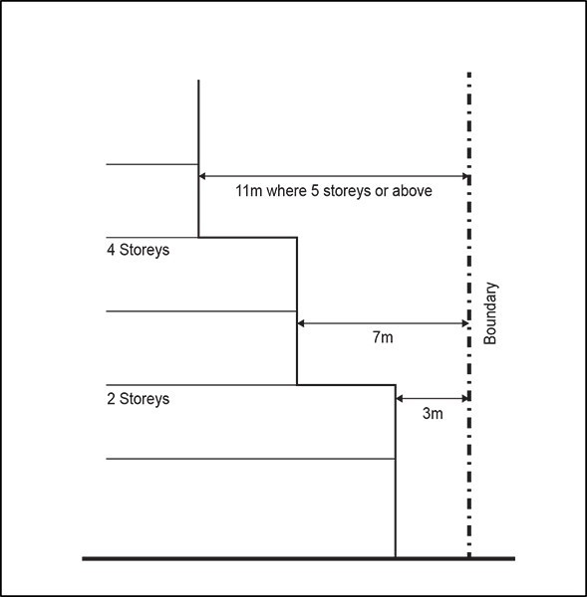

    - This control does not apply where a common wall of the same height exists or is proposed.

Minimum frontage and site width

Purpose: ensure sites are of a size sufficient to:
- enable higher density development including apartment buildings

- provide a positive interface with the public realm

- provide a good standard of on­site amenity.

    - A site must be at least 25m wide:
      - at the road boundary

      - for at least 80 per cent of the length of its side boundaries

      - where a building of up to four storeys is proposed.

    - Where a building of more than four storeys is proposed, a site must be at least 30m wide:

      - at the road boundary

      - for at least 80 per cent of the length of its side boundaries.

Maximum impervious area

Purpose: manage the amount of stormwater runoff generated by a development.

    - Maximum impervious area: 60 per cent.

    - Maximum impervious area within a riparian yard: 10 per cent.

Building coverage

Purpose: provide for a mid­rise urban built character within the zone.

    - Maximum building coverage: 40 per cent.

Landscaping

Purpose:
- provide for on­site amenity and an attractive streetscape character

- improve stormwater absorption on­site.

    - At least 40 per cent of a site must comprise landscaped area.

Outlook space

Purpose:
- Ensure a reasonable standard of visual and acoustic privacy between different dwellings, including their outdoor living space, on the same or adjacent sites

- Encourage the placement of habitable room windows to the site frontage or to the rear of the site in preference to side boundaries, to maximise both passive surveillance of the street and privacy, and to avoid overlooking of neighbouring sites.

    - An outlook space must be provided from the face of a building containing windows or balconies to a habitable room. Where the room has two or more external faces with windows or balconies the outlook space must be provided from, in order of priority, the face with the largest balcony or largest area of glazing.

    - The minimum dimensions for a required outlook space are as follows:
      - principal living room: 6m in depth and 4m in width

      - principal bedroom: 3m in depth and 3m in width

      - all other habitable rooms: 1m in depth and 1m in width.

    - The depth of the outlook space is measured at right angles to and horizontal from the window or balcony to which it applies. Where the outlook space applies to a balcony, it must be measured from the outside edge of the balcony.

    - The width of the outlook space is measured from the centre point of the largest window on the building face to which it applies or from the centre point of the largest balcony.

    - The height of the outlook space is the same as the floor height, measured from floor to ceiling, of the building face to which the control applies.

    - Outlook spaces may be within the site, over a public street, or other public open space.

    - Outlook spaces required from different rooms within the same dwelling may overlap.

    - Outlook spaces must:
      - be clear and unobstructed by buildings

      - not extend over adjacent sites or overlap with outlook spaces required by another dwelling.

    - An outlook space at ground floor level from a principal living room may be reduced to 4m deep if privacy to adjacent dwellings is provided by fencing at least 1.6m in height.

Figure 20: Required outlook space

  - Separation between buildings within a site

Purpose: require reasonable separation between buildings on the same site to manage dominance, provide access to daylight and natural ventilation.

    - Buildings must be separated where the habitable room of a dwelling has windows or balconies that face out to the wall of another building on the same site (the facing wall). Where the room has two or more external faces with windows or balconies the building separation must be applied from, in order of priority, the face with the largest balcony or the largest area of area of glazing.

    - The separation space required must be free of buildings for the depth, width and height set out below.

    - The depth of the separation space is measured at right angles to, and horizontal from, the window or balcony to which it applies across to the facing wall, excluding eaves or guttering. Where the building separation applies to a balcony, it is measured from the outside edge of the balcony.

    - For the principal living room, the depth of the separation space required is equal to the height of the facing wall above the floor level of the habitable room, or 15m, whichever is the lesser.

    - For the principal bedroom, the depth of the separation space required is 6m.

    - For other habitable rooms , the depth of the separation space required is 3m.

    - The width of the separation space is 50 per cent of its depth and is measured from the centre point of the largest window on the building face to which it applies or from the centre point of the largest

balcony.

    - The height of the separation space is from the height of the floor or balcony upwards, clear to the sky except that eaves or gutters may protrude into it.

    - Where the adjacent building is not perpendicular to the distance being measured, the minimum separation depth required must be measured as an average around the centre line of the window/balcony.

Outdoor living space

Purpose: provide dwellings with outdoor living space that is of a usable size and dimension for the type of dwelling and is accessible from the principal living room.

    - A dwelling with the principal living room at ground level must have an outdoor living space capable of containing a delineated area measuring at least 20m² that:
      - has no dimension less than 4m

      - is directly accessible from the principal living room

      - has a gradient not exceeding 1 in 20.

    - Where an entire dwelling is above ground level, it must have an outdoor living space in the form of a balcony or roof terrace that:
      - is at least 8m²

      - has a minimum depth of 2.4m.

Maximum building length

Purpose: require breaks in building facades and manage the length of buildings along side and/or rear boundaries and the separation between buildings on the same site to visually integrate them into the neighbourhood.

    - There must be a recess in the façade of a building where it faces a side or rear boundary from the point at which the building exceeds a length of 16m. The recess must:
      - be at least 2m, for a length of at least 4m

      - be for the full height of the wall, excluding any structures 1m or less in height above ground level

      - include a break in the eave line and roof line of the façade.

    - The maximum length of a building along a side or rear boundary is 30m, after which there must be a separation of at least 5m along the same boundary to any other building on the same site.

Fences

Purpose: enhance passive surveillance over the street and public open space and maintain the open character of front yards.

    - Fences in a front yard must not exceed 1.2m in height.

Figure 21: Fences within the front yard

  - Garages

Purpose:
- reduce the dominance of garages as viewed from the street

- avoid parked cars over­hanging the footpath.

    - A garage door facing a street must be no greater than 40 per cent of the width of the front facade of the dwelling to which the garage relates.

    - Garage doors must not project forward of the front façade of a dwelling.

    - The garage door must be set back at least 5m from the site’s frontage.

Minimum dwelling size

Purpose: dwellings are a sufficient size to provide for the day­to­day needs of residents.

    - Dwellings must have a minimum net internal floor area as follows.
      - 40m2 for studio dwellings

      - 45m2 for one bedroom dwellings.

Daylight to dwellings

Purpose: ensure dwellings receive a good degree of daylight.

    - The principal living room must have external glazing that is at least 40 per cent of the floor area of that space.

    - Bedrooms must have external glazing that is at least 20 per cent of the floor area of that space.

Minimum dimension of principal living rooms and principal bedrooms

Purpose: principal living rooms and bedrooms are of a size sufficient to accommodate standard size furniture and circulation space.

    - The principal living room within a dwelling must have no dimension less than 3m, measured perpendicular from the internal walls of the room.

    - The principal bedroom within a dwelling must be at least 3m in width and 3.5m in length measured perpendicular from the internal walls of the room. Cupboards and other storage space may be included in the minimum dimension.

Servicing and waste

Purpose: dwellings within medium to large­scale residential development have sufficient space within the building to accommodate the storage of waste.

    - A building or development containing 10 or more dwellings must provide a communal storage area for waste. The size of the communal storage area must be an aggregate of the minimum areas specified for the dwelling types below:
      - studio and one bedroom – 0.3m²

      - two bedrooms – 0.5m²

      - three bedrooms – 0.7m²

      - four or more bedrooms – 1m².

    - An additional 30 per cent in area of floor area required above must be provided within the communal storage area for manoeuvring or sorting within the waste storage area.

Storage

Purpose: ensure dwellings have sufficient space for the storage of everyday household items and bulky items, such as bicycles.

    - A building or development containing five or more dwellings must provide covered storage space for each dwelling with internal measurements of at least 4m3, excluding storage within the kitchen and bedroom wardrobes. The storage may be within the dwelling or external to it, within the site.

    - The required storage space for each dwelling must include a single covered storage space within internal dimensions of at least 2m3.

Dwelling mix

Purpose: large­scale residential development provides variety in dwelling sizes.

    - In a single development containing more than 20 dwellings, the combined number of studio and one bedroom dwellings must not exceed 70 per cent of the total number of dwellings within the development.

Minimum floor to floor/ceiling height

Purpose: buildings are adaptable to a wide variety of uses over time and provided with adequate daylight access.

    - The ground floor of a new building must have a minimum finished floor to floor height of 4m for a minimum depth of 10m where it adjoins an arterial road.

    - In all other instances, the finished floor to finished ceiling height of habitable rooms must be at least 2.55m.

Universal access

Purpose: medium to large­scale residential development provides equal physical access and use for people of all ages and abilities.

    - Where a new building or development contains 10 or more dwellings, 20 per cent of those dwellings must comply with the following:
      - doorways must have a minimum clear opening width of 810mm

      - stairwells must have a minimum width of 900mm

      - corridors must have a minimum width of 1050mm

      - the principal means of access from the frontage, or the parking space serving the dwelling, to the principal entrance of the dwelling must have:

i.

ii. iii.
a minimum width of 1.2m a maximum slope of 1:20
a maximum cross fall of 1:50.

    - Where the calculation of the dwellings required to be universally accessible results in a fractional dwelling, any fraction that is less than one­half will be disregarded and any fraction of one­half or more will be counted as one dwelling.

    - All dwellings required to be universally accessible must provide at least one parking space for people with a disability. The dimensions and accessible route requirements for such parking spaces are detailed in Section 5.5 of the New Zealand Building Code D1/AS1 New Zealand Standard for Design for Access and Mobility – Buildings and Associated Facilities (NZS 4121­2001).

Assessment ­ Restricted discretionary activities

10.1 Matters of discretion
The council will restrict its discretion to the matters below for the activities listed as restricted discretionary in the zone activity table.

  - Visitor accommodation up to 200m² GFA, dairies up to 100m² GFA, restaurants up to 100m² GFA, care centres between 200m²­400² GFA, healthcare facilities up to 200m² GFA
    - intensity and scale

    - noise, lighting and hours of operation.

  - The conversion of a dwelling into two dwellings in the Large Lot and Rural and Coastal Settlements zone
    - wastewater capacity.

  - Four or more dwellings in the Mixed Housing Suburban and Mixed Housing Urban zone, more than one dwelling in the Terrace Housing and Apartment Buildings zone
    - building design and external appearance

    - design and scale of buildings adjoining historic heritage and historic character areas

    - topography, site orientation and earthworks

    - design and layout of dwellings, visitor accommodation and boarding houses

    - design of landscaping

    - design of parking and access

    - infrastructure and servicing

    - water sensitive design.

  - New buildings accessory to the permitted or restricted discretionary non­residential activities listed in the activity table
    - building design and external appearance

    - design of landscaping

    - design of parking and access

    - servicing

    - water sensitive design.

Assessment criteria
The council will consider the relevant assessment criteria below for the restricted discretionary activities listed above. The ADM may also provide guidance on how the outcomes of particular criteria can be met.
    - Visitor accommodation up to 200m² GFA, dairies up to 100m² GFA, restaurants up to 100m² GFA, care centres between 200m²­400² GFA, healthcare facilities up to 200m² GFA
      - Intensity and scale

i.

ii.
The intensity and scale of the activity, in particular the number of people involved and traffic generated by the activity, size and location of buildings and associated car parking should be compatible with the planned future form and character of the area/zone.

For care centres, the site should be of an adequate size and road frontage to accommodate the activity. In particular, sufficient space will need to be provided for a safe pick­up and drop­ off area.

      - Noise, lighting and hours of operation
        - Noise and lighting from the activity should not adversely affect the amenity of surrounding residential properties. In determining this consideration will be given to the location of any potentially noisy activities e.g. outdoor play areas associated with a care centre, and any proposed measures to mitigate noise including:
          - locating noisy activities away from neighbouring residential boundaries

          - screening or other design features

          - the proposed hours of operation.

    - The conversion of a dwelling into two dwellings in the Large Lot and Rural and Coastal Settlements zones
      - Wastewater capacity
        - Any application must demonstrate adequate wastewater capacity exists within the on­site wastewater system and in particular:
          - the extent to which the existing on­site wastewater treatment and disposal system demonstrates that significant adverse effects on public health, water quality and amenity values are avoided and other adverse effects are remedied or mitigated

          - the type of wastewater treatment system, and the method of land application, is suitable for any increased capacity disposal requirements of the additional dwelling.

    - Four or more dwellings in the Mixed Housing Suburban and Mixed Housing Urban zones, more than one dwelling in the Terrace Housing and Apartment Buildings zone
      - Building design and external appearance

Contributing to sense of place in the Mixed Housing Suburban and Mixed Housing Urban zones

i.

ii.
Residential developments of increased density should be designed and located on the site to be consistent with a suburban residential character within the Mixed Housing Suburban zone and an urban residential character within the Mixed Housing Urban zone.

The alignment, form and location of dwellings should consider and respond to the
established urban pattern of development in the neighbourhood. Methods to achieve this may include:

- modulating or separating buildings into smaller groups of buildings as illustrated below in Figure 22 below

- transitioning the form and placement of dwellings as illustrated in Figure 23 below.

Figure 22: Placement of buildings
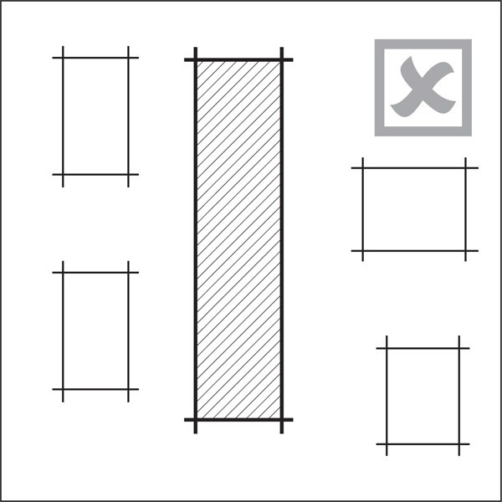

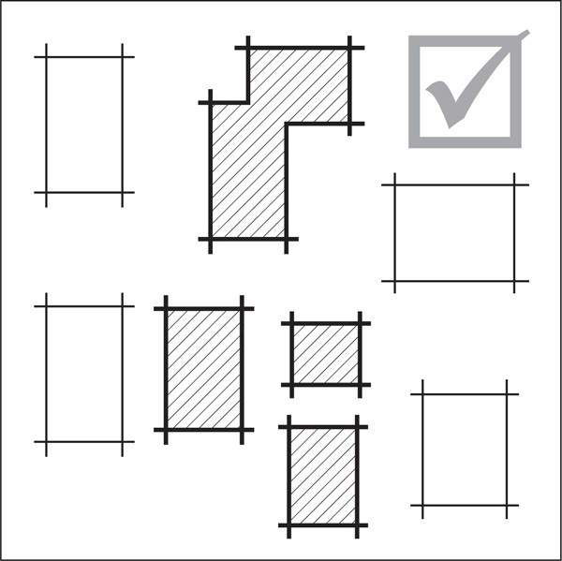

Figure 23: Transitioning the form and placement of buildings
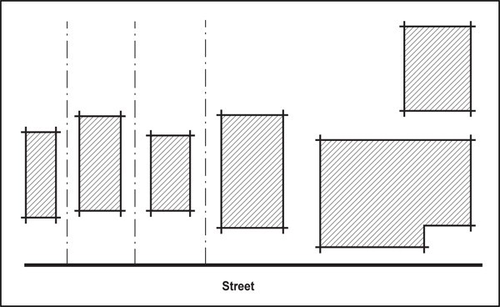

Contributing to sense of place in the Terrace Housing and Apartment Buildings zone

iii.

iv.
Residential development should be designed and located on the site to be consistent with a medium density urban residential character.
Creating a positive frontage

Buildings should have clearly defined public fronts, as illustrated in Figure 24 below, that positively contribute to the amenity and pedestrian safety of streets and public open spaces by:

- maximising doors, windows and balconies over all levels on the front façade

- introducing visual interest through a variety of architectural detail and building materials

- clearly defining the boundary between the site and the street or public open space by planting or fencing.

Figure 24: Defined public fronts and clear sense of address
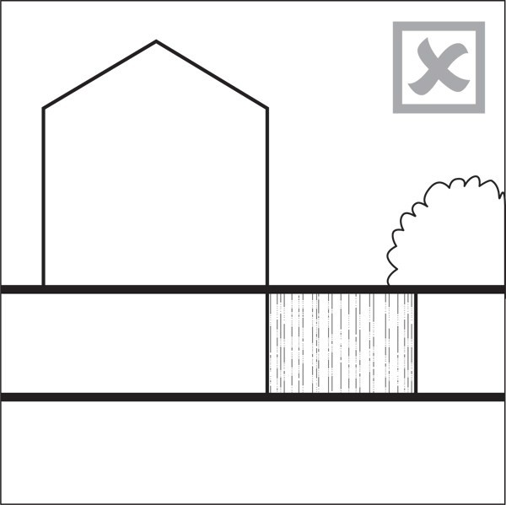

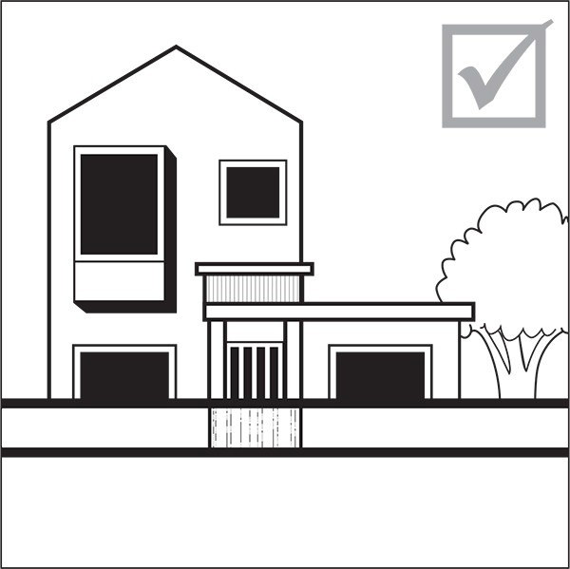

v.

vi. vii.

viii.
Ground level balconies or patios to a street or public open space should be a height sufficient to provide privacy for residents while enabling sightlines to the public realm.

The number of dwellings that directly front, align and orientate to public streets should be maximised.

Ground level dwellings closest to the street should each have direct and clearly defined pedestrian access from the street in preference to a single building entrance.

Building design and external appearance ­ Visual interest and variation in building form

Buildings should be designed to:

- avoid long unrelieved frontages and excessive bulk when viewed from streets and public open spaces

- break up their mass into visually distinct elements, particularly when of a greater height of bulk than surrounding buildings, to reflect a human scale and the typical pattern of development in the area.

ix.

Techniques to achieve this include the use of physical separation, variations in building height and roof

form, horizontal and vertical rhythms, façade modulation and articulation and building materials.

x.

xi.
Blank walls should be avoided on all building frontages to streets, accessways and public open spaces. Side or rear walls should be designed to provide interest in the facade including modulation, relief or surface detailing.

For larger scale developments:

- the mechanical repetition of unit types should be avoided

- balconies should be designed as an integral part of the building and a predominance of cantilevered balconies should be avoided

- internal access to apartments is encouraged.

Materials and finishes

xii.

b.
Quality, durable and easily maintained materials should be used on the façade of dwellings, with particular emphasis on frontages to the street and public open space.

Design and scale of buildings adjoining historic heritage and historic character areas

i.

ii.
Development adjoining or across the street from an identified historic character area should be designed and located to respect rather than replicate the prevailing character of the area. Notwithstanding this, new and contemporary interpretations in form and detail may be used.

Development adjoining or across the street from scheduled historic heritage places should be designed and located to respect rather than replicate the key historic heritage design and location elements of that building. Notwithstanding this, new and contemporary designs may be used.

- Topography, site orientation and earthworks

i.

ii.

iii.
The topography, orientation, size and proportions of the site should be suitable to accommodate the housing type proposed. In particular, development on steep land with poor solar orientation or narrow sites is discouraged unless sites are carefully designed to optimise on­site amenity values and complement the surrounding neighbourhood landform.

Building platforms, outdoor living spaces, car parking areas and driveways should be located and designed to respond to the natural landform and site orientation in an integrated manner.

Earthworks should be minimised and retaining avoided where possible. However, where retaining or earthworks are required they should be incorporated as a positive landscape or site feature by:

  - integrating retaining as part of the building design

  - stepping and landscaping earthworks or retaining over 1m in height, to avoid dominance or overshadowing effects

  - ensuring all earthworks or retaining visible to the public, including neighbours, is attractively designed and incorporates modulation, landscaping and quality materials to provide visual interest.

- Design and layout of dwellings, visitor accommodation and boarding houses
- Dwellings should be located, proportioned and orientated within a site to maximise the amenity of future residents by:
  - clearly defining communal, semi­private and private areas, including outdoor living space, within the development

  - maximising passive sunlight access, particularly for high density development by methods including maximising north facing windows, while balancing the need for dwellings to front the street.

  - providing for natural cross ventilation by window openings facing different directions.

ii.

iii.
Dwellings should be designed to provide a good standard of internal amenity by providing adequate circulation space around standard sized household furniture. The ADM illustrates possible ways of achieving this.

Outdoor living space should balance the need to achieve the following, in order of priority:

  - avoid a southerly orientation and be located on site to maximise the number of hours that the majority of the outdoor living space receives winter sunlight

  - maintain privacy between the outdoor living space of adjacent dwellings and between outdoor living space and the street. Outdoor living space should be located away from street frontages, where practicable

  - be sheltered from the prevailing wind

  - be located to take advantage of any views or outlook from or within the site.

iv.
In addition to the above, any communal open spaces should be designed to:

  - provide an attractive, functional and high quality outdoor environment, located within the site to form a focus of the development

  - be conveniently accessible to all residents

  - be overlooked by the principal living rooms and balconies of dwellings, where at ground or lower levels, to enhance safety.

v.

vi.

The size of the communal outdoor living space should be adequate for the number of people the development is designed to accommodate.

Appropriate management and maintenance systems should be provided for communal outdoor living space dependent on the scale of development and the extent of communal access to ensure it is available for all residents of the development.

- Design of landscaping

i.

ii.
Development should integrate and retain significant natural features including trees, streams and ecological areas.

Site landscaping should be located and designed to:

  - assist with blending new developments with the surrounding streetscape and/or any adjacent public open space

  - allow space for the planting of large trees

  - enhance energy efficiency and stormwater management, including shading and swale systems

  - enhance on­site amenity and improve privacy between dwellings.

- Design of parking and access

Connections to the neighbourhood

- Developments on larger sites with frontages to two or more streets should extend and connect a pedestrian and cycle links or where practicable, a public street through the site. Cul­de­sacs should be avoided unless there is no design alternative available.

Location and design of parking

ii.
Individual or communal car parking areas should be located and designed to:

  - be close and convenient to dwellings

  - be secure, well lit, or visible from dwellings

  - be well ventilated if enclosed

  - minimise noise and fumes by providing separation from bedroom windows

  - avoid surface car parking areas fronting streets and public open spaces

- provide visual interest and an attractive appearance, including the use of paving patterns and different material types in combination with landscaping.

iii. iv.
v.

vi.

vii.

viii.

ix.

x.

Parking areas and garages should be designed and grouped to make efficient use of land. Parking areas should be attractively landscaped.
Where practicable, parking should be located underground, or in semi­basements projecting no more than 1m above ground.

Location and design of vehicle and pedestrian access

Vehicle crossings and access ways should be designed to reduce vehicle speed, be visually attractive, using quality paving and landscaping and clearly signal to pedestrians the presence of a vehicle crossing or access way.

Vehicle crossings and access ways should be clearly separated from pedestrian access. The spaces may be integrated where designed as a shared space with pedestrian priority.

The design of pedestrian routes between dwelling entries, carpark areas, private and communal open space and the street should provide equal physical access for people of all ages and physical abilities and provide a high level of pedestrian safety and convenience.

Ramps, where necessary, should be minimal in length and integrated into the design of the building and landscaping.

Accessibility of common areas

Common areas within buildings should be designed to provide equal physical access for people of all ages and abilities. Common areas should also allow for standard household furniture to be easily moved in and out. This includes providing corridors and circulation spaces of sufficient dimension and minimising stairs where possible. The ADM illustrates possible ways of achieving this.

- Infrastructure and servicing

i.

ii.

iii.

iv.
There should be adequate capacity in the existing stormwater and wastewater network to service the proposed development.

Required infrastructure should integrate into the design of the site. This includes low impact stormwater design devices, overland flow paths/floodplains, wastewater systems, and water supply.

Rubbish storage areas should be either incorporated into the design of the building and screened from public view.

Plant, exhaust, intake units and other mechanical and electrical equipment located on the roof of a building should be integrated into the overall design and be contained in as few structures as possible.

- Water sensitive design
- New dwellings should be designed to incorporate water sensitive design principles that use natural systems and processes for stormwater management to minimise adverse effects and protect and enhance the values and functions of natural ecosystems. This may include:
  - a water sensitve design approach that is appropriate to the scale of the development

  - maximising localised water collection, retention and re­use

  - avoiding the use of high contaminant generating building products

  - minimising stormwater runoff by maximising vegetated areas and soil infiltration

  - using ecologically sensitive techniques to reduce and treat stormwater flows.

    - New buildings accessory to the permitted or restricted discretionary non­residential activities listed in the activity table
      - Building design and external appearance
        - Refer to the assessment criteria in clauses 3(a)(iv), 3(a)(viii)­(x) and 3(a)(xii) above.

      - Design of landscaping
        - Refer to the assessment criteria in clause 3(e)(ii) above.

      - Design of parking and access
        - Refer to the assessment criteria in clause 3(f)(ii) above.

      - Servicing
        - Refer to the assessment criteria in clauses 3(g)(iii)­(iv) above.

      - Water sensitive design
        - Refer to the assessment criteria in clauses 3(h) above.

Assessment ­ Development control infringements

11.1 Matters of discretion
In addition to the general matters set out in clause 2.3 of the general provisions, the council will restrict its discretion to the matters listed below for the relevant development control infringement:

  - Building height, height in relation to boundary, building coverage, side and rear yards
    - effects of additional building scale on neighbouring sites, streets and public open spaces (sunlight access, dominance, visual amenity)

    - consistency with the planned future form and character of the area/zone

    - protection from coastal inundation and sea­level rise within identified areas.

  - Maximum impervious area
    - refer to clause 1.4 of the Auckland­wide ­ Stormwater management rule.

  - Outlook space
    - effects of reduced privacy and outlook.

  - Separation between buildings within a site
    - dominance effects

    - effects of reduced daylight and sunlight access and ventilation.

  - Landscaping
    - effects on streetscape amenity

    - effects on stormwater absorption.

  - Front yards, fences
    - effects on streetscape amenity and safety.

  - Minimum dwelling size, daylight to dwellings, minimum floor to ceiling height, storage, servicing and waste, minimum dimension of principal living rooms and principal bedrooms, outdoor living space
    - effects of reduced living and circulation space, sunlight/daylight access and storage on residential amenity.

  - Universal access
    - effects on accessibility.

Assessment criteria
In addition to the general assessment criteria for development control infringements in clause 2.3 of the general provisions the council will consider the relevant criteria below for the listed development control infringements.

    - Building height, height in relation to boundary, building coverage, side and rear yards
      - Effects of additional building scale on neighbouring sites, streets and public open spaces (sunlight access, dominance, visual amenity)

i.

ii.
Infringing of the control should not result in the building dominating or unreasonably shading the outdoor living space or windows to habitable rooms of adjoining dwellings.

The building should be designed to avoid dominance, over­shadowing, or reduced access to sunlight of the adjoining dwellings and their outdoor living spaces. Methods to achieve this include providing variations in building heights building setbacks, or breaks in building massing.

      - Consistency with the planned future form and character of the area/zone
        - Where height is infringed, the proposal must demonstrate that the relevant policy in the zone regarding character and building height and bulk.

      - Protection from coastal inundation and sea­level rise within identified areas
        - Development that infringes the building height may be acceptable where the finished floor level is raised 500mm above the water depth of the one per cent AEP coastal storm tide inundation plus the 1m projected sea level rise in the locations identified on the planning maps.

    - Outlook space
      - Development that infringes the outlook control will need to demonstrate that there will be a reasonable standard of visual and acoustic privacy between dwellings, including their outdoor living space. Methods to achieve this include, off­setting or changing the orientation of balconies and windows to avoid direct over­looking, the use of screening devices and landscaping.

    - Front yards, fences
      - Effects on streetscape amenity and safety

i.

ii.
Development that infringes the front yard control will need to demonstrate that the proposed setback is consistent with the typical depth of yard in the surrounding neighbourhood, particularly those of adjoining sites. This is particularly important where the development is in close proximity to an identified historic character or historic heritage area.

Development that infringes the fences control will need to demonstrate that the proposed fence will enable direct sightlines to the dwelling from any adjoining street or public open space and vice versa.

    - Minimum dwelling size, daylight to dwellings, minimum floor to ceiling height, storage, servicing and waste, minimum dimension of principal living rooms and principal bedrooms, outdoor living space
      - Effects of reduced living and circulation space, daylight access and storage on residential

amenity

i.

ii.

iii.
All habitable rooms in dwellings should be naturally lit and should not rely on borrowed light from other rooms.

Dwellings should have adequate natural light that avoids the need for the dwelling to be artificially lit during daylight hours.

Consideration will be given to the configuration and orientation of the dwelling so that sunlight access is maximised to principal living rooms.

    - Separation between buildings within a site
      - Dominance effects
        - Development that infringes this control should not result in the building visually dominating the outdoor living space or windows to habitable rooms of dwellings on the same site.

      - Effects of reduced daylight and sunlight access and ventilation
        - Development that infringes this control will need to demonstrate that the dwellings will receive a good degree of daylight and ventilation, and will not reduce access to sunlight, particularly for dwellings at lower building levels.

    - Universal access
      - Effects on accessibility

i.

ii.
For development that infringes this control consideration will be given to whether meeting the control would cause a significant amount of land modification and adverse effects on the landscape or natural features of the site.

Consideration will also be given to whether other universal design features are incorporated into the development that would mitigate any adverse effects created by the infringement.

Special information requirements

  - Design statement

A design statement is required for the activities specified in the tables below. The design statement is required to include as a minimum the matters indicated within the table as set out in clause 2.7.2 of the general provisions. Drawings, illustrations and supporting written explanation should be proportionate to the complexity and significance of the development proposal. Refer to the ADM for guidance on the preparation of design statements.

Table 9: Design statement requirements

Activity |  | Any discretionary or non­ complying activity involving a new  building | Any building associated with a non­ residential activity | Additions and alterations to buildings in the THAB zone | 4­15  dwellings in all Residential zones | 15+  dwellings in all Residential zones | Apartments in all Residential zones
A. Context analysis
1. Site analysis
a. | Existing site  plan | X | X | X | X | X | X
b. | Streetscape  character | X | X | X | X | X | X
2. Neighbourhood analysis

a. | Natural and cultural  environment | X | X | X | X | X | X
b. | Movement | X | X |  | X | X | X
c. | Neighbourhood  character | X | X | X |  | X | X
d. | Use and activity | X | X |  |  | X | X
e. | Urban structure | X | X |  |  | X | X
3. Opportunities and constraints analysis
a. | Opportunities and constraints  diagram | X | X | X | X | X | X
B. Design response
a. | Concept design | X | X | X | X | X | X
b. | Proposed site  plan | X | X | X | X | X | X
c. | Proposed  elevations | X | X | X | X | X | X
d. | Sunlight access | X | X | X | X | X | X
e. | Landscape | X | X | X | X | X | X
f. | Streets, accessways &  lanes | X | X |  | X | X | X
g. | Urban structure | X |  |  |  | X
h. | Public open  space | X | X |  |  | X

