PART 3 ­ REGIONAL AND DISTRICT RULES»Chapter I: Zone rules»

21 Special Purpose ­ Retirement Village zone

Activity table

The following table specifies the activity status of activities in the Retirement Village zone.

Activity | Activity Status
Accommodation
Retirement villages | P
Development
Any development complying with an incorporated concept plan | P
Alterations, additions and demolition, unless otherwise specified in an incorporated  concept plan | P
Demolition of buildings | P
New buildings | RD
Any development not complying with an incorporated concept plan | D

Land use controls

2.1 Density

  - No density limits apply where the site has a minimum net site area of 1200m² and is at least 25m wide:
    - at the road boundary

    - for at least 80 per cent of the length of its side boundaries.

  - Development that does not comply with this control is a discretionary activity.

Development controls

Retirement villages will be subject to the following controls along with any additional controls in the zone unless otherwise stated. The underlying zone development controls will apply if they allow a greater level of development.

3.1 Incorporated concept plans

  - The development controls in an incorporated concept plan will apply in place of any of the development controls specified below where relevant.

Building height

Purpose: manage the height of buildings to be consistent with a residential character of up to three storeys.
    - Buildings must not exceed 11m in height.

Height in relation to boundary

Purpose: manage the bulk and scale of buildings at boundaries to limit over­shadowing to neighbouring sites and provide space between buildings.
    - Where a site in the Retirement Village zone directly adjoins a site in another zone, the height in relation to boundary control that applies in the adjoining zone applies to the adjoining boundary in the Retirement Village zone.

    - Where the adjoining zone does not specify a height in relation to boundary control, the yard and/or

setback controls in the adjoining zone applies to the boundary directly adjoining the Retirement Village zone.

Maximum impervious area

Purpose: manage the amount of stormwater runoff generated by a development.
    - Maximum impervious area: 60 per cent.

    - Maximum impervious area within a riparian yard: 10 per cent.

Building coverage

Purpose: manage the density of buildings on the site consistent with the residential character of the zone.
    - Maximum building coverage: 40 per cent.

Landscaping

Purpose:
- provide for on­site amenity and an attractive streetscape character

- improve stormwater absorption on­site.

    - Minimum landscaped area: 40 per cent.

Yards

Purpose: provide an attractive transition from the street to the development and ensure dwellings are adequately set back from lakes, streams and the coastal edge to maintain water quality and provide protection from natural hazards.

Table 1

Yard | Minimum depth
Front | 2.5m
Side | 1m
Rear | 1m
Riparian | 10m from the edge of all other permanent and  intermittent streams
Lake | 30m
Coastal protection yard | 10m, or as otherwise specified in appendix 6.7

Outlook

Purpose:
- Ensure a reasonable standard of visual and acoustic privacy between different dwellings, including their outdoor living space, on the same or adjacent sites

- Encourage the placement of habitable room windows to the site frontage or to the rear of the site in preference to side boundaries, to maximise both passive surveillance of the street and privacy, and to avoid overlooking of neighbouring sites.

    - An outlook space must be provided from the face of a building containing windows or balconies to a habitable room. Where the room has two or more external faces with windows or balconies the outlook space must be provided from, in order of priority, the face with the largest balcony or largest area of glazing.

    - The minimum dimensions for a required outlook space are as follows:
      - principal living room: 6m in depth and 4m in width

      - principal bedroom: 3m in depth and 3m in width

      - all other habitable rooms: 1m in depth and 1m in width

    - The depth of the outlook space is measured at right angles to and horizontal from the window or balcony to which it applies. Where the outlook space applies to a balcony, it must be measured from the outside edge of the balcony.

    - The width of the outlook space is measured from the centre point of the largest window on the building face to which it applies or from the centre point of the largest balcony.

    - The height of the outlook space is the same as the floor height, measured from floor to ceiling, of the building face to which the control applies.

    - Outlook spaces may be within the site, over a public street, or other public open space.

    - Outlook spaces required from different rooms within the same dwelling may overlap.

    - Outlook spaces must:
      - be clear and unobstructed by buildings

      - not extend over adjacent sites or overlap with outlook spaces required by another dwelling.

    - An outlook space at ground floor level from a principal living room may be reduced to 4m deep if privacy to adjacent dwellings is provided by fencing at least 1.6m in height.

Figure 1: Required outlook space
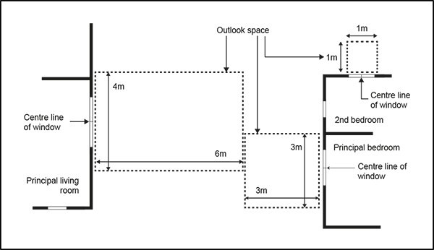

  - Outdoor living space

Purpose: provide dwellings with outdoor living space that is usable and accessible.
    - Where a dwelling has the principal living room at ground level, it must have an outdoor living space measuring at least 20m² that:
      - Is free of buildings, car parking, servicing and manoeuvring areas

      - has no dimension less than 3m

      - is directly accessible from the principal living room

      - has a gradient not exceeding 1 in 20.

    - Where a dwelling has the principal living room above ground level, part of the required outdoor living space must include a balcony or roof terrace that:
      - is directly accessible from the principal living room

      - has a minimum area of 8m²

      - has a minimum depth of 2.4m.

    - Where an entire dwelling is above ground level, it must contain an outdoor living space in the form of a balcony or roof terrace that is at least 10m² and has a minimum depth of 2.4m.

Communal open space

Purpose: a communal facility is provided that meets the amenity needs of residents.
    - Communal open space must be provided at a rate of 8m² per dwelling.

    - Ground floor dwellings are exempt from this requirement where the 8m² is provided as additional outdoor living space for the dwelling.

Daylight to dwellings

Purpose: dwellings receive a good degree of daylight.
    - The principal living room must have external glazing that is at least 40 per cent of the floor area of that space.

    - Bedrooms must have external glazing that is at least 20 per cent of the floor area of that space.

Minimum dwelling size

Purpose: dwellings are of a sufficient size to provide for the day­to­day needs of residents.
    - Dwellings must have a minimum net internal floor area of 45m2.

Minimum dimension of principal living rooms and principal bedrooms

Purpose: principal living rooms and bedrooms are of a size sufficient to accommodate standard size furniture and circulation space.
    - The principal living room within a dwelling must have no dimension less than 3m, measured perpendicular from the internal walls of the room.

    - The principal bedroom within a dwelling must be at least 3m in width and 3.5m in length including cupboards and other storage space, measured perpendicular from the internal walls of the room.

Minimum floor to ceiling height

Purpose: dwellings have good daylight access.
    - The finished floor to finished ceiling height of new buildings above ground floor must be at least 2.55m where those floors will accommodate dwellings.

Servicing and waste

Purpose: dwellings within medium to large­scale residential development have sufficient space within the building or site to accommodate the storage of waste.
    - A building or development containing 10 or more dwellings must provide a communal storage area for waste. The size of the communal storage area must be an aggregate of the minimum areas specified for the dwelling types below:
      - studio and one bedroom – 0.3m²

      - two bedrooms – 0.5m²

      - three bedrooms – 0.7m²

      - four or more bedrooms – 1m².

    - An additional 30 per cent in area of the total floor area required above must be provided within the communal storage area for manoeuvring or sorting within the waste storage area.

Assessment ­ Restricted discretionary activities

4.1 Matters of discretion
The council will restrict its discretion to the matters below for the activities listed as restricted discretionary in the activity table.
  - New buildings
    - building design and external appearance

    - topography, site orientation and earthworks

    - design of communal open space

    - design and layout of dwellings

    - design of parking and access

    - infrastructure and servicing.

Assessment criteria
The council will consider the relevant assessment criteria below for the restricted discretionary activities listed above.

    - New buildings
      - Building design and external appearance

i.

ii.

iii.

iv.

v.

vi. vii.
Buildings should be designed and located to respect the character of the neighbourhood and amenity of adjacent properties.

Buildings should positively contribute to the amenity and pedestrian safety of streets and public open spaces by introducing visual interest through a variety of architectural detail and building materials.

Ground level balconies or patios to a street or public open space should be screened to a height sufficient to provide privacy for residents while enabling sight lines to the public realm.

Development should be designed to avoid long unrelieved building mass and excessive bulk and scale. Building mass should be broken up into visually distinct building forms by the use of physical separation, variations in building height and building materials.

Blank walls should be avoided on all building frontages to streets, accessways and public open spaces. Side or rear walls should be designed to provide interest in the façade including modulation, relief or surface detailing.

Where balconies are provided, they should be designed as an integral part of the building.

Mechanical and electrical equipment located on the roof of a building should be integrated into the overall design and be contained in as few structures as possible.

      - Topography, orientation and earthworks
        - Building platforms, outdoor living spaces, car parking areas and driveways should be located and designed to respond to the natural landform and site orientation.

ii.
Significant natural features including trees, streams, and ecological areas should be retained and integrated into the development.

      - Design of communal open space

i.

ii. iii. iv.
v.

vi. vii.
Communal open spaces should be located at ground or lower levels and be designed to: provide an attractive, functional and high quality outdoor environment
be conveniently accessible to all residents maximise winter sunlight access
be overlooked by the principal living rooms and balconies of dwellings to enhance safety be located within the site to form a focus of the development
be sheltered from the prevailing wind.

      - Design and layout of dwellings
        - Dwellings should be located, proportioned and orientated within a site to maximise the amenity of future residents by:
          - clearly defining communal, semi­private and private areas within the development

          - maximising passive sunlight access, particularly, while balancing the need for dwellings to front the street and maximise views

          - providing for natural cross ventilation by window openings facing different directions.

ii.

iii.
Dwellings should be designed to provide a good standard of internal amenity by providing adequate circulation space around standard sized household furniture. The ADM illustrates possible ways of achieving this.

Outdoor living space should balance the need to achieve the following, in order of priority:

          - be located to maximise winter sunlight access

          - maintain privacy between the outdoor living space of adjacent dwellings and between outdoor living space and the street.

          - be sheltered from the prevailing wind

          - be located to take advantage of any views or outlook from or within the site.

      - Design of parking and access
        - Individual or communal parking areas should be located and designed to:
          - be close and convenient to the facilities/l dwellings they service

          - be secure and well lit

          - be well ventilated if enclosed

          - provide visual interest and an attractive appearance.

ii.

iii.
Parking areas should be designed and grouped to make efficient use of land.

Vehicle access ways should be:

          - designed to reduce vehicle speed and be visually attractive by limiting the width of the access and using quality paving and landscaping

          - clearly separated from pedestrian access.

iv.
The design of pedestrian routes between building entries, parking areas, open space areas and the street should provide equal physical access for people of all ages and abilities and

provide a high level of pedestrian safety and convenience.

      - Infrastructure and servicing

i.

ii.
There should be adequate capacity in the existing stormwater and wastewater network to service the proposed development.

Rubbish storage areas visible from the street or public open space should be either incorporated into the design of the building or screened from public view.

      - Concept plan
        - The proposal should generally accord with the outcomes sought in a concept plan.

Assessment ­ Development control infringements

5.1 Matters of discretion
In addition to the general matters set out in clause 2.3 of the general provisions, the council will restrict its discretion to the matters listed below for the relevant development control infringement:

  - Height, height in relation to boundary, building coverage and side and rear yards
    - Effects of additional building scale on neighbouring sites, streets and public open spaces (sunlight access, dominance, visual amenity)

    - Consistency with the planned future form and character of the area/zone.

  - Maximum impervious area
    - Refer to clause 1.4 of the Auckland­wide ­ Stormwater management rules.

  - Outlook
    - Effects of reduced privacy and outlook

    - Effects of reduced daylight access and ventilation.

  - Landscaping
    - Effects on streetscape amenity

    - Effects on stormwater absorption.

  - Front yards
    - Effects on streetscape amenity and safety.

  - Minimum dwelling size, daylight to dwellings, minimum floor to ceiling height, waste storage, minimum dimension of principal living rooms and principal bedrooms, outdoor living space
    - Effects of reduced living and circulation space, sunlight/daylight access and storage on residential amenity.

Assessment criteria
In addition to the general assessment criteria for development control infringements in clause 2.3 of the general provisions, the council will consider the relevant criteria below for the listed development control infringements.

    - Height, height in relation to boundary, building coverage, side and rear yards, walls on boundaries
      - Effects of additional building scale on neighbouring sites, streets and public open spaces (sunlight access, dominance, visual amenity)

i.

ii.
Infringing the height in relation to boundary or building coverage controls should not result in the building dominating or unreasonably shading adjoining properties, particularly their outdoor living areas.

Consideration will be given to whether the building can be designed or located to minimise dominance or over­shadowing of outdoor living space on neighbouring sites by providing variations in building heights, breaks in building massing or locating buildings in a way that maximises sunlight access to neighbouring sites while achieving a good standard of on­site amenity.

      - Consistency with the planned future form and character of the area/zone
        - Where height is infringed, the proposal must demonstrate that relevant policy in the zone

regarding building height and bulk.

    - Outlook
      - Effects of reduced privacy and outlook
        - Dwellings that infringe the outlook control must demonstrate that occupants will have a good standard of outlook and visual and acoustic privacy between principal living rooms and bedrooms on the same and adjacent sites and will not prevent a complying residential development on an adjoining site.

      - Effects of reduced daylight access and ventilation
        - Dwellings that infringe the outlook control must also demonstrate that the dwellings will receive a good degree of natural light and ventilation, particularly those at lower building levels.

    - Front yards, fences, garages, dwellings fronting the street
      - Effects on streetscape amenity and safety
        - Development that does not comply with the yards will need to demonstrate that the proposed setback is consistent with the pattern of development in the surrounding neighbourhood. This is particularly important where the development is in close proximity to an identified historic character or historic heritage area.

    - Minimum dwelling size, daylight to dwellings, minimum floor to ceiling height, storage, waste storage, minimum dimension of principal living rooms and principal bedrooms, outdoor living space
      - Effects of reduced living and circulation space, sunlight/daylight access and storage on residential amenity.

i.

ii.

iii.
All habitable rooms in dwellings should be naturally lit and should not rely on borrowed light from other rooms.

Dwellings should have adequate natural light and sunlight that avoids the need for the dwelling to be artificially lit during daylight hours.

Consideration will be given to the configuration and orientation of the dwelling so that sunlight access is maximised to principal living rooms.

Special information requirements

6.1 Design Statement
A design statement is required for the activities specified in the table below. The design statement is required to include as a minimum the matters indicated within the table as set out in clause 2.7.2 of the general provisions. Drawings, illustrations and supporting written explanation should be proportionate to the complexity and significance of the development proposal. Refer to the ADM for guidance on the preparation of design statements.

Table 2:

Activity |  | 1­8 dwellings/units and associated facilities | 9­15 dwellings/units and associated facilities | 15+  dwellings/units and associated facilities
A. CONTEXT ANALYSIS
1. Site analysis
a. | Existing site plan | X | X | X
b. | Streetscape character | X | X | X

2. Neighbourhood analysis
a. | Natural and cultural  environment |  | X | X
b. | Movement |  | X | X
c. | Neighbourhood character |  |  | X
d. | Use and activity |  |  | X
e. | Urban structure |  |  | X
3. Opportunities and constraints analysis
a. | Opportunities and  constraints diagram | X | X | X
B. DESIGN RESPONSE
a. | Concept design | X | X | X
b. | Proposed site plan | X | X | X
c. | Proposed elevations | X | X | X
d. | Shadow diagrams | X | X | X
e. | Landscape | X | X | X
f. | Streets, accessways &  lanes |  | X | X
g. | Urban structure |  |  | X
h. | Publicly accessible open  space |  |  | X

Concept plans

Concept plan 1: 42 Herd Rd
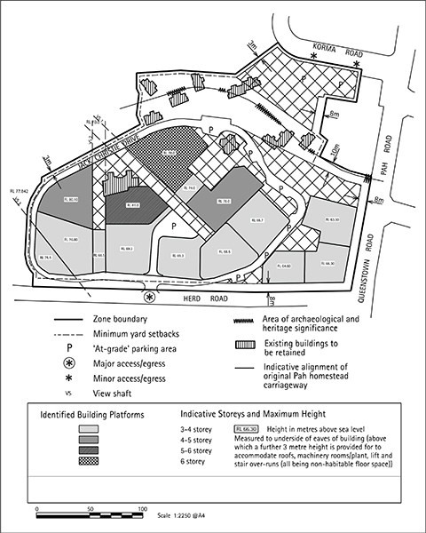

Concept plan 2: 42 Herd Rd
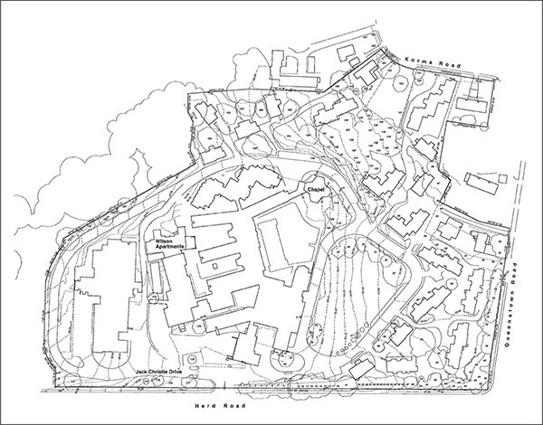

Concept plan 3: 43 Target St
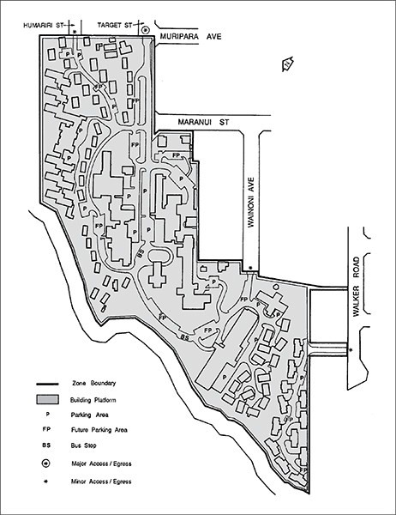

Concept pli'1"14: 142 Shakespeare Rd

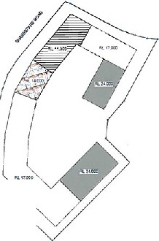

'•t.•

Concept plan 5: 10 Ranfurly Rd
