PART 3 ­ REGIONAL AND DISTRICT RULES»Chapter J: Overlay rules»1 Infrastructure»

1.1 Airport Approach Path

- Activity table

The following table specifies the activity status of activities in the Airport Approach Path overlay.

Detailed height restriction diagrams for Kaipara Flats Airfield, North Shore Airfield, Auckland Gliding Club and Parakai Airfield are contained in this overlay section of the Unitary Plan. Auckland Airport (AIA), Whenuapai Airbase and Ardmore Airport diagrams are contained in the designation overlay section of the Unitary Plan.

Activity | Activity status
Trees and vegetation
Removal or topping of a tree that protrudes into the airfield height restriction shown in  clause 3 Airport Approach Path Maps 1 ­ 4 below | P

Development controls

2.1 Height

  - Buildings, structures, masts and trees must not exceed 8m in height or the height limits within the airfield height restrictions shown in clause 3 Airport Approach Path Maps 1 ­ 4 below, whichever is the lesser.

  - A building, structure, mast or tree that does not comply with clause 2.1 is a prohibited activity.

Measuring Height

    - In determining compliance with clause 2.1.1, the following controls apply.

    - At any point where two surfaces overlap and are at differing elevations, the lower of the two surfaces applies.

    - The height controls consist of three separate height controls around North Shore Airfield and two around Kaipara Flats and Parakai Airfields as follows:
      - Take off/landing fans
        - These fans extend for 5.5km (north Shore) and 1.2km (Kaipara Flats and Parakai) from each end of each runway. The height limit begins at ground level and rises at a slope of 1 in 40 (North Shore) and 1 in 20 (Kaipara Flats and Parakai).

      - Transitional side surfaces
        - This height restriction runs at right angles to the runway strip and the centre line of the fans.
The height limit begins at ground level at the edge of runway strip and rises at a slope of 1 in 7 (North Shore) and 1 in 4 (Kaipara Flats and Parakai) to a maximum height of 45 metres (North Shore) and 2 metres (Kaipara Flats and Parakai) above the runway ground level. This height limit also applies from the outside edge of each fan, the surface rising at the same slopes to a maximum height of 45 metres (North Shore) and 2 metres (Kaipara Flats and Parakai).

      - Horizontal surface
        - All properties within 2.6km of North Shore Airfield are subject to a horizontal height control which is 45 metres above the average runway ground level i.e. 107 metres above mean sea level. There is no horizontal surface control for either Kaipara Flats or Parakai Airfields.

    - All height controls are affected by the elevation of the property, and height limits must be assessed in terms of elevation relative to the runway itself.

    - Appendix 2.1 provides detailed guidance on how to assess whether a proposal complies with the height controls.

Figure 1: Explanation of terms for airport approach overlay calculations
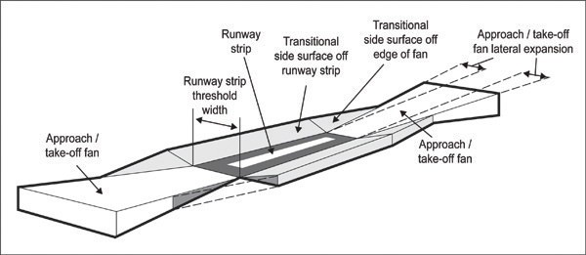

The following table below gives the specifications for the three airfields: Table 1:
Feature | North Shore | Kaipara Flats |  | Parakai
Runway threshold ground level | Main Runway: | East End | 33m | East End | 5m
above mean sea level | East End 65m | West End | 33m | West End | 6m
 | West End 63m
 | Crosswind Runway:
 | East End 63m
 | West End 60m
Runway strip width | 90m | 100m |  | 65m
Approach/take­off fan  Length (from runway threshold) Slope (rate of rise)  Lateral expansion | 5,500m  1 in 40  1 in 10 | 1,200m  1 in 20  1 in 20 |  | 1,200m  1 in 20  1 in 20
Transitional side surface  Slope (rate of rise)  Maximum height above runway | 1 in 7 45m | 1 in 4 2m |  | 1 in 4 2m
Horizontal surface  Height  Lateral extent | 107m above sea level 2.6km from edge of  runway strip | N/A N/A |  | N/A N/A

Airport Approach Path maps

Map 1: Kaipara Flats airfield height restriction

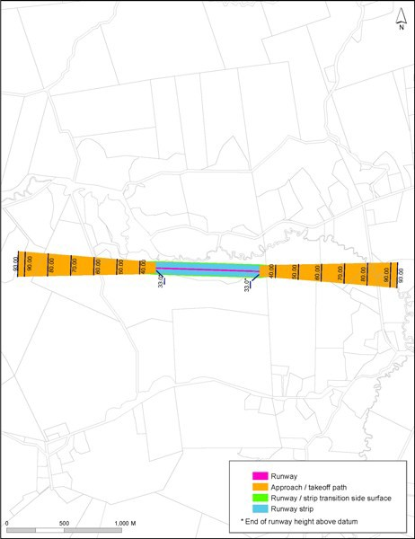

Map 2: North Shore airfield height restriction
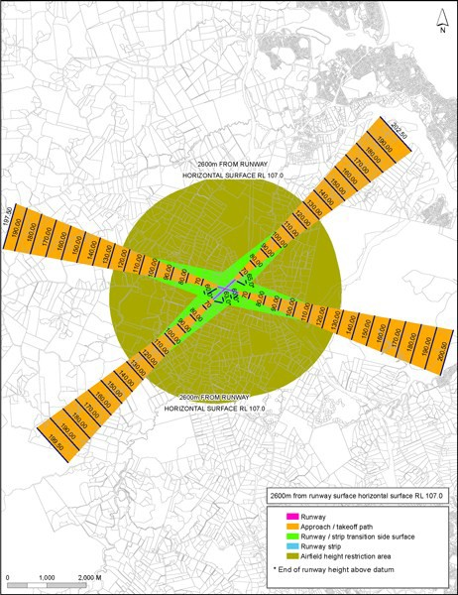

M 3: PiW'ak::ai airfield height restriction

D•.

--:,w,.,..
-J<Cfl:fo(.lo I bN:d' llort'l
-'lo.w""'.' •otr• W. *'w'b:t
-'IU'I..o) lll
  - fl'(l OJ(o.Mo-.11)' h,.;JI!I <,ho!o)IIO

Map 4: Auckland Gliding Club airfield height restrictions
