PART 3 ­ REGIONAL AND DISTRICT RULES»Chapter J: Overlay rules»3 Special Character»

3.5 Special Character General

- Activity table

The following table specifies the activity status of activities in the Special Character general overlay. Refer to Appendix 10.2 for the Special Character statement and clause 7 below containing maps for each area identifying character­defining and character­supporting buildings.

Activity | Activity Status
Character­defining or character­supporting places or features:  - external maintenance, redecoration or repair of a building or structure  - internal maintenance, redecoration, repair, or alterations to a building or structure  - maintenance of a landscape feature, tree or other vegetation where identified as character supporting or character­defining  - minor alterations (but not additions) to the rear of a building or structure.  Where works to buildings or structures use the same design and materials to the existing building or structure. | P
Character­defining or character­supporting places or features:  - maintenance, redecoration or repair of a building or structure  - maintenance of a landscape feature, tree or other vegetation where identified as character supporting or character­defining  - external alterations and/or additions  Not provided for above. | RD
Character­supporting places or features:  - total or substantial demolition (more than 30 per cent by volume) or destruction  - removal or destruction of landscape features, trees or other vegetation where identified as special character supporting or special character­defining  - any demolition of the street frontages of a building or structure  - removal or relocation within or beyond a site. | RD
Character­defining places or features:  - Total or substantial demolition (more than 30 per cent by volume) or destruction  - removal or destruction of landscape features, trees or other vegetation where identified as special character supporting or special character­defining  - any demolition of the front facade of a building or structure  - removal or relocation within or beyond the site | D
Character­supporting or special character­defining buildings or features:  ­ demolition not specified above. | RD
New and relocated buildings | RD
Additions, alterations to or demolition of to any place or feature within the special character area, not identified as character­defining or character­supporting, where the  change is permitted in the underlying zone | C

Notification

An application for the total or substantial demolition or destruction, any demolition of a front facade, or any relocation or removal of a special character­supporting will be subject to the normal test for notification under the relevant sections of the RMA.

Development controls

  - Yards

Table 1:

Yard | Dimension
Front | The same as the two adjoining dwellings or the average setback of the adjoining two  dwellings, where they are different; or 3m
Rear | 3m

Building coverage

Table 2:

Site | Maximum building coverage
Sites 300m2 or smaller | 45%
Sites 300m2 or greater | 35%

Garages/ carports

1. Garages and carports located at the front or side of a building must be set back at least 1.5m from the road boundary.

Decks

Construction of a deck within a character­defining or character­supporting places or feature:
- must be located at the rear of the building or structure

- must not extend towards the side boundary any further than the rear corner of the building or structure on either side and

- the floor level must be no higher than 1m above existing ground level, or have a balustrade.

Assessment ­ Controlled activities

4.1 Matters of control
The council will reserve its control over the activities listed below for the controlled activities listed in the activity table.
  - Additions or alterations to any place or feature within the special character area, not identified as character­defining or character­supporting, where the change is permitted in the underlying zone
    - architectural design

    - streetscape and special character context

    - landscape and vegetation.

Assessment criteria
    - Architectural design
      - Alterations and additions should be compatible with the surrounding special character of the area.
Special attention should be paid to the bulk, scale, massing, form, detail and use of materials.

      - Alterations and additions should not detract from the continuity of the front facade alignment of buildings on the street.

    - Streetscape and special context character
      - Alterations and additions should not adversely affect the group value or coherence of the streetscape.

    - Landscape and vegetation
      - Alterations to landscape features or vegetation should be compatible with the surrounding special character of the area, and should not adversely affect the group value or coherence of the streetscape.

      - Any alteration to street trees should not disrupt continuity along the street.

      - Any boundary treatment (such as fencing, walls or hedges) associated with existing structure, whether present, remnant or wholly absent will be taken into consideration.

Assessment ­ Restricted discretionary activities

5.1 Matters of discretion
The council will restrict its discretion to the activities listed below for the restricted discretionary activities listed in the activity table and for specific development control infringements.
  - Character­defining or character­supporting places or features external alterations and/or additions
    - architectural design

    - streetscape and special character context

    - retention of original fabric or features

    - landscape and vegetation.

  - Special character­supporting places or features including: total or substantial demolition or destruction, removal or destruction of landscape features, trees or other vegetation, any demolition of the front facade of a building or structure, removal or relocation
    - architectural design

    - condition

    - streetscape and special character context

    - landscape and vegetation.

  - Character­supporting or character­defining buildings or features demolition not specified above
    - architectural design

    - condition

    - streetscape and special character context

    - landscape and vegetation.

  - New and relocated buildings a. architectural design
    - streetscape and special character context

    - retention of original fabric or features

    - landscape and vegetation.

  - Development control infringement ­ height between 8m and 9m
    - architectural design

    - streetscape and special character context

    - retention of original fabric or features.

Assessment criteria
    - Landscape and vegetation
      - Alterations to landscape features or vegetation should be compatible with the surrounding character of the area, and should not adversely affect the group value or coherence of the streetscape.

      - Any new or relocated building should minimise adverse effects on the special character of the area by considering the placement of the building on the site in relation to existing vegetation and landscape features.

      - Identified landscape features and vegetation should only be removed where they are in such poor physical condition or so substantially altered that restoration or repair is not practicable.

    - Additional Assessment Criteria for the Special Character general overlay

      - Additions and alterations to the exterior of a building.

Note: A site and context analysis will be required to show that the form, mass, proportion and materials of the additions and alterations are sympathetic to the original house on the site, and the architectural styles predominant in the street. The detail required will be in accordance with the scale of the works and their effects. This analysis may include plans, elevations and photographs of the subject site and all other buildings which contribute to the streetscape in the immediate vicinity. This analysis will form part of the assessment of effects. Those applications that are likely to be subject to criterion (vii) will need to consider a wider context than just the immediate vicinity.

Some alterations include significant demolition, removal or enclosure of original fabric which can adversely affect streetscape values, and diminish the authenticity of the character environment. Additionally, cumulative change can exacerbate the adverse effects associated with individual proposals. Proposals for significant change raise the issue of consideration of any design alternatives, in order to minimise effects on streetscapes, and special character. In many instances, such proposals can also provide opportunities to reverse or remediate previous unsympathetic change, as part of a comprehensive proposal which improves the liveability and amenity of a dwelling. Accordingly additional assessment criteria have been included as a guide for designers, and for assessment of such proposals.

All proposals for external additions or alterations to existing buildings will be assessed against criteria (i) ­ (vii) below. Where a proposal for changes to the roof or walls exceeds the threshold limits outlined below, it will also be assessed against criteria (viii) ­ (x) below.

The threshold limits outlined below have been determined in consideration of the sensitivity to change inherent in the various elements of period buildings. These thresholds distinguish between relatively minor proposals for change and proposals which will require additional consideration and assessment.

The following thresholds are defined in terms of the percentages of the area of the existing wall elevations and the rear half of the existing roof area.

An application which proposes:
- no change to the front elevation (excluding the roof); and/or

- changes involving up to 20 per cent of the area of one or each of the side elevations (excluding the roof)

- changes involving up to 80 per cent of the area of the rear elevation (excluding the roof)

- no change to the front half of the roof

- changes involving up to 10 per cent of the rear half of the roof

will be assessed only against criteria (i) ­ (vii) below.

An application which proposes:
- any change to the front elevation (excluding the roof); or

- changes involving more than 20 per cent of the area of either side elevation (excluding the roof)

- changes involving more than 80 per cent of the area of the rear elevation (excluding the roof)

- any change to the front half of the roof

- changes involving more than 10 per cent of the rear half of the roof

will be assessed against criteria (i) ­ (vii) and (viii) ­ (x) below.

Determination of front, side and rear
With older houses it is usually clear which is the front, side and rear of the house e.g. on corner sites. The front can be determined by the traditional architectural design and detailing given to the front elevation compared to other elevations of the house. Also the front of the house usually faces the street.

When assessing an application for resource consent for additions and alterations to existing buildings, the council will consider the following criteria. The site and context will inform the manner in which the following criteria are applied:

i.

ii.

iii.

iv.

v.

vi.

vii.

viii.

ix.

x.
Any additions and alterations should preserve the essential character, with street facade changes generally avoided except for minor changes which are entirely in character with the original building, and recovery or replication of original detail based on physical or documentary evidence, or in the absence of this, detail on similar buildings in the proximity.

Any proposed alterations and/or additions should retain or reflect the architectural and historic form (including the ridges and geometry of the roof), proportions and style of the building, and other design characteristics of the original building such as design detailing, original fabric, materials, finishes, proportions, and fenestration (window size, proportion and location within walls). Alterations to expand the building within a roof­space shall respect, and leave dominantly visible, the form and lines of the existing roof.

The proposal should not adversely affect the contribution the subject building makes to a group of buildings which contribute to the special character of the area, and should not detract from any continuity of façade alignment of buildings in the street. Particular care shall be exercised where the proposal is adjacent to or in the vicinity of any scheduled historic heritage place.

The materials used for additions and alterations should be sympathetic to the special character of the area.

For proposed alterations and/or additions, the design and appearance of the alterations should be compatible with the original building in terms of form, materials and detailing, and should be designed in a manner that avoids dominance of, or contrast with, the character of the wider streetscape and neighbourhood.

Alterations to the rear of a building should be carried out in a manner that is generally compatible with the style of the original buildings in terms of form, use of materials, and detailing, and should be sympathetic to the special character of the area. (Greater flexibility in the type of change that may be acceptable at the rear is provided for through this criterion to allow for modern living requirements and for a relationship with the outdoors, the design should however still reflect the style of the subject building).

Alterations to buildings that are clearly visible from public vantage points such as reserves, beaches, the waterfront and other roads beyond the site should fit compatibly within the context of surrounding buildings and the neighbourhood and should avoid dominance of or contrast with the special character of that context. Special attention must be paid to the bulk, scale, form, use of materials and consistency with the style of the original building.

Where significant adverse effects on character are likely applicants should demonstrate that the proposal that is the subject of the application has been chosen through the consideration of design alternatives, to minimise the adverse effects on the streetscape, heritage values and neighbourhood character.

Proposals should be designed to avoid cumulative adverse effects.

If cumulative effects cannot be avoided, proposals will need to remedy or mitigate the cumulative adverse effects arising from successive additions and alterations. Proposals should include initiatives such as the recovery of original built form and lost details, particularly at the front of the building.

      - New and relocated buildings

Note: A site and context analysis will be required which shows that the form, mass, proportion and materials of the proposal are sympathetic to the architectural styles predominant in the street. The detail required will be in accordance with the scale of the works and their effects. This analysis may include plans, elevations and photographs of the subject site and all other buildings which contribute to the streetscape in the immediate vicinity. This analysis will form part of the assessment of effects. Those applications that are likely to be subject to criterion (ix) will need to consider a wider context than just the immediate vicinity.

When assessing an application for resource consent for additions and alterations to existing buildings, the council will consider the following criteria. The site and context will inform the manner in which the following criteria are applied:

i.

ii.

iii.

iv.

v.

vi.

vii. viii.

ix.

x.
The design and external appearance of proposed buildings and structures should be in keeping with
that of surrounding buildings and the streetscape. Public visibility of the front façade and its relationship with the street are particularly important. Blank or near­blank facades to the street are considered inappropriate. The materials used should be in keeping with, and should have a clear relationship with the character and materials of the surrounding traditional residential buildings.

For new and relocated buildings, the form, mass, proportion and materials should be compatible with the special character of the area, and should not ignore, dominate, or compete with that character.

New and relocated buildings proposed on the same site as an existing special character building should be positioned to the rear of the existing special character building. The form, mass, proportion and materials of the new or relocated building should be compatible with the special character of the street­fronting building (including both street frontages of a corner site), and should not ignore, dominate or compete with that character. The special character building should not be partially or substantially demolished, relocated, or inappropriately altered to accommodate a new or relocated building on the same site.

The spaciousness of the siting in relation to the siting of neighbouring buildings should contribute to the special character of the area, particularly ensuring that building siting does not detract from existing facade lines, and that it protects the physical setting of places or features that contribute to, support or define the special character of the area.

Proposed roof forms should be compatible with traditional roof forms predominant in the special character area.

The provision of vehicle access and parking should complement the character of the streetscape, having particular regard to location, design, detailing, use of materials and landscaping.

The proposal should maintain and enhance significant landscape planting, especially mature trees.

The front boundary treatment should be sympathetic to the special character of the area and, in particular, include the retention or reinstatement of fences and hedges, where practicable.

New buildings and relocated buildings that are clearly visible from public vantage points such as reserves, beaches, the waterfront and other roads beyond the site should fit compatibly within the surrounding context and should avoid dominance of or contrast with the special character of that context. Special attention must be paid to the bulk, scale, form, detail and use of materials.

For buildings relocated within their own site, the new location should retain a compatible setting for the building in accordance with the special character of the street and other buildings in the vicinity. This includes maintenance of the existing façade lines of neighbouring buildings in terms of setback, orientation to front and side boundaries and typical side yard distance between buildings in the vicinity.

      - Total or substantial demolition or removal of an existing buildings

Note: A site and context analysis will be required which shows the building which is proposed for demolition or removal, within the context of the streetscape. This analysis may include plans, elevations and photographs of the subject site and all other buildings which contribute to the streetscape in the immediate vicinity. This analysis will form part of the assessment of effects, which should include an assessment of the contribution the subject building makes to any identifiable group of buildings, similarities and differences between the architectural styles and design qualities of buildings in the immediate vicinity, and the contribution the subject building makes to the streetscape as a whole.

When assessing an application for resource consent for additions and alterations to existing buildings, the Council will consider the following criteria. The site and context will inform the manner in which the following criteria are applied:

i.

ii.

iii.

iv.

v.

vi.

vii.
Where buildings contribute to the special character, they should not be demolished or removed unless they are in such poor structural or physical condition or so substantially altered, that rehabilitation is not practicable.

Whether the costs of restoration are excessive in comparison to the costs of a new building of similar size.

Effects on special character and historic heritage values will be assessed on an individual and wider context basis.

Whether the appearance of the building contributes to the special character of the area.

Regard will be had to any evidence presented by the owner as to the consequences of the demolition or removal consent process, or other compelling reasons indicating why the work is necessary.

Demolition or removal, to be granted consent, should generally not have any significant adverse effect on major landscape features such as mature trees or landscape features.

Relocating within the same community as the original site will be considered as an alternative to demolition.

Assessment ­ Development control infringements

6.1 Matters of discretion
The council will restrict its discretion to the matters listed below which relate to the assessment criteria above. Refer to clause 5.2 above for the relevant assessment criteria.
  - Height
    - architectural design

    - streetscape and special character context

    - landscape and vegetation.

Special Character area maps

Map 1: Residential Balmoral East
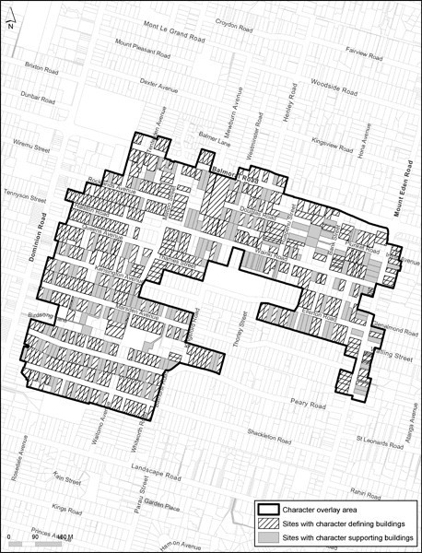

Map 2: Residential Balmoral West
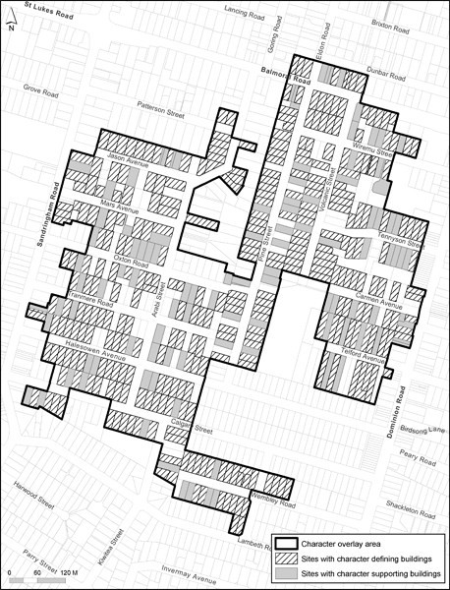

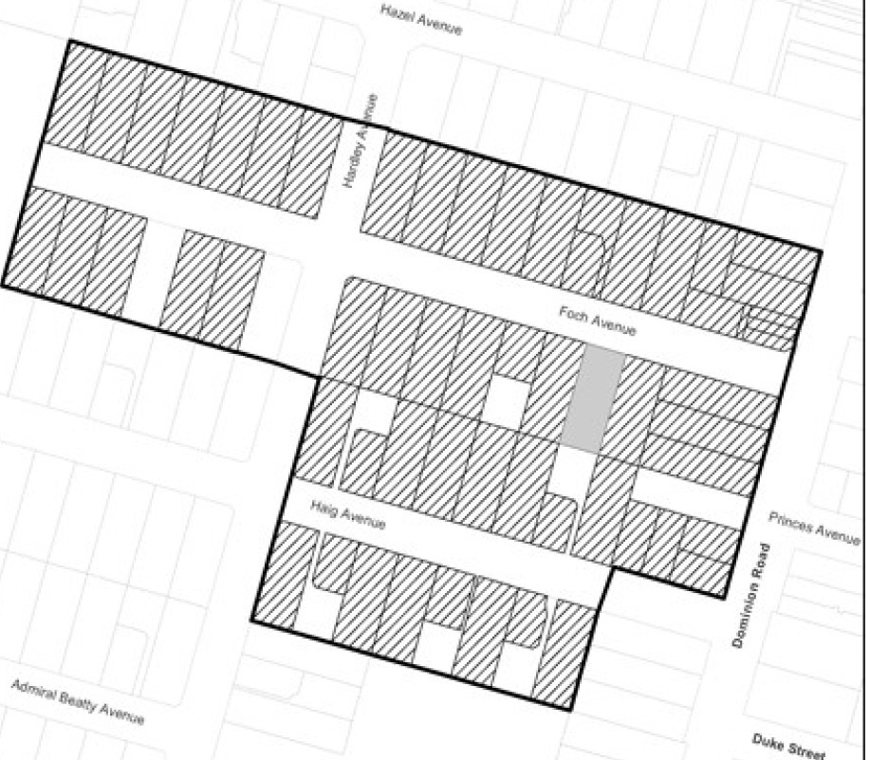Map 3: Foch- Haig Ave

C]c a•l!l(;ll!t' atl!lll
Slb>s wilh c:hamctor de6nq' buillllng'
$Ia$ wt.h chamctor $llpportlng buldn

Map 4: Station Road, Manukau
