PART 3 ­ REGIONAL AND DISTRICT RULES»Chapter J: Overlay rules»4 Built Environment»

4.1 Auckland War Memorial Museum Viewshaft

Activity | Activity Status
Development (where it penetrates the floor of the viewshaft)
Minor infrastructure upgrading | P
Operation, repair and maintenance of existing network  utilities | P
Road lighting and support structures | P
Traffic and direction signs, road name signs | P
Traffic signals and support structures | P

- Development controls

1.1 Height

  - Buildings, structures, parapets, chimneys, communication devices, tanks or building services components, ornamental towers, lift towers or advertising signs that exceed the height limits specified on Figures 1­3 within the areas identified on the planning maps to protect views to or from the Auckland War Memorial Museum without a resource consent.

  - Development that does not comply with this control is a non­complying activity.

Figure 1
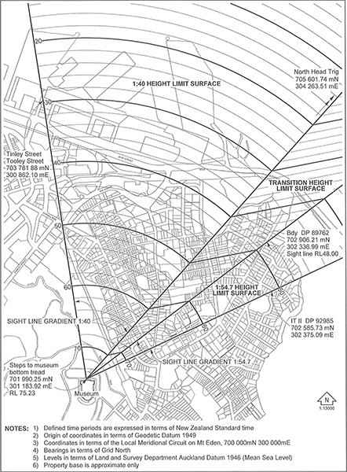

Figure 2
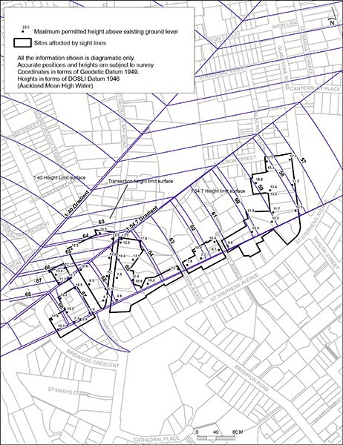

Figure 3
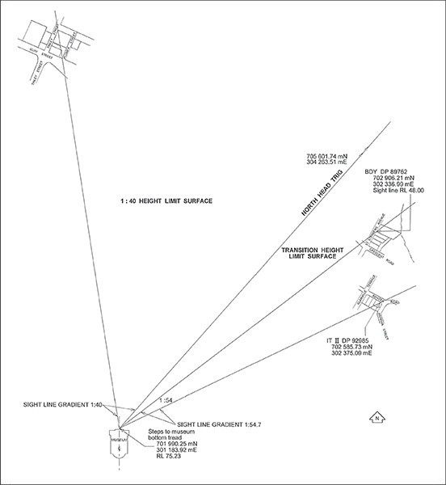

  - Building coverage

    - For sites where the view protection height limit surface is lower than the height limit in the underlying zone, the maximum building coverage is 40 per cent, unless a greater building coverage is allowed in the underlying zone.

Minor infrastructure upgrading and operation, repair and maintenance of existing network utilities

    - Maximum height no greater than 25m or 10 per cent in addition to the existing height of the structure whichever is the lesser.

Assessment ­ Non­complying activities

  - Height
    - While not limiting its discretion in assessing such applications, the council will consider the particular matters specified for a non­complying activity listed below:

i.

ii.
the nature, extent and form of the proposed non­complying feature

the extent to which the proposed non­complying built element will obscure the protected view

to and from the museum

iii.
the extent to which the proposed non­complying element constitutes a visually competing intrusion into the foreground or background of the unencumbered view to and from the museum.

    - Conditions may be imposed on any consent to a non­complying activity to ensure that the integrity of views to the museum are not jeopardised.

