PART 3 ­ REGIONAL AND DISTRICT RULES»Chapter K: Precinct rules»2 Central»

2.19 Saint Heliers

- Activity table

The activities in the Local Centre and Mixed Housing Urban zones apply in the St Heliers precinct unless otherwise specified in the activity table below.

Activity | Activity status
Development
Substantial demolition of buildings where resource consent has been granted for a  replacement building | C
Substantial demolition of buildings where resource consent has not been granted for a  replacement building | D
Additions and alterations | RD
New buildings | RD
Development of the site at Pt 24 & 25 BLK DP 410 CT NA623/103 (448m2) and PT 24 & 25 BLK DP410 CT NA 624/111 (465m²) which exceeds the Frontage Setback Control in Figure 1  below | RD

Notification

  - The notification provisions of the Local Centre and Terrace Housing and Apartment Buildings zones apply within the precinct except as outlined below.

  - The following activities are subject to the normal tests for notification under the relevant sections of the RMA:
    - Development which infringes clause 3.1 below, except at Pt 24 & 25 BLK DP 410 CT NA623/103 (448m2) and PT 24 & 25 BLK DP410 CT NA 624/111 (465m²).

Development controls

3.1 Frontage setback control and maximum height

  - Buildings must not exceed 8.5m in height within 2.5m of the site frontage (refer to figure 1 below), except where:
    - the construction of a balcony or parapet penetrates the frontage setback control by no more than 1.5m.

    - the construction of a roof penetrates the frontage setback control, provided it is no more than 9.5m high.

  - Where buildings or parts of buildings are not within 2.5m of the street boundary, they must not exceed 12.5m and 4 stories in height. Refer to figures 2 and 3 below for an explanation of the exceptions to this development control.

  - Development that does not comply with clauses 3.1.1 and 3.1.2 is a discretionary activity.

Figure 1: Frontage set back control
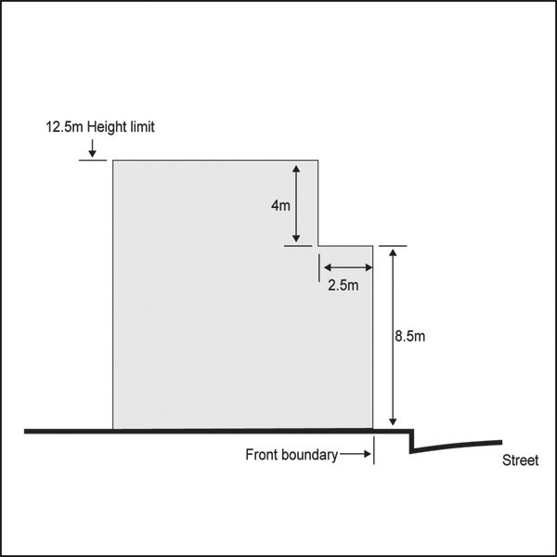

Figure 2: Frontage set back control – balcony exception
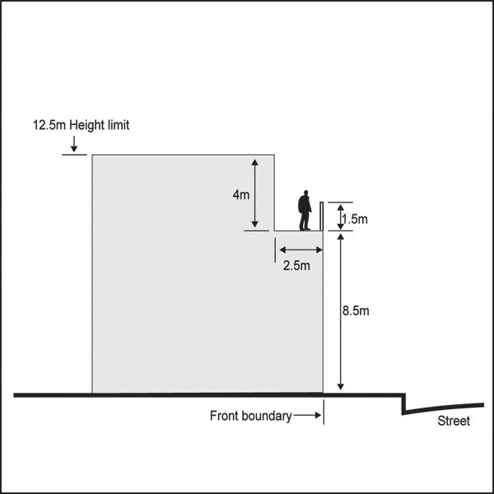

Figure 3: Frontage set back control – roof exception
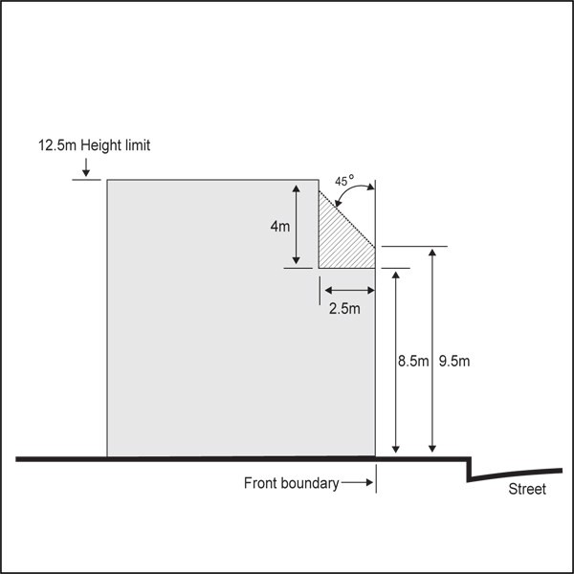

  - Access and car parking

    - New vehicle crossings must not be located on sites that front:
      - Tamaki Drive, St Heliers Bay Road and the north side of Polygon Road between Maheke Street and St Heliers Bay Road

      - Maheke Street, Turua Street and the north side of Polygon Road between St Heliers Bay Road and Lombard Street where vehicle access for car parking and loading is available by other means, such as rear service lanes, right­of­ways or from side roads.

    - Car parking and loading spaces, including car parking buildings, must not front Tamaki Drive, St Heliers Bay Road, Turua Street, Polygon Road, or Maheke Street.

    - Development that does not comply with clause 3.2.1 and 2 above is a discretionary activity.

Assessment ­ Controlled activities

4.1 Matters of control
The council will reserve its control to the matters below for the activities listed as controlled in the precinct table:
  - Substantial demolition of buildings where resource consent has been granted for a replacement building:
    - timing

    - dust, safety and amenity effects.

Assessment criteria
The council will consider the relevant assessment criteria below for the controlled activity listed above.
    - Timing
      - The timing of the demolition should be closely linked with commencement of a replacement building on the site.

    - Dust, safety and amenity effects
      - Construction, safety and visual amenity effects arising between demolition and commencement of a replacement building should be minimised.

Assessment ­ Restricted discretionary activities

5.1 Matters of discretion
For activities/development that are a restricted discretionary activity in the St Heliers precinct, the council will restrict its discretion to the following matters, in addition to the matters specified for the relevant restricted discretionary activities in the Local Centre and Mixed Housing Urban zones.
  - St Heliers precinct character.

Assessment criteria
    - St Heliers precinct character
      - Additions and alterations should maintain the integrity of existing buildings on the site. In particular, consideration should be given to the overall building footprint, form, mass, scale, proportions, its relationship to the street and its overall contribution to the character of St Heliers.

      - Detailed design features should be compatible with key architectural features of the existing building.

      - Materials and colours should be compatible with the existing building.

      - The design of verandahs should be compatible with the architectural form of existing or surrounding buildings.

      - New buildings should respond to the elements that contribute to the character of St Heliers and have regard to:

i.

ii. iii.
the contribution any existing building on the site previously made to the character of St Heliers as described in Appendix 11.2.1 St Heliers character statement

where the site is located

the existing or original street subdivision pattern and the extent to which buildings are articulated to avoid potential adverse effects of scale and bulk.

      - The visual interest at street level should be maintained in order to enhance the pedestrian amenity of the street environment. Buildings should be designed to front streets, concentrating main entrances and windows on frontages facing the street.

      - Where appropriate incorporate a recessed street frontage to create transition space for outdoor dining, seating, planting or other uses.

      - The scale of proposed building elements should be compatible with that of existing buildings in
the vicinity. In particular, where a proposed building is higher than an existing adjoining building, to reduce the dominance of upper levels consideration should be given to differentiating upper
storeys from lower storeys. For example, this can be achieved by setback from the frontage, change of building form, change of building materials/colour, or by other appropriate design variation.

      - Roof design should maintain or contribute to the varied roofscape of the centre as viewed from the surrounding residential area.

      - Rooftop projections including towers, chimneys, lift towers, machinery rooms, air conditioning equipment, ventilation ducts and equipment, or water towers should be integrated in an architecturally attractive manner as part of the overall design of the building.

      - In the case of Polygon Road and Turua Street, buildings should address the topographical difference at the south­eastern end where these streets intersect. Buildings may sit higher at the Polygon Road level and follow a reducing height towards the north.

      - Site development should respond to features of the surrounding context including: topography, streetscape character, scale and pattern of the public/private interface.

      - On­site car parking and vehicle circulation areas should not visually dominate views of the site from the surrounding public realm.

      - For development across two or more sites, including amalgamated sites:

i.

ii.

iii.
the clarity of the grid­like structure should be maintained or enhanced

the number, variety, scale and quality of public spaces, such as streets, lanes, alleys, squares and/or parks, are maintained or enhanced

pedestrian permeability and comfort should be maintained or enhanced.

      - Where, in new development, including additions and alterations to existing buildings, where the frontage setback control is exceeded.

i.

ii.

iii.

iv.
buildings should be visually and physically differentiated from the lower levels generally at the 8.5m frontage.

buildings should address the spatial relationship of the built form to the street and have regard to the location and context of the site.

upper levels of the building should be set back from the street frontage and articulated to avoid dominance of the upper levels and to maintain the characteristic open aspect ratio of built form to the street.

the design of buildings should include a visually 'light' upper level structure.

