PART 3 ­ REGIONAL AND DISTRICT RULES»Chapter K: Precinct rules»2 Central»

2.4 Central Park

The activities, controls and assessment criteria in the Business Park zone apply unless otherwise specified below.

Any activity not listed as permitted, controlled, restricted discretionary, or discretionary in this precinct or in the underlying Business Park zone is a non­complying activity.

Activity table

Activity | Activity status
Accommodation
Dwellings | D
Visitor accommodation | D
Commerce
Food and beverage not exceeding 250m2 of GFA per building | P
Food and beverage exceeding 250m2 of GFA per building | D
Retail not exceeding 250m2 GFA per building, provided any single tenancy does not exceed  150m2 of GFA | P
Retail exceeding 250m2 GFA per building, provided any single tenancy does not exceed  150m2 of GFA | D
Gymnasiums and accessory facilities not exceeding 250m2 of GFA per building | P
Gymnasiums and accessory facilities exceeding 250m2 of GFA per building | D
Accessory parking to permitted activities | P
Entertainment facilities | D
Community
Healthcare facilities | P
Development
New buildings | RD
External additions and alterations to buildings | P
Construction of streets | C
Subdivision
Subdivision | D

- Land use controls

2.1 Entertainment facilities

  - New entertainment facilities must be ancillary to the dominant office activity on the site.

Buildings

    - New buildings which exceed the height development control at clause 3.2 below but meet all other development controls are a restricted discretionary activity.

    - New buildings that do not comply with clause 1 above are a discretionary activity.

Development controls

  - Any activity that does not comply with one or more development controls below is a discretionary activity.

External alterations and additions to buildings

    - External alterations and additions to buildings must:
      - be non­structural

      - not increase the development area by more than 2.5 per cent

      - not increase the height of the building.

Building height

    - Buildings must not exceed the heights specified in the table below:

Table 1

Building development areas | Height above mean sea level | Height above ground level  (average)
A | 44.2m | 19.8m
B | 53.3m | 30.4m
C | 73.0m | 48.0m
D | 90.0m | 67.9m

    - The location of the building development areas within the precinct are shown on precinct plan 1.

    - Building height coordinates are shown on Precinct plan 3 – building height coordinates.

    - The height above mean sea level method is the prevailing maximum height measure.

Yards

    - 6m front, side and rear yards are required where a site adjoins a residential or open space zone.

    - Where a yard is required it must be satisfactorily landscaped and maintained to promote a good standard of visual amenity.

    - Clause 3.3.1 above will be satisfied by the provision of a 3m wide strip of landscaping adjacent to the length of the required yard's boundary.

Roof tops

    - In development areas A, B and C:
      - Rooftop projections must not exceed the maximum building height by more than 10 per cent.

      - The total area of rooftop projections must not exceed 10 per cent of the total roof area.

Site intensity

    - Prior to 2016, the GFA of buildings within the precinct must not exceed 60,000m2.

    - The maximum FAR for building development areas A, B, C and D is 1.8:1 and the GFA of buildings within the precinct must not exceed 114,000m2.

    - Within the maximum FAR, the GFA of the following activities must not exceed 3,500m2 for:
      - gymnasiums and accessory facilities

      - food and beverage

      - retail provided that the total GFA for retail must not exceed 2000m2

    - The GFA of buildings within the precinct must not exceed 85,000m2 until buildings on the eastern frontage of building development area A have been constructed in accordance with clause 3.7 below.

Glazing

    - On every frontage identified as transparency on precinct plan 2, the ground floor of a building must:
      - have clear glazing for at least 50 per cent of its width and 75 per cent of its height, excluding repair and maintenance services

      - not have blank walls that exceed 7m in length. Blank walls include solid walls, ventilation louvers, garage doors, shelving and reflective glass.

Buildings fronting the street

    - On every frontage identified as pedestrian orientated area on precinct plan 2, buildings must adjoin the site frontage for at least 80 per cent of the length of the pedestrian orientated area.

    - Where part of a building is set back from the site frontage, the area must be an open space, landscaped or used as an outdoor eating area or similar.

Ground floor activities

    - On every frontage identified as pedestrian orientated area on precinct plan 2, the activities listed below must occupy 100 per cent of the ground floor of the building for a depth of at least 5m:
      - gymnasiums and associated facilities

      - retail

      - food and beverage

      - lobbies

      - care centres

      - healthcare facilities.

Activity buffers

    - A solid screen at least 1.8m high must be erected to screen any outdoor storage or refuse disposal area that faces the street.

    - The screen must be constructed of concrete, brick, stone, timber or other permanent material.

Timing of development

    - The total GFA permitted is 60,000m2 until 2016 to limit any adverse traffic effects on the Ellerslie­ Panmure Highway interchange.

    - GFA above 60,000m2 will be considered as a restricted discretionary activity with regard to traffic and transportation effects.

    - From 2016 the total GFA will be 114,000m2.

Upper and lower storey setbacks

    - A minimum distance between buildings must be provided as follows:
      - for the portion of the building façade located between ground level and 13m above ground level: 18m

      - for the portion of the building façade located more than 13m above ground level: 24m.

    - Figures 1 – 4 below illustrate how the control is applied.

    - An existing or consented building will set the building line on one side of the street, and any future building setback must comply with clause 1 above.

    - Parking structures (except the parking structure along the eastern frontage of building development area A) will not set the first building line.

Figure 1: Method 1 of complying with the upper and lower storey setback control
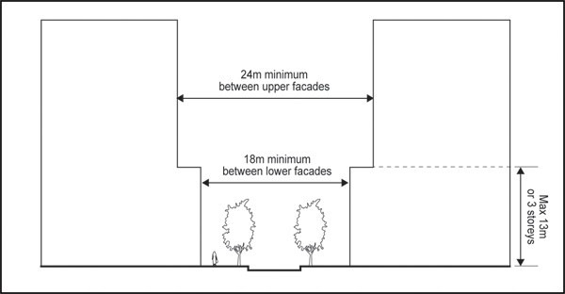

Figure 2: Method 2 of complying with the upper and lower storey setback control
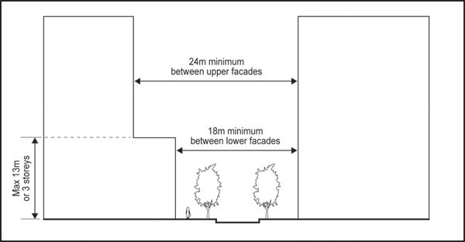

Figure 3: Method 3 of complying with the upper and lower storey setback control

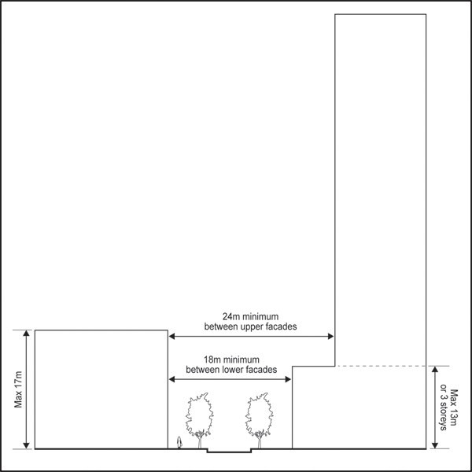

Figure 4: Method 4 of complying with the upper and lower storey setback control

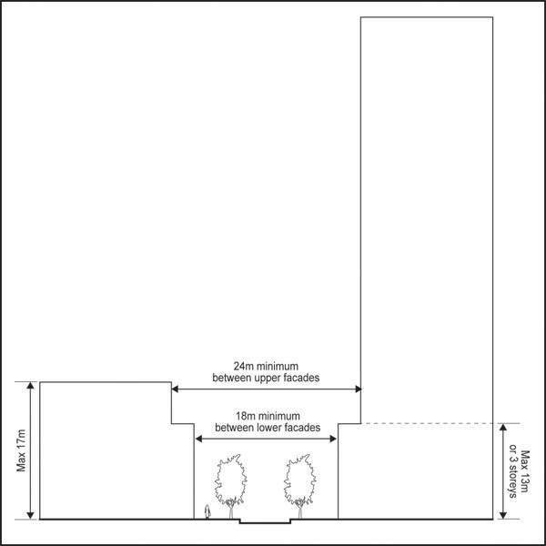

  - Pedestrian plaza and landscaped amenity spaces

    - The indicative pedestrian plaza and indicative landscaped amenity spaces must be provided in the general locations shown on precinct plan 2.

    - The pedestrian plaza must have a minimum area of 600m² (excluding footpaths on road frontages) and must be provided by the time the first building in the precinct is constructed.

    - A minimum of 10 per cent of the total developable area of the precinct (excluding internal road corridors) must be provided as landscaped amenity spaces. The landscaped amenity spaces may comprise:
      - pedestrian plaza areas

      - pocket parks i.e. small parks and breakout areas

      - stormwater retention ponds where they are designed for dual purpose as amenity features.

Footpaths in the pedestrian oriented area

    - Footpaths within the pedestrian oriented area must be a minimum of 1.8m wide on both sides of the street.

    - This control does not apply to existing or consented footpaths as at June 2010 that do not comply with this control.

Pedestrian connections

    - Pedestrian connections must be provided and maintained throughout the site, generally in the locations shown on precinct plan 2. The following pedestrian connections must be provided:
      - an at grade pedestrian link as shown on precinct plan 2

      - internal pedestrian links as shown on precinct plan 2

      - signage at the Great South Road and Sultan Road entrances to the pedestrian connection advising the public of the availability of the link, subject at all times to any temporary restrictions that may reasonably be required to be imposed for security purposes.

    - Any development on the site must not prevent or impede the creation of an upper level pedestrian link over the motorway to connect to Ramsgate Street.

    - Pedestrian connections must be provided as part of the development or redevelopment of the building development areas.

Vehicle access over footpaths

    - Vehicle entries and exits to the precinct must be in the locations shown on precinct plan 2.

    - Vehicle crossings within the site must comply with the relevant controls in the Auckland­wide Transport rules and the following:
      - vehicle crossings must not exceed one for every building frontage facing the pedestrian orientated area

      - vehicle crossings must not exceed two for every building frontage that does not face the pedestrian orientated area

      - vehicle crossings at the internal street frontage must not exceed 6m in width.

Car parking

    - Car parking in the precinct must comply with the following controls and Figure 5: Car parking ratios below.
      - Car parking above the 1,815 car parking spaces existing on the site in June 2010 must not be provided if the GFA of buildings in the precinct is 72,600m2 or less.

      - When the GFA of buildings in the precinct exceeds 72,600m2 one additional car parking space may be provided within the precinct per 40m2 of additional GFA. The total car parking spaces within the precinct must not exceed 2,850 and an effective car parking ratio of one space per 224m2.

Figure 5: Car parking ratios
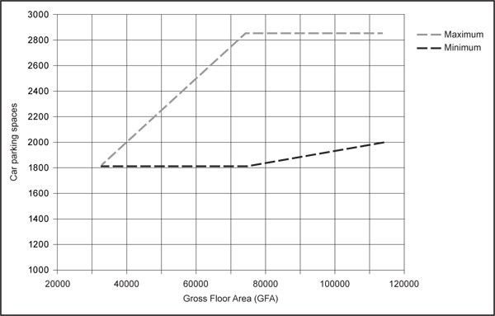

- Subdivision controls

4.1 Easements

  - Overland drainage easements must be surveyed and registered against the certificate of title for the sites generally in the locations shown on precinct plan 4. Any existing easements (as at June 2010) that are obsolete must be removed from the certificate of title at that time.

Assessment ­ Controlled activities

Matters of control
The council will reserve its control to the matters below for the activities listed as controlled in the activity table.
    - Construction of streets
      - Pedestrian amenity traffic calming measures.

Assessment criteria
The council will consider the relevant assessment criteria below for the controlled activities listed above.
    - Construction of streets
      - Internal roads should be designed as pedestrian oriented, encouraging slow movement of vehicles and providing a high level of pedestrian priority and amenity.

      - The traffic calming measures to be implemented should encourage the slow movement of vehicles and enhance pedestrian safety, including narrower than usual traffic lanes, tight tracking curves, textured road surfaces and/or other accepted traffic engineering mechanisms.

      - A high quality, high amenity, pedestrian environment should be achieved on both sides of the street by the use of such design elements as, and the coordinated use of, high quality materials, street furniture, landscaping, signage and lighting.

Assessment ­ Restricted discretionary activities

6.1 Matters of discretion
The council will restrict its discretion to the matters below for the activities listed as restricted discretionary in the activity table.
  - New buildings
    - the matters set out for the same activity in the Business Park zone

    - pedestrian connections and vehicle access

    - pedestrian amenity.

Assessment criteria
The council will consider the relevant assessment criteria below for the restricted discretionary activities listed above.
    - New buildings
      - Pedestrian connections and vehicle access

i.

ii.
Pedestrian links through buildings should be provided where these will provide short and convenient pedestrian routes.

Pedestrian links through the ground floor of buildings should:

        - be overlooked by adjacent uses

        - be lined by internal walls which contribute to visual interest and pedestrian safety

        - include a variety of architectural detail and maximise building entrances and glazing

        - minimise blank walls

        - adopt CPTED principles (i.e. avoid potential entrapment areas and deep recesses)

        - avoid chicanes which limit natural surveillance

        - provide adequate internal lighting.

      - Pedestrian amenity
- The pedestrian plaza and landscaped amenity spaces should:
  - be visible from the pedestrian routes on the site and overlooked by buildings to maximise personal safety

  - be lined with active edges on the ground floor in the case of the pedestrian plaza

  - be landscaped with soft and hard landscape elements

  - include adequate seating, lighting, signage and street furniture

  - feature high quality materials and robust detailing.

ii.
In addition, street trees and other landscape elements should also be provided to achieve the following:

  - visual enhancement of internal private roads and pedestrian routes

  - screening of parking areas where these are visible from the pedestrian routes.

iii.
Outdoor storage and refuse disposal areas should be avoided in the pedestrian oriented area.

Assessment ­ Development control infringements

Matters of discretion
In addition to the general matters in clause 2.3 of the general provisions, the council will restrict its discretion to the following matters specified:

1.

2.

3.

4.

5.

6.

7.

8.

9.

10.

11.

12.

13.

14.

15.
Rooftops

Upper and lower storey setbacks Building form and articulation Gateway and landmark features Building height
Glazing, buildings fronting the street, ground floor activities

Pedestrian connections, pedestrian plaza and landscape amenity areas Vehicle access over footpaths
Activities

Infrastructural constraints Sustainability
Crime prevention Travel management Flooding
Car parking

Assessment criteria
The relevant assessment criteria in the Business zones rules and the Auckland­wide Transport rules, will be considered as they relate to the matters of discretion listed above for the particular development control infringement.
- Roof tops
  - roof profiles should be designed as part of the overall building form

  - roof profiles should contribute to the architectural quality of the skyline as viewed from ground level and higher surrounding buildings

  - plant, exhaust and intake units as well as other mechanical and electrical equipment should be integrated into the overall rooftop design wherever possible.

- Upper and lower storey setbacks
  - buildings that do not comply with the upper and lower storey setbacks will need to demonstrate that the proposed height, scale, location and design does not adversely affect the:

i.

ii.

iii.

iv.
precinct character of predominately 18m setbacks along the lower storeys, and 24m setbacks along the upper storeys, of buildings

daylight and sunlight access to pedestrian connections, specifically pedestrian oriented areas, and surrounding buildings, sites and the proposed building

human scale, and dominate pedestrian connections, when viewed from pedestrian connections or other locations (both within and outside the precinct)

views from pedestrian connections and buildings within the precinct, and other locations

v. pedestrian connections throughout the precinct.

- Building form and articulation
  - the exterior design and appearance of the building should contribute to the avoidance of adverse building bulk and dominance effects:
    - methods to moderate the apparent bulk of the building include the consideration of articulation of the exterior form and surface treatment of the building

  - the building should create a human scale environment at street level

  - rooftop projections including towers, turrets, chimneys, lift towers, machinery rooms which exceed the parapet or roof height should be compatible with the overall architectural form and detailing of the building

  - similarity in facade design and materials and continuity in form and appearance of canopies with the facades of other buildings is encouraged

  - signage on the building should be incorporated as part of the building design

  - pedestrian connections throughout the precinct should be landscaped.

- Gateway and landmark features
  - buildings on highly visible locations should be designed to feature architectural accents such as special architectural features, articulation, extra glazing or lighting.

- Building height
  - Refer to the matters of discretion for bulk and location controls in the Business zone rules.

- Glazing, buildings fronting the street, ground floor activities
  - refer to the matters of discretion for street frontage controls in the Business zones rules.

- Pedestrian connections
  - buildings should be designed to provide strong architectural cues to building entrances and through­site links to enhance a visible sense of pedestrian access throughout the precinct

  - the design of ingress and egress should be primarily considered from the perspective of pedestrians, particularly in terms of visibility and the choice of paving materials

  - refer to the matters of discretion for amenity controls in the Business zones rules.

- Vehicle access
  - vehicle accesses to servicing and parking areas should be located so as to avoid multiple interruptions to building frontages

  - vehicle and pedestrian accessways should be clearly separated

  - the location of vehicle access along the pedestrian orientated area is discouraged and should only be considered where no alternative access point is available

  - refer to the matters of discretion for infringing the vehicle access controls in the Auckland­wide rules ­ Transport.

- Activities
  - buildings should be designed to maximise outlook onto streets and open spaces for the activities conducted inside

  - activities are encouraged which engage and activate the street at ground level

  - parking areas inside buildings should be designed so that they are not visible from streets or open spaces in pedestrian orientated areas

  - activated building space should be provided between car parking areas in buildings and street and open space frontages.

10.

Infrastructural constraints

- the precinct must be able to sustain the infrastructural servicing needs of the contributing catchment including the development (e.g. drainage)

- where the existing infrastructure cannot sustain the new development's whole contributing catchment, the proposal must demonstrate an ability to meet the needs of the whole contributing catchment together with its own servicing needs

- a condition requiring this to be achieved through the physical provision of infrastructure may be imposed by the council.

11.

Sustainability

- buildings should be designed to be sustainable through the use of durable low maintenance materials, inert exterior cladding (avoiding the use of materials containing copper or zinc), maximising solar access and natural ventilation and the incorporation of mechanical and electrical systems that optimise energy efficiency

- onsite landscaping should consist of indigenous vegetation where appropriate

- on­site stormwater conservation measures should be incorporated where appropriate including rainwater harvesting devices, green roofs, site landscaping, rain gardens and wetland treatment systems and stormwater planter boxes (subject to soil contamination considerations)

- adequate storage space and containers must be provided for rubbish and recyclable materials in a location which is clearly visible on the site and easily accessible for occupants and collection vehicles

- building and demolition should be undertaken in a way that maximises the use of waste materials for reuse and recycling.

12.

Crime prevention

a. the proposal should be in accordance with crime prevention through environmental design principles.

13.

Travel management

- the proposal should encourage the use of public transport, walking and cycling through the provision of facilities and 'green building' initiatives such as travel plans, showers and covered cycle parking

- the proposal should provide for small vehicle parking in accordance with the Green Building council's standards

- an enforceable travel plan for the site should be implemented or proposed and other methods should be proposed to promote the use of public transport, car sharing or travel by modes other than private cars.

14.

Parking

- the parking ratio should not be exceeded. If ratios are exceeded, a more than minor adverse effect on the capacity of the adjacent road network (and internal road network) caused by the predicted traffic generation of a proposal, under the precinct provisions, may require mitigation by upgrading of the internal or external roading network

- unless it can be demonstrated that they are not required, the measures listed below must be implemented to manage the traffic effects generated by the redevelopment of the site:
  - a second signalised right turn into the site from Great South Road

ii.

iii. iv.
queue detection and/or electronic signage to manage right turn queues into the site from Great South Road

at the existing signalised site access (north) – a double right turn into and out of the site

internal road upgrades required to meet internal traffic flow demands, including (but not limited to):

    - two lanes being provided in both directions between the Great South Road northern site access to the onsite roundabout

    - installation of a solid median extending from the signals at the northern site access to beyond the first park entrance, approximately 90m (with a gap to allow access to the site north of the Central Park precinct)

    - speed tables on approaches

- conditions of consent requiring any of the traffic management measures in criteria b above may be imposed when individual applications for resource consent for individual buildings (or groups of buildings) are granted. Traffic monitoring may also be required as a condition of consent

- refer to the matters of discretion for exceeding the maximum car parking ratio in the Auckland­ wide rules Transport section of the Unitary Plan.

15.

Flooding

a. Floor levels and the layout of proposed buildings require specific design to account for the flood hazard on the site.

Special information requirements

  - Traffic impact assessment and travel plan
    - Resource consent applications that involve traffic movements and/or additional traffic on the site, including a proposal to increase the existing 1,815 car parking spaces, must be accompanied by a traffic impact assessment and travel plan.

    - The traffic impact assessment lodged with an application must address the following specific matters in addition to the general requirements:

i.

ii.
the baseline (current capacity) of the road network, and the expected traffic generation of the proposal

the current and/or proposed travel plan including details of the use by all those working at the site of alternative forms of transport including private vehicles, walking, cycling and public transport and including detail of any approved travel plans that apply to the site.

  - Site plan
    - Resource consent applications for individual buildings or groups of buildings must be accompanied by a site plan.

    - The site plan should provide the context for consideration of the application, particularly where development of the site is staged.

    - The site plan should include parking, vehicle, and pedestrian connections and landscaped amenity spaces as they relate to the relevant stage of development and their relationship with the remainder of the site and the precinct.

  - Landscaping and amenity plan
    - Resource consent applications for new buildings must be accompanied by a landscaping and amenity plan.

    - The landscaping and amenity plan must show how the proposed buildings will satisfy the relevant

development controls in clause 3 above.

Precinct plans

Precinct plan 1: Central Park Building heights
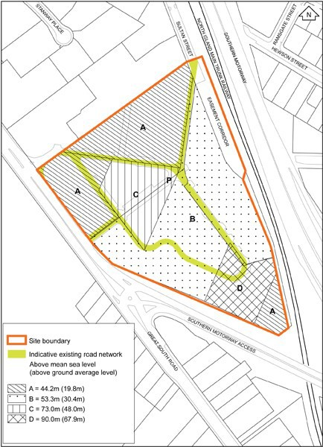

Precinct plan 2: Central Park urban design framework
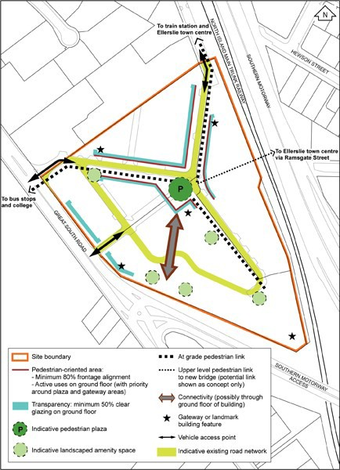

The Proposed Auckland Unitary Plan (notified 30 September 2013)

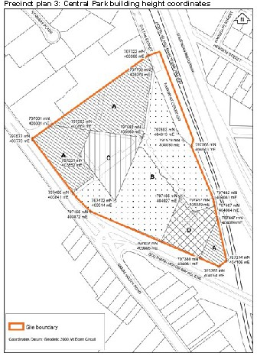

Precinct plan 4: Central Park existing and indicative proposed overland drainage easements
