PART 3 ­ REGIONAL AND DISTRICT RULES»Chapter K: Precinct rules»2 Central»

2.6 Ellerslie 1

- Activity table

Activity | Sub­precinct A | Sub­precinct B | Sub­precinct C | Sub­precinct  D
Accomodation
More than 25 dwellings | RD | RD | RD | NC
Fewer than 25 dwellings | NC | NC | NC | NC
Retirement villages | RD | RD | RD | NC
Supported residential care | D | D | D | NC
Visitor accommodation | D | D | D | NC
Commerce
Conference facilities | D | NC | NC | NC
Entertainment facilities | D | NC | NC | NC
Organised sport and recreation | D | NC | NC | NC
Car parking (non­accessory) | D | NC | NC | NC
Restaurants and cafes | D | NC | NC | NC
Community
Care centres | D | D | D | NC
Healthcare facilities | D | D | D | NC
Horse racing, including accessory television  towers | NC | P | NC | NC
Overflow car parking associated with events  on the Ellerslie Racecourse land | P | P | P | P
Community facilities | D | D | D | NC
Temporary activities associated with horse  racing | P | P | P | P
Subdivsion
Subdivision of land | D | D | D | NA
Development
Any activity in/on/above or under the dripline which endangers trees identified in Table 1  and shown on the precinct plan 2 | NA | RD | NA | NA
Cutting, damaging, altering, injuring, destroying, or partially destroying, or removing any of the trees identified in Table  1 and shown on the precinct plan 2 | NA | RD | NA | NA
Modifications to the existing stone walls on the Morrin Street and Mitchelson Street frontages to the extent identified on the  precinct plan 2 | NA | C | NA | C

Trimming the canopy of any tree identified in  Table 1 and shown on the precinct plan 2 | NA | P | NA | NA

- Land use controls

  - The land use controls in the relevant underlying zone apply in the Ellerslie 1 precinct unless otherwise specified below.

Maximum density

    - Dwellings must not exceed one per 110m² net site area.

    - Net site area is the area of the site excluding the area of an adjoining private road. For the avoidance of doubt, the net site area in sub­precincts A, B and C are those areas marked A, B and C on the precinct plan.

    - Development that does not comply with clauses 1 and 2 above is a discretionary activity.

Development area

    - Resource consent applications for more than 25 dwellings must comprise either the whole of sub­ precinct A or C or cover an area (including access roads) of at least 1ha within, or comprising the residue area of sub­ precinct B.

    - Development that does not comply with clause 1 above is a non­complying activity.

Horse racing

    - Horse racing must be undertaken within the area identified as 'intermittent racecourse use’ on the precinct plan.

    - Horse racing within sub­precinct B that does not comply with clause 1 above is a restricted discretionary activity.

    - Horse racing within sub­precincts A, C and D that does not comply with clauses 1 above is a non­ complying activity.

Temporary activities associated with horse racing

    - Temporary activities associated with horse racing must be accompanied with temporary facilities such as marquees and mobile toilets. These are to be located within 30 metres of the adjoining Major Recreation Facilities zone boundary.

Development controls

  - The development controls in the relevant underlying zone apply in the Ellerslie 1 precinct unless otherwise specified below.

  - An application to infringe the development controls in this section, with the exception of clause 3.12 below will be considered as a discretionary activity.

  - An application to infringe clause 3.12 will be considered as a non complying activity.

  - Development controls 3.1 ­12 apply to sub­precincts A­D. Development control 3.13 applies only to sub­precinct E. Development controls 3.14 ­ 16 apply to the entire precinct.

Height

    - Buildings must not exceed the heights specified below, excluding basement parking:
      - Sub­precinct A: 26m – eight storeys

      - Sub­precinct B: 20m – six storeys

      - Sub­precinct C: 14m ­ four storeys.

    - Buildings must be constructed to achieve the minimum heights specified below, excluding basement parking:
      - Sub­precincts A and B: 14m – four storeys

      - Sub­precinct C: 12m – three storeys.

Yards and building setbacks at upper levels

    - Front yard: 2.5m.

    - Where sites adjoin the Mixed Housing Suburban zone, buildings must be set back at least 3m from side and rear boundaries for storeys one and two and 5m for storeys three and four.

    - Where development is separated from land zoned Major Recreation Facilities by a private road or private way, or immediately adjoins land zoned Major Recreation Facilities, clause 2 above does not apply.

Maximum impervious area, building coverage and landscaping

Table 1

Sub­precinct | Maximum impervious area (of net site area) | Maximum building coverage (of net site  area) | Minimum landscaped area (of net site area)
A | 60% | 55% | 40%
B | 60% | 35% | 40%
C | 60% | 55% | 40%

Outdoor living space for dwellings in retirement villages

    - Retirement villages must provide outdoor living space for each dwelling as follows:
      - at least 6m² for each studio and one­bedroom dwellings

      - at least 10m² for each dwelling with two or more bedroom

    - The outdoor living space must have a minimum dimension of 3m in length.

Sightline from the existing grandstand to 2400m start­line

    - No part of any building can extend north­east of the sightline as illustrated in the precinct plan.

Building line

    - No buildings maybe constructed south­west of the building line which runs near parallel with Morrin Street

    - No buildings maybe constructed east of the building line which runs in a northerly direction towards the 2400m start chute.

Required building frontage

    - In those areas identified as the required building frontage in the precinct plan, the adjoining building facades must be set back:
      - no less than 3m and no more than 5m from the nearest private road boundary

      - no less than 3m and no more than 5m from the building line located close to the 2400m race start chute.

Maximum building length and minimum building separation

    - Within sub­precinct B, buildings that adjoin a required building frontage must:
      - not exceed 70m in length

      - have a minimum separation distance between buildings of 15m.

Distance to existing buildings within the adjoining Major Recreation Facilities zone

    - A minimum separation of 15m is required between any new buildings within sub­precinct A and any existing buildings within the adjoining Major Recreation Facilities zone.

Internal private roads and private ways

    - Internal private roads must be constructed to provide access within the precinct and must be laid out in general accordance as shown in the precinct plan.

    - The private road must be built in accordance with the engineering standards and cross section profiles as set out in Auckland Transport’s code of practice.

    - Where private ways other than those shown in the precinct plan are proposed these must also be built in accordance with the engineering standards and cross section profiles set out in Auckland Transport’s code of practice.

    - The private roads shown in the precinct plan must be treated in the same way as public roads when applying the development controls of the underlying zone and Auckland­wide subdivision controls.

Landscaping area

    - The area between Morrin Street and the building line running generally parallel to it, which contains identified protected trees at 80­100 Ascot Ave, Greenlane which are listed below must be maintained as an informal open space.

Table 2

Precinct plan ref no. | Botanical name | Common name
1 | Quercus robur | English Oak
2 | English Oak palustris | Pin Oak
3 | Platanus x acerifolia | London Plane
4 | Quercus palustris | Pin Oak
5 | Ulmus sp. | Elm
6 | Ulmus sp. | Elm
8 | Platanus x acerifolia (x 11) | London Plane
9 | Ulmus sp. | Elm
10 | Corynaocarpus laevigatus (x 5) | Karaka
11 | Ulmus sp. (x7) | Elm

12 | Platanus x acerifolia | London Plane
13 | Quercus robur | Oak
14 | Corynocarpus laevigatus (x 5) | Karaka
15 | Acmena smithii (x 11) | Lilly Pilly
16 | Platanus x acerifolia (x2) | London Plane
17 | Corynocarpus laevigatus | Karaka
18 | Populus yunnanesis | Yunnan Poplar
19 | Corynocarpus laevigatus | Karaka

Fences on required building frontage

    - Any fence, wall or other structure erected within the required frontage areas as shown in the precinct plan must be no higher than 1.2m.

Special yards

    - Special yards must be provided within sub­precinct E, in accordance with precinct plan 1 and subject to the following:
      - a 2.5m front yard is required

      - except on sites other than rear sites not less than 60 per cent of that part of the site between the road boundary and a parallel line 6m there from shall comprise landscaped permeable surface.

      - the landscaping requirement applies on each frontage of a corner site.

    - Buildings maybe erected within the 5m side yard as shown in the precinct plan, provided that such buildings do not exceed a height of 3m.

    - Buildings maybe erected in the 8m rear yard as shown in the precinct plan, provided that such buildings do not exceed a height of 3m and a building coverage of 10 per cent of the rear yard.

Trimming the canopy of the protected tree

    - The trimming of the canopy of the protected tree identified in Table 1 above and shown on the precinct plan is permitted provided that:
      - the trimming does not damage the tree’s health,

      - no more than 20 per cent of live growth can be removed in any one year,

      - must be in accordance with currently accepted arboricultural practice, ensuring the natural form and branch habit of the tree species is maintained.

    - The trimming of any protected tree identified in Table 1 above and shown in the precinct plan that is to be undertaken by qualified arborists or arbiculturalist is permitted provided that:
      - the trimming of the canopy is no more than 30 per cent of live growth removal in any one year,

      - is in accordance with currently accepted arboricultural practise

      - ensure the natural form and branch habitat of the tree species is maintained.

Activity noise controls on adjoining residential properties outside the precinct

    - The L10 noise level and maximum level (Lmax) arising from any activity measured at or within the boundary of any residentially zoned property located outside this precinct shall not exceed the following limits on any days including public holidays:

- on any residentially zoned property on Mitchelson and Morrin Streets up to the intersection with Somerfield Street:

Table 3

Times | dBA Level
7.00am to 10.00pm | L10 55 dBA
10:00pm to 7:00am | L10 45 dBA  Lmax 75 dBA

- On any other adjacent residentially zoned property located outside this precinct (and not provided for by clause 3.15.1.a above):

Table 4

Times | dBA Level
8:00am to 8:00pm | L10 55 dBA  Lmax 85 dBA
8:00pm to 8:00am | L10 40 dBA  Lmax 75 dBA

The above noise levels must be measured at the boundary with adjacent residentially zoned land. Measurement and assessment shall be in accordance with the requirements of the NZS 680:1991 "Measurement of Sound" and NZS 6802:1991 "Assessment of Environmental Sound".

The noise levels must be measured with a sound level meter complying at least with the International Standard IEC 651 (1979): Sound Level Meter, Type 1.

Acoustic privacy for residential properties within the precinct

    - External residential noise levels
      - The L10 noise level and maximum level (Lmax) arising from any activity measured at or within the boundary of any residential zoned property shall not exceed the following limits:
Table 5

Monday to Saturday | 7.00am – 10.00pm | L10 50dBA*
Sunday & Public Holidays | 9.00am – 6.00pm
At all other times | L10 40 dBA*, Lmax 75dBA

      - noise levels may be exceeded by intermittent noise associated with normal household activity
(e.g. lawn mowing) undertaken at reasonable times during the day

      - The above noise levels shall be measured at the boundary with adjacent residentially zoned land.
Measurement and assessment shall be in accordance with the requirements of the NZS 680:1991 "Measurement of Sound" and NZS 6802:1991 "Assessment of Environmental Sound".

      - The noise levels shall be measured with a sound level meter complying at least with the International Standard IEC 651 (1979): Sound Level Meter, Type 1.

    - Internal noise levels within residential properties
      - The following internal noise levels within residential units will be required:
        - In all bedrooms:
          - 10.00pm – 7.00am, no more than 35dBA (L 10)

          - 7.00am – 10.00pm – no more than 45dBA (L 10)

          - In all other habitable rooms, no more than 45dBA (L 10)

      - at the same time and under the same physical conditions as the internal noise levels in clause
3.16.2.a above, all bedrooms and other habitable rooms will be adequately ventilated in accordance with the Building Code;

      - after completion of the construction of the building, the consent holder shall submit a report to the satisfaction of Council, which is signed by a suitably qualified engineer, and certifies that the building has been built in compliance with the noise and ventilation rules in clause 3.16.2.a and b above.

      - in assessing compliance with the ventilation requirements of the Building Code for the purposes of clause 3.16.2.b above, no source or means of ventilation shall be taken into account unless:
        - It is available at all times while achieving the internal noise levels required under clause
3.16.2.a of this rule. For example, adjustable doors, windows or louvers may not be relied upon to meet the ventilation requirements of the Building Code if they can be adjusted to allow internal noise levels to exceed those specified in clause 3.16.2.a of above.

      - any report signed by an engineer in accordance with part clause 3.16.2.b above, shall not be deemed to be a producer statement or the building certificate under the Building Act 2004, or be relied upon by the Council for the purposes of the Building Act 2004.

      - the noise shall be measured with a sound level meter complying at least with the International Standard IEC 651 (1979): sound Level Meter, Type 1.

Subdivision

  - The subdivision rules in the Auckland­wide rules apply for subdivision in the precinct unless otherwise specified below.

  - Any application for subdivision of land within the precinct must be lodged no later than the application for building consent on the subject land, and preferably contemporaneously with the application for resource consent.

  - There are no minimum frontage and site width requirements for the subdivision of sites within this precinct.

Assessment ­ Controlled activities

Matters of control
The council will reserve its control to the matters listed below for modifications to the existing stone walls on the Morrin Street and Mitchelson Street frontages:
    - The length of stone wall to be removed.

    - The extent and manner in which the removed stone is proposed to be reused.

Assessment criteria
    - The length of stone wall to be removed should be in accordance with the precinct plan or otherwise appropriate to achieve the purpose for which it is being demolished.

    - Any removed stones should be reused to form wall returns or gateways in the vicinity of where the stone originated.

    - The style of any proposed new stone walls should be the same or similar to the existing stone walls.

    - For walls removed from the vicinity of the Mitchelson and Morrin Streets intersection, the residual stone walls should provide adequate sightlines for traffic based on the new road alignment.

Assessment ­ Restricted discretionary activities

Matters of discretion
The council will restrict its discretion to the following matters, in addition to the matters specified for the relevant restricted discretionary activities in the relevant underlying zone:

Activity/matters of discretion | Design and layout | Design of car parking, access and  servicing | Traffic and roading | Tree modification or removal | Infrastructure and construction | Lava cavities
Any activity in, on, above or under, the dripline, which is likely to endanger, any tree identified in Table  1 and shown on the precinct plan 2 |  |  |  | X
Cutting, damaging, altering, injurying, destroying, or partially destroying, or removing any of the trees identified in Table 1 and shown on the precinct  plan 2 |  |  |  | X
More than 25 dwellings | X | X | X |  | X | X
Retirement villages | X | X | X |  | X | X

Assessment criteria
- Design and layout
  - development should be in general accordance with the precinct plan 2.

  - development should provide views between buildings into the racecourse from both the surrounding and internal roads.

  - in order to reinforce the curved geometry of the racetrack, development should result in a semi­ continuous series of medium­rise facade buildings which address the racetrack and align with the internal private road which runs generally parallel to the racetrack’s outer rail.

  - minor variance in the required setback is acceptable to avoid architectural monotony.

  - building heights should be varied within and between sub­precincts with gaps between lengths of longer building facades.

  - buildings should be generally simple in form, relying on elegant proportioning, façade composition and detail, including recesses, pilasters, balconies, changes in surface texture and colour, for their aesthetic appeal rather than complex forms.

  - development should maintain continuity of architectural form within each individual building and also between separate buildings.

  - dlevations facing streets and other publicly accessible spaces should be restrained and relatively formal, befitting the somewhat grand character of the racecourse grounds and gardens.

  - building form should acknowledge site corners where these form a main entry into the racecourse grounds or are visually prominent.

  - the area between the Major Recreation Facilities zone boundary, which coincides with the outer rail of the racetrack, and the adjoining parallel private road should remain visually unimpeded so
as to preserve views from the carriageway and footpath within the private road into the racecourse.

  - development layout should substantially avoid adverse shadowing effects on existing residential properties within adjoining or nearby sites with Mixed Housing Suburban zone between 9am­3pm in mid­winter.

  - development should maximise outlook over publicly accessible areas, the racecourse and infield and minimise outlook over adjoining residential property.

  - landscaping associated with development should be responsive to the restrained, elegant and formal character of the racecourse grounds.

  - the street boundary of sites should be defined by visually permeable steel, wrought iron or aluminium fencing or stone or concrete walls up to 1.2m, which may incorporate hedging. The use of stone, basalt or volcanic stone similar in appearance and detail to the existing stone walls is encouraged.

  - streets should be constructed in general accordance with Figure 1: Indicative Section – Streets adjacent to Racetrack (16.5m minimum width – where it is closest to the racetrack), Figure 2: Indicative Street Section – Walpole Street extension between sub­precincts A and B (16.5m wide), and Figure 3: Indicative Street Section for all other streets (13.5m wide).

  - in addition to the above, development should be consistent with the relevant assessment criteria in the Residential zone rules

- Design of car parking, access and servicing
  - adequate signposted public pedestrian access should be provided within the area, including a well­formed route on the racecourse side of the private road paralleling the racecourse, and also pedestrian connections to public transport including between Derby Downs Place and the Greenlane railway station, via Mitchelson Street and The Avenue of Palms, and Ellerslie Town Centre and railway station via Morrin Street.

  - at least one publicly accessible footpath should be constructed between the private road and the racecourse’s outer rail should an at­grade pedestrian crossing to the infield eventuate.

  - access to any basement or outdoor car parking facility should be from the sides or rear of buildings rather than their trackside faces.

  - buildings containing car parking facilities at or above ground level should provide a sleeve of apartments or active uses between the car parking areas and the street or publicly accessible space frontages. Where sleeving is not practicable, all vehicles at or above ground level should be

screened from view from public areas.

  - unsleeved parking should not form any of the required building frontages indicated on Figure 1 and required by clause 3.7 above.

  - in addition to the above, development should be consistent with the relevant assessment criteria in the Residential zone rules.

- Traffic and roading
  - the proposal should include the detailed design of, or any necessary design change to, the following parts of the adjacent roading network identified in Figure 1:

i.

ii. iii. ii.
the T­intersection on the northern side of Morrin Street in the vicinity of Somerfield Street the realignment of Mitchelson Street
the roundabout at the intersection of Mitchelson and Morrin streets.

The proposal should adequately assess whether and to what extent works maybe required to upgrade or modify intersections based on whether traffic modelling shows this is needed to accommodate traffic flows arising from the proposed development. These intersections may include:

    - Great South Road and Woodbine Avenue

    - Great South Road and Kalmia Street

    - Mitchelson and Walpole streets

    - Main Highway and Walpole Street

    - Ellerslie Racecourse Drive and Greenlane East intersection

    - Greenlane and Ellerslie Panmure Interchanges.

Note: If any of these intersections are included in Auckland Transport’s programme of works, development contributions will be sought to assist in the funding of those works instead of conditions being imposed requiring works and services or imposing financial contributions.

iii.

A travel plan should be provided, prepared in consultation with the NZTA and Auckland Transport, and to the council’s satisfaction, which includes measures to reduce private car travel and promote walking, cycling and public transport use.

- Tree modification or removal
  - the degree to which the tree contributes to the existing amenities of the precinct and protects the surrounding environment from the adverse effects of development.

  - the necessity for carrying out the works.

  - Any alternative methods and locations available to the applicant for carrying out the work or activities.

  - the degree to which the tree or a part of the tree is, in the opinion of a council arborist, structurally unsound. e. The degree to which removal of the tree would be beneficial to the health and growth of existing trees on the site, taking into account the size, appearance, health and condition of the existing trees.

  - the impact of the tree on ground stability.

  - proposed activities within the dripline of the tree should, in the opinion of council, not damage the tree or endanger its health.

  - conditions may be imposed as part of any consent to an application and may include the following requirements:

  - payment of a bond to ensure a tree is not damaged or destroyed during pruning and maintenance or works or activities in the dripline area

  - providing a replacement tree where a tree is removed or destroyed where appropriate, having regard to the amenity of the area.

- Infrastructure and construction
  - a method of stormwater disposal to the satisfaction of council should be provided.

  - the proposal should demonstrate that construction effects will be appropriately managed.

- Lava cavities
  - a protocol should be provided to council’s satisfaction setting out a suitable response should lava cavities be discovered during construction.

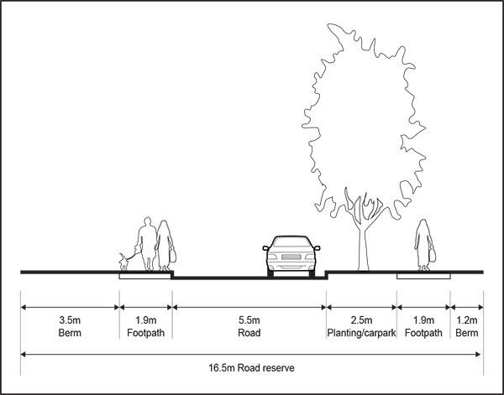Figure 1: Indicative Section – Streets adjacent to Racetrack (16.5m minimum width – where it is closest to the racetrack)

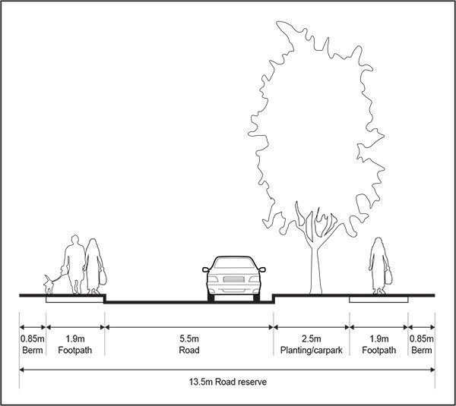Figure 2: Indicative Street Section – Walpole Street extension between sub­precincts A and B (16.5m wide)

Figure 3: Indicative Street Section for all other streets (13.5m wide)
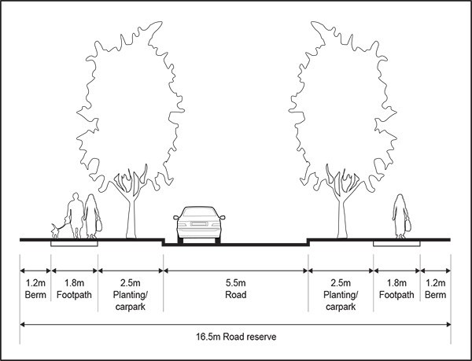

- Assessment ­ Discretionary activities

7.1 Matters of discretion
While not limiting the exercise of its discretion, the council may consider the particular matters listed below when assessing an application for subdivision consent:
  - site configuration

  - consistency with precinct plan 2

  - footpath network

  - private open space.

Assessment criteria
    - Proposed boundaries should adequately accommodate intended buildings and other features on the land, after taking into account the applicable development controls.

    - The layout of any private road should be in general accordance with the precinct plan.

    - Proposed footpaths should link into the existing or proposed footpath/pedestrian network to ultimately provide continuous public pedestrian access between Derby Downs Place and the Greenlane railway station via the reserve at the western end of Derby Downs Place, Mitchelson Street and The Avenue of Palms, and Ellerslie railway station via the reserve at the end of Derby Downs Place and Morrin Street

    - The proposed private road adjoining the racecourse should include a footpath of generous width on its outer racecourse side.

    - Proposed site(s) should include sufficient private open space, including areas attached to individual units and jointly usable land, to meet the needs of residents.

8. Pf"e(:inct plans

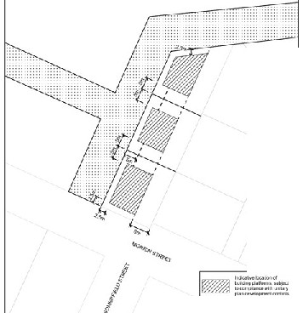Precinct 1: Mixed zone: tvbrrin Ellerslie

..
!

0-•-""'

r=:-::1 ---

Precinct plan 2: Ellerslie 1 precinct
