PART 3 ­ REGIONAL AND DISTRICT RULES»Chapter K: Precinct rules»3 City Centre»

3.12 Victoria Park Market

The activities, controls and assessment criteria in the underlying City Centre zone and Auckland­wide rules apply in the following precinct, unless otherwise specified below.

Refer to the planning maps for the location and extent of the precinct.

Activity table

  - The activities in the City Centre zone apply in the Victoria Park Market precinct unless otherwise specified in the activity table below.

Activity table – Victoria Park Market precinct
Activity | Activity Status
Development
Minor cosmetic alterations to a building that does not change its external design and  appearance | P
New buildings, and alterations and additions to buildings not otherwise provided for | RD
Buildings or external alterations to buildings within the areas identified as scheduled buildings  on precinct plan 1. | NC

Development controls

The development controls in the City Centre zone apply in the Victoria Park Market precinct unless otherwise specified below.

2.1 Activities at courtyard level

Purpose: manage the location of activities to maintain and enhance amenity of courtyards and residential amenity.
  - Community facilities and offices must locate at least 3m above courtyard level.

  - Dwellings and visitor accommodation fronting Drake Street must locate at least 3m above mean street level using the Drake Street frontage.

  - Dwellings and visitor accommodation not fronting Drake Street must locate at least 3m above courtyard level

  - The combined gross floor area of community facilities, education facilities, entertainment facilities and commercial services (excluding all related nested activities) must not exceed 25 per cent of the total gross floor area at the courtyard level (excluding the Building Platforms A and B shown on precinct plan 1).

  - The gross floor area of any individual tenancy for community facilities, education facilities, entertainment facilities and commercial services at courtyard level (excluding all related nested activities) must not exceed 100m².

  - In clauses 1­5 above, "courtyard level" is defined as mean street level using the Victoria Street frontage.

  - Development that does not comply with clauses 1­6 above is a non­complying activity.

Building height

Purpose: manage the height of buildings to achieve policy 2 of the Victoria Park Market precinct.

    - Buildings on platforms A to J shown on precinct plan 1 must not exceed the heights set out below.

Datum 0.00 = LINZ (Lands and Survey New Zealand Datum) Building platform A = 24m above mean street level
Building platform B = 16m above mean street level
Building platform C = ridge and parapet height not to exceed existing ridge and parapet height of adjacent scheduled building 3
Building platform D = ridge and parapet height not to exceed existing ridge and parapet height of adjacent scheduled building 4
Building platform E = ridge and parapet height not to exceed existing ridge and parapet height of adjacent scheduled building 5
Building platform F = Max. RL. 11.675 Building platform G = Max. RL. 9.00 Building platform H = Max. RL. 9.65
I = Max. RL. 13.50
J = 31m above mean street level
    - Canopies, verandah and walkway shelters within the courtyard shown on precinct plan 1 must not exceed a height of RL 15.50.

    - Development that does not comply with clauses 1­2 above is a non­complying activity.

Courtyard

Purpose: manage the location of buildings to maintain the amenity of the courtyard
    - Buildings must not locate within the courtyard shown on precinct plan 1. This control does not apply to canopies, verandahs and walkway shelters.

    - Development that does not comply with clause 1 above is a non­complying activity.

Adelaide Street Viewshaft

Purpose: manage the location of buildings to achieve policy 5 of the Victoria Park Market precinct.
    - Buildings must not locate with the Adelaide Street viewshaft shown on precinct plan 1 and in Figures 1 and 2 below.

    - Development that does not comply with clause 1 above is a non­complying activity.

Figure 1: Adelaide Street viewshaft
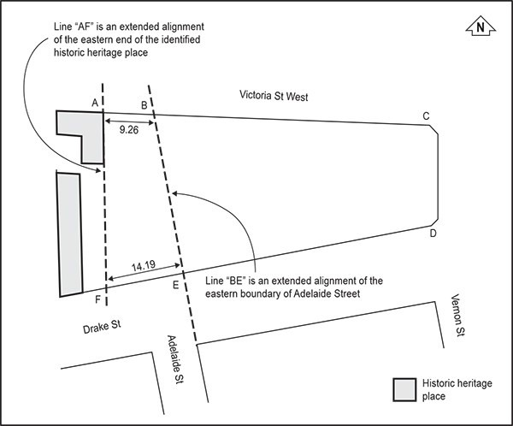

Figure 2: Adelaide Street viewshaft elevation
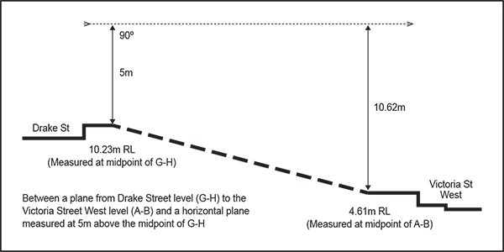

  - Building Setback – Building platform 4

Purpose: manage the location of buildings to maintain and enhance amenity.
    - Buildings must be setback 2.5m from building platform D shown on precinct plan 1.

    - Development that does not comply with clause 1 above is a non­complying activity.

Assessment ­ Restricted discretionary activities

3.1 Matters of discretion
For development that is a restricted discretionary activity in the Victoria Park Market precinct, the council will restrict its discretion to the following matters, in addition to the matters specified for the activity in the City Centre zone
  - New buildings, and alterations and additions to buildings not otherwise provided for
    - the effects of development on historic heritage values.

Assessment criteria
For development that is a restricted discretionary activity in the Victoria Park Market precinct, the following assessment criteria apply in addition to the criteria specified for the activity in the City Centre zone.
    - New buildings, and alterations and additions to buildings not otherwise provided for
      - The effects of development on historic heritage values

i.

ii.

iii.

iv.

v.

vi.

vii.

viii.

ix.

x.

xi.
The form, mass, proportion and materials should conform to the architectural character and heritage value of the scheduled heritage buildings.

Any alterations should retain the consistency of profile which characterises the Victoria Street and Drake Street frontages. In this respect, the vertical profile of the scheduled heritage buildings are considered particularly sensitive to change.

Permanent canopies over any part of the courtyard should not detract from the architectural character and heritage value of the buildings. Through the use of height, design and materials, canopies should maintain the appearance of openness and light in the courtyard area. In this respect, glazing and translucent materials and/or retention of openings to the sky are potentially important design elements to achieve this.

New buildings should not detract from the heritage features of existing buildings within the site, particularly the western brick wall of the destructor building.

The open view to the courtyard from Drake Street as shown on precinct plan 1 should be retained.

New buildings should be designed to read as contemporary structures to maintain a distinction between them and the historic market buildings. They should however, be sympathetic in terms of their scale, form and materials used.

New buildings should generally be separated from the historic buildings. Any connections between the two should be lightweight and only touch the historic buildings lightly.

Historic site elements and features such as basalt cobblestones should be retained and protected as far as possible. Where cobblestones are affected by new building works, such as the western courtyard building, they should be uplifted and stored for future reinstatement. Any other cobblestones that are uncovered during the course of the work should also be retrieved. The final location of the cobblestones should be determined in the course of discussions between the heritage architect, the NZHPT and the council.

Existing historic fabric assessed as having significance in the conservation plan should be retained and protected wherever possible. This includes brickwork, joinery and internal fabric such as original wall linings, roof trusses and match­lined ceilings.

Particular care should be taken to retain and protect any fabric that dates from the building’s original uses as the Auckland City Destructor and works depot. This may include steel columns and beams, pulleys, furnace doors and the like.

Later fabric deemed not to be significant may be removed after consultation with the heritage

architect, the NZHPT and the council.

xii.

xiii.

xiv.

xv.

xvi.

xvii.

xviii.

xix.

xx.

xxi.

xxii.

xxiii.
Historic fabric should be repaired as required. This may include replacement of severely eroded bricks, repointing where mortar has weathered and repairs of cracks and other defects. Bricks should be carefully selected to match the original bricks and mortar should be lime based to match the original. Roofs and gutters should be repaired or replaced as necessary, either with like materials or to match the original. Some joinery may also need to be repaired or replaced.

Repairs to the heritage buildings should be carried out under the guidance of a heritage architect.

The historic buildings on the Victoria Park Market site should be returned to an earlier form where possible. This may involve the reconstruction of missing elements such as windows and doors, the restoration or reinstatement of elements to their original locations and the removal of later accretions such as conservatories or canopies.

The overhead walkway should be cut back in various locations where it currently encroaches on the heritage buildings including the chimney, stables, destructor and generator/powerhouse/battery house complex. This will enable these buildings to be reconstructed or restored to their earlier form.

In general, the historic buildings should not be extended or added to other than the provision of two new levels above the battery building and another bay alongside. Some additional space is proposed to be constructed towards the western end of the western depot building in an area that has previously been extensively modified. The eastern depot is also proposed to be extended over part of its length.

Some minor modifications may be required to adapt the heritage buildings for a new use. These include the destructor building, the depot buildings, the stables and generator/powerhouse building. In general, work to adapt these buildings may involve the provision of new openings and the installation of appropriate new doors and windows in the exterior fabric.

New joinery should be detailed to have a consistency of design and appearance and shall be sympathetic to the character of the historic buildings. For example, the destructor building has steel windows and any new windows shall be fabricated to match. The remaining heritage buildings have timber windows.

New joinery should be designed to "read" as being new so as to maintain the distinction between old and new fabric. Some new joinery will also be required in areas such as the shop fronts in the depot buildings.

All work to adapt the buildings for their new uses shall be designed in conjunction with the heritage architect, following consultation with the NZHPT and the council.

In general, in terms of internal fit­outs tenants should be encouraged to leave original fabric exposed. This includes brick walls, trusses, raking ceilings with match lining and original trim.

It is accepted that some tenants may wish to provide new ceilings and wall linings to create a modern retail environment and that this may involve covering over or concealing significant heritage fabric such as brickwork. Any heritage fabric that is not wanted to be seen should be covered over, rather than be removed.

New linings should be sympathetic to the historic buildings and not to detract from their heritage values. For example, modern suspended ceilings with tiles set into exposed rails would not be considered appropriate.

xxiv.

xxv.

xxvi.

xxvii.

xxviii.

xxix.

xxx.

xxxi.
Tenants should avoid damage to heritage fabric when installing new wall and ceiling linings. The later linings should also be able to be removed at some future date without damaging fabric and the spaces returned to their earlier form.

The reticulation of new services should be considered at an early stage to minimise their impact on heritage fabric. The location of all duct work and other services shall be discussed with the heritage architect, the council and the NZHPT.

In particular, large scale ductwork such as kitchen extracts should be run within the building envelope and large ducts should not be run on the outside of buildings. Consideration should be given to routing ductwork through new buildings. Service providers are encouraged to co­ ordinate the installation of services to prevent a proliferation of ductwork and cabling.

The location of air­conditioning services should similarly be carefully considered with the aim of avoiding a proliferation of exposed ductwork and air­conditioning plant on walls and roof areas. The location of such equipment must be discussed at an early stage with the heritage architect, the NZHPT and the council. Where appropriate, plant may be screened to reduce its impact.

Other services such as electrical and data cabling shall be concealed wherever possible. Television aerials and dishes must be concealed behind parapets and the like.

Any significant new development within the precinct should involve the substantial restoration of scheduled buildings identified on the precinct plan 1.

Any lightweight shelters to the proposed new courtyard buildings should be constructed of steel and glass and should be designed to avoid visual conflict/obfuscation with existing heritage buildings on the site. All such structures should be designed in consultation with the council.

Where possible, development of sites along the original shoreline cliff near the northern edge of Drake Street should avoid destruction of, and should identify and enhance that natural and historic feature.

4. Precinct plan

Precinct plan 1
