PART 3 ­ REGIONAL AND DISTRICT RULES»Chapter K: Precinct rules»3 City Centre»

3.1 Britomart

The activities, controls and assessment criteria in the Auckland­wide rules apply to the Britomart Precinct, unless otherwise specified below.

The activities, controls and assessment criteria in the underlying City Centre zone apply to the Britomart precinct unless otherwise specified below.

Refer to Britomart precinct plan 1 for the location and extent of the precinct.

Activity tables

  - The activities in the City Centre zone apply in the Britomart precinct except in those areas identified as public open space on Precinct Plan 4, including those listed in the following table.

Activity table – Britomart precinct
Activity | Activity status
Development
Minor cosmetic additions and alterations to a building that does not change its external  design and appearance | P
New buildings, and alterations and additions to buildings not otherwise provided for | RD

  - The following table specifies the activity status of activities within the identified public open spaces shown on Precinct Plan 4.

Activity table – Britomart precinct (identified public open spaces shown on Precinct Plan 4)
Activity | Activity status
Community
Informal recreation | P
Landscaping | P
Artworks | P
Playgrounds | RD
Seating and picnic tables | P
Awnings, canopies or similar weather protection structures accessory to tables and  seating | RD
Kiosks and market stalls | RD
Development
Glazed roof structures/atrium and/or glazed verandahs and physical connections  between buildings above public walkway level (only in relation to Te Ara Tahuhu) | RD
New buildings | D

Land use controls

The land use controls in the City Centre zone apply in the Britomart precinct unless otherwise specified below.

Dwellings and visitor accommodation

Purpose: to avoid the potential for reverse sensitivity effects on the Port of Auckland.
    - Dwellings and visitor accommodation must be subject to a restrictive non­complaint covenant* in favour of the Ports of Auckland.

    - Dwellings and visitor accommodation that do not comply with clause 1 above are a discretionary activity.

    - For the purposes of this rule a 'restrictive non­complaint covenant' is defined as a restrictive covenant registered on the Title to the property or a binding agreement to covenant, in favour of Ports of Auckland Limited, by the landowner (and binding any successors in title) not to complain as to effects generated by the lawful operation of the port. The restrictive non­complaint covenant is limited to the effects that could be lawfully generated by the port activities at the time the agreement to covenant is entered into. This does not require the covenantor to forego any right to lodge submissions in respect of resource consent applications or plan changes in relation to port activities (although an individual restrictive non­ complaint covenant may do so. Details of the existence of covenant documents may be obtained from Ports of Auckland Limited, its solicitors, or in the case of registered covenants by searching the Title to the relevant property.

Development controls

3.1 Building height

Purpose: manage the height of buildings to achieve policies 2, 3 and 12 of the Britomart precinct.
  - Buildings must not exceed the heights specified on precinct plan 1.

  - The Britomart station ventilation stacks may exceed the maximum building height specified on precinct plan 1 provided that they do not exceed 10m above the roof to the storey immediately below.

  - A single lift machine room or over­run within the 50m height area shown on precinct plan 1 may exceed the maximum building height provided that:
    - the height of the projection does not exceed 5.4m above the maximum permitted height

    - the area of the projection does not exceed a floor area equal to 10 per cent of the area of the roof to the storey immediately below.

Minimum frontage height

Purpose: ensure streets are well defined by buildings and provide a sense of enclosure to enhance pedestrian amenity.
    - New buildings and additions to buildings must adjoin the site frontage for its entire length excluding vehicle and pedestrian access areas and have a minimum frontage height of 16m above mean street level.

Paving of public open spaces

Purpose: Maintain and enhance the amenity of public open space.
    - Paving of areas of public open space, as shown on precinct plan 3, must be provided by adjacent site owners in conjunction with any new development of the site.

    - Applications for any new building or external alteration or addition to any existing building on sites adjacent to areas identified for paving in precinct plan 3 must provide details of ground surface designs particularly in relation to the paving materials to be laid and the pattern of their layout.

    - The pavers must be at least equal to the standard of paving and detailing in Station Plaza.

View shaft

Purpose: manage development to maintain views from Britomart Place through to the Chief Post Office building

and provide an important visual guide for pedestrians moving into and through the Precinct. The view shaft is intended to protect this view for the benefit of pedestrians.
    - Buildings must not locate within the areas of the view shaft shown on precinct plan 3, except for:
      - temporary buildings which are permitted activities or for which resource consent has been granted

      - parts of buildings or structures above first floor level

      - verandahs required by clause 4.28 of the City Centre zone rules or for which resource consent has been granted.

    - Development that does not comply with clause 1 above is a non­complying activity.

Site intensity

Purpose: manage the scale, form and intensity of development to maintain the character of the Britomart precinct.
    - The basic and the maximum floor area ratios permitted within the Britomart precinct are as shown on precinct plan 2.

    - In sub­precinct B the bonus floor area provisions for bonus area 1a (refer clauses 4.9 ­ 4.19 of the City Centre zone rules) apply except that the light and outlook bonus does not apply. The basic FAR plus the bonus FAR must not exceed the MTFAR shown in precinct plan 2.

    - In sub­precinct B the basic FAR and the MTFAR is the GFA allowed as a permitted activity, except that for the sites notated on precinct plan 2 the floor area ratio must be limited to the GFA achievable within the existing special character building or scheduled historic heritage place.

    - In sub­precinct B the 11:1 FAR shown in precinct plan 2 for sites to the east of Takutai Square is the basic/maximum total FAR for a building or combination of structures covering all sites, and is not the basic/maximum total FAR for individual sites.

    - Development that does not comply with clauses 1­4 above are a non­complying activity.

Heritage buildings

Purpose: manage heritage buildings to achieve policies 7 and 8 of the Britomart precinct.
    - Development must provide for and ensure the preservation of identified historic heritage buildings within the precinct.

    - All works relating to identified historic heritage buildings must be subject to conservation plans and obtain all necessary resource consents required by the Historic Heritage overlay rules and the Historic Places Act 1993.

    - All works relating to the following non­scheduled buildings must be subject to approved conservation plans:
      - Levy Building, 20 Customs Street East (Lot 2 DP 361575)

      - Charter House, 54­58 Customs Street East (Part Lot 2 DP 382501)

      - Newdick Building, 104 Quay Street (Part Lot 1 DP 369895)

      - Quay Buildings, 106­108 Quay Street (Part Lot 1 DP 369895)

      - Maritime Building, 130 Quay Street (Lot 57 DP 317575).

    - Development that does not comply with clauses 1­3 above is a discretionary activity.

Noise

Purpose: Manage noise to maintain amenity.
    - Any activity must comply with clause 6.2 of the Auckland­wide rules for noise and vibration except

that noise from events and temporary activities must be measured 1m from the façade of the nearest dwelling or visitor accommodation building located outside of the Britomart precinct.

    - Any activity that does not comply with clause 1 above is a discretionary activity.

Parking

Purpose: Limit parking to the eastern end of the precinct to maintain main pedestrian thoroughfares and retain the visual amenity provided by heritage buildings.
    - For the purpose of calculating the maximum permitted parking, clause 1.2.3.2 of the Auckland­wide ­ Transport rules apply except that:
      - The area shown as Precinct Area 2 on Precinct Plan 2 and Lot 5 DP 325137 in the Quay Park precinct is defined as a site. Parking accumulated within this area is limited to the areas indicated as “xx” on Precinct Plan 2 and to Lot 5 DP 325 137 within the Quay Park precinct.

      - Within these sites parking must be confined to basement levels and vehicle access must be from Galway Street only.

    - Any development that does not comply with clauses 1 ­ 2 above is a discretionary activity.

Assessment ­ Restricted discretionary activities

4.1 Matters of discretion
For development that is a restricted discretionary activity in the Britomart precinct, the council will restrict its discretion to the following matters, in addition to the matters specified for the relevant restricted discretionary activities in the City Centre zone.
  - New buildings, and alterations and additions to existing buildings not otherwise provided for
    - The matters of discretion in clause 6.1.1 of the City Centre zone rules apply.

  - Restricted discretionary activities within the public open spaces identified on Precinct Plan 4
    - Location, design and external appearance of temporary or permanent buildings, structures and signs.

Assessment criteria
For the development that is a restricted discretionary activity in the Britomart precinct, the following assessment criteria apply in addition to the criteria specified for the relevant restricted discretionary activities in the City Centre zone.
    - New buildings, and alterations and additions to existing buildings not otherwise provided for
      - Building design and external appearance ­ contributing to sense of place

i.

ii.

iii.

iv.
Individual building facades should achieve physical and architectural continuity with those buildings immediately adjacent.

Buildings should combine to produce an urban form characterised by public squares, streets and lanes, with a perimeter block form of urban development of a human scale.

Buildings occupying a corner site are more exposed to public view and thus their position should be reinforced by a special architectural device or element which responds to such a location.

The consistency of the existing character in a cohesive streetscape should be maintained, with new buildings acknowledging traditional design and detailing. However, new buildings and additions need not replicate this style.

      - Building design and external appearance ­ variation in building form/visual interest
        - Buildings should contain a predominance of vertical or neutral emphases on their elevations (rather than horizontal), and thus contribute to the visual reduction in the scale of buildings, and an appropriate scale close to public places.

ii. iii.

iv.

v.

vi.

vii.

viii.
Building design and external appearance ­ creating a positive frontage

The ground floor level of buildings adjacent to public spaces should make use of architectural elements of columns, windows, doors, verandahs, colonnades, and recessed entrance ways to achieve a strong visual and physical integration of public and private space.

The treatment of exterior walls should continuously define the edge of the street (or open space) but with individual variation in architectural character to avoid long, dull, monotonous lengths of undifferentiated wall.

Buildings should be designed to address and align to the street boundaries and adjoining public spaces to develop a strong visual axis along streets and at intersections.

Buildings should contain activities that have a strong interaction with the use of adjoining public space in order to provide increased security and surveillance and contribute to the vitality of the area.

Buildings adjacent to public open space should not dominate it or 'privatise' it by giving the impression that the open space is a forecourt to any private development adjoining it.

Verandahs, where required, should be continuous along the length of the street but should be designed separately on a site by site basis. The architecture of each verandah should relate directly to the building on that site and should not be designed as a uniform or standardised building element.

      - Building design and external appearance ­ materials and finishes

i.

ii.

iii.
Materials and colour used in new buildings should complement existing buildings, but may use new and contemporary interpretations in form and detail.

The design of ground surfaces should ensure conformity of detail and material where private developments are integrated with streets or adjacent public open spaces.

New buildings or external alterations or additions to buildings on sites adjacent to areas identified for paving in precinct plan 4 must ensure the adjoining ground surface design is appropriate and sensitive and has regard to the manner in which the development is integrated with adjacent public spaces.

      - Signage and temporary buildings

i.

ii.
Signage should be designed to a high standard and should complement the architectural qualities, materials, details and colours of the buildings to which it relates.

Temporary buildings, including structures, should show design sensitivity, be located in areas that will not compromise pedestrian access, and be simple in colour, form and materials and not conflict with the architectural style of permanent buildings.

      - Design and scale of buildings adjoining historic heritage places
        - Redevelopment of sites adjoining scheduled historic and character buildings on Quay Street should incorporate a podium of similar height, complementing the building form of the existing adjoining buildings in terms of scale and proportion.

      - Design of access and parking

i.

ii.
Service access points to buildings should not be located in pedestrian intensive areas and, where possible, should be combined with access to parking areas.

Where vehicles and pedestrians share the same circulation network, the ground surface should be pedestrian orientated, that is, designed primarily for people on foot, but across which vehicles may have clearly defined and free access.

      - Design and layout of dwellings, visitor accommodation and boarding houses

        - Buildings to be used for any form of dwelling or visitor accommodation should be appropriately located and designed to reduce reverse sensitivity effects and any adverse noise effects from the surrounding environment (including noise from the port, traffic and other uses in the Britomart precinct such as entertainment). The design of such buildings should take into account the location of bedrooms, the type and thickness of glass, and the presence or otherwise of opening windows or doors to the exterior.

5. Assessment ­ Development control infringements

Matters of discretion
In addition to the general matters set out in clause 2.3 of the general provisions, the council will restrict its discretion to the matters below for the relevant development control infringement.
    - Building height
      - building scale and dominance / visual amenity effects

      - effects on the current or planned future form and character of the precinct.

    - Minimum frontage height
      - building scale and dominance / visual amenity effects

      - pedestrian amenity.

    - Paving of public open spaces
      - pedestrian amenity.

Assessment criteria
In addition to the general assessment criteria in clause 2.3 of the general provisions, the council will consider the relevant assessment criteria below for the relevant development control infringement.
    - Building height
      - Building height may be exceeded where it would provide an attractive and integrated roof form that also meets the purpose of the control.

      - Where building height is exceeded, policies 1, 2, 3, 5, 7, 9 and 12 of the Britomart precinct and
policy 17 of the City Centre zone should be considered.

    - Minimum frontage height
      - Buildings should frame the street to provide a sense of enclosure.

      - Pedestrian amenity should be maintained or enhanced.

    - Paving of public open spaces
      - Public open space should be maintained and be functional.

Precinct plans

Precinct plan 1: Building height
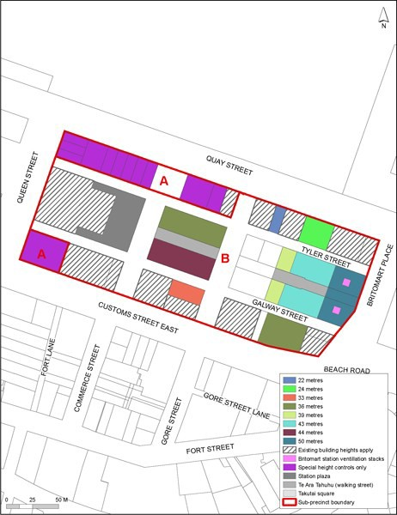

Precinct plan 2: Site intensity
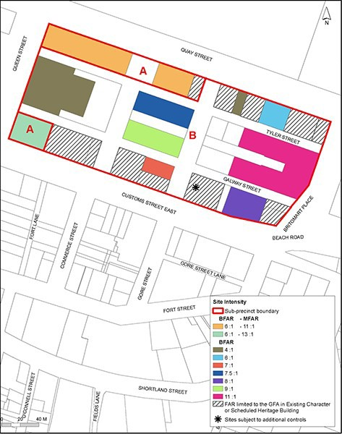

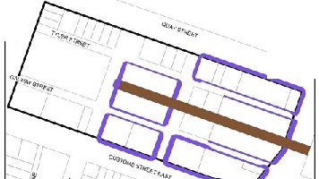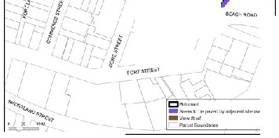

Precinct 3:

I
c
I
I
I!
I
  - I
$ I
6 I
I
•

>
I t
I I 1
.,I I
- ":'J) t.l
I 1-eiJ:!
I I .)

Precinct plan 4: Public open space
