PART 3 ­ REGIONAL AND DISTRICT RULES»Chapter K: Precinct rules»3 City Centre»

3.5 Karangahape Road

The activities, controls and assessment criteria in the City Centre zone and Auckland­wide rules apply in the Karangahape Road precinct unless otherwise specified below.

Refer to planning maps for the location and extent of the precinct.

Activity table

  - The activities in the City Centre zone apply in the Karangahape Road precinct unless otherwise specified in the activity table below.

Activity table – Karangahape Road precinct
Activity | Activity Status
Development
Minor cosmetic alterations to a building that does not change its external design and  appearance | P
New buildings, and alterations and additions to buildings not otherwise provided for | RD
The total or substantial demolition (more than 30 per cent by volume), or any demolition of the  front façade of a building constructed prior to 1 January 1940 | RD

Notification

  - An application for the total demolition, substantial demolition (more than 30 per cent by volume) or any demolition to the front facade of a building constructed prior to 1940 will be subject to the normal tests for notification under the relevant sections of the RMA.

Development controls

The development controls in the City Centre zone apply in the Karangahape Road precinct unless otherwise specified below.

Frontage height and setback

Purpose: manage the scale of development to maintain and enhance pedestrian amenity, and to avoid buildings dominating public open space.
    - For frontages shown in precinct plan 1, buildings must:
      - adjoin the site frontage for its entire length excluding vehicle and pedestrian access areas

      - not have a building frontage that exceeds 14m in height above mean street level, and:

i.

ii.
where the building is located on the southern side of Karangahape Road, not project beyond a 45 degree recession plane measured at all points along the site frontage from 14m above mean street level, or

where the building is located on the northern side of Karangahape Road, not project beyond a 30 degree recession plane measured at all points along the site frontage from 14m above mean street level.

    - Clause 1 above does not apply to towers, turrets or similar structures located on a corner site at the intersection of Karangahape Road and the following roads: Queen Street, Upper Queen Street, Pitt Street, Mercury Lane, East Street, and West Terrace.

    - Towers, turrets or similar structures located on a corner site at the intersection of Karangahape Road

and the following roads: Queen Street, Upper Queen Street, Pitt Street, Mercury Lane, East Street, and West Terrace must not:
      - exceed the maximum height by more than 5m

      - exceed an area of 18m²

      - exceed a horizontal dimension of 4m measured along the site frontage

      - contain signs at a height greater than 12.5m above mean street level.

    - Development that does not comply with clauses 1 or 3 above is a non­complying activity.

Figure 1: Karangahape Road frontage height and setback
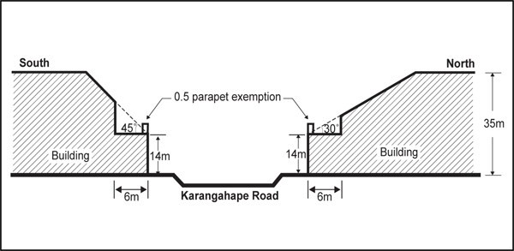

- Assessment ­ Restricted discretionary activities

4.1 Matters of discretion
For development that is a restricted discretionary activity in the Karangahape Road precinct, the council will restrict its discretion to the following matters, in addition to the matters specified for the relevant restricted discretionary activities in the City Centre zone.
  - New buildings, and alterations and additions to buildings not otherwise provided for
    - Building design and external appearance.

  - The total or substantial demolition (more than 30 per cent by volume), or any demolition of the front façade of a building constructed prior to 1 January 1940
    - Effects of building demolition on built form and streetscape character.

Assessment criteria
For development that is a restricted discretionary activity in the Karangahape Road precinct, the following assessment criteria apply in addition to the criteria specified for the relevant restricted discretionary activities in the City Centre zone.
    - New buildings, and alterations and additions to buildings not otherwise provided for
      - Building design and external appearance ­ creating a positive frontage
        - Buildings must be designed to address and align to the street boundary. Minor modulation and variance of the frontage such as recessed pedestrian entrances is encouraged to avoid architectural monotony.

      - Building design and external appearance ­ variation in building form/visual interest
        - Building levels must incorporate design elements which acknowledge the existing human scale and character of the precinct. In particular:

          - Frontage height and design should have regard to existing buildings in the vicinity and to maintain a consistent scale. This does not mean a rigid adherence to a single height but it does mean a respect for the general scale of the surrounding buildings to avoid dominance.

          - The design of building frontages should include vertical and horizontal details that avoid dominance of frontage design elements larger than historically present. Where existing sites are amalgamated, the frontage design should have regard to the existing grain of development and convey a residual sense of the original subdivision pattern.

          - The consistency of the existing character in a cohesive streetscape should be maintained with the design of new buildings acknowledging the scale, sense of proportion and level of intricacy of detail on neighbouring buildings in the precinct.

          - The design of the ground level should contribute to the continuity of pedestrian interest and vitality. However, frontages entirely of glass (curtain walling or continuous shopfront glazing) or of solid materials (including roller shutter doors of any size), should not be used at street level as they detract from the streetscape. Where feasible, restoration of original ground level detail should be included in plans for buildings adjoining historic heritage buildings or for alterations to historic heritage buildings.

          - At upper levels, large expanses of glass or blank walls should be avoided. This will tend to favour solid walls penetrated by a pattern of windows above verandah level, articulation of floor levels and an appropriate treatment of the parapet level.

ii.

iii.

iv.

The design of upper setback levels should relate naturally to the lower frontage height levels in an acceptable architectural manner such as continuation of an elevational rhythm or recognisable visual theme or proportions.

The design of buildings on corner sites and at the terminus of significant axial views should use special features to accentuate focus and should have a landmark quality which can be easily identified from many directions, creating a sense of place.

Signs and logos on frontages and fasciae should be carefully integrated and visually clear so that they are unobtrusive and sympathetic with the architectural pattern of the buildings.

      - Building design and external appearance ­ materials and finishes

i.

ii.
Materials, decoration and colour used for the exterior of new buildings or for alterations to the frontage of existing buildings should have regard to existing buildings. New and
contemporary interpretations in form and details may be used.

Frontage colour should integrate with the existing vibrant streetscape, with colour considered as a whole, integrating under­verandah shop fronts with the frontage above. A frontage may be unified through the use of subdued colours or be given a sense of individuality by emphasising architectural features in contrasting colour.

    - The total or substantial demolition (more than 30 per cent by volume), or any demolition of the front façade of a building constructed prior to 1 January 1940
      - Effects of building demolition on built form and streetscape character
        - The demolition or removal of a pre­1940's building within the precinct should not significantly adversely affect the built form and streetscape character of the precinct. In particular, consideration will be given to:
          - Whether the existing building forms part of a cohesive group of buildings in terms of similarity of age, scale, proportion or design and the extent to which the building’s demolition would detract from the shared contribution that group makes to streetscape, the unique character or the history and context of the precinct.

          - Whether the existing building is a remnant example of a building type that reflects the history of the area.

          - The contribution the individual building makes to the historic context, character or cohesiveness of the streetscape or precinct.

          - The contribution the building makes to adjoining or nearby scheduled historic heritage buildings, either through the context and the relationship of the building to the scheduled historic heritage building or through the building’s mass, height or rhythm of facades, and whether its demolition would adversely impact on the historic heritage values of the building.

          - Whether reasonable use of the site can be achieved through adaptive re­use of the building rather than through its demolition and replacement.

          - Notwithstanding the above, other factors will be considered and balanced when assessing an application for the demolition of a pre­1940's building, including whether the building is beyond rehabilitation in terms of poor structural or physical condition, and whether the costs of the repair work or upgrading necessary to extend the useful
life of the building are prohibitive, (in comparison to the costs of a new building of similar size).

5. Precinct plans

Precinct plan 1: Frontage height and setback

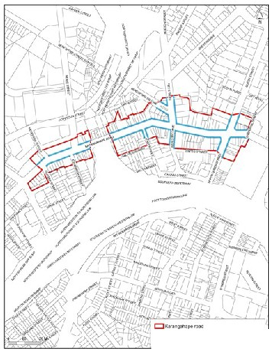

-••cn NIJ"'••.t"'-.--cr«c.,,ts
Vl l»u'do.,

