PART 3 ­ REGIONAL AND DISTRICT RULES»Chapter K: Precinct rules»3 City Centre»

3.6 Learning

The following provisions form part of the district plan where they apply to land in the Learning precinct. The Auckland­wide rules apply in the following precinct, unless otherwise specified.

Refer to the planning maps and precinct plans for the location and extent of the precinct.

Activity table

  - The following table specifies the activity status of activities in the Learning precinct.

Activity table – Learning precinct
Activity | Activity status
Residential
Boarding houses | P
Dwellings | P
Visitor accommodation | P
Commerce
Commercial services | P
Entertainment facilities | P
Offices | P
Retail | P
Community
Care centres | P
Community facilities | P
Educational facilities | P
Emergency services | P
Healthcare facilities | P
Hospitals | P
Information facilities | P
Organised sport and recreation | P
Development
An entry canopy (and any associated steps, balustrades and retaining walls defined as “building”) located in the position indicated by the symbol “#” within the “No buildings except as provided for by entry canopy and fire egress stair criteria area shown on  Precinct Plan 1 | RD
Alterations to or replacement of the existing fire egress stairs located in the position indicated by the symbol “@” within the “No buildings except as provided for by entry  canopy and fire egress stair criteria” area shown on Precinct Plan 1 | RD
Demolition | RD
New buildings, and alterations and additions to buildings not otherwise provided for | RD
Minor cosmetic alterations to a building that does not change its external design and  appearance | P

Conversion of a building or part of a building to dwellings, visitor accommodation or  boarding houses | RD
The transfer and utilisation of unrealised parking within sub­precinct A complying with  clause 2.1 below | RD

Land use controls

The land use controls in the City Centre zone apply in the Learning precinct unless otherwise specified below.

2.1 Parking

  - The total number of parking spaces within sub­precinct A must not exceed 2000.

  - Where a site is located within sub­precinct A and is accessed from either Grafton Road or Alten Road, an application for a restricted discretionary activity may be made to transfer to the recipient site the unrealised permitted parking from any other site or sites within sub­precinct A held in the same ownership as the recipient site. Any transferred parking may be provided in addition to the amount of parking permitted on the recipient site in respect of any building or buildings erected on, or proposed for that site.

  - The unrealised permitted parking able to be transferred from the donor site, is the difference between the amount of parking permitted on the donor site and the amount actually provided, but only if the number of parking spaces provided on the donor site is less than that permitted.

  - For the purpose of monitoring the total number of parking spaces a register must be maintained by the council and the following must be recorded in it:
    - the address and legal description of the donor and recipient sites;

    - the number of parking spaces transferred to the recipient site and/or retained on the donor site; and

    - the date of the consent permitting a transfer.

  - Development that does not comply with clause 1 above is a non­complying activity.

Development controls

The development controls in the City Centre zone apply in the Learning precinct unless otherwise specified below.

Building height

Purpose: manage the height of buildings to achieve policy 6 of the Learning precinct.
    - Buildings must not exceed the heights specified on precinct plan 1.

    - Building height will be measured as the vertical distance between mean street level and a horizontal plane above that level for sites where no contour applies on Precinct Plan 3. For all other sites on precinct plan 3, building height will be measured in accordance with clause 4.7 of City Centre zone rules.

    - No additional height is permitted for buildings within the area shown on precinct plan 1 as “existing buildings only”.

Frontage Height and Setback

Purpose: manage the scale of development to maintain and enhance pedestrian amenity, and to avoid buildings dominating public open space.
    - On every frontage shown as “A” on Precinct Plan 4:
      - the building frontage must not exceed a height of 20m for a minimum depth of 10m from the site frontage

      - the building must not project beyond a 50 degree recession plane measured at all points along the site frontage from 20m above street level

      - the building setback must be an emphatic or a stepped profile of at least two stories and must not be a literal regression of the 50 degree angle.

      - Where the building is on a corner site, the requirements of clauses (a) and (b) above apply to both frontages.

    - On every frontage shown as “B” on Precinct Plan 4:
      - the building frontage must not exceed a height of 30m for a minimum depth of 10m from the site frontage.

    - On every frontage shown as “C” on Precinct Plan 4:
      - the building frontage must not exceed a height of 15m for a minimum depth of 15m from the site frontage

      - the building must not project beyond a 45 degree recession plane measured at all points along the site frontage of the site from 15m above street level

      - the building setback must be an emphatic or a stepped profile of at least two stories and must not be a literal regression of the 45 degree angle.

      - Where the building is on a corner site, the requirements of clauses (a) and (b) above apply to both frontages.

    - On every frontage shown as “D” on Precinct Plan 4:
      - the building frontage must not exceed a height of 35m for a minimum depth of 10m from the site frontage.

    - On every frontage shown as “E” on Precinct Plan 4:
      - the building frontage must not exceed a height of 41.623m (Lands and Survey Datum (MSL)
Auckland 1946) for a minimum depth of 15m from the site frontage

      - the building must not project beyond a 45 degree recession plane measured at all points along the site frontage from RL 41.623m (Lands and Survey Datum (MSL) Auckland 1946) above street level

      - the building setback must be an emphatic or a stepped profile of at least two stories and must not be a literal regression of the 45 degree angle.

      - Where the building is on a corner site, the requirements of clauses (a) and (b) above apply to both frontages.

Figure 1: Frontage control A
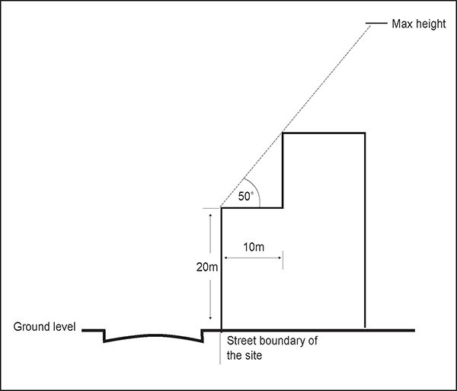

Figure 2: Frontage control B
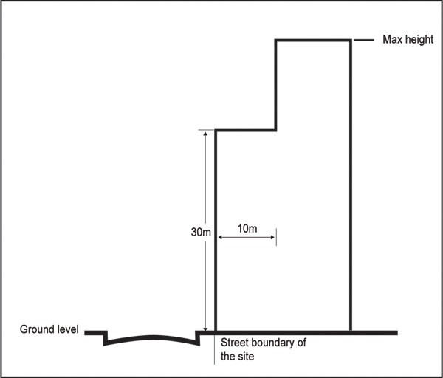

Figure 3: Frontage control C
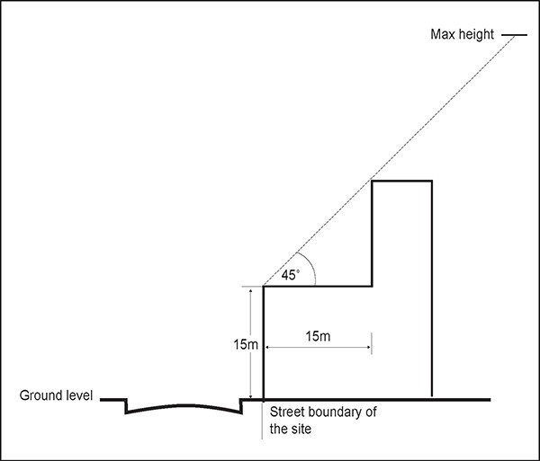

Figure 4: Frontage control D
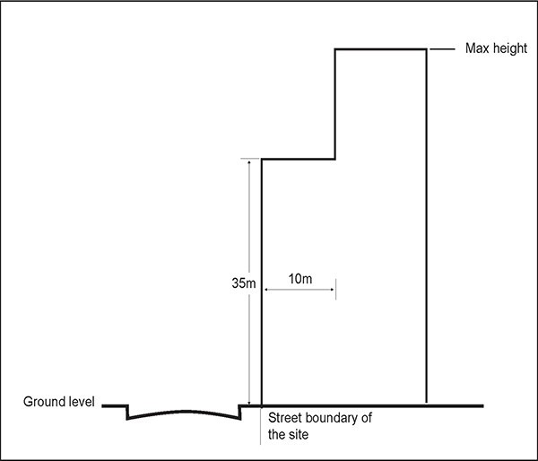

Figure 5: Frontage control E
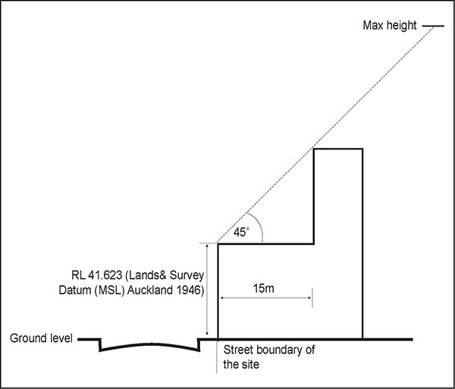

  - Wynyard Street Coverage and Pedestrian Link

Purpose: manage the scale, form and intensity of development to maintain and enhance pedestrian amenity within the precinct.
    - For areas shown on precinct plan 1 as being subject to the “Wynyard Street coverage and pedestrian link control”:
      - the maximum building coverage is 50 per cent.

      - a continual pedestrian link must be provided from Grafton Road to Alten Road:

i.

ii.

iii.
that includes a continuous minimum width of 10m. This does not apply to the first 50m from the Alten Road boundary where the width may be reduced to a minimum of 6m.

that is open to the air and aligned so as to maintain a clear line of sight for pedestrians on Grafton Road through to Alten Road.

of which sections may be covered by glazing for weather protection and narrow pedestrian over bridges for pedestrian connectivity to upper floors of adjacent buildings providing that Wynyard Street remains open to the air for the majority of its length and a clear line of sight for pedestrians on Grafton Road through to Alten Road is maintained. Pedestrian over bridges and glazing will be counted as coverage for the purpose of this control.

Assessment ­ Restricted discretionary activities

4.1 Matters of discretion
The council will restrict its discretion to the matters below for the activities listed as restricted discretionary in the precinct activity table.
  - New buildings, and alterations and additions to buildings not otherwise provided for
    - building design and external appearance

    - effects of buildings on historic heritage places

    - safety

    - the design of covered plazas, open spaces and pedestrian linkages

    - the design and location of parking

    - travel plans and integrated transport assessments

  - An entry canopy (and any associated steps, balustrades and retaining walls defined as “building”) in the position indicated by the symbol “#” within the “No buildings except as provided for by entry canopy and fire egress stair criteria” area shown on Precinct Plan 1
    - design and scale.

  - Alterations to or replacement of the existing fire egress stairs in the position indicated by the symbol “@” within the “No buildings except as provided for by entry canopy and fire egress stair criteria” area shown on Precinct Plan 1
    - design, materials and orientation.

  - The transfer and utilisation of unrealised parking within sub­precinct A
    - traffic generation and safety

    - pedestrian safety

    - design of parking areas.

Assessment criteria
The council will consider the relevant assessment criteria below for the restricted discretionary activities listed above.
    - New buildings, and alterations or additions to buildings not otherwise provided for
      - Building design and external appearance ­ creating a positive frontage

i.

ii.

iii.

iv.
Buildings and their uses should maintain and where practicable enhance the quality and usability of streets, the public realm and campus pedestrian linkages through appropriate building scale, design and location. Generally, buildings should have interactive frontages where they face public streets to enable a public experience of activities within the campuses. ‘Interactive frontages’ are frontages which enable some form of public view or experience of activities within the campus, whether directly through openings and glazed areas into internal campus spaces or indirectly through landscaping, façade design, or artwork expressive of campus activities.

In areas shown on precinct plan 2 as being within an active use node, active commercial and retail or entertainment uses are encouraged that provide for the needs of students, as well as residents, workers and visitors. Where not feasible buildings are encouraged to be designed with a ground floor that could adapt to these activities in the future.

When adjacent to public streets, buildings must be designed to encourage visual and physical interaction with the street to support its safety and amenity for pedestrians.

The main entries for all buildings adjacent to streets shall generally be from the street or directly visible from the street and when a building has more than one street frontage,

multiple entries are encouraged. If the main entry is internal to the site a secondary street entry is encouraged.

v.

vi.

Generous canopies must be provided at all entries and encouraged in intermittent locations along street frontages to provide pedestrian shelter, when this can be incorporated into the design of the building. Verandahs are encouraged on streets and within campuses.

Artwork is encouraged to be incorporated into the street facades of buildings, open spaces and plazas.

      - Building design and external appearance ­ variation in building form/visual interest

i.

ii.
Buildings should be designed to address the street, through alignment, façade modulation, windows, pedestrian entrances/plazas and materials that are appropriate for a contemporary university and compatible with heritage buildings and objects

Buildings fronting streets and open spaces should incorporate design elements which acknowledge the adjacent built form, and enhance pedestrian comfort and amenity, and the character of the precinct. In particular:

        - Frontage height and design should have regard to existing buildings in the vicinity and maintain a compatible scale. This does not mean a rigid adherence to a single height but it does mean a respect for the general appearance of the surrounding blocks.

        - Buildings should ensure high levels of visual quality and visual interest, as viewed from near and afar, by the use of the number and composition of elements on the building’s façade, and the contrasting relationships between them, having regard to the scale and proportions of components on existing buildings within the vicinity. At every scale, from a range of viewing distances, building surfaces should appear rich in detail.

        - Buildings should employ the use of human scale proportions in the components of a façade, especially at the lower levels where pedestrians are experiencing the building from closer distances in order to maintain high levels of pedestrian visual interest.

        - At all levels, large expanses of blank walls should be avoided and must not be visible from streets or public open spaces. If blank walls cannot be avoided, they should be minimal in relation to the overall size and length of the building frontage or located within campuses and mitigated with architectural detailing, artwork or landscaping.

        - Where the frontage height and setback control applies, the design of upper setback levels should relate naturally to the lower frontage height levels in an acceptable architectural manner such as continuation of an elevational rhythm or recognisable visual theme or proportion.

        - The design of buildings on corner sites should enhance the particular spatial qualities of street intersections that contribute to the prominence of sites. Building design on such sites should consider the relationship to other buildings and open spaces on opposite and adjacent corner sites.

        - Materials used in new buildings should be durable and of high quality, particularly at ground level to enhance the pedestrian experience.

        - Designs should provide strong architectural cues to accessways and pedestrian routes that reflect the hierarchy of routes and clearly express pedestrian entrances to enhance the visibility of pedestrian access to and through the campuses and their buildings.

        - Frontages should be designed to avoid service and access interruptions to frontage continuity, by locating and agglomerating such requirements internally within the campuses where practicable.

        - Where the proposed development is an extension or alteration to an existing building, it should be designed with consideration to the architecture of the original building.

        - Building form and height should consider the impact of shading and wind on the internal communal spaces of the campus and public streets.

        - Building and landscape design should include environmentally sustainable design features, such as passive solar design on­site stormwater conservation measures, rainwater harvesting devices, green roofs, site landscaping, rain gardens and wetland treatment systems and stormwater planter boxes.

      - Development on the corners Symonds Street and Wellesley Street

i.

ii.

iii.
For buildings on the corner sites of Symonds and Wellesley Street, a high standard of architecture is expected due to its high profile, landmark location on the crest of the Wellesley Street axis, the location of scheduled historic heritage places in close proximity to the corner sites, its prominence as a significant gateway to the city centre from the Grafton Gully, and to the campuses from Wellesley and Symonds Street. Particular attention is required to the views of the building along Wellesley Street from the direction of both the city and motorway ends, and along Symonds Street.

On the north­eastern corner of the intersection where a 50m height limit is applied without a frontage control, the architectural detailing on both frontages of the corner should support the articulation of the corner as distinctive from the rest of the building, and include a vertical emphasis in keeping with its location on the crest of the ridge. It should support the creation of a distinctive landmark that in the horizontal proportions of its façade complements the historic forms of the nearby heritage buildings.

Development on the corner of Wellesley Street East and St Paul Street should be sympathetic to the heritage building at 59­67 Wellesley Street East.

      - Grafton Gully

i.

ii.
All buildings that adjoin the motorway corridor or connecting streets, as shown on precinct plan 2 as subject to the “Grafton Gully landscaped edge”, must be designed to incorporate a varied building form that responds to the landscape context of this area, is organic in character, and does not present the appearance of a solid wall. Particular attention is required to the view of proposed buildings from Grafton Bridge, along Grafton Gully, from within the Domain, and from Auckland Hospital. The landscape context is the valley with the green open space of the Domain; the steep slopes, mature trees and vertical towers of the city centre, and the unfolding views of Rangitoto and the Harbour. Geological and ecological heritage values are present in this gully and should be recognised and protected from significant adverse effects. Building podiums and parking levels along this corridor must exhibit a high quality of architectural design befitting their prominent location and be planted at their base using eco­sourced species naturally occurring in the area.

An emphasis on enhancing the vertical characteristics of buildings and limiting the appearance of dominant horizontal elements along the Grafton Gully landscaped edge is encouraged. Buildings should provide architectural interest along this edge, provide fronts rather than backs to this edge, and where practical maintain views in between buildings into and from the campus, to enhance Grafton Gully’s role as a gateway to the city centre.

      - Effect of buildings on historic heritage places
i. The scale, form and design of new buildings should have regard to the significant heritage elements and built form of any scheduled heritage places adjacent to or in close proximity to the development site. This will require careful consideration to avoid the potential for dominance due to height and bulk. In doing so, the full development potential otherwise offered by the development controls may not be able to be achieved.

ii.

iii.

iv.

v.
New buildings and additions to existing buildings adjacent to or in close proximity with a scheduled heritage building should have regard to and respect the latter’s contribution to the streetscape, so that the historic heritage building is able to maintain its contribution to the streetscape and its historical relationship with its site surrounds and wider area, including any adjacent open space.

Landscaping, where contextually appropriate, should acknowledge both the natural and cultural heritage of the area, particularly when in proximity to or adjacent to any scheduled heritage building, its surrounds or conservation area.

Design features that reflect the cultural heritage of the area, including Māori cultural values associated with the historic settlement and use of the area, are encouraged. For example, in the design of buildings, landscaping, artwork, signs and place names. This should be undertaken in consultation with the council and Mana Whenua.

New and upgraded buildings must avoid inappropriate adverse effects on scheduled street trees and must respect their visual prominence on the streetscape.

      - Safety

i.

ii.
New and upgraded buildings and public open spaces must be designed in accordance with CPTED principles. For the purpose of this assessment, internal open spaces, plazas, foyers, lanes and pedestrian linkages within the campuses will be considered as if they are public open spaces.

For open spaces, plazas, foyers, lanes and pedestrian linkages, multiple entrances and exits are generally considered more appropriate in a campus environment rather than a single way in and out of such places and spaces.

      - The design of covered plazas, open spaces and pedestrian linkages

i.

ii.

iii.

iv.
Covered plazas, open spaces and pedestrian linkages must generally be in the position shown on precinct plan 2. With the exception of Wynyard Street, the location and orientation of these covered plazas, and pedestrian linkages are indicative only, however, building and open space design should seek to incorporate these elements, whether internally within buildings or externally, in a manner that provides for the same degree of permeability, legibility and accessibility within the campuses and beyond as envisaged by the indicative layout of open spaces and pedestrian linkages shown on precinct plan 2.

Wynyard Street is part of the historical street network and must maintain its historic alignment and become primarily a pedestrian route and linear open space. It must maintain a minimum width of 10m, except for the first 50m from the Alten Road boundary where the width may be reduced to a minimum of 6m, to reinforce its primacy as a major pedestrian route through the campus. Wynyard Street must be open to the air for the majority of its length. Pedestrian over bridges and sections of the street may be covered by glazing for weather protection. These must be designed and located to enhance the amenity of the street and to maintain views along its length.

The network of covered plazas, open spaces and linkages must above all ensure a cohesive, permeable and legible or ‘self­explaining’ network of pedestrian links and routes to create efficient, safe and attractive circulation around the campuses for people of all movement ability levels.

Building heights and form should be designed to allow a reasonable level of natural light into existing and planned communal open spaces within the campuses, appropriate to their intended use and limit the adverse effects of shading on student amenity. This may require building form to be modified to the north of such spaces.

v.

vi.

vii.

viii.
Buildings should be designed to support high quality open spaces and where appropriate provide views to the wider landscape and/or surrounding streets, to enhance the legibility, accessibility and character of the campuses.

Buildings must provide legible entrances and exits to covered plazas, open spaces and pedestrian linkages.

The detailed design of pedestrian routes should also support the legibility of the campuses from the public realm (namely adjoining streets and open spaces).

Provision for cycle access and cycle parking should be included along major entries where practicable.

      - Parking
i. Parking, whether at­grade or within buildings must be screened from public open spaces and streets.

      - Travel plans and integrated transport assessments

i.

ii.
Where no current travel plan exists for the precinct or that part of a campus within which a development is proposed, one must be submitted with a development with gross floor area greater than 2,500m².

Where additional floor area greater than 2,500m² is provided for within a development, then it must be subject to an integrated transport assessment scoping process to determine whether it is required. If an integrated transport assessment is required by the council, then it should be prepared in accordance with current best practice guidelines adopted by Auckland Transport.

    - An entry canopy (and any associated steps, balustrades and retaining walls defined as “building”) in the position indicated by the symbol “#” within the “No building except as provided for by entry canopy and fire egress stair criteria” area shown on Precinct Plan 4
      - Design and scale

i.

ii.
The canopy should enhance the visibility, legibility and overall quality of the entrance at this position.

The canopy should be designed and have a scale that maintains the open space qualities of the no­building area and the character of the street and its context, including the scheduled building, identified surrounds and the street trees.

    - lterations to or replacement of the existing fire egress stairs in the position indicated by the symbol “@” within the “No buildings except as provided for by entry canopy and fire egress stair criteria” area
shown on Precinct Plan 4
      - Design, materials and orientation
i. The altered/replaced stairs should avoid or mitigate their impact on the street, and the landscaping and open space characteristics of the no building area, through measures such as their design, materials, and orientation, while meeting functional and regulatory requirements.

    - The transfer and utilisation of unrealised parking within sub­precinct A
      - Traffic generation and safety

i.

ii.
Vehicle access to and from the site should provide adequate sight distances and avoid, remedy or mitigate congestion likely to have more than minor adverse effects.

Traffic generated from the parking area on the site should not adversely affect the surrounding roading network, having regard to the current and future traffic volumes in the area and any traffic problems in the area e.g. high accident rates.

      - Pedestrian safety

i. Vehicle accessways should be designed to ensure the safety of pedestrians.

      - Design of parking areas
i. Parking areas should be designed to enable safe and efficient on­site vehicle circulation to avoid or mitigate adverse effects on the road network.

5. Precinct plans

Precinct plan 1: Building height
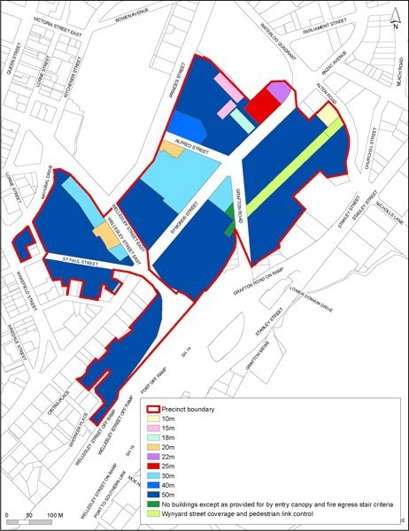

Precinct plan 2: Open spaces and pedestrian linkages
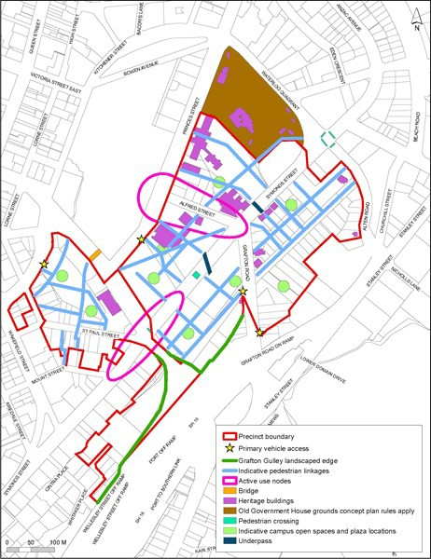

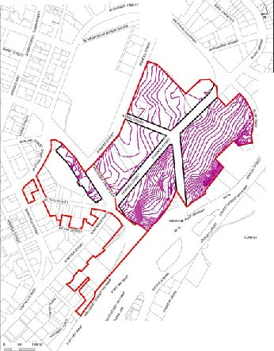Precinct plan 3: Contours

f
i

>..

-r:..........
c::JNu ..,..•11=-grrc •_,.,.d n ac-::w::n ::o til-tci OI •C•II
CJP, ' I:911rl(!f.oy

Precinct plan 4: Frontage types
