PART 3 ­ REGIONAL AND DISTRICT RULES»Chapter K: Precinct rules»3 City Centre»

3.7 Port

The activities, controls and assessment criteria in the Auckland­wide rules in the following precinct, unless otherwise specified below.

The activities, controls and assessment criteria in the underlying General Coastal Marine zone apply to the CMA in the Port Precinct, unless otherwise specified below.

The activities, controls and assessment criteria in the underlying City Centre zone do not apply to land in the Port precinct, unless otherwise specified below.

Activity table

  - The activities in the General Coastal Marine zone apply to the CMA in the Port precinct unless otherwise specified in the activity table below.

  - The following table specifies the activity status of activities on land in the Port precinct.

  - Those activities in the CMA marked with * apply when the activity is on a CMA structure.

Activity table – Port precinct
Activity | CMA [rcp] | Land [dp]
Works in the CMA
Maintenance or repair of a lawful reclamation or drainage system | P | NA
Minor reclamation for the purpose of maintaining, repairing or upgrading a lawful  reclamation | RD | NA
Reclamation or drainage carried out as part of rehabilitation or remedial works | D | NA
Reclamation or drainage not otherwise provided for | NC | NA
Declamation | RD | RD
Maintenance dredging | RD | NA
Capital works dredging | RD | NA
Residential
Workers accommodation | P | P
Commerce
Offices accessory to marine and port activities | P* | P
Maritime passenger operations | P | P
Food and beverage east of Solent Street | NA | P
Marine retail | NA | P
Service stations only on those sites with frontage to Quay Street, between the western  boundary of the Port Precinct and Plumber Street | NA | D
Aquaculture activities (including any activities under RMA s.12(1), s. 12(2), s. 12(3) and  s.15) | Pr | NA
Community
Artworks | P | P
Community facilities, education facilities and healthcare facilities east of Solent Street | P* | P

Activity table – Port precinct
Activity | CMA [rcp] | Land [dp]
Information facilities | P* | P
Emergency services | P | P
Helicopter facilities (including the landing and taking off of helicopters and associated  fuelling and service facilities), except as specified below | D | D
Industry
Marine and port activities, including the landing and taking off of helicopters associated  with the loading and unloading of cargo | P | P
Artificial lighting | P* | P
Development
Marine and port facilities | P | P
Maritime passenger facilities | P | P
Marine and port accessory structures and services | P | P
New buildings, and alterations and additions to buildings on land or on CMA structures  outside of Area A shown on precinct plan 2 | P* | P
Minor cosmetic alterations to a building within Area A that does not change its external  design or appearance | P* | P
New buildings, and alterations and additions to buildings not otherwise provided for on land or on CMA structures within Area A shown on precinct plan 2, excluding marine and port facilities, marine and port accessory structures and services and temporary  structures or buildings | RD* | RD
Demolition of buildings | P | P
Public amenities | P* | P
Wave attenuation devices | RD | RD
Observation areas, viewing platforms, boardwalks and boat launching facilities | P | P
New and existing swing moorings and pile moorings including occupation and use by  vessel to be moored | P | NA
Buildings not listed a permitted or restricted discretionary activity | D | D

Land and water use controls

  - The land and water use controls in the General Coastal marine zone apply to the CMA in the Port Precinct, unless otherwise specified below.

  - The City Centre zone land use controls do not apply to land in the Port Precinct, unless otherwise specified.

Noise

    - These controls do not apply to temporary activities allowed under the Auckland­wide ­ Temporary activities rules.

    - The LAeq(15 min) noise level and maximum noise levels (LAFmax) arising from any activity (except construction or blasting activities) within the Port precinct must not exceed the following:
      - when measured on the southern side of Quay Street or Tamaki Drive (the inner control boundary) shown on precinct plan 3:

11pm to 7am 60dBLAeq
85dBLAFmax

      - when measured at the outer control boundary shown on precinct plan 3:

7am to 11pm | 55dBLAeq
11pm to 7am | 50dB LAeq  75dB LAFmax
    - In determining compliance with the above the following applies:
      - The long term average sound level, averaged over any 7 days (i.e. 7 days of short­term average levels) must not exceed the specified levels by more than 3dBA due to statistical variation over those days.

      - There must be no exceedance of the specified short­term average levels by more than 5dBA. The short­term LAeq (15 min) sound level will be the average of any four LAeq(15 min) values obtained during a single night or day when the wind speed at the site where measurement is taken is less than 2mper second. If the wind speed in the vicinity of both the subject site and the receiver, or any intervening area is known to have exceeded 2m per second during any measurement interval, then that measurement must not be used to determine the short­term average sound level. Measurements must be accompanied by records of air temperature. There must be no other restrictions on weather conditions.

      - Care must be taken to ensure that the short­term average sound level represents noise from port activities and is not influenced by noise from other sources. The time period between 3:00am and 5:00am is the preferred time for noise measurements. If the short­term average level is wholly or partly determined from measurements at other times, then records must be adequate to demonstrate that the short­term average sound level was not influenced by noise from non­port sources.

      - Except as noted above, the noise levels must be measured and assessed in accordance with New Zealand Standard on Acoustics ­ Measurement of Environmental Sound (NZS 6801:2008) and New Zealand Standard on Acoustics – Environmental Noise (NZS 6802:2008).

Lighting

    - Artificial lighting illuminance must not exceed 150 lux, measured at any point on the site containing the light source, in a horizontal or vertical plane at ground level.

    - Illumination associated with vehicles, mobile plant, and quay cranes are exempt from this control.

Parking

    - Clause 1.2.3.2 of the Auckland­wide ­ Transport rules do not apply to land and CMA west of Solent Street.

Development controls

  - The development controls in the General Coastal Marine zone apply to the CMA in the Port Precinct, unless otherwise specified.

  - The City Centre zone development controls do not apply to land in the Port Precinct, unless otherwise specified.

Building height

Purpose: manage the height of buildings to achieve policy 7 of the Port precinct.

    - Buildings, structures, marine and port facilities, maritime passenger facilities and marine and port accessory structures and services must not exceed the heights specified on precinct plan 1.

Occupation of the CMA

Purpose: enable Ports of Auckland Limited to manage occupation of the CMA in accordance with their occupation consent.
    - Any occupation of the CMA where Ports of Auckland Limited has been granted an occupation consent requires the written approval of Ports of Auckland Limited or of any party to whom Ports of Auckland Limited has transferred the water space management.

Assessment ­ Restricted discretionary activities

4.1 Matters of discretion
For development that is a restricted discretionary activity in the Port precinct, the council will restrict its discretion to the following matters, in addition to the matters specified for the relevant restricted discretionary activities in the General Coastal Marine zone where the activity is in the CMA.
  - Minor reclamation for the purpose of maintaining, repairing or upgrading a lawful reclamation
    - The matters of discretion in clause 5.1 of the General Coastal Marine zone rules apply.

  - Declamation
    - construction or works methods, timing and hours of operation

    - location, extent, design and materials used

    - effects on coastal processes, ecological values, water quality and natural character

    - effects on public access, navigation and safety

    - effects on existing uses and activities

    - effects on mana whenua values

    - consent duration

  - Maintenance dredging and capital works dredging
    - The matters of discretion in clause 5.1 of the General Coastal Marine zone rules apply.

  - Wave attenuation devices
    - The matters of discretion in clause 5.1 of the General Coastal Marine zone rules apply.

  - New buildings, and alterations and additions to buildings not otherwise provided for
    - building design and external appearance

    - effects on public access, navigation and safety.

Assessment criteria
For development that is a restricted discretionary activity in the Port precinct, the following assessment criteria apply in addition to the criteria specified for the relevant restricted discretionary activities in the General Coastal marine zone where the activity is in the CMA.
    - Minor reclamation for the purpose of maintaining, repairing or upgrading a lawful reclamation
      - Refer to the clauses 5.2.1 and 5.2.9 of the General Coastal Marine zone rules.

    - Declamation
      - The adverse effects of declamation must be avoided, remedied or mitigated in respect of the effects of the final land/water configuration on:

i.

ii.
the marine environment (including coastal processes, water quality, sediment quality and ecology) of the coastal marine area

hydrogeology (ground water) and hydrology

iii.
sediment accumulation and the need for ongoing maintenance dredging of the coastal marine area.

      - Declamation works, including the construction of seawalls, should avoid, remedy or mitigate the adverse effects of construction, particularly through the management of silt, contaminated soils and groundwater, and other contaminants.

      - Declamation should be located and designed so that the adjacent land area can provide adequate public open space adjacent to, and public access around along the waters edge whether on land or on the adjacent water space.

    - Maintenance dredging and capital works dredging
      - The assessment criteria in clauses 5.2.1 and 5.2.11 of the General Coastal Marine zone rules apply in addition to the criteria below.

      - The dredging should be necessary to achieve the outcomes sought by the objectives and policies for the Port precinct.

    - Wave attenuation devices
      - The assessment criteria in clauses 5.2.1 and 5.2.16 of the General Coastal Marine zone rules apply in addition to the criteria below.

      - The location and design of the wave attenuation device should consider existing activities including marine related industries, other marina activities and/or adjoining residential/coastal activities.

    - New buildings, and alterations and additions to buildings not otherwise provided for
      - The assessment criteria in clause 6.2.1(a), (b)(v), (c)(i), (c)(iii), (c)(v) ­ (ix), (d), (e), (g) of the City Centre zone rules apply in addition to the criteria below.

      - Buildings within Area A shown on precinct plan 2 should where reasonably practicable be designed to avoid long, unrelieved frontages and excessive bulk and scale when viewed from Quay Street, while acknowledging any functional and operational requirements of marine and port activities to be accommodated within the building.

      - Building mass should be visually broken up into distinct elements. Techniques include the use of recesses, variation in building height and roof form, horizontal and vertical rhythms and façade modulation and articulation.

      - Any loading and servicing activities including the storage and collection of wastes located on­site should be screened and occur behind buildings and away from Quay Street.

      - The quality of building design should reflect and acknowledge Quay Street’s importance as a gateway to the city centre. In particular, it should have regard to the area’s high visibility in views along Quay Street and from a range of over­looking viewpoints, whilst acknowledging any functional and operational requirements of marine and port activities to be accommodated within the building.

      - Buildings should have clearly defined public fronts that address the street to positively contribute to the public realm and pedestrian safety. Where the ability to achieve this is constrained by the functional and operational requirements of marine and port activities, building facades should be articulated with architectural features, compositional elements or projecting or recessed surfaces or elements.

Assessment ­ Development control infringements

5.1 Matters of discretion
In addition to the general matters set out in clause 2.3 of the general provisions, the council will restrict its

discretion to the matters below for the relevant development control infringement.
  - Building height
    - building scale and dominance / visual amenity effects

    - effects on the current or planned future form and character of the precinct.

  - Occupation of the CMA
    - building scale and dominance / visual amenity effects

    - effects on the current or planned future form and character of the precinct

    - Effects on the transportation network.

Assessment criteria
In addition to the general assessment criteria in clause 2.3 of the general provisions, the council will consider the relevant assessment criteria below for the development control infringement.
    - Building height
      - Building height may be exceeded where it would provide an attractive and integrated roof form that also meets the purpose of the control.

      - Where building height is exceeded, policy 7 of the Port precinct and policy 17 of the City Centre zone should be considered.

    - Occupation of the CMA
      - Reverse sensitivity issues between port occupation and occupation of the CMA for other uses should be avoided.

6. Precinct plans

Precinct plan 1: Building height
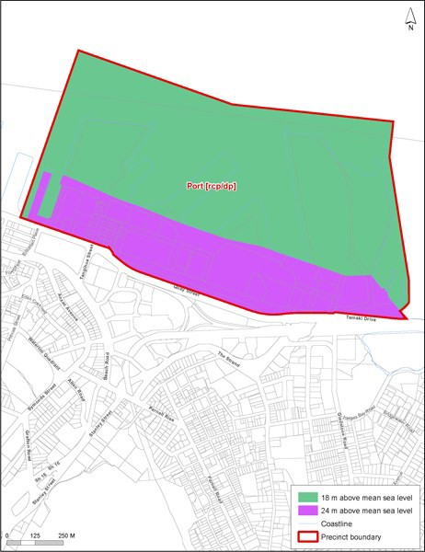

Precinct pli'll 2: Bdent of ea A

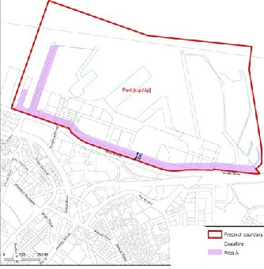'

Precinct plan 3: Noise boundaries
