PART 3 ­ REGIONAL AND DISTRICT RULES»Chapter K: Precinct rules»3 City Centre»

3.8 Quay Park

The activities, controls and assessment criteria in the Auckland­wide rules apply to the Quay Park Precinct, unless otherwise specified below.

The activities, controls and assessment criteria in the underlying City Centre zone apply to the Quay Park precinct unless otherwise specified below.

Refer to the planning maps for the location and extent of the precinct.

Activity table

  - The activities in the City Centre zones apply in the Quay Park precinct unless otherwise specified in the activity table below.

Activity table – Quay Park precinct
Activity | Activity status
Framework plans
A framework plan, amendments to an approved framework plan, or a replacement  framework plan complying with clause 3.1 below | RD
A framework plan, amendments to an approved framework plan or a replacement  framework plan not complying with clause 3.1 below | NC
Development
Minor cosmetic alterations and repairs to a building that does not change its external  design and appearance | P
New buildings, and alterations and additions to buildings, that comply with an approved  framework plan | RD
Alterations and additions to buildings established before the date of notification of this Unitary Plan, prior to the approval of a framework plan, or that do not comply with an approved framework plan (excluding minor cosmetic alterations or repairs which do not change the design and appearance of the building) provided the height or gross floor area  of the building is not increased by more than 10 per cent | RD
New buildings, and alterations and additions to buildings, that do not comply with an approved framework plan, or prior to the approval of a framework plan, except for minor  alterations and additions provided for as a restricted discretionary activity | NC

Notification

  - The council will consider restricted discretionary activity resource consent applications for framework plans (including amendments to an approved framework plan or a replacement framework plan) without the need for public notification, however limited notification may be undertaken, including notice being given to any owner of land within sub­precinct A who has not provided their written approval.

Framework plans

  - A resource consent application for a framework plan, amendments to an approved framework plan or a replacement framework plan must:
    - apply to all or part of sub­precinct A, or

    - apply only to land that the applicant is the land owner of, or to sites in multiple ownership where the landowners make a joint application, and

    - comply with the general rules applying to framework plans specified in clause 2.6 and 2.7.3 of the general provisions

    - contain the following land uses:

i.

ii. iii. iv.

v.

vi.
the location of building platforms building envelopes
the location of land uses activities within the development

the location, physical extent and design of public open spaces, streets and pedestrian connections

the location and capacity of infrastructure servicing the location of parking and vehicle access.

  - Where a concurrent application is made to infringe building height (clause 4.1 of the City Centre zone rules) or maximum floor area ratio (clause 4.20 of the City Centre zone rules), the status of framework plan will be the same status as the development control infringement.

  - In circumstances where an approved framework plan applies, any subsequent application to infringe the building height (clause 4.1 of the City Centre zone rules) and maximum floor area ratio (clause 4.20 of the City Centre zone rules) development controls will require an application to either amend the framework plan or an application for a new framework plan. In these instances, the activity status of the development control infringement will apply.

Development controls

The development controls in the City Centre zone apply in the Quay Park precinct unless otherwise specified below.

4.1 Building height

Purpose: manage the height of buildings to achieve policies 4 and 5 of the Quay Park precinct.
  - Buildings must not exceed the heights shown on precinct plan 2­4.

Building frontage height

Purpose: manage the frontage height of buildings to maintain pedestrian amenity and maintain low building heights around public open space.
    - On every frontage identified on precinct plan 1, buildings must not project beyond a 45 degree recession plane measured at all points along the frontage of the site from 18m above mean street level. The building setback must be an emphatic or a stepped profile of at least two stories and must not be a literal regression of the 45 degree angle.

Site intensity

Purpose: manage the scale, form and intensity of development to maintain the character of the Quay Park precinct.
    - The basic and the maximum floor area ratio permitted within the precinct is 3:1.

    - Excluded from the calculation of the basic and maximum floor area ratio are parking areas incorporated within the building to an equivalent FAR of 1:1.

    - For sites within the area bounded by Quay Street, Tangihua Street, Beach Road and Britomart Place the following applies:
      - the basic floor area ratio is 4:1 and the maximum total floor area ratio is 8:1

      - the maximum total floor area achievable is limited by the ratio of average floor area to site area as

follows.

Where:

        - AFA < 0.6 SA
(b) 0.6 < AFA < 0.75

SA

(c) AFA > 0.75

SA
MTFAR equals 8 : 1

12.8 ­ (8 x AFA) : 1 SA
6.5 : 1

iii.

4.
The bonus floor area provisions under clauses 4.10 to 4.19 including the bonus features for bonus area 2 apply.

Development that does not comply with clauses 1­3 above is a non­complying activity.

Assessment ­ Restricted discretionary activities

5.1 Matters of discretion
For development that is a restricted discretionary activity in the Quay Park precinct, the council will restrict its discretion to the following matters, in addition to the matters specified for the relevant restricted discretionary activities in the City Centre zone.
  - Framework plan, amendments to a framework plan and a replacement framework plan
    - integration of the development with neighbouring areas

    - the relationship of land form/site contours with building levels

    - the location, physical extent and design of streets and pedestrian connections

    - the location, physical extent and design of open space

    - the location and capacity of infrastructure servicing

    - the staging of development and the associated resource consent lapse period

    - the location of land use activities within the development

    - the location and physical extent of parking areas and vehicle access

    - the location and form of buildings (building footprints and envelopes).

  - New buildings, and alterations and additions to buildings that comply with an approved framework plan and alterations and additions to buildings established before the date of notification of this Unitary Plan that do not comply with an approved framework plan (excluding minor cosmetic alterations that do not change the design and appearance of the building) provided the height or gross floor area of the building is not increased by more than 10 per cent
    - The matters of discretion in clause 6.1.1 of the City Centre zone rules for new buildings and/or alterations and additions to buildings apply.

Assessment criteria
For development that is a restricted discretionary activity in the Quay Park precinct, the following assessment criteria apply in addition to the criteria specified for the relevant restricted discretionary activities in the General Coastal Marine and City Centre zones.
    - Framework plan, amendments to a framework plan and a replacement framework plan
      - Integration of the development with neighbouring areas
        - Where the framework plan is for a particular site or sub­precinct within a wider precinct, the

framework plan should demonstrate how the development achieves the overall objectives of the precinct, including the integration of streets, pedestrian connections, open spaces and other infrastructure that will serve the development.

ii.

The relationship of land form/site contours with building levels

- The proposed finished contour levels across the subject land area should avoid variations between the ground floor level of future buildings and adjoining existing and proposed public open space (where information is available). Where ground floor dwellings or visitor accommodation is proposed, some minor variation between the ground floor level and the level of adjoining public open space may be acceptable to provide for the privacy of residents consistent with the assessment criteria for ground floor dwellings in the City Centre zone.

- The location and form of buildings (building footprints and envelopes)
  - Building footprints, profiles and heights (as opposed to detailed building design) should establish an integrated, legible and high quality built form and spatial framework across the subject land area while also:
    - avoiding monotonous built form when viewed from public open space through variation in building footprints, height and form.

    - enhancing and activating proposed open space areas within the site.

    - enhancing the form and function of existing and proposed streets, and lanes (including through site links) within and outside of the site.

    - maximising views, outlook and sunlight access for future site occupants.

    - protecting views to scheduled heritage places i.e. Dilworth Viewshafts and Auckland Museum

- The location of land use activities within the development

i.

ii.
The location and staging of anticipated activity types and/or the location, orientation or layout of buildings should avoid or mitigates potential conflicts between activities within the subject land area.

Opportunities to establish community facilities for future occupants of the site and for the wider community are encouraged within the development.

- The location, physical extent and design of open space, streets and pedestrian connections

i.

ii.

iii.

iv.
The framework plan should demonstrate that a fine­grained street and block pattern is provided within sub­precinct A that enhances connectivity between the Strand, Quay Street and Beach Road. The framework plan should also demonstrate how the proposed street layout provides logical, convenient and attractive connections with other streets, pedestrian connections and open spaces within the precinct.

The layout of buildings should ensure well­connected, legible and safe vehicular and pedestrian routes with appropriate provision for footpaths, servicing, infrastructure services and landscape treatment.

Safe, practical and efficient 24hr through­site links are encouraged through the block. Where provided, the through­site link must be able to comply with the requirements for through­site links in the City Centre zone.

The layout and design of public open space should meet the demand of future occupants of the site and be of a high quality, providing for public use and accessibility, views, sunlight access and wind protection within the application area.

- The location and capacity of infrastructure servicing
  - Stormwater, wastewater, water supply, electricity and telecommunication infrastructure will need

to be provided to adequately service the nature and staging of anticipated development within the application area.

ii.

Stormwater management methods that utilise low impact stormwater design principles and improved water quality systems are encouraged.

- The staging of development and the associated resource consent lapse period
  - The framework plan should detail the methods by which the demolition and development of the site will be staged and managed to compliment the proposed open space, road and lane network and to avoid, remedy or mitigate adverse effects associated with vacant disused areas of the site.

- The location and physical extent of parking areas and vehicle access

- Parking, loading and servicing areas should be integrated within the application area taking account of location and staging of anticipated activity types.

    - New buildings, and alterations and additions to buildings, that comply with an approved framework
plan and alterations and additions to buildings established before the date of notification of this Unitary Plan that do not comply with an approved framework plan (excluding minor cosmetic alterations that do not change the design and appearance of the building) provided the height or gross floor area of the building is not increased by more than 10 per cent
      - The assessment criteria in clause 6.2.1 of the City Centre zone rules for new buildings and/or alterations and additions to buildings apply.

Assessment ­ Development control infringements

6.1 Matters of discretion
In addition to the general matters set out in clause 2.3 of the general provisions, and the specific matters set out for the infringement in the City Centre zone, the council will restrict its discretion to the matters below for the relevant development control infringement:
  - Building height
    - building scale and dominance / visual amenity effects

    - effects on the current or planned future form and character of the precinct.

  - Building frontage height
    - building scale and dominance / visual amenity effects

    - effects on the planned future form and character of the precinct

    - pedestrian amenity and function.

Assessment criteria
In addition to the assessment criteria in clause 2.3 of the general provisions, and the specific assessment criteria for the infringement in the City Centre zone, the council will consider the relevant assessment criteria below for the infringement listed.
    - Building height
      - Building height may be exceeded where it would provide an attractive and integrated roof form that also meets the purpose of the control.

      - Where building height is exceeded, policies 4 and 5 of the Quay Park precinct and policy 17 of the City Centre zone should be considered.

    - Building frontage height
      - The scale of the development should be consistent with the planned future character of Quay Park as established through the objectives and policies for the Quay Park precinct.

      - Pedestrian amenity should be maintained or enhanced.

Special information requirements

  - An application for a framework plan, amendments to an approved framework plan or a replacement framework plan must comply with the special information requirements for framework plans
in clause 2.7.3 of the general provisions, and provide the following information as a minimum:
    - Plans showing the proposed building profile and height as viewed from all existing and proposed street and lane frontages and existing and proposed public open spaces. Building profile means two dimensional and three dimensional building block elevations and building cross sections showing:

i.

ii. iii. iv.
overall building form and height (as opposed to detailed design) indicative proposed floor to floor heights of each building storey
areas at ground level adjoining public open space intended to be available for active uses

areas of walls likely to contain windows for principal living areas of accommodation units to demonstrate how the outlook space development control will be met.

    - Plans showing the general location of activity types which have potential to influence the staging and design of development across the subject land area including accommodation and entertainment uses.

Precinct plans

Precinct plan 1: Frontage height and setback
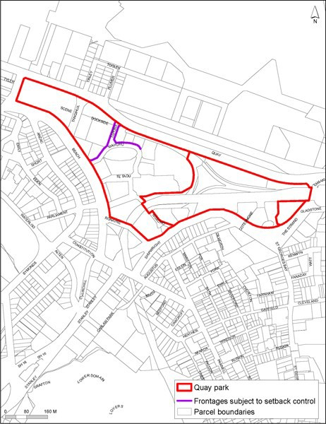

Precinct plan 2: Building height controls outside of sub­precinct A
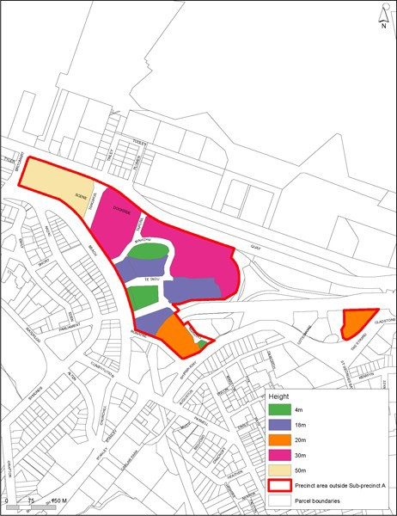

Precinct plan 3: Building height controls Wthin sub-precinct A before the approwl of aframev.ork
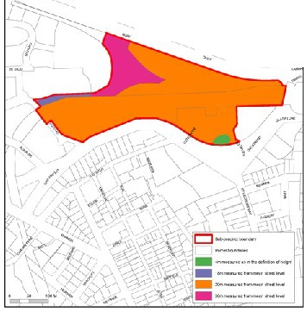pi"'
7 --......::-........t.... )
....... .... J
.............................,.._..............
/
I • ..._ ......... ,.
I I 'ir...._::_-.......;-'
I I II ...., I
........._ I I II II
........_ .!.
J........_.../1 I 1

..._--........ -J
II I 1 ..

-.............. -..., I I I "',-........_
............. -(_l I \ ............
I  I | \ | ,,  '
 | II | I  I

'-
-........_ ;
' -....._ .........I
I

........_ ........._
........._
.........
.....
....,
_ ....._ I

-'­
-. ' ....._

Precinct plan 4: Building height controls within sub­precinct A after approval of a framework plan
