PART 3 ­ REGIONAL AND DISTRICT RULES»Chapter K: Precinct rules»5 North»

5.16 Hobsonville Corridor

The activities, controls and assessment criteria in the underlying zones and the Auckland­wide rules apply in the following precinct and sub­precincts except as specified below.

Activity table

  - The activities in the underlying zone apply in the Hobsonville Corridor precinct except as specified in the activity table below.

Activity table 1 sub­precinct A

Activity | Activity  Status
Any building activity, development, or subdivision in area 2 before the following are approved:  - An integrated catchment management plan  - Network discharge consents for the whole of area 2  - An integrated transport assessment | NC
Accommodation
Dwellings | Pr
Commerce
Drive­through facilities | NC
Garden centres | NC
Industrial activities | RD
Motor vehicle sales | NC
Service stations | RD
Trade suppliers | NC
Development
New buildings and external alterations and additions to buildings | RD
Stormwater controls in accordance with the integrated catchment management plan and  relevant network discharge consents | RD
Subdivision | RD

Activity table 2 sub­precinct B

Activity | Area 1 | Area 2
Offices | NC | RD
Service stations | NC | RD
Trade suppliers | NC | RD
Food and beverage up to 200m2 GFA per site | P | RD
Dwellings | P | P
Retail up to 200m2 GFA per site | P | P

Activity table 3 sub­precinct C

Activity | Activity  Status
Dwellings located more than 400m from the intersection of Hobsonville and Clark/Wisely  Roads | D
Dwellings located within 400m from the intersection of Hobsonville and Clark/Wisely Roads | P
Retail | P
Two supermarkets up to 4000m2 GFA each | RD
Commercial services | P

Activity table 4 Framework plan and development ­ sub­precincts B and C

Sub­precincts B and C
Framework plan | Activity  Status
A framework plan, amendments to an approved framework plan or a replacement framework  plan complying with clause 3.2 below | RD
A framework plan, amendments to an approved framework plan or a replacement framework  plan not complying with clause 3.2 below | NC
Alterations to building facades that are less than:  - 10 per cent of its total surface area, or  ­ 15m2  - whichever is the lesser | P
Any buildings, subdivision or development complying with an approved framework plan | RD
Any buildings, subdivision or development, except for alterations to building facades provided for as a permitted activity in this table, not complying with an approved framework plan or prior  to the approval of a framework plan | NC
Stormwater controls in accordance with the integrated catchment management plan and  relevant network discharge consents | RD

Notification

  - Restricted discretionary resource consent applications for framework plans, and amendments to framework plans, will be considered without the need for public notification. However, limited notification may be undertaken, including notice being given to any land owner within the sub­precinct who has not provided written approval to the application.

Land use

  - Any activity that does not comply with the land use controls is a non­complying activity unless otherwise stated.

  - Except as specified, the land use controls in the underlying zones apply in the sub­precincts.

Permitted controls

    - Dwellings

      - Dwellings in sub­precinct B ­ area 1 must be located above the ground floor.

Retail

      - Food and beverage and dairies in sub­precinct B – area 2 must be located on the ground floor and must not exceed 200m2 in GFA.

      - Retail in sub­precinct C:
        - must not exceed 500m2 GFA

        - must have a maximum average GFA not exceeding 300m2.

      - A maximum of two supermarkets may locate within sub­precinct C. Each supermarket must not exceed 4000m2 GFA.

Framework plans

    - A resource consent application for a framework plan, amendments to a framework plan or a replacement framework plan must:
      - apply to the whole of a sub­precinct, or

      - apply only to land that the applicant is the owner of, and

      - comply with:

i.

ii.
the general rules and information requirements applying to framework plans in clause 2.6 and
2.7.3 of the general provisions

the special information requirements for framework plans specified in clause 6 below.

      - Seek consent for the following land uses:

i.

ii. iii. iv.
v.

vi. vii.
earthworks associated with the development the design and location of public open spaces
the design and location roads and pedestrian linkages stormwater management devices
the design and location of vehicle accessways and slip lanes the landscape buffer and set­back in sub­precinct A
the design and layout of blocks fronting Hobsonville Road in sub­precinct C.

Development controls

  - Except as specified, the development controls in the Light Industry zone apply to sub­precinct A, the Mixed Use zone applies sub­precinct B and the Local Centre zone applies to sub­precinct C.

  - Development that does not comply with the development controls is a discretionary activity.

Landscape interface control ­ sub­precinct A

Purpose: ensure industrial development adjoining Hobsonville primary school mitigates potential adverse effects on the school.

    - Any development of a site adjoining the Hobsonville primary school identified on precinct plan 1 as being subject to a landscape interface control must:
      - include a landscape interface plan with the resource consent application

      - provide continuous impermeable fencing of at least 1.8m in height

      - set buildings back 6m from the property boundaries of Hobsonville primary school

      - along landscape interface area A, provide a minimum 3m wide and 1m high landscaped bund, and along landscape interface area B provide a minimum 3m wide landscape area

      - contain buildings within a recession plane of no more than 35 degrees as measured from any relevant point 2.5m vertically above ground level on any site boundary in landscape interface area

A and within a recession plane of no more than 45 degrees as measured from any relevant point 2.5m vertically above ground level on any site boundary in landscape interface area B.

    - Development that does not comply with this control is a non­complying activity.

Future Roads

Purpose: ensure that roads are constructed to serve development in general accordance with precinct plan 1.

    - Any new buildings on a site that contains an indicative future road must make provision for the development of that road in general accordance with precinct plan 1 and precinct plan 3).

Buildings Fronting Hobsonville Road

Purpose: ensure buildings define the street edge of Hobsonville Road and contribute to:
- providing an attractive streetscape

- enhancing pedestrian amenity

- making buildings accessible.

    - In sub­precincts A and C a new building on a site fronting Hobsonville Road must adjoin the site frontage for its entire length.

    - Vehicle access areas in accordance with precinct plan 1 are excluded from the requirements of this control.

Building frontage height on Hobsonville Road

Purpose: ensure buildings adequately define the street and provide a sense of enclosure.

    - In sub­precincts A and C a new building on a site fronting Hobsonville Road must have a minimum height of 8.5m or two storeys above the finished level of the street for a minimum depth of 10m from the frontage.

Verandahs

Purpose: provide pedestrians with weather protection, safety and amenity on the frontages of sites on Hobsonville Road.

    - In sub­precinct C the ground floor of a building fronting Hobsonville Road must provide a verandah along the full extent of the frontage.

    - The verandah must:
      - be related to its neighbours to provide continuous pedestrian cover of the footpath, excluding vehicle access

      - have a minimum height of 3m and a maximum height of 4.5m above the footpath

      - be set back at least 600mm from the kerb.

Subdivision controls

  - The subdivision controls in the Auckland­wide rules apply in the Hobsonville Corridor precinct except as specified below.

Subdivision in sub­precinct A

    - Any subdivision of a site adjoining the Hobsonville primary school must be in accordance with precinct plan 1 and incorporate the features shown on precinct plan 4.

Subdivision in all sub precincts

    - Any subdivision of a site that contains an indicative future road must make provision for the development of that road in general accordance with the position shown on precinct plan 1.

    - The central spine road shown on precinct plan 1 must be designed as a collector road.

Assessment ­ Restricted discretionary activities

Matters of discretion
The council will restrict its discretion to the matters below for the activities listed as restricted discretionary in the precinct activity table, in addition to the matters of discretion for the activity in the underlying zone.

Table 1

Activity | Building interface with  public realm | Design, location and  scale | Framework Plan | Transport | Infrastructure
A framework plan, amendments to an approved framework plan or a replacement framework  plan | X | X | X | X | X
Buildings, and alterations and additions to buildings, in sub­precincts B or C complying with an  approved framework plan | X | X
Buildings, and alterations and additions to buildings,  in sub­precinct A | X | X |  | X | X
Stormwater controls in  sub­precinct C |  |  |  |  | X
Subdivision in sub­ precincts B or C complying with an approved  framework plan |  | X

Assessment criteria
- Building interface with the public realm
  - Buildings should activate the adjoining street or public open space by:

i.

ii.

iii. iv.

v.

vi.
being sufficiently close to the street boundary and of a frontage height that contributes to street definition, enclosure and pedestrian amenity. On sites adjoining Hobsonville Road, buildings should adjoin the site frontage unless there are exceptional circumstances

having a pedestrian entrance visible from the street and located sufficiently close to reinforce pedestrian movement along the street

having a floor to floor height that allows for a range of uses

providing a level of glazing that allows a high degree of visibility between the street/public open space and building interior to contribute to pedestrian amenity and passive surveillance

providing pedestrian cover from the weather and wind of a design consistent with the pedestrian focal point role of Hobsonville Road

avoiding blank walls at ground level

vii.
providing convenient and direct entry between the street and building for people of all ages and abilities.

  - Vehicles access should be shared between buildings to reduce gaps in the streetscape and service lanes should be provided within urban blocks in accordance with the precinct plan 1.

  - Buildings within the sub­precinct B ­ area 2 should be located and designed to encourage pedestrian movement and the support of public transport integration along the Hobsonville Road adjoining the Hobsonville Road corridor.

  - Buildings, particularly those adjoining Hobsonville Road, should consider the effects of any infringement on the appearance and integrity of the streetscape as a whole.

- Design, location and scale
  - Buildings, development and subdivision should be consistent with:

i.

ii. iii. iv.
the policies for that particular sub­precinct Precinct plan 1
Precinct plan 2

Precinct plan 3.

  - All development should be well­connected and via a public road system that allows for public transport, vehicle and pedestrian connections.

  - Buildings, vehicle accesses, carparking and other development should be of a size, location, scale and design that complement the character of buildings and development of adjoining land and sub­precincts and surrounding zones, having regard to the existing and potential use of that adjoining land.

  - Redevelopment of, or additions or alterations to existing buildings should complement existing development having regard to:

i.

ii. iii.
the architectural elements of the building which contribute to its character, such as cladding and fenestration

the visual appearance of the development from the road amenity values and neighbourhood character.

  - Landscaping should be used to off­set the visual effect of new buildings and a high standard of amenity should be achieved that complements and enhances the natural landscape character of adjoining land.

  - Development should provide a good standard of aural and visual amenity, particularly between residential activities and non­residential activities and between residential activities and roads.

  - Design car parking and loading spaces should be either:

i.

ii.

iii.
located to the rear of the building, in a basement (or semi­basement) below ground level or within the building at ground level, provided that the building must be able to accommodate a non­residential activity between any ground floor parking area and the street which is oriented towards streets rather than parking areas, or

for larger sites according to a perimeter block layout where parking is provided behind or within buildings (except for kerbside parking), and with the active street frontages oriented towards streets rather than parking areas, and/or

maximising the opportunity for provision of communal parking areas.

Sub­precinct A
  - Any proposed development, buildings and subdivision in sub­precinct A that adjoin to or are visible from Hobsonville Road or the Hobsonville primary school should achieve a high standard of visual amenity through such methods as design articulation of building facades, limiting building height and bulk, building set backs, the design of the landscape interface area, landscape treatment of front yards, fencing on the Hobsonville primary school boundary, and screening of storage areas.

  - Any proposed development, buildings and subdivision in sub­precinct A that are in the vicinity of Hobsonville Road or the Hobsonville Primary School are designed and/or managed to avoid or mitigate any potential for effects arising from noise, discharges to air or odour.

  - Any proposed development, buildings and subdivision in sub­precinct A that adjoin to, or are visible from the northern and western boundary of the Hobsonville primary school, achieves the mitigation of noise and visual effects on the school through the implementation of a landscape
interface plan. The frontage control (refer precinct plan 4) should be adhered to where buildings are of a design or function that does not require an active interface with the street, and where a setback is required to maintain a satisfactory standard of visual amenity for any outlook from residential development directly opposite the site on Hobsonville Road.

  - Activities and structures in areas 1 and 2 should maintain and enhance the modern industrial park character and amenity of Hobsonville Corridor precinct area.

Sub­precinct C
  - Retail activities proposed within sub­precinct C should serve the neighbourhood catchment.

  - Development or buildings in sub precinct C where street typologies apply, should contribute to high standards of design, pedestrian amenity, safe and attractive streets and public places including open spaces and stormwater features and encourage pedestrian activity through the use of:

i.

ii.

iii.
modulation, and architectural elements

active street frontages through glazing, lighting, balconies on upper floors and the avoidance of blank walls on street frontages

in the case of large format buildings avoid blank walls, by providing active street frontages. Where this is not achieved buildings should be sleeved with smaller buildings and activities which provide active street frontages

  - Excessive earthworks (cut and fill), retaining walls on the street frontage that affect the continuity of active street frontages, the visual appearance of the street frontage and easy pedestrian access to the site should be avoided.

  - Development should incorporate crime prevention through environmental design and universal design principles.

  - Outdoor plazas and seating areas associated with cafes and restaurants should be designed to enhance the streetscape. These should be open to the street with limited use of walls and changes in height to delineate semi­public spaces, so as to maintain a visual connection between the activity and the street.

  - The two supermarkets provided for in sub­precinct C must be designed to contribute to the creation of a cohesive local centre.

- Framework plan
  - A proposed framework plan, amendments to an approved framework plan or a replacement framework plan should:
    - result from a process involving consultation with all landowners within that precinct and

adjoining precincts

ii. iii.

iv.

v.

vi.

vii. viii.
be consistent with the precinct plans 1, 2 and 3

address all relevant matters contained within the objectives and policies for the precinct and sub­precinct

provide for a coherent design and integrate with the surrounding environment and the context of the surrounding development and natural features

utilise areas of open space, planting and streetscape treatment to avoid or mitigate the visual effects and impacts of buildings and development

provide for the efficient use of sites with the use of shared facilities between similar activities both on adjoining sites and in the vicinity

ensure that buildings are linked and developments promote walkable neighbourhoods

ensure that the proposed sites are of adequate size to accommodate the proposed activity together with associated parking, landscape treatment and any other facilities.

  - The level of detail supplied should reflect ownership patterns. Specific detailed information is required for land that the applicant owns or has an interest in. For that part of the precinct that the applicant does not own or have an interest in, the extent of detailed information to be provided is
to depend on whether there are any specific development proposals at the time of the framework plan application. The applicant is to provide as much relevant detail as possible, after making reasonable enquiries, concerning any such developments. If there are no such development proposals, a general outline only may be provided reflecting the type of development envisaged by precinct plan 1.

  - Refer to the general assessment criteria for framework plans in clause 2.6 of the general provisions.

- Transport
  - All the following assessment criteria are to be addressed in an integrated transport management plan prepared in consultation with Auckland Transport and the New Zealand Transport Agency to satisfy the assessment criteria below.

  - The design of roads and the development of adjoining sites should ensure well­connected attractive and safe transport routes, with appropriate provision for vehicle, cycle and pedestrian movements, car parking, infrastructure services, street tree planting and landscape treatment.

  - The council may require compliance with frontage controls set out in precinct plan 4 as a condition of framework plan approval in respect of sub­precinct C.

  - A highly inter­connected public road system should be provided so as to reduce trip distances and to improve local accessibility to community facilities, reserve, public transport facilities and sub­precinct B and C. It is expected that the preparation of framework plans will include consultation with the Auckland Council and Auckland Transport.

  - Any development having access to Hobsonville Road or Brigham Creek Road should be designed to minimise the need for vehicle crossings to Hobsonville road and achieve safe access, without compromising the ability of those roads and the Brigham Creek interchange to efficiently function as a strategic network. It is expected that the applicant will consult with New Zealand Transport Authority and Auckland Transport in respect of this criterion.

  - Roads and intersection design should create high quality public spaces, and incorporate quality amenity features such as tree planting and footpath paving.

  - Stormwater management features such as rain gardens, swales and permeable paving should be incorporated into roading design.

  - A pedestrian and cycle network should be provided that safely and directly links schools, reserves, commercial areas and passenger transport routes with living areas

  - The design and construction of on­site roads should be capable of providing access to the wider movement network.

  - Traffic generation should not create adverse effects on:

i.

ii. iii. iv.
the capacity of roads giving access to the site

the safety of road users including cyclists and pedestrians neighbourhood character
the sustainability of the primary road network and the frequent network (Note: NZ Transport Authority and Auckland Transport interprets sustainability of the primary roading network as preserving the transport function of the state highway network, and regional arterial roads to maintain the optimum level of speed and capacity for both private vehicles and public transport).

  - Good walking and cycle connection should be provided between parks/reserves, town centres and schools

  - The design of roads and slip lanes should utilise land efficiently and encourages walkability by using minimal dimensions for carriageways creating safe entry and exit points on the slip lanes and integrating service lines beneath footpaths or parking bays.

  - Development should achieve:

i.

ii.

iii.

iv.
an overall level of service (LOS) of ‘E’ (or higher) for interchanges and intersections within and immediately adjacent to sub­precincts A and C

an overall LOS of ‘E’ or (higher) or a degree of saturation less than or equal to 0.95 for an individual movement along Hobsonville Road and at Brigham Creek interchange

safe and efficient stacking capacity within the intersections and interchanges shown on the Hobsonville Corridor urban concept transport plan (precinct plan 3)

the mitigation of any adverse transport effects on the roading network, where practicable.

  - Provision should be made for public transport facilities, including a public transport interchange, taxi stops and bus stops.

  - Development should be designed to integrate land uses with transport systems, using an integrated transport assessment methodology for major trip generating activities. The integrated transport assessment should include consideration of public transport within each sub precinct, and between sub­precincts.

  - Parking areas should accommodates expected peak demand of an activity, having regard to:

i.

ii. iii.

iv.

v.
the existing provision of parking areas in the vicinity of the site the capacity of roads giving access to the site
the safety of road users including cyclists and pedestrians, including where appropriate for this purpose, avoiding car parking for an activity being separated by a road

neighbourhood character

parking demand for different activities at different times of the day.

  - Car parking should be designed according to a perimeter block layout where parking is provided behind buildings, except for kerbside parking, and with the main activity frontage for buildings oriented towards public streets rather than parking area.

  - Car parking should be provided that:

i.

ii.
has sufficient parking spaces for visitors in all sub­precincts

has sufficient parking spaces for residents in sub­precinct B and C.

  - Parking areas should be secure, well lit and conveniently accessible for residents in sub­precinct C.

  - Parking areas should be located behind buildings, screened with landscaping (not visible from street) or be located in semi or full basements.

  - Development should provide for on­site loading facilities for service vehicles, delivery vehicles, including furniture removal and delivery, rubbish collection vehicles.

  - Worker or student parking for non­residential activities should be provided for within a five minute walking distance of land uses, rather than necessarily adjoining each non­residential activity.

  - Development should promote a safe environment for pedestrians and cyclists, including adequate lighting and appropriate location and design of entrances, windows and driveways.

  - Driveways, parking areas and roads should provide for safe and efficient provision for motor vehicles.

  - A travel plan should be developed for the proposed activity that sets out how the development will reduce the number of car journeys generated by the activity and how those on site will be provided with greater transport choices.

- Infrastructure
  - Infrastructure for stormwater, wastewater and water supply should be designed to ensure techniques are used to minimise water use and generation.

  - The infrastructure provided should incorporate sustainable principles, with a particular emphasis on the efficient use and natural treatment of water systems.

  - The infrastructure provided to serve any new development should be of a recognised public standard.

  - Provision for storm water management and land use must meet the requirements of the integrated catchment management plan – Waiarohia. Development must not cause a non­compliance with the condition of consent for network discharge consent for Auckland Regional Council Permit 25692.

  - Development should retain and enhance riparian margins and provides protection through a range of building setbacks and replanting measures.

  - Development should incorporate on­site stormwater mitigation techniques that limit stormwater runoff in the Hobsonville Corridor precinct to pre­development levels (in terms of quality and quantity), including storm water from building, driveways, roads and other facilities.

  - An integrated approach to stormwater management should be adopted for stormwater mitigation, with the emphasis being in the first instance on the reduction of stormwater generated from sites through re­use of stormwater and increase permeable area, including de­compaction of soils following earthworks. Catchment wide stormwater management facilities such as wetlands and treatment ponds must only be used as a final form of treatment, not the primary form.

  - The sites to be created should be of a size and dimension that can meet (at later building and

development stage), provision for stormwater mitigation on­site.

  - The design of development should define the 100 year flood plain, and limit development within that floodplain to infrastructure, including roads, water supply, wastewater, stormwater facilities and reserves.

  - Stormwater retention and treatment facilities should be designed to retain in­stream ecological values and added additional habitat (e.g. wetlands) where possible.

  - Earthworks and other site works should be undertaken in such a way that avoids adverse effects on watercourses, areas of ecological values and neighbouring properties arising from changes in landform and the generation of sediments.

Assessment criteria ­ Supermarkets in sub­precinct C
In addition to the assessment criteria for new buildings stated above, the following criteria apply to
supermarkets in sub­precinct C. Where the assessment criteria for new buildings above is inconsistent with any criteria listed below, the criteria below take precedence.
- Building design and interface with the public realm
  - The preferred option for development is building up to the street boundary with no car parking to the street.

  - Buildings should address public open space, principal parking areas and in particular the street, by bringing visual activity, pedestrian amenity and activity to these edges. One or more of the following techniques should be used in order of importance, having regard to the context of the site:

i.

ii. iii.
sleeving street facing building elevations with smaller scale, active uses, such as retail, provided the use is enabled in the zone

providing a significant amount of ground floor glazing, particularly to street facing facades

designing the building to a human scale through facade modulation that visually breaks up longer frontages. This may include use of horizontal and vertical articulation to create a series of smaller elements, structural bays or other similar techniques.

  - Frontages should be integrated with the prevailing rhythm and scale of existing or intended future frontages along streets. The stepping of building mass should be used on street frontages where adjoining buildings are of a smaller scale.

  - Where alterations and additions are proposed to buildings that are set back from the road with parking in front, the continuation of this form of site layout is acceptable.

- Parking, access and servicing
  - Loading bays and site storage should be located away from and/or appropriately screened from public open spaces, pedestrian paths, streets and adjoining residential zones.

  - Where loading bays/service areas front a street, with the exception of service lanes, a high standard of design is expected in relation to that facade to contribute to streetscape and pedestrian amenity.

  - Where loading bays/service areas are located internal to the site a lesser standard of design may be appropriate for that facade.

  - High­quality pedestrian connections should be provided between the main building entrances and the street.

  - Pedestrian connections through a site should be provided where the site has two or more frontages.

  - The development should be designed to provide a high level of pedestrian safety, including

movement through the parking area from street frontage to building entrance.

  - Parking areas, including parking buildings or at grade parking areas, should be located away from the street frontage, particularly along the street frontage with Hobsonville Road. However, where parking areas are located at or near the street frontage, then that parking building or area should be:

i.

ii.

iii.
designed to contribute to streetscape and pedestrian amenity

have landscaping, including tree planting, of a scale and amount that visually breaks up the car parking area. As a guide, one tree should be planted every sixth car parking bay

of a depth that minimises building setback from the street.

  - Where practicable, delivery vehicles should enter the site by way of a rear lane or access way that leads directly to loading and storage areas.

  - Where a site adjoins or contains on its rear or side boundary a service lane or access way (whether private or public ownership) that serves a significant pedestrian role, that service lane or access way should be considered as a street for the purpose of assessment criteria and in regard to the appropriate level of pedestrian amenity.

Special information requirements

- An application for a framework plan, amendments to an approved framework plan or replacement framework plan must be accompanied by the following information.
  - The overall context of the application area relative to existing buildings, public open space, boundaries between the sub ­precinct and adjoining precincts, and any approved buildings and approved framework plans.

  - The exact location and design of roads, including the design of all strategic road linkages as identified in precinct plan 1 and precinct plan 3.

  - An indicative layout of proposed sites.

  - Where changes to site contours are intended, the relationship those site contours to existing and proposed streets, lanes, any adjacent coastal environment, and, where information is available, public open space.

  - Identification of the main pedestrian routes that provide circulation around each sub­precinct area and between sub­precincts, to parks and community services, showing how they are integrated with public transport nodes and bus stops.

  - Areas to be developed for stormwater treatment and detention purposes consistent with the relevant network discharge consent.

  - Low impact design and source control of contaminants in accordance with the integrated catchment management plan.

  - The location of stormwater, wastewater and water supply infrastructure.

  - The location and dimensions of vehicle access and parking areas, and where relevant loading or service bays for all proposed activities.

  - The location of building platforms.

  - The landscaping concept for the application area.

  - The proposed location of residential and non­residential activities.

  - How each sub­precinct is to be staged and the means of managing any vacant land through the staging process.

  - Where a joint framework plan is not prepared the application will need to show how the development integrates with other sites within the sub­precinct and neighbouring sub­precincts including details of any development proposals on adjoining sites and any other approved framework plan for the precinct and/or sub­precinct.

  - An assessment of the proposal against design guidelines.

  - An integrated transport assessment in accordance with the assessment criteria in clause 5.2.4 above.

  - An infrastructure management plan in accordance with the assessment criteria in clause 5.2.5 above.

  - How the development provides or facilitates adequate transport connections across the precinct and/or sub­precinct, including connections to the surrounding road network.

- An application for a framework plan must be accompanied by site development and building design guide for the each sub­precinct plan showing:
  - An indicative layout of proposed sites, including the indication location of buildings.

  - The exact location and design of proposed roads and boundaries between the sub­precinct and adjoining sub­precincts and areas to be developed.

  - Where changes to site contours are intended, the relationship those site contours to existing and proposed streets, lanes, any adjacent coastal environment, and, where information is available, public open space.

  - Elevations of each building to demonstrate how the building will visually relate to adjoining activities and the street.

Precinct plans

Precinct Plan 1: Hobsonville Corridor precinct
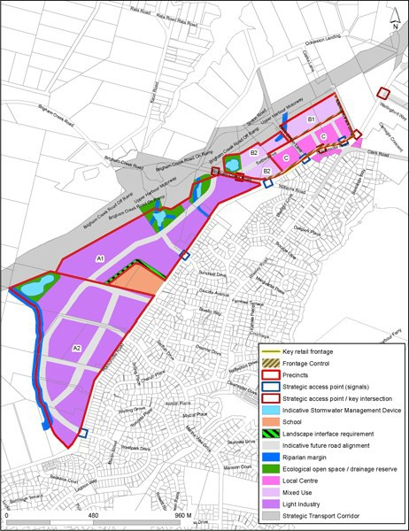

Precinct Plan 2: Hobsonville Corridor street typology plan
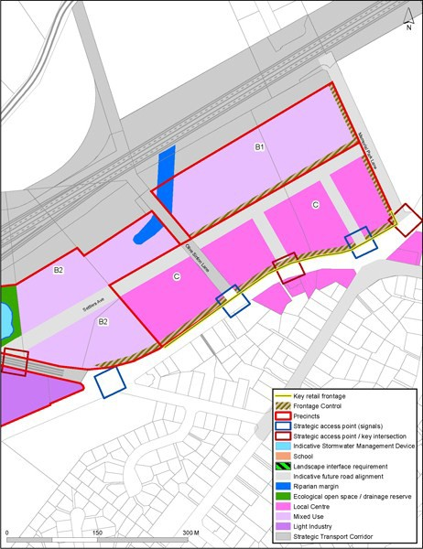

Precinct Plan 3: Hobsonville corridor transport plan
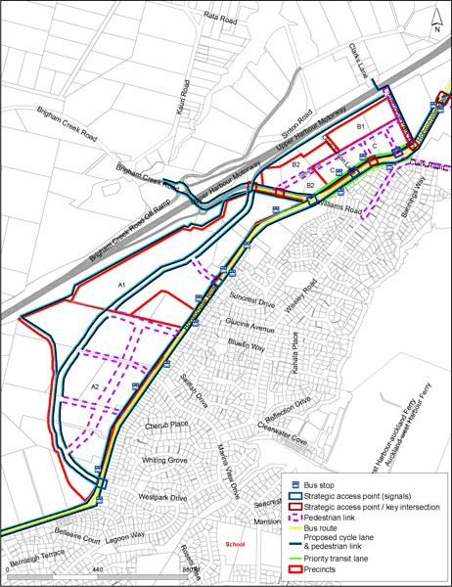

Precinct Plan 4: landscapefrontage control diagram

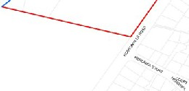

'
Figure 4a
-.................""............_.
-t••.....,. .........,............e
D,.,....,i'>J l_,.,..,
ra-ccl l>,.....,;.,,

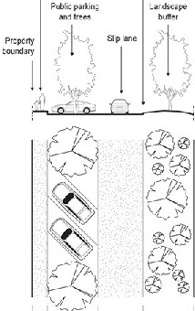

Road rewrve
WJn l:.11

.5m S.Sm Sm

Figure 4b

Page 19 of 19

