PART 3 ­ REGIONAL AND DISTRICT RULES»Chapter K: Precinct rules»5 North»

5.31 Orewa 2

The activities, controls and assessment criteria in the underlying Single House, Neighbourhood Centre and Open Space ­ Conservation zones and Auckland­wide rules apply in the precinct unless otherwise specified below. Refer to the planning maps, Precinct Plan 1: Orewa 2 Precinct Plan and Precinct Plan 2: Orewa 2 precinct development areas for the location and extent of the precinct and Development Areas.

Activity table

  - The following table specifies the activity status of activities in the Single House zone in the precinct.

  - Except as specified, the activities in the underlying zones apply.

Activity | Activity status
Residential
One dwelling on a site greater than 650m2 net site area | P
One dwelling on a site between 450m2 – 650m2 net site area in accordance with an approved framework  plan | P
Two or more dwellings on a site in accordance with  clause 3.1.2 and an approved framework plan | RD
Retirement villages in accordance with an approved  framework plan | D
Development
Buildings for dwellings on sites complying with an  approved framework plan | P
Any buildings or development, other than buildings for  dwellings complying with an approved framework plan | RD
Any buildings or development , not complying with an approved framework plan or prior to the approval of a  framework plan | NC
Framework plans
A framework plan, amendments to an approved framework plan or a replacement framework plan  complying with clauses 3.2 below | RD
A framework plan, amendments to an approved framework plan or a replacement framework plan not  complying with clauses 3.2 below | NC
Subdivision
Subdivision complying with an approved framework  plan | RD
Subdivision not complying with an approved framework  plan or prior to the approval of a framework plan | NC
Subdivision application for sites that do not comply  with Rule 5.2.1 Wastewater Servicing | NC
Subdivision application for sites that do not comply  with Rule 5.2.2 Water Servicing | D

Notification

  - Restricted discretionary resource consent applications for framework plans, and amendments to framework plans, will be considered without the need for public notification. However, limited notification may be undertaken, including notice being given to any land owner within the Development Area who has not provided written approval to the application.

Land use controls

  - Any activity that does not comply with the land use controls is a non­complying activity.

  - Except as specified, the land use controls in the underlying Single House zone apply in the precinct.

Density

    - Densities are those allowed in the Single House zone except as specified below.

    - The percentage of sites within a Development Area of the specified density must not exceed the maximums specified below:

Table 1

Density (net site size) | Maximum percentage of sites in a Development Area
150m2 – 450m2 | 10­20%
450m2 – 650m2 | 60­70%
Greater than 650m2 | 10­30%
    - A framework plan approved under clause 3.2 below may alter the percentage of sites of a specified size by transferring rights from one Development Area to another if:
      - The number of sites within any specified density band in Table 1 for any Development Area must not be varied by more than 40%

      - An equivalent percentage of sites within the specified density band must be provided in a second precinct under the control of the applicant

      - A framework plan must be prepared and approved for both Development Areas.

    - An application under clause 3.1.3 above to transfer density from one Development Area to another is a discretionary activity.

Framework plans

    - A resource consent application for a framework plan, amendments to a framework plan or a replacement framework plan must:
      - apply to the whole of a Development Area; or

      - apply only to land that the applicant is the owner of; and

      - comply with:

i.

ii. iii.
the general rules and information requirements applying to framework plans specified in clauses 2.6 and 2.7.3 of the General provisions.

the special information requirements for framework plans specified in clause 6.2 below.

seek consent for the following land uses:

        - earthworks associated with the development

        - the design and location of public open spaces

        - the design and location of roads

        - stormwater management devices

        - vehicle accessways

        - transfers of site density from one Development Area to another under clause 3.1.3 above

        - subdivision layout and site densities.

    - Where a framework plan infringes a land use or development control, a concurrent land use/development control infringement application must be made. Except where it is a non­complying activity to infringe a land use or development control, a concurrent land use/development control infringement does not alter the restricted discretionary activity status of a framework plan.

    - In Development Area 3 a framework plan shall not be required to be prepared for the retirement village granted as part of resource consent number RMA 51843. If this consent is not implemented a framework plan is required for Development Area 3.

Development controls

  - Except as specified, the development controls in the underlying Single House zone apply in the precinct.

  - Development that does not comply with development controls is a restricted discretionary activity.

  - The development controls in the underlying Open Space – Conservation and Neighbourhood Centre zones apply without change.

Height

    - Buildings must not exceed 9m in height.

Height in relation to boundary

    - On sites between 450m2 and 650m2 no part of any building shall exceed a height equal to 3 metres plus the shortest horizontal distance between that part of the building and any site boundary, except a front boundary and except that on side boundaries within 14 metres of the road frontage the maximum height of a building shall not exceed a height equal to 5 metres plus the horizontal distance between that part of the building and the side boundary.

    - This rule shall not apply to:
      - chimneys, radio and television aerials, domestic satellite dishes less than 1 metre in diameter

      - the apex of any roof or gable end not exceeding 1m2 in area

      - dormers not exceeding 2 metres in width (not more than two per building facing the same boundary)

      - those parts of buildings that share a common wall on a site boundary.

    - Where a site boundary adjoins a site of 650m2 or greater that is not part of a multi­unit development then the height in relation to boundary control for the Single House zone applies to that boundary.

Yards

    - The development controls for yards in the Single House zone apply except as specified below:

Table 2

Yard | Minimum depth
Front (for sites 650m2 or greater) | 6m
Front (for sites between 450m2 and 650m2) | 3m

Side | 1m on one side yard  3m on one side yard
Rear (for sites 650m2 or greater) | 6m
Rear (for sites between 450m2 and 650m2) | 3m

    - In the case of rear sites between 450m2 and 650m2 only one yard of a minimum of 6m will be required.
All other yards are deemed to be side yards, only one of which will be required to be a minimum of 3m.

    - For sites between 450m2 and 650m2 the combined depth of the front and rear yards must be a minimum of 9m.

    - For sites between 450m2 and 650m2 the minimum depths in Table 2 are subject to the following:
      - Bay windows, steps, verandahs, porches and balconies may protrude into the 3.0 maximum front yard but shall not be closer than 1.5m to the front boundary;

      - No fence, wall, or screen located within the front yard shall exceed 0.8m in height;

      - Where a garage faces the street, then the front wall (containing the garage door) of the garage shall be set back a minimum of 6m from the front boundary.

Impervious area threshold and building coverage

    - The following maximum areas apply:

Table 3

Development Area/area | Impervious area threshold | Maximum building coverage
Sites greater than 450m2 not within  a Physical Limitation area | 50% | The controls in the Single House  zone apply
Sites less than 450m2 developed in accordance with an approved  framework plan | 60% | 60%
Sites within a Physical Limitation  area | 50% | 11.5%
Sites within a Physical Limitation area developed in accordance with  an approved framework plan | 60% | 35%

Building frontages

    - For sites between 450m2 and 650m2 the total area of all attached or detached garages doors or the open façade of a carport fronting the street shall not occupy more than 35% of the active building frontage.

    - For the purposes of this control, the active building frontage is defined as:

The front façade of a dwelling including any attached or detached garage that faces the street but excluding:
- any vertical faces that are located more than 3m to the rear of the garage door

- any roof.

Additional controls for two or more dwellings on a site

    - The following development controls in the Mixed Housing Suburban zone apply where two or more dwellings are proposed on a site in accordance with clause 3.1.2 above:
      - Clause 7.17 Minimum dwelling size

      - Clause 8.18 Daylight to dwellings

      - Clause 7.18 Minimum dimension of principal living rooms and principal bedrooms

      - Clause 7.19 Servicing and waste

      - Clause 8.23 Dwelling mix

Subdivision controls

  - The subdivision controls in the Auckland­wide ­ Subdivision rules apply in the Development Areas unless otherwise specified below.

Subdivision layout

    - The layout of subdivision within the precinct must be in accordance with Precinct Plan 1: Orewa 2 precinct

Minimum lot size

    - Sites within the Physical Limitations areas must have a minimum net site area of 1500m² with an average net area of 5000m² across the overlay area.

    - The minimum net site area or average net area for sites within the Physical Limitations areas may be reduced if the Council is satisfied that:
      - the geotechnical constraints are removed as shown on a consented subdivision scheme plan, or

      - a smaller net site area or average net area can be justified in geotechnical terms.

Wastewater and water servicing

    - All sites shall be connected to a public reticulated sewerage scheme, except:
      - sites for open space or reserve purposes where the open space or reserve status is guaranteed in perpetuity

      - sites to be used exclusively for utility services (eg stormwater ponds and pump stations) where no occupation will occur

      - roads and access lots, or

      - sites with a minimum site area of 1500m2 resulting from the boundary relocation of sites existing at 24 June 2010

    - All sites shall be connected to a public reticulated water supply network except:
      - sites for open space or reserve purposes where the open space or reserve status is guaranteed in perpetuity

      - sites exclusively used for utility services (eg stormwater ponds and pump stations) where no occupation will occur, or

      - roads and access lots.

Indicative roads

    - Roads within the precinct must comply with the road cross­sections inFigure 1: Orewa 2 precinct ­ Collector road and Figure 2: Orewa 2 precinct ­ Collector road park edge.

    - The indicative roads shown on Precinct Plan 1 must comply with clause 4.4 of the Indicative roads and open space overlay rules, except, for the purposes of clause 4.4.2.1.2:
      - the alignment of that part of the indicative road specifically identified on the Precinct Plan 1 may be varied by more than 20m.

      - clause 4.4.2.1.2(a) does not apply to local road intersections.

      - clause 4.2.1.2(b) applies except that site boundary and precinct crossings may be varied with the agreement of the adjoining property owner at the time of the preparation of a framework plan.

Figure 1: Orewa 2 precinct ­ Collector road
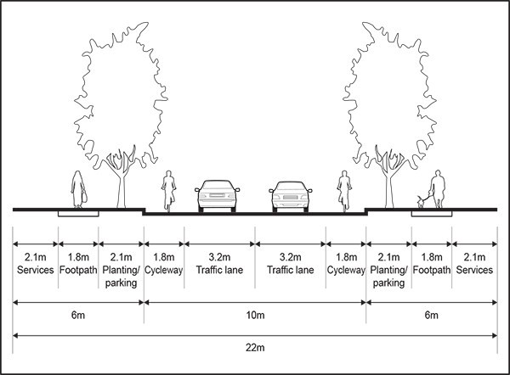

Figure 2: Orewa 2 precinct ­ Collector road park edge
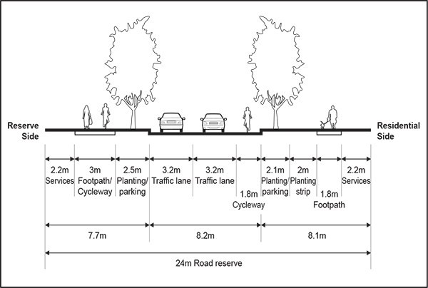

- Assessment ­ Restricted discretionary activities

  - Matters of discretion
In addition to the matters specified in the Auckland­wide rules for subdivision and framework plans, the council will restrict its discretion to the matters below for activities listed as restricted discretionary activities in the activity table.

Table 4

Activity | Design, location and scale | Framework plan | Transport | Infrastructure
A framework plan, amendments to an approved framework plan or a replacement  framework plan | X | X | X | X
Two or more dwellings on a site complying with clause 3.1.2 above and an approved  framework plan | X | X
Buildings and subdivision complying with an approved  framework plan | X | X

Assessment criteria
- Design location and scale
  - Buildings, development and subdivision should be consistent with:

i.

ii.
the policies for the precinct Precinct Plans 1 and 2.

  - The extent to which the density of sites within a development area comply with the maximums specified in Table 1 of clause 3.1 above.

  - The extent to which the development area layout provides for housing densities in appropriate locations, having regard to typographical conditions and the location of watercourses and existing native vegetation.

  - Higher density development should be located adjacent to public open spaces and retail areas, and should be designed to protect and maintain significant viewshafts.

  - Appropriate low intensity development should be located within the Physical Limitations area that retains such physical limitations, or it can be demonstrated that a smaller site area and/or average area can be justified in geotechnical terms.

  - Aites proposed for two or more dwellings on the site in accordance with clause 3.1.2 above should have sufficient street frontage to allow dwellings to face on to the street.

  - The extent to which all development is well­connected by a street network which takes into account typographical, watercourse and existing native vegetation features and is in accordance with the street network shown on Precinct Plan 1: Orewa 2 precinct.

  - Landscaping should be used to off­set the visual effect of new buildings and a high standard of amenity should be achieved that complements and enhances the natural landscape character of

adjoining land.

  - Development should avoid the degradation of natural permanent watercourses and not destroy or reduce their ability to support in­stream flora and fauna, and adequate riparian buffers are provided.

  - Development should provide a good standard of aural and visual amenity, particularly between residential activities and non­residential activities and between residential activities and roads.

  - The extent to which the bulk and scale of the building is consistent with the character of existing development in the development area or adjoining development areas.

  - The design or location of development adjacent to strategic routes and district arterial routes should avoid or mitigate potential reserve sensitivity effects on sensitive activities.

  - The extent to which a subdivision provides for various site sizes to be spread throughout the Development Area.

  - Development of two or more dwellings on a site in accordance with clause 3.1.2 above will be assessed against the relevant assessment criteria in the Mixed Housing Suburban zone.

- Framework Plan
  - Aproposed framework plan, amendments to an approved framework plan or a replacement framework plan should:

i.

ii. iii. iv.

v.

vi.

vii.

viii.
result from a process involving consultation with all landowners within that development area and adjoining development areas

be consistent with Precinct Plans 1, 2 and 3
address all relevant matters contained within the objectives and policies for the precinct provide for a coherent design and integrate with the surrounding environment and the context
of the surrounding development and natural features

utilise areas of open space, planting and streetscape treatment to avoid or mitigate the visual effects and impacts of buildings and development

provide for the efficient use of sites with the use of shared facilities between similar activities both on adjoining sites and in the vicinity

ensure that development areas are linked and developments promote walkable neighbourhoods

ensure that the proposed sites are of adequate size to accommodate the proposed activity together with associated carparking, landscape treatment and any other facilities.

  - The extent to which the street network is well connected taking into account topographical, watercourse and existing native vegetation features and is in accordance with the street network as shown on Precinct Plan : Orewa 2 precinct.

  - The extent to which a legible public street pattern is created with street blocks having a maximum plan dimension in any direction of 250m and a maximum block perimeter of 800m.

  - Public parks and reserves should be bounded by public streets for 75% of their entire perimeter, (excluding any coastal frontage) taking into account topographical, watercourse and vegetation features.

  - The extent to which significant viewshafts are retained by the pattern of development.

  - The extent to which the proposed landscape concept is appropriate to the urban and natural context, and to the creation of neighbourhood identity.

  - Indigenous vegetation, and significant natural and historic heritage features (including archaeological sites), should be retained where practicable and incorporated into new development.

  - The removal of indigenous vegetation, or the adverse effects on significant natural and historic heritage features (including archaeological sites), should be remedied or mitigated.

  - The amount of earthworks required to implement the framework plan should take into account the existing topographical constraints and landform, having regard to the matters set out in policy 7 above.

  - A framework plans for two or more dwellings on a site in accordance with clause 3.1.2 above should ensure that the design of dwellings within the development, including layout, access and relationship to neighbouring dwellings, is comprehensively planned and integrated.

  - In the development of framework plans, the council, Auckland Transport and New Zealand Transport Agency should be consulted.

  - The general assessment criteria for framework plans specified in clause 2.6 of the General Provisions also apply.

- Transport
  - The extent to which proposed roads comply with Precinct Plan 1: Orewa 2 precinct and Precinct Plan 3: Orewa 2 precinct road hierarchy .

  - Aproposed streets network should ensure well­connected, attractive and safe transport routes, with appropriate provision for:

i.

ii. iii. iv.
pedestrian, cycle and vehicle movements car parking
infrastructure services

street tree planting and landscape treatment consistent with the overall existing or introduced environmental context.

  - The local road network should provide an efficient and legible roading system so as to reduce trip distances and to improve local accessibility to community facilities, reserves and retail activities.

- Infrastructure
  - Roads should create high quality public spaces, and incorporate quality amenity features such as tree planting and footpath paving.

  - Infrastructure for stormwater, wastewater and water supply should be designed to ensure minimisation of water use, storm and wastewater generation and maximise water re­use.

  - Infrastructure should be provided to serve any new development.

  - The management of stormwater flows should be consistent with the relevant Catchment Management Plan.

  - The proposed stormwater outlet configuration should be designed to avoid multiple discharge points concentrating flows within sensitive receiving environments.

  - A Precinct Sediment Management Plan should demonstrate appropriate methods that can be implemented to ensure that sedimentation effects are adequately minimised.

  - Development retains, enhances and provides protection for riparian margins, coastal edges and esplanade reserves.

  - Areas of open space and walkways should be provided and identified on the framework plan.

  - Earthworks and other site works avoid adverse effects on watercourses, areas of ecological values and neighbouring properties.

Special information requirements

- The overall context of the application area relative to existing buildings and site boundaries, public open space, boundaries between the development area and adjoining development areas, and any approved framework plans.

- The elements shown on Precinct Plan 1: Orewa 2 precinct including the indicative road and open space network, and the Physical Limitations area.

- An indicative layout, and density, of proposed sites.

- The existing and proposed site contours, the relationship of those site contours to existing and proposed streets and, where information is available, public open space.

- Details of proposed earthworks.

- The location and dimensions of proposed:
  - open space areas

  - walkways

  - natural features to be retained or enhanced.

7.

8.

9.

10.

11.

12.

13.

14.

15.

16.
Areas to be developed for stormwater treatment and detention purposes consistent with the relevant network discharge consent.

The location of stormwater, wastewater and water supply infrastructure.

The distribution of various densities/site sizes throughout the application area including sites proposed to be developed with two or more dwellings on the site in accordance with clause 3.1.2 above.

The landscaping concept for the application area.

How each development area is to be staged and the means of managing any vacant land through the staging process.

How development areas will integrate with each other and other surrounding land.

Where a joint framework plan is not prepared the application will need to show how the development integrates with other sites within the Development Area and precinct including details of any development proposals on adjoining sites and any other approved framework plan for the precinct.

How the development provides or facilitates adequate transport connections across the precinct and/or Development Area, including connections to the surrounding road network.

An integrated transport assessment in accordance with the assessment criteria in clause 6.2.3 above. An infrastructure management plan in accordance with the assessment criteria in clause 6.2.4 above.

Precinct plans

Precinct plan 1: Orewa 2 precinct
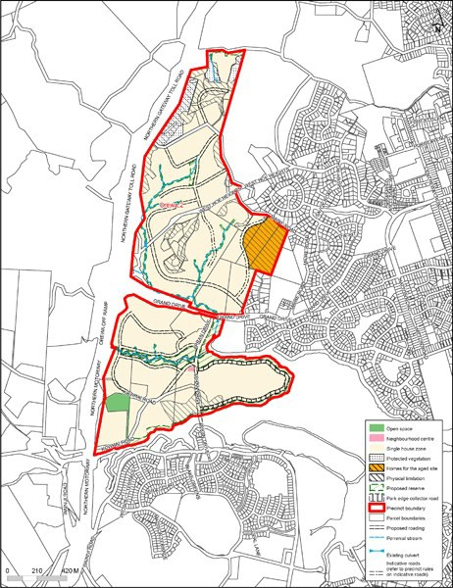

The Proposed Auckland Unitary Plan (notified 30 September 2013)

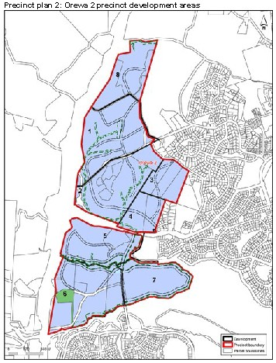

Precinct plan 3: Orewa 2 precinct road hierachy
