PART 3 ­ REGIONAL AND DISTRICT RULES»Chapter K: Precinct rules»5 North»

5.5 Albany Centre

The activities, controls and assessment criteria in the underlying zone apply in the following precinct and sub­ precincts unless otherwise specified. Refer to planning maps for the location and extent of the precinct and sub­ precincts. The applicable underlying zones in relation to Albany Centre precinct include the Metropolitan Centre zone (including sub­precincts A, B and C), Business Park zone (including sub­precinct D), and Public Open Space – Civic and Community zone.

Activity tables

  - The activities in the underlying zone apply in the Albany Centre precinct unless otherwise specified in the activity table below.

Activity table 1 ­ Sub­precinct A

Activity | Activity  Status
Commerce
Entertainment facilities | RD
Food and beverage up to 200m2 GFA per site | P
Food and beverage greater than 200m2 GFA per site | RD
Garden centres | D
Marine retail | D
Motor vehicle sales | D
Offices greater than 500m2 GFA per site | D
Retail up to 100m2 GFA per site | P
Retail greater than 100m2 GFA per site | D
Supermarkets | NC
Trade suppliers | D
Industry
Light manufacturing and servicing | RD
Repair and maintenance services | RD
Warehousing and storage | RD
Development
Additions and alterations to buildings that are less than 15m2 in area on the facade of a  building that fronts a road or Public Open Space zone | P

Activity table 2 ­ Sub­precinct B

Activity | Activity Status
Accommodation
Dwellings | RD
Retirement villages | RD
Supported residential care | RD

Commerce
Entertainment facilities | RD
Food and beverage up to 200m2 GFA per site | P
Food and beverage greater than 200m2 GFA per site | RD
Garden centres | D
Marine retail | D
Motor vehicle sales | D
Retail up to 100m2 GFA per site | P
Retail greater than 100m2 GFA per site | D
Supermarkets | NC
Trade suppliers | D
Industry
Light manufacturing and servicing | RD
Repair and maintenance services | RD
Warehousing and storage | RD
Development
Additions and alterations to buildings that are less than 15m2 in area on the facade of a  building that fronts a road or Public Open Space zone | P

Activity table 3 ­ Sub­precinct C

Activity | Activity Status
Accommodation
Dwellings | RD
Retirement villages | RD
Supported residential care | RD
Commerce
Offices greater than 500m2 GFA per site | RD
Retail up to 2000m2 GFA per site | NC
Retail greater than 2000m2 GFA per site, including large format retail | P
Service stations | RD
Development
Additions and alterations to buildings that are less than 15m2 in area on the facade of a  building that fronts a road or Public Open Space zone | P

Activity table 4: Sub­precinct D

Activity | Activity Status
Commerce
Retail up to 450m2 within the Retail/Mixed Use Retail activity area (see Precinct Plan 3) | P
Retail greater than 450m2 within the Retail/Mixed Use Retail activity area (see Precinct Plan  3) | RD
Retail greater than 450m2 within other activity areas (see Precinct Plan 3) | NC

- Land use controls

2.1 Dwellings in sub­precinct A

  - Any new dwelling must be subject to a no­complaint covenant entered onto the title and registered in favour of the North Shore Stadium and North Shore Domain Trust.

  - The no­complaint covenant will require any landowner or occupant to forego any right to lodge submissions in opposition to, or otherwise restrict, noise from concerts at the stadium which are in accordance with any approved framework plan, any lawfully established activities, any approved resource consent for a controlled or restricted discretionary activity or liquor license renewal.

Development controls

  - For permitted activities in the Albany Centre precinct and sub­precincts, the development controls in
the Metropolitan zone or the Business Park zone apply in the precinct or sub­precinct unless otherwise stated below.

Compliance with Precinct Plan 1

    - Development must provide the streets (arterial, collector and local) within 20m of their location as shown in Precinct Plan 1, except that:
      - local street (main street) must join Don McKinnon Drive in the same location as the collector (main street)

      - local street (main street) must be provided within 10m of its location as shown in Precinct Plan 1.

    - The design of all streets, including dimensions and design features, must be in accordance with the relevant figures in Appendix 11.5.1.

    - All streets shown in Precinct Plan 1 must be transferred to the council as public roads except those shown as local streets (public/private).

    - Reserves must be provided in accordance with Precinct Plan 1.

    - Open air pedestrian only areas longer than 50m must have a clearway of 3.5m to enable access by emergency vehicles with an overall minimum width between buildings of 12m.

    - Infringement of this control is a discretionary activity except for the following which are restricted discretionary activities:
      - variations to the location, width and design of local streets

      - variations to the location of the local street (main street), provided that the alignment follows the secondary axis and is no more than 20m from the alignment at the boundary with the land zoned Public Open Space ­ Civic and Community

      - variations to the location, size and design of:
        - reserves and open spaces

ii.
identified features on Lot 2 DP 338562.

Front yard

Table 1

Area | Minimum front yard
Sub­precinct A local streets where dwellings are  located on the ground floor | 3m
Sub­precinct C arterial and collector (commercial) | 5m
Sites fronting Oteha Valley Road | 7.5m

    - Any development not meeting the front yard controls is a non complying activity, except for the following which are restricted discretionary activities:
      - in sub­precinct A, reducing the front yard to 1.8m

      - on sites fronting Oteha Valley Road, the front yard may be reduced to 5m, provided that a minimum 40 per cent of that part of the building fronting Oteha Valley Road is fully glazed to provide showroom and display areas.

Maximum building setback

    - Buildings on sites in sub­precinct A or B that front arterial, collector (commercial) and local street (commercial) must not be set back more than 5m from the road frontage for the full length of the building, except that 40 per cent of the length of the building may be set back up to 15m where any setback greater than 5m is at least 40m beyond any intersection with collector (main street) or local street (main street).

    - Buildings on sites located along the local street connecting collector (main street) with Munroe Lane must not be set back more than 3m from the road frontage for the full length of the building.

    - Buildings on sites in sub­precinct C fronting Munroe Lane and Appian Way must not be set back more than 12m from the road frontage for the full length of the building.

    - Any development not meeting the building setback controls is a non complying activity except for the following which are restricted discretionary activities:
      - Buildings on sites fronting a collector (main street) or local street (main street), where:

i.

ii.
the building setback is provided to accommodate plazas, eating areas, arcade entrances and pedestrian through routes associated with a ground floor use and is no more than 12m, or

the building setback accommodates rain gardens installed to mitigate the effects of stormwater runoff and is no more than 3m.

      - Buildings on sites fronting arterials or local streets (commercial), where the building is set back more than 15m but less than 20m, provided that the setback is at least 40m from any intersection with a collector (main street) or local street (main street).

    - Buildings on sites in sub­precinct D must be set back in relation to the setbacks shown in Precinct Plan 4.

    - Sites in sub­precinct D must provide 10m yard setback to Public Open Space zone boundaries.

Location of parking

    - Ground floor parking within a building must not be located adjacent to the street frontage or any space in public ownership. Buildings must be designed to accommodate a business or residential activity, depending on the zone, between any ground floor parking and the building frontage.

    - On sites in sub­precinct A, there must not be parking between any building and the front boundary of the site. Parking must be located to the side of, the rear of, within or under buildings.

    - On sites in sub­precinct C fronting Munroe Lane and Appian Way, no more than one aisle of parking may be located directly between a building’s frontage and the front boundary of the site. All other parking must be located to the side of, the rear of, within or under buildings.

    - Any development not meeting the location of parking controls is a non complying activity, except for the following which is a restricted discretionary activity:
      - ground floor parking located adjacent to the street frontage within a building, provided that it does not occupy more than 20 per cent of the street frontage of that site.

Landscaping

    - Sites in sub­precinct D must provide minimum landscaped areas as follows:

Table 2

Activity area | Minimum landscaped  area
Office | 20%
Light commercial/Office | 10%
Retail/Mixed use retail | No minimum

Assessment ­ Development control infringements

4.1 Matters of discretion
In addition to the general matters set out in clause 2.3 of the general provisions and the relevant assessment criteria in the Metropolitan Centre zone, the council will restrict its discretion to the relevant matters listed below when infringing a development control in the precinct:
  - Compliance with Precinct Plan 1

  - Front yard.

Assessment criteria
    - Compliance with Precinct Plan 1
      - Local streets should be provided to ensure good amenity and the same level of connectivity for pedestrians and motorists as that indicated on Precinct Plan 1.

      - Reserves and open spaces should be in a similar location and of a similar scale to those indicated in Precinct Plan 1.

    - Front yard
      - Any reduction of the front yard should ensure that:

i.

ii.
The privacy of residents is protected

The safety and amenity of the street is maintained.

      - On sites adjacent to Oteha Valley Road, any reduction of the front yard should ensure that a visually appealing frontage to Oteha Valley Road is achieved.

Precinct Plans

Precinct Plan 1: Albany Centre
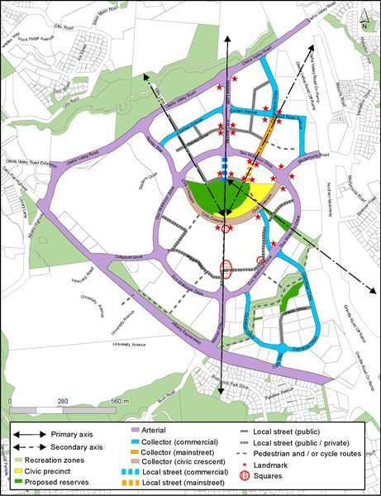

Precinct Plan 2: Sub­precincts
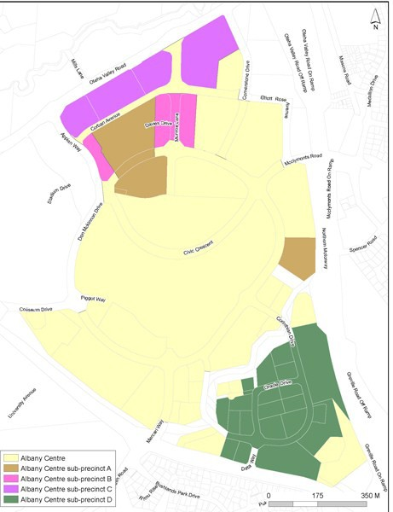

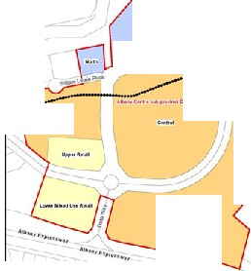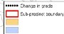Precinct Pli'n 3: SUb-precinct 0 activity areas
_,
'·,,\

/ \ ··
\

I

I I I
\
  - \
:::::: \ \ .
\

--

·

uti!'C.f'ln -tloo \:1"(10
•
·""·"loOt': - P.tl;•
;...""h..........

Precinct Plan 4: Sub­precinct D building setbacks
