PART 3 ­ REGIONAL AND DISTRICT RULES»Chapter K: Precinct rules»6 South»

6.7 Franklin

The activities, controls and assessment criteria in the relevant underlying zones and the Auckland­wide rules apply in the following precinct and sub­precincts unless otherwise specified below. Refer to planning maps for the location and extent of the precinct and sub­precincts.

Activity table

The activities, controls and assessment criteria in the underlying zones apply in the following sub­precincts unless otherwise specified below.

 | Sub­precinct
Activity | A | B | C | D | E | F | G | H | I
Development
Infringing a  development control | RD | RD | RD | RD | RD | RD | RD | RD | RD
Community
Community facilities in the Neighbourhood  Centre zone only | NA | NA | NA | NA | P | NA | NA | NA | NA
Subdivision
Subdivision which complies with the  subdivision controls | RD | RD | RD | NA | RD | NA | NA | NA | NA
Subdivision which does not comply with the subdivision  controls | NC | NC | NC | NC | NC | NC | NC | NC | NC
A framework plan, amendments to an approved framework plan or a replacement framework plan complying with  clause 3.2 below | NA | NA | NA | NA | NA | RD | NA | RD | RD
A framework plan, amendments to an approved framework plan or a replacement framework plan not complying with  clause 3.2 below | NA | NA | NA | NA | NA | NC | NA | NC | NC

Creation of freehold titles complying with an approved framework plan and the subdivision  controls | NA | NA | NA | NA | NA | RD | NA | RD | RD
Creation of freehold titles not complying with an approved  framework plan | NA | NA | NA | NA | NA | D | NA | D | D
Creation of freehold titles prior to the approval of a  framework plan | NA | NA | NA | NA | NA | NC | NA | NC | NC

Development controls

Development controls in the Franklin precinct are those listed in the underlying Rural and Coastal Settlements, Single House Countryside Living and Neighbourhood Centre zones except as specified below:

2.1 Building height

  - In sub­precinct E (and part of sub­precinct C)

  - Buildings must not exceed 5m in height excluding a single building in growth area C identified in the Matingarahi Concept Plan.

Yards

    - In sub­precincts D, F, H and I

Table 1

Yard | Dimension
Front yard | 20m ­ where the site has frontage to an arterial road
Side and rear yards | 20m – where adjoining the Rural Coastal and Rural  Production zones
Coastal | 30m
River, lake or  wetland | 30m

Specified building area

    - All sub­precincts
      - Buildings must be located within a specified building area defined on a site plan, and if applicable, in compliance with any consent notice attached to the certificate of title.

Location of buildings and earthworks

    - All sub­precincts
      - Specified building area
        - Buildings must be located within a defined platform shown on an approved subdivision site plan or consent notice.

      - Restricted areas for buildings and works
        - Buildings and works must be located outside any restricted development areas shown on a

relevant concept plan or framework plan.

Subdivision controls

3.1 Minimum site size

  - Sites must comply with the minimum area and requirements in shown in Table 2 below.

Table 2. Minimum and average site sizes

Sub­precinct | Minimum and average site size
 | Growth Area (where stated and as shown on the precinct plans)
A | Growth Area A  Minimum: 2500m2 | Growth Area B  Minimum: 5000m2
B | Growth Area A  Minimum: 10000m2 | Growth Area B  Minimum: 2500m2
C | Minimum: 2500m2
D | Minimum: 2500m2 | Average: 5000m2
E | Growth Area A Minimum: 10000m2 | Growth Area B ­ if reticulated wastewater available  Minimum: 800m2 | Growth Area B ­ where no reticulated wastewater available  Minimum: 2500m2 | Growth Area C Minimum: 2500m2
F | Minimum: 2500m2
G | Growth Area A  Minimum: 1600m2 | Growth Area B  Minimum: 800m2 | Growth Area C  Minimum: 400m2
H | Minimum: 2500m2
I | Minimum: 2500m2

  - On land zoned Rural and Coastal Settlements and Countryside Living, any minimum site size in the above table is subject to meeting the wastewater requirements in clause 3.3 below. If the requirements of clause 3.3 cannot be met, the minimum site size for unserviced sites is 4000m².

Framework plan

A framework plan may be prepared within sub­precincts F, H and I.

A resource consent application for a framework plan, amendments to an approved framework plan, or a replacement framework plan must:
    - apply only to land within the sub­precinct that the applicant is the owner of, or to sites in multiple ownership where the landowners make a joint application.

    - comply with:
      - the general rules and information requirements applying to framework plans specified at clauses
2.6 and 2.7 in the general provisions.

      - the special information requirements for framework plans specified in clause 4(d) below

    - seek consent for the following land uses:
      - the location and alignment of roads, cycle and pedestrian routes to provide convenient access throughout the settlement and adjacent areas. In particular, provide linkages to activities within or near the residential area, including where applicable: local shops, schools, reserves, existing village centres and places of community significance.

      - the layout of lots and building platforms.

    - Address the following special information requirements :
      - management of natural environmental values by: ­designing roads, activities and subdivision that will complement the natural landscape and avoid the need for significant modification

i.

ii.

iii.
manage earthworks and the location and density of development to minimise the impact on the environment

protect significant trees and areas of bush on recreation reserves, road reserves and allotments that are or a size and design to achieve this purpose

protect and enhance the natural features of the site.

      - Identify areas for development that:

i.

ii. iii.
respond to the landscape features while incorporating the design and layout of framework plan elements

comply with the density and minimum site site requirements for the relevant precinct

identify and provide for the location and alignment of roads, cycle and pedestrian routes to provide convenient access throughout the settlement and adjacent areas. In particular, provide linkages to activities within or near the residential area, including where applicable: local shops, schools, reserves, existing village centres and places of community significance.

      - Ensure stormwater management is an integral component of the pattern of development and:

i.

ii. iii. iv.
considers of the impact of land use on water quantity and quality, including cumulative effects protects the integrity of the 1 per cent AEP flood plain and secondary flow path
protects and enhances the ecological value of riparian areas and aquatic ecosystems

facilitates multiple objectives where appropriate, including provision of recreational facilities and protection of significant natural and physical resources.

      - Provide an assessment that:­defines the road access points and road pattern including the location of pedestrian and cycle routes

i.

ii. iii. iv.
v.

vi. vii.
identifies areas of high environmental and landscape sensitivity, including sensitive ridgelines identifies existing vegetation that should be retained
identifies areas for environmental enhancement and amenity planting identifies areas where development is inappropriate and will be avoided identifies areas which are sensitive to development
provides a framework which will provide opportunities for future intensification

considers wastewater and stormwater treatment and disposal, including future proofing infrastructure.

Wastewater disposal

    - All sites must be connected to a public reticulated wastewater system if available.

    - Any site that cannot be connected to a public reticulated wastewater system must demonstrate that all wastewater discharges can be contained within the site. The council may require a geotechnical report or require that soakage or other appropriate tests are carried out prior to a s. 224 certificate being issued. The council may also impose consent notices to ensure the ongoing performance of any system.

Sub­precinct G

    - All sites in sub­precinct G must be connected to a public reticulated wastewater system.

    - A s. 224c certificate must not be granted for subdivision within sub­precinct G until either a new effluent discharge permit has been obtained, or that it has been established that one is not required, with respect to any particular stage of subdivision.

    - All development within sub­precinct G should be reticulated by a gravity sewer to the existing Fletchers Pump Station, except that other pumps may be approved by council.

Stormwater management

Sub­precinct G
    - A comprehensive stormwater discharge consent must be approved by council prior to approval of a subdivision consent in sub­precinct G.

Protected and enhancement areas

    - Protection and maintenance covenants must prepared over areas identified for protection and enhancement where shown on a concept or approved framework plan. These must be implemented by way of a consent order or registration of a covenant on the certificate of title.

Assessment ­ Development control infringements

Matters of discretion
  - In addition to the general matters set out in clause 2.3 of the general provisions and the specific matters set out for the infringement in the underlying zone, the council will restrict its discretion to the matters below for the relevant development control infringement:
    - consistency with the concept plan or framework plan

    - the location of any buildings and earthworks

    - the design of any roads or vehicle access ways shown on a concept plan or framework plan

    - protection and planting of vegetation

    - landscape character and amenity

    - any specific policies which are unique to the relevant sub­precinct.

Assessment criteria
- In addition to the general assessment criteria in clause 2.3 of the general provisions and the specific assessment criteria for the infringement in the underlying zone, the council will consider the relevant assessment criteria below for development control infringements:
  - The extent to which an activity complies with the relevant concept plan or framework plan.

  - The location of any buildings and works within the site should be contained within any building platform identified on a concept plan or framework plan.

  - The design of any roads, vehicle access ways or pedestrian walkways should be consistent with the relevant concept plan or framework plan.

  - The extent to which existing vegetation will be removed and what mitigation planting is proposed to increase the overall vegetated area.

  - How the landscape character and amenity of the area will be enhanced.

  - Where it can be demonstrated it is not possible or practicable to meet other assessment criteria with respect to vegetation provision should be made for replacement planting that will enhance the landscape character and amenity of the area.

  - Buildings and works should not be visually prominent or create any scars on the landscape that

would be visually prominent.

  - The height and the scale, massing and form of the building should be compatible with the low density and natural character of the landscape.

Assessment ­ Subdivision

Matters of discretion
  - In addition to the specific matters set out for the 5.4 of the Auckland­wide subdivision rules, the council will restrict its discretion to the matters below for the relevant subdivision control infringement:
    - consistency with the concept plan or framework plan

    - compliance with minimum site size requirements

    - the extent of compliance with the development controls and assessment criteria

    - the location of any building envelopes shown on the plan of subdivision

    - the layout of any roads, vehicle access ways or pedestrian walkways shown on a concept plan or framework plan

    - protection and planting of vegetation

    - h landscape character.

Framework plans, amendments to an approved framework plan and replacement framework plans
  - In addition to the matters specified at clause 2.6 of the general provisions for an application for a framework plan, amendments to an approved framework plan or a replacement framework plan, the council will restrict its discretion to the further matters listed at clause 5.1.3 below.

Subdivision complying with subdivision controls, creation of freehold titles complying with an approved framework plan
  - The council will restrict its discretion to the matters below:
    - the matters set out in clause 5.1.1 and 5.1.2 above, as if any reference in those matters to a "framework plan" were a reference to the proposal

    - the relevant matters set out for the activity in the underlying zone or Auckland­wide rules.

Assessment criteria
- In addition to the specific assessment criteria for the 5.4 of the Auckland­wide subdivision rules, the council will consider the relevant assessment criteria below for subdivision control infringements.

All sub­precincts
  - The design of the subdivision, the layout of any roads, vehicle access ways or pedestrian walkways and the location of any buildings envelopes shown on the plan of subdivision should be consistent with the relevant concept plan or framework plan.

  - Site sizes should meet the minimum requirements in clause 6.7.3.1 above.

  - Subdivision should be designed to protect existing indigenous vegetation and provide for the planting of new vegetation to mitigate the effects of removing any existing significant vegetation.

  - In addition to the above criteria council will consider the following additional criteria.

Assessment for sub­precincts A and B
  - The extent to which a site will be visible from the coastal and marine area and the need for a consent notice to be recorded on the certificate of title limiting the reflectivity level of colours and materials of any future building or structure.

  - Reflectivity level should range between 0 – 40 per cent for external walls and 0 – 25 per cent for roofs

based on British Standards BS5252 – standard specification colour ranges.

Assessment for sub­precincts F, H and I
  - The extent to which a subdivision:

i.

ii.

iii.

iv.

v.

vi.

vii.

viii.
implements an approved framework plan

proposes an appropriate form of development and lot distribution in areas identified as sensitive to development on an approved framework plan

manages reverse sensitivity issues and where appropriate, uses additional buffers or setbacks to avoid or mitigate adverse effects at the boundary of an area

manages the position, design, construction and maintenance of a on­site wastewater system so it can adequately treat and dispose of wastewater

creates lots are of a sufficient size to accommodate reserve fields and manage the cumulative adverse effects of multiple on­site wastewater systems

has investigated and provided for the management of potentially contaminated land associated with rural land use and other contaminating uses

proposes appropriate remediation works to satisfactorily deal with any potential adverse effects on human health, in instances where contaminants have been identified as being present

viii. proposes mitigation measure to deal with any potential effects (if any) of undertaking remedial works.

- Framework plan, amendments to an approved framework plan or a replacement framework plan
  - The council will consider the proposal against the following criteria:

i.

ii.
The general assessment criteria for framework plans specified at clause 2.6 of the general provisions and the relevant matters set out in clause 5.2.1 above.

The extent to which a framework plan responds to the characteristics of the site and surrounding area, including the following:

    - physical characteristics

    - environmental values

    - cultural features

    - infrastructure

    - landscape.

iii.
The extent to which a framework plan addresses:

    - natural environmental values, in particular the need for restoration and enhancement planting with indigenous vegetation along the coastal edge to filter runoff

    - areas where development is and is not appropriate

    - road, cycle and pedestrian routes

    - stormwater and wastewater management

    - sensitive development areas

    - the principles, matters and information in clause 3.2 above.

iv.

v.
The extent to which the framework plan provides for quality urban design and buildings that complement the rural and coastal character of the village.

The extent to which the framework plan has been properly documented, including

consultation with nearby landowners, the community, relevant council staff, relevant statutory bodies and other organisations having an interest in the development with regard to both interim and future development proposals.

- Subdivision complying with subdivision controls, creation of freehold titles complying with an approved framework plan
  - The council will consider:

i.

ii.
the assessment criteria set out in clause 5.2.2 above, as if any reference in those criteria to a "framework plan" were a reference to the proposal

the relevant assessment criteria set out for the activity in the underlying zone or Auckland­ wide rules.

Precinct plans

  - Sub­precinct A ­ Big Bay

Precinct plan 1: Sub­precinct A ­ Big Bay
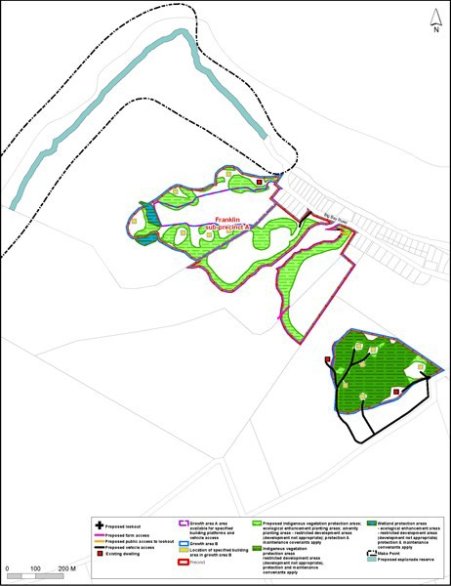

  - Sub­precinct B ­ Grahams Beach

Precinct plan 2: Sub­precinct B ­ Grahams Beach
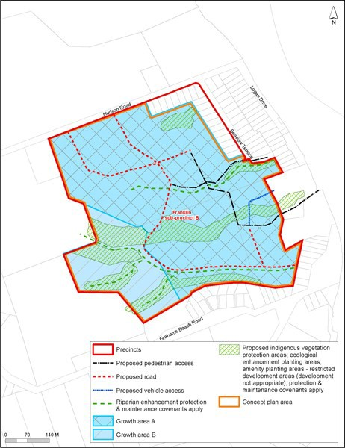

Sub­precinct C ­ Karaka South

Precinct plan 3: Sub­precinct C ­ Karaka South
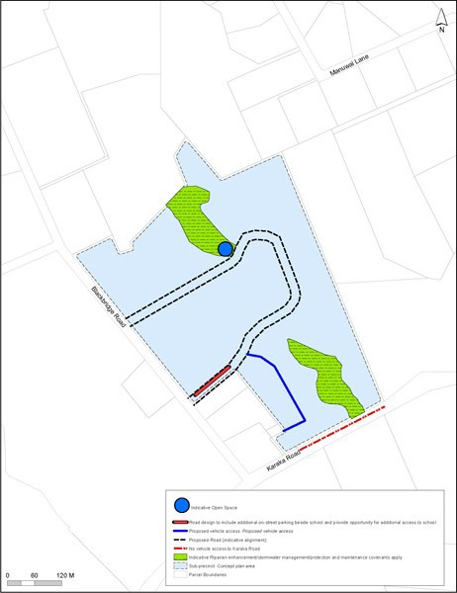

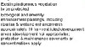

6.4 Sub-pret::inct E - Ma1ingarahi

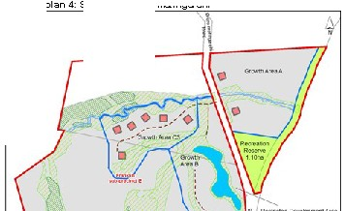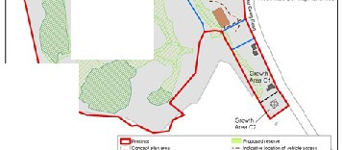Precinct E-

t..'i
_rt.., C'!'1l' 'ft. ll

=_".'-,.•..•...•..•.."...-..a.......
- -
liM'_,...............
.....

6.5 Sub­precinct G ­ Patumāhoe

Precinct plan 5: Sub­precinct G ­ Patumāhoe
