PART 3 ­ REGIONAL AND DISTRICT RULES»Chapter K: Precinct rules»7 West»

7.7 Penihana North

Refer to clause 7 below for definitions that are specific to this precinct.

Activity table

The activities in the Large Lot, Single House and Mixed Housing Urban zones apply in the Penihana North precinct unless otherwise specified in the activity table below.

Activity | Activity Status
 | Sub­precinct A | Sub­precinct B | Sub­precinct C
Development
Dwellings | P | P | NA
Medium density housing | NA | NA | RD
Subdivision | RD | RD | RD
Driveway access to Christian Road | NA | RD | RD

Land use controls

  - The land use controls in Penihana North are those listed in the Large Lot, Single House and Mixed Housing Urban zones, except as specified below.

Maximum density in sub­precincts A and B

    - The number of dwellings on a site must not exceed the limits specified below:
      - Sub­precinct A ­ One dwelling per 1200m2

      - Sub­precinct B ­ One dwelling per 600m2

    - Development that does not comply with the maximum density in sub­precinct A is a non­complying activity.

    - Development that does not comply with the maximum density in sub­precinct B is a discretionary activity.

Restricted discretionary controls for medium density housing in sub­precinct C

    - Medium density housing is a restricted discretionary activity if it meets the following controls:
      - minimum density of one dwelling per 349m2, exclusive of roads, reserves, communally owned driveways, open space and other commonly owned or public facilities

      - housing types include terrace housing or townhouses but not apartments

      - minimum site area of 2000m2

      - the consent application precedes or is concurrent with the related subdivision application.

    - Medium density housing which does not meet these restricted discretionary controls is a discretionary activity.

Development controls

  - The development controls in Penihana North are those listed in the relevant underlying Large lot, Single House and Mixed Housing Urban zones, except as specified below.

Yards

    - Yards in sub­precincts A and B
      - Buildings shall be set back from the road boundary by a minimum of 3m

      - Buildings shall be set back from the road boundary of Christian Road by a minimum of 6m.

    - Yards in sub­precinct C
      - Buildings should be set back from the road boundary by a minimum of 3m and a maximum of 6m.

      - Garages should be set back from the road boundary by a minimum of 5m where the door of the garage faces the road.

Driveway access

    - Any driveway access directly to Christian Road is a restricted discretionary activity.

Height in relation to boundary

The height in relation to boundary control in clause 6.3 of the residential zone rules do not apply to a boundary adjoining a road in sub­precinct B.

Impervious surface areas in sub­precinct A

    - Maximum impervious area where there is no connection to a reticulated stormwater system: 15 per cent.

    - Maximum impervious area where there is a connection to a reticulated stormwater system: 60 per cent.

Building coverage in sub­precinct A

    - Maximum building coverage in sub­precinct A: 35 per cent net site area.

    - Development that does not comply with the clause above is a discretionary activity.

Subdivision controls

  - The subdivision controls in Penihana North are those listed in the relevant underlying Large Lot, Single House and Mixed Housing Urban zones, except as specified below.

Restricted discretionary subdivision controls

Subdivision is a restricted discretionary activity where it meets the following controls
    - Minimum net site area
      - the minimum net site area, provided that subdivision will not require or lead to development in the identified vegetation area on the Penihana North precinct plan is:

Table 1

Sub­precinct A | 1200m2
Sub­precinct B | 600m2
Sub­precinct C | 2000m2

      - The minimum net site area is 1000m2, where more than 50 per cent of a proposed site is within the identified vegetation area on the Penihana North precinct plan.

    - Where proposed sites fall within the boundary of two sub­precincts, the subdivision rules relating to the majority (over 50 per cent) of that proposed site must apply, provided that no such site will have a net

site area exceeding 2000m2.

    - For all proposed sites with a road boundary to Christian Road:
      - the minimum width of a proposed site boundary to Christian Road must be no less than 20m, and

      - the proposed site must not be designed to rely on Christian Road for driveway access unless resource consent has been granted pursuant to clause 3.2 above.

    - Combined cycleway and pedestrian pathway connections
      - the first application for subdivision in sub­precinct C, must provide for the design and formation of one or more combined cycleway and pedestrian pathway connections from the subdivision, which will provide public access between the rail overbridge and the secondary road link as shown as an indicative key pedestrian linkage on the precinct plan or to an alternative rail corridor linkage point, to be designed and formed to the satisfaction of council and be available for use by the public.

    - Except as provided for in clause 6 below, subdivision that does not comply with the applicable restricted discretionary controls above is a discretionary activity.

    - Subdivision in sub­precinct A that does not comply with the minimum site area controls above or could lead to or require development in an identified vegetation area on the precinct plan is a non­complying activity.

Assessment ­ Restricted discretionary activities ­ Land use and development controls

5.1 Matters of discretion
Council will restrict the exercise of its discretion to the General provisions clause 2.3.2, the underlying zone, and the matters listed below for the relevant activity:
  - Driveway access directly to Christian Road
    - design

    - visual appearance

    - neighbourhood character

    - location

    - safety.

  - Medium density housing ­ Design Criteria
    - design and location

    - scale

    - outdoor space

    - screening

    - landscape treatment

    - provision for vehicles and pedestrians

    - subdivision assessment criteria in clause 5.4.2 of the Auckland­wide ­ subdivision rules.

Assessment criteria
The following assessment criteria apply in addition to those listed in the Large Lot, Single House and Mixed Housing Urban zones.
    - General
      - Refer to the general development control infringement assessment criteria in clause 2.3.3 of the General provisions ­ General rules and special information requirements rules.

    - Driveway access

      - Driveways should be designed to provide safe, maintenance­free, adequately drained, efficient, effective and visually attractive vehicular access from the road to the buildings.

      - Driveways and associated car parking should minimise adverse visual or aural effects on adjoining sites.

    - Medium density housing – Design Criteria
      - Development should be consistent with the Penihana North precinct plan and the relevant subdivision assessment criteria in clauses 5.3.2 – 5.4.2 of the Auckland­ wide subdivision provisions

      - The maximum height of buildings should not exceed two storeys to achieve an appropriate neighbourhood character in Swanson

      - The type of medium density housing provided in Penihana North should be predominantly based on detached townhouses and/or semi­detached duplex houses

      - Development along Christian Road should reinforce the location of the road along the rural edge and provide a transition between rural and urban.

Assessment ­ Restricted discretionary activities ­ Subdivision

6.1 Matters of discretion
Council will restrict the exercise of its discretion to the following matters, in addition to any relevant matters in the Auckland­wide subdivision rules:
  - Subdivision
    - the design, location, construction and alignment of driveways and roads and pedestrian linkages

    - the design, scale and location of sites

    - avoidance of flooding on or downstream of the site

    - the provision of landscape treatment

    - protection of natural features

    - the location, design and construction of infrastructure

    - density

    - roading, pedestrian and cycle network layout and connections

    - layout, scale and shape of blocks and lots

    - character and physical form of roads and pedestrian and cycle routes

    - design, location and positioning of reserves and linkages between reserves and their surrounds.

Assessment criteria
    - General
      - Subdivision should be consistent with the general assessment criteria in clause 5.4.2 of the subdivision rules.

      - Subdivision should be consistent with the subdivision design criteria in clause 5.4.2 of the subdivision rules.

      - Subdivision should utilise stormwater management devices.

      - Subdivision should revegetate and restore the stream margins.

      - The design of sites and roads should support the integration of land use and transport in proximity to the Swanson railway station and Swanson local centre.

      - Subdivision design and site dimensions for sites over 2000m2 in sub­precinct C should provide for the development of terraced housing.

    - Subdivision design – Traffic networks
      - Subdivision should maximise secondary roading connections to provide convenient access options to Swanson railway station.

      - The pedestrian network should be provided mostly on roads, as well as separated routes through the reserves and provide linkages to the railway line crossings at locations shown on the precinct plan.

      - Roads and pedestrian and cycle linkages should be vested in accordance with s.239 of the RMA.

    - Subdivision design – Block size and lot type

The following assessment criteria are illustrated in Figures 1 and 2 below.
- The lot layout should provide:
  - differing density in dwellings by accommodating smaller lots or blocks to accommodate future terraced housing or other form of comprehensive development, such as retirement villages, closer to the railway station.

  - in sub­precinct B, lots that have access to a road or access lot to avoid lots backing onto public open space reserves where practical, as illustrated by Figure 1 below.

  - lots with road frontage to Christian Road which minimise individual driveway access to this road (refer Figure 2 below), and have sufficient width and depth to provide for a building set back greater than 3.0m from the front road boundary.

4.

i.

ii.

iii.

iv.

5.

i.

ii.

iii.

Subdivision design – Design of roads

The following assessment criteria are illustrated in Figures 3, 4 and 5 below.
The primary road identified on the precinct plan should be suitable for accommodating a bus route.

The character and physical form of the secondary road shown along the railway edge on the precinct plan should include landscape planting and complement the pedestrian and cycle network adjoining this area (refer to Figure 5 below).

Road design should also address additional pedestrian and cycle linkages to the adjoining rail corridor and commuter car parking demand on roads in proximity to the railway station. This may include a pedestrian and cycle route in the rail corridor and car parking lane on the railway line side of the road with car parking restrictions on the other.

The character and physical form of Christian Road where it adjoins should reinforce the location of the road along the rural edge and provide a transition between rural and urban (refer to Figures 6 and 7 below).

Subdivision design – Design of reserves

The following assessment criteria are illustrated in Figures 6 and 7 below.
The proposed informal recreation reserve in the precinct plan should be designed and located to ensure it is opposite to and aligns with the edges of the conservation reserve (which includes riparian vegetation).

The proposed conservation reserve (which includes riparian vegetation and is identified on the precinct plan as Drainage and Public Open Space ­ Conservation) should enable viewshafts from both identified secondary roads to the Waitakere Ranges foothills.

The conservation and informal recreation reserves should be physically linked by the secondary road with a view to the railway station area.

iv.

v.
The conservation and informal recreation reserves should be designed to adjoin roads or front onto dwellings and associated access lots where necessary.

Reserves should be vested in accordance with Section 239 of the RMA.

Figure 1: Block size and lot type 1
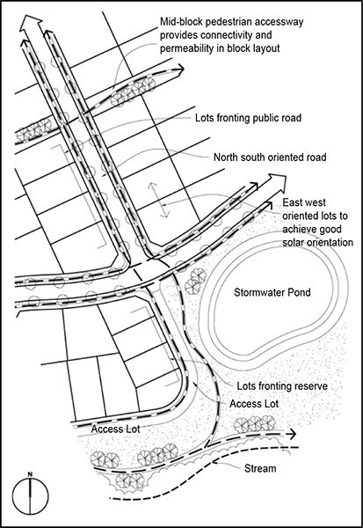

Figure 2: Block size and lot type 2

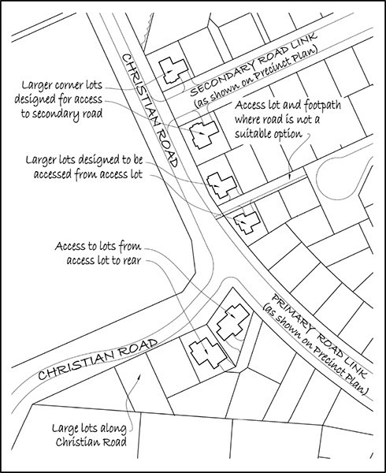

Figure 3: Combined cycle and pedestrian route
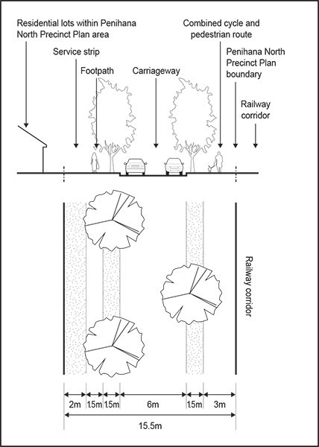

Figure 4: Christian Road cross section adjacent to sub­precinct C
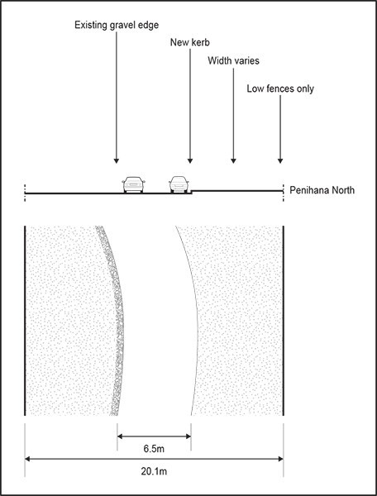

Figure 5: Christian Road cross section adjacent to sub­precinct B
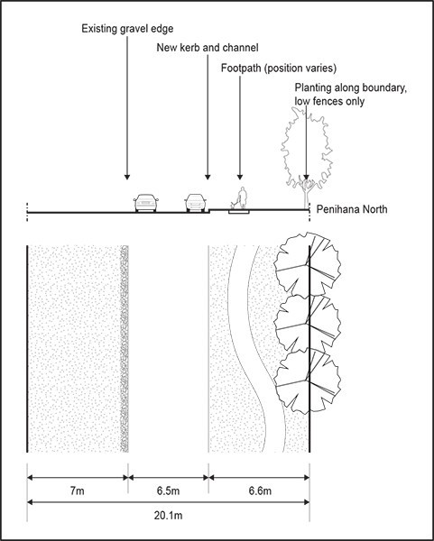

Figure 6: Recreation and stormwater reserves 1
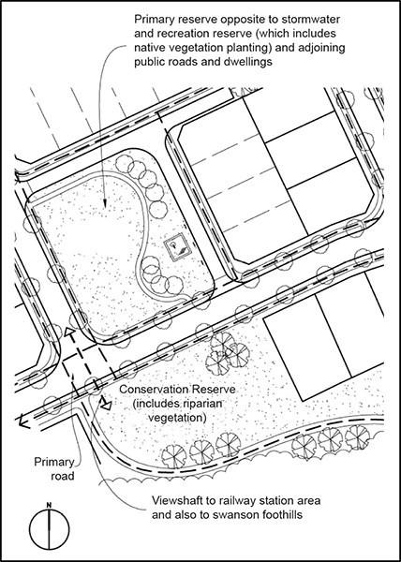

Figure 7: Recreation and stormwater reserves 2
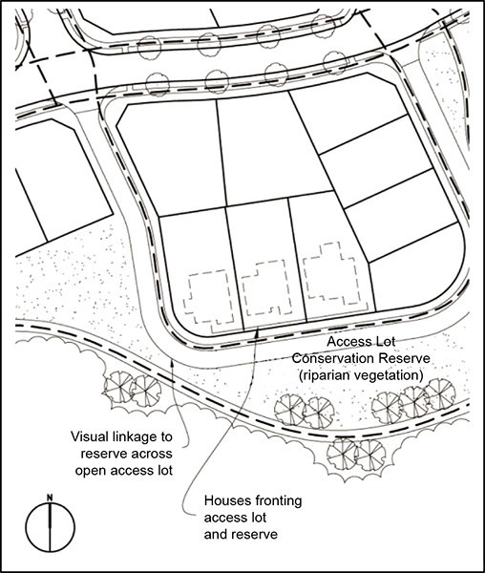

- Definitions

Medium density housing
Development on a site with a minimum net site area of 2,000 m2 containing dwellings at a density of more than one dwelling for every 349m2 of net site area exclusive of roads, reserves, communally owned driveways, open space and other commonly owned or public facilities, and includes housing types such as terrace housing or townhouses but does not include apartments.

Apartment(s)
A dwelling or dwellings within a multi storey development and any associated common internal access, recreation facilities or parking and access, but does not include medium density housing.

Precinct plan

Precinct plan: Penihana North
