PART 3 ­ REGIONAL AND DISTRICT RULES»Chapter K: Precinct rules»7 West»

7.8 Swanson North

The activities, controls and assessment criteria in the underlying Countryside Living zone and Auckland­wide rules apply in the Swanson North precinct unless otherwise specified below. Refer to planning maps for the location and extent of the precinct.

Activity table

The activities in the Countryside Living zone apply in this precinct unless otherwise specified in the activity table below.

Activity | Activity Status
Subdivision | C

Subdivision controls

  - The subdivision controls in the Auckland­wide rules ­ subdivision and the underlying Countryside Living zone apply in this precinct unless otherwise specified below.

Controlled activities

    - Subdivision in the precinct that meets all the standards below will be assessed as a controlled activity:
      - the subdivision complies with all Auckland­wide standards for subdivision unless otherwise specified

      - the subdivision will not lead to any development on land in a SEA

      - vegetation clearance arising from the subdivision will be mitigated by the balance areas of native vegetation on the site being permanently protected by suitable covenants or other legal mechanisms

      - a minimum site area of 4ha, unless the land being subdivided is shown on Precinct Plan 5.
Swanson North as having an indicated pattern of subdivision, or a maximum number of sites that can be created, in which case Precinct Plan 5. Swanson North shall apply

      - the subdivision will comply with the indicative layout of site boundaries, or the maximum number of sites able to be created, as shown on Precinct Plan 5. Swanson North.

    - Any subdivision not meeting the controls in clause 1.(d) above will be a restricted discretionary activity.

Restricted discretionary activities

    - Subdivision in this precinct is a restricted discretionary activity where:
      - the subdivision creates new sites in accordance with the number shown on Precinct Plan 5.
Swanson North for an existing site.

      - new fences are not within any SEA, or within riparian margins as shown on Precinct Plan 5.
Swanson North, except to isolate stock crossings.

      - all stock is permanently removed from the site or from any Indicative Enhancement area to be planted and from any SEA or riparian margin shown on Precinct Plan 5. Swanson North, and these areas have been provided with an adequate fence to prevent stock entering these areas.

      - all weeds have been (or will be) removed from any Indicative Enhancement area to be planted, riparian margin and SEA as shown on Precinct Plan 5. Swanson North.

      - the landowner and any future landowner will maintain any Indicative Enhancement area and riparian margin to be planted and all SEAs as shown on Precinct Plan 5. Swanson North, and will be kept substantially weed­free for 10 years.

      - any Indicative Enhancement area or riparian margin will have planting of vegetation as shown on the management plan prepared as part of the subdivision consent application, over an area of 0.125m² per 1m² of the site (excluding any SEA) as shown on Precinct Plan 5. Swanson North.

      - if the sum of the Indicative Enhancement area or riparian margin is less than the area required to be planted, the difference will made up by planting on any area within the site outside a SEA.

      - any planting which dies prior to effective canopy closure will be replaced.

      - the subdivision of any site in the precinct that contains a second dwelling located greater than 15m from a dwelling on the same site will ensure that either the second dwelling is placed on a separate proposed site to the existing dwelling or it is removed.

      - any proposed subdivision will include the formation of a public walkway in general accordance with the indicative public walkways shown on Precinct Plan 5. Swanson North and protected by registered right of way as an easement in gross.

      - the subdivision of any site meets the standards of any site specific rules provided for the precinct, as set out in Table 1 below.

Site specific rules

    - Where the land being subdivided is listed in the following schedule of site­specific rules and shown on the precinct plans as having a site­specific rule that imposes a permitted building area:
      - the schedule of site­specific rules and permitted building area shown on the relevant precinct plans apply.

      - the scheme plan of subdivision must show the site nominated for a dwelling and accessory buildings, and their curtilage, to be located within the permitted building area identified on the precinct plans. This rule may be included in a consent notice which council may require to be attached to the title of the new site created and the balance area. The site­specific assessment criteria must be used in the assessment of the scheme plan of subdivision. Where the site­ specific rules refer to a management plan, this must be submitted with the scheme plan and must address the matters referred to.

Table 1

Schedule of site specific subdivision rules
Address | Site specific rules | Site specific matters of control
49­73 Birdwood Road | - Any subdivision must ensure any proposed residential buildings are located within the permitted building area shown on Precinct Plan 3. Swanson North Area 3.  - Any subdivision must ensure access to any proposed dwellings is from the existing driveway | - The extent to which any proposed residential buildings are located so that the rural character of the western part of the site is  protected and remains free of any residential buildings  - The extent to which any subdivision uses the existing driveway to access any proposed residential buildings

15 Crows Road | 1. Any subdivision must ensure that any proposed dwelling associated with any proposed site which does not contain the existing dwelling or the minor household unit is located in the western part of the site close to Crows Road shown as permitted building area on Precinct Plan 1. Swanson North Area 1. | 1. The extent to which any proposed site not containing the existing dwellings avoids adverse effects on the sensitive ridge by locating any proposed dwelling close to the  road boundary in the western part of the site.
33 Crows Road | 1. Any subdivision must ensure that any new dwelling(s) on any proposed site(s) are within the permitted building area as shown on Precinct Plan 2. Swanson North Area 2. | 1. The extent to which the central, pastoral area of the site remains clear of any proposed dwelling(s) so as to protect the rural character of this site
26 Mudgeways Road | 1. Any subdivision must provide for the existing remote minor household unit to remain on the same site as the existing dwelling and any new dwelling to be located in the northern part of the site provided that written approval from the neighbour at 24 Mudgeways Road is obtained.
73 Sunnyvale Road | 1. Any subdivision must ensure that any new dwelling is located within the permitted building area as shown on Precinct Plan 4. Swanson North Area 4. | 1. The extent to which any proposed dwelling(s) on any proposed site(s) are located south of the existing dwelling and avoid locations along the northern boundary of the site.
20 Yelash Road | 1. Any subdivision must ensure that there are no proposed residential building(s) or earthworks within the sensitive ridge area as shown on the Ridgeline Protection Overlay in clause 4.3 of the Overlay Rules. | 1. The extent to which any subdivision does not result in earthworks or further residential buildings within the sensitive ridge shown on Ridgeline Protection Overlay in clause 4.3 of the Overlay Rules.

Discretionary activities

    - Subdivision that does not meet the controls in clauses 2.1.1(d) and 2.2.1 above will be a discretionary activity where:
      - the subdivision creates sites at a density within site(s) boundaries existing as at 14 October 1995 not exceeding that shown on Precinct Plan 5. Swanson North.

      - any Protected or Enhancement areas shown on Precinct Plan 5. Swanson North within a site have required planting established prior to the issue of a certificate under s. 224c of the RMA and are protected by way of covenant, encumbrance or consent notice.

    - Subdivision of Lot 2 DP 173199 (30 Crows Road) will be a discretionary activity where the controls set out in clause 2.2.1 are met.

    - Subdivision of Pt Lot 3 124026 (27­37 Crows Road) will be a discretionary activity where the subdivision creates sites within the discretionary building area shown on Precinct Plan 2.

Non­complying activities

The following activities are non­complying activities.
    - Any subdivision in the precinct that does not meet the controls contained in clauses 2.1.1(d), 2.2.1 or
2.3.2 above provided that the subdivision creates sites at a density within site boundaries existing at 27 February 2002 not exceeding that shown on Precinct Plan 5. Swanson North.

Prohibited activities

    - Any subdivision to which these rules apply which is not a controlled, restricted discretionary, discretionary or a non­complying activity is a prohibited activity.

Assessment ­ Controlled activities

Matters of control
  - The Council will reserve its control to the matters below for controlled activities in this precinct.
    - design

    - layout

    - operation (including hours and duration).

Assessment criteria
- The character, scale, hours of operation and intensity of the activity should be compatible with amenity values, neighbourhood character, and the natural landscape and not result in cumulative adverse effects.

- The activity should not compromise rural character.

- Purpose built buildings should be compatible with the scale and appearance of other buildings in the neighbourhood.

- The activity should not create adverse effects on water quality, native vegetation and fauna habitat.

- The activity should not individually or cumulatively lead to pressure for urban expansion nor the fragmentation of rural character and amenity.

- The adequacy of carparking and the standard and safety of driveway access and sight lines.

Assessment ­ Restricted discretionary activities

Matters of discretion
The council will restrict its discretion to the matters below for the land use activities listed in this precinct as restricted discretionary:
  - The general matters set out in clause 2.3 of the general provisions, clause 13.4 of the rural zones and:
    - scale and intensity

    - retention and maintenance of vegetation

    - screening and landscape treatment

    - car parking and access.

Assessment criteria
- The character, scale, hours of operation and intensity of the activity should be compatible with amenity values, neighbourhood character, and the natural landscape and not result in cumulative adverse effects.

- The activity should not compromise rural character.

- Purpose built buildings should be compatible with the scale and appearance of other buildings in the neighbourhood.

- The activity should not create adverse effects on water quality, native vegetation and fauna habitat.

- The activity should not individually or cumulatively lead to pressure for urban expansion nor the fragmentation of rural character and amenity.

- The adequacy of carparking and the standard and safety of driveway access and sight lines.

Assessment ­ Subdivision controls

Matters of discretion ­ controlled activities
  - When assessing controlled activity applications, council will restrict its discretion to:
    - the design, scale and location of sites

    - the design, location, construction and alignment of driveways and roads

    - provision for landscape treatment

    - protection of natural features

    - the location, design and construction of infrastructure

  - The council will also consider the assessment criteria in 5.3 below.

Matters of discretion ­ restricted discretionary activities
- When assessing restricted discretionary subdivision applications, council will restrict its discretion to:
  - the design, location, construction and alignment of driveways and roads

  - the design and scale of and the location of building platforms on proposed sites

  - provision for landscape treatment

  - provision for works intended to protect and enhance vegetation in areas where the precinct map provides detailed subdivision provisions requiring such works, and other drainage works and other infrastructure works

  - driveway construction between road carriageways and individual sites

  - the location of building platforms on Lot 14 DP 86225 and Lot 1 DP 63568

  - the details of, and information in, the management plan (to be lodged with any subdivision application)

  - the precise delineation of any SEA and Indicative Enhancement Area within the site

  - the location of fence lines

  - planting and the management and removal of weeds in any SEA and Indicative Enhancement Area within the site

  - the mitigation of impacts on landscape and amenity values that may arise as a result of the future establishment of buildings

  - the location and formation of indicative public walkway linkages shown on the precinct map

  - the design and location of proposed building platforms

  - the possible removal or relocation of any existing second dwellings or other accessory buildings.

Assessment criteria Design location and scale
- Sites should be of a useable shape.

- Proposed subdivision should identify a stable building platform and stable vehicle access within each proposed site, and whether these proposals are or are likely to be subject to material damage by erosion, falling debris, subsidence, slippage, or inundation from any source.

- Any subsequent use that is likely to be made of the land should not accelerate, worsen, or result in material damage to that land, other land, or structure, by erosion, falling debris, subsidence, slippage or inundation from any source.

- The proposal should contribute to the achievement of the relevant character and amenity of the local area

Transportation
- The design and placing of roads and driveways should minimise alteration to landform, avoid visible scars on the landscape and take advantage of natural drainage systems.

- Carriageways of roads and shared driveways should be constructed of materials and to a design strength sufficient to carry the likely wheel loads of travelling and parked vehicles, and which enable the carriage of vehicles at a minimum future maintenance cost.

- Carriageways on roads and shared driveways should be of a design quality and durability to provide for the safe passage of motor vehicles, cyclists and pedestrians, maintenance of comfortable riding quality and discharge of stormwater.

- The edges of roads and shared driveway carriageways should be appropriately designed and constructed to:
  - avoid edge fretting

  - adequately delineate the edge for driveway or road users

  - allow safe and ready access to adjoining sites at appropriate locations.

9.

10.

11.

12.
The design of any roads should incorporate and provide for amenity features including planting.

The materials used in the construction of any road and road markings, should complement the surrounding environment.

The road reserve and carriageway width and alignment should allow for the safe and efficient movement of pedestrians, cyclists and motor vehicles, the provision of infrastructure, and planting.

Construction works within any road including carriageways, drainage works and other infrastructure works and driveway construction between road carriageways and individual sites should be designed to minimise the necessity for earthworks and clearance and should be constructed of materials that are visually and aurally appropriate to the neighbourhood character.

Infrastructure

13.

14.

15.
The subdivision design should avoid development within the natural environment, retain or link significant vegetation and fauna habitat areas, avoid development on natural landscape elements and heritage features, give regard to natural character, minimise soil erosion, encourage on­site water retention, avoid development on floodplains and use drainage methods that protect and enhance streams.

The subdivision design should enable the efficient provision of infrastructure.

The subdivision design should integrate with the surrounding landscape character.

16.
Measures should be incorporated into the subdivision proposal which avoid, remedy or mitigate any threat to the natural environment that could arise from the introduction of animals as a result of the subdivision.

Servicing

17.
The design, construction and location of stormwater treatment and disposal systems should:

- ensure maintenance of water quality in receiving natural waters

- not result in flooding on or downstream of the site

18.
within the precinct area, and ensure that the amount of impervious surface is minimised to the greatest extent practicable and that stormwater discharge mimics natural over land flow conditions by any appropriate method. An engineer’s report is required to demonstrate how the stormwater runoff from the buildings and impermeable surfaces will be managed and/or contained.
Having regard to the requirements of any comprehensive catchment resource consent issued by the council, the stormwater treatment and disposal system should be designed, constructed and located to:

- serve the whole of the natural upstream catchment area, including potential future development

- ensure maintenance of minimum standards of water quality in receiving natural waters, including treatment where necessary to provide for removal of contaminants and enhancement of riparian areas

- ensure sufficient capacity to provide for the safe and efficient disposal of stormwater from the subdivision and future development

- ensure adequate measures are taken to screen out litter, silt and other contamination

- be of a sufficient standard and compatibility with existing stormwater disposal systems to minimise maintenance costs

- ensure no more that minor adverse effects on other infrastructure or potential building development

- provide for stormwater disposal from all of the land within each site

- viii. avoid flooding on or downstream of the site.

19.

20.

21.
The design of stormwater systems should incorporate measures to reduce run­off rates where there may be damage caused to natural waterway systems.

The design, construction and location of the wastewater treatment and disposal system should have regard to the upstream catchment and effect on the downstream catchment, including likely future development.

The design, construction and location of wastewater treatment and disposal systems should:

- ensure sufficient capacity and treatment to provide for the safe and efficient disposal of wastewater to be generated by development likely on each site, having particular regard to human health and water quality

- ensure adequate measures to avoid leakage, entry of stormwater and penetration by plant roots

- be constructed so that there are no more than minor adverse effects on natural features

- give sufficient regard to suitability in respect of topography, soils, water tables and proximity to natural water courses or water bodies.

22.

Easements and consent notices should be applied to protect the integrity of wastewater treatment and disposal systems.

23.
Stormwater and wastewater treatment and disposal systems should avoid adverse effects on land stability erosion, slippage and inundation within each proposed site and on any other properties.

Subdivision

24.
Proposed subdivision should:

- Avoid, mitigate or remedy any impact on the landscape arising from the existing or future establishment of multiple clusters of buildings, and associated accessways.

- Avoid the potential for further development of existing building areas that are established in visually sensitive landscapes.

- Retain the rural character of the environment, taking into account any cumulative effects arising in association with existing buildings on the site and on surrounding sites.

- Retain the characteristic open spaciousness of the rural environment, rural amenity and the amenity of neighbours.

- Locate any new residential buildings (assessed by having regard to criteria above) in a more appropriate location than any existing minor household unit or propose to remove any existing poorly placed minor household unit and any other buildings.

- Where relevant, subdivision should provide for public access to and alongside the coast, streams, lakes and wetlands and for any public walkway linkages shown on Precinct Plan 5. Swanson North.

- For any subdivision of any site within the precinct the management plan should provide for:

i.

ii. iii. iv.
v.
areas of vegetation to be removed

the number, location, grade, size and species of plants to be planted weed control measures
the replacement of any planting which dies prior to effective canopy closure the management of natural regeneration.

- Where any proposed subdivision creates fewer lots than the allocation shown on Precinct Plan 5.
Swanson North, that subdivision should ensure that an appropriate design layout is provided which:

i.

ii. iii.

iv.

v.

vi. vii.
anticipates future subdivision up to the full allocation shown on Precinct Plan 5. Swanson North

provides for the future location of building platforms

establishes the size of any proposed site(s) appropriate to the landscape character of the area

limits the area of impermeable surface(s) through the use of shared driveways

provides for the protection of any Protected or Managed Natural Area and the establishment of any required planting in any Indicative Enhancement Area(s) over the whole site

provides for the management of stormwater runoff over the whole site

provides for any indicative walkway linkages shown in the Precinct Plan 5. Swanson North.

25.
Proposed subdivision should ensure:

- Protection and Enhancement areas are encompassed within proposed sites in a manner which best provides for their future maintenance and protection

- Protection and Enhancement areas are permanently fenced, if necessary, to exclude stock

- subdivision boundaries are positioned so that there is no more than one dwelling per site.

26.
The subdivision should ensure that:

- Enhancement Areas are, or will be, planted with eco­sourced species appropriate to the landscape and ecology of the area

- Bush Improvement Areas are, or will be, planted using native species.

27.
Any Enhancement Areas shown on Precinct Plan 5. Swanson North should have planting established and protected by way of covenant, encumbrance or consent notice.

Assessment ­ Development control infringements

Matters of discretion
The council will restrict its discretion to the matters listed below for the relevant modification:
  - Yards
    - location, privacy, screening and planting.

  - Building coverage
    - building bulk, screening and landscape treatment

    - provision of outdoor space.

Assessment criteria
The council will consider the assessment criteria listed for each activity below:
- Yards
  - The extent to which buildings are located:

i.

ii. iii.
a sufficient distance back from the site boundary to avoid more than minor adverse effects on the natural landscape

in a position which maintains opportunities to retain vegetation around the edges of the site

a sufficient distance back from site boundaries of adjoining sites to ensure a minimum level of privacy.

  - All development must be consistent with the character and amenity of the local area.

- Building coverage
  - The extent to which the scale of buildings detracts from the natural landscape, in particular:

i.

ii. iii.
extent of landscape modification, including earthworks and vegetation alteration visual prominence of the building
relationship with neighbouring sites.

  - All development must be consistent with the character and amenity of the local area.

Special information requirements

An application for subdivision activity must be accompanied by:

Design statement
  - A management plan including a topographic site map is required to accompany an application for resource consent. The management plan must show:
    - the contours of the site surveyed to one metre intervals

    - all existing buildings and an indication whether they are to be retained, removed or relocated onto new sites

    - the boundaries of any Protected or Managed Natural Area and Indicative Enhancement Area provided that:

i.

ii.
if there is any ambiguity in the maps as to the location and/or area of the areas then by covering letter the applicant must explain why and how the areas shown on the management plan has been chosen by reference to the vegetation and topography of the site

if there is any formed track running through a proposed Enhancement Area, the track may be excluded from any planting requirements

    - areas of vegetation to be removed

    - the number, location, grade, size and species of plants to be planted

    - the areas of planting calculated under an appropriate planting standard

    - all existing and proposed internal fences.

Precinct Plans

Precinct Plan 1: Swanson North Area 1
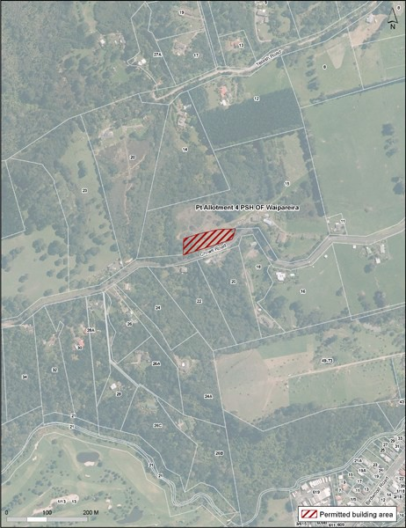

Precinct Plan 2: Swanson North Area 2
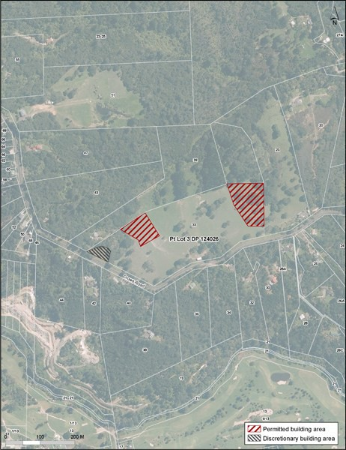

Precinct Plan 3: Swanson North Area 3
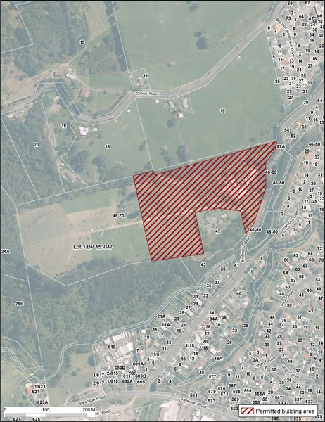

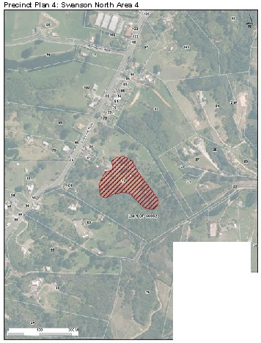

•

•

Precinct Plan 5: Swanson North
